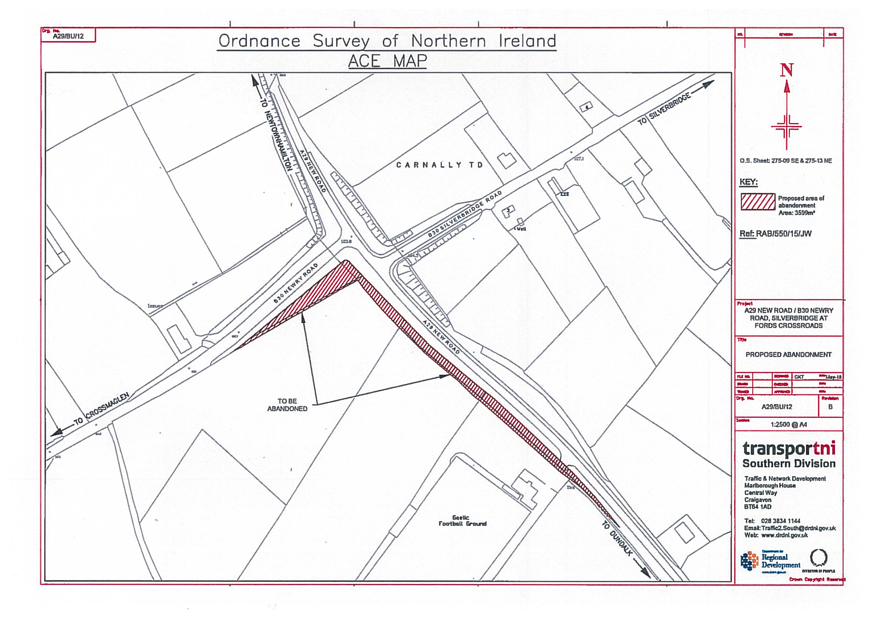

DEPARTMENT FOR INFRASTRUCTURE
Map No. IN1/19/327540 referred to in “The A29 New Road and B30 Newry Road, Silverbridge (Abandonment) Order (Northern Ireland) 2020” made by the Department on 18th August 2020 and coming into operation on 7th October 2020.

©Based upon the Ordnance Survey map with the Permission of the Director and the Chief Executive.
Crown Copyright SCALE 1:2500@A4
Area to be abandoned

