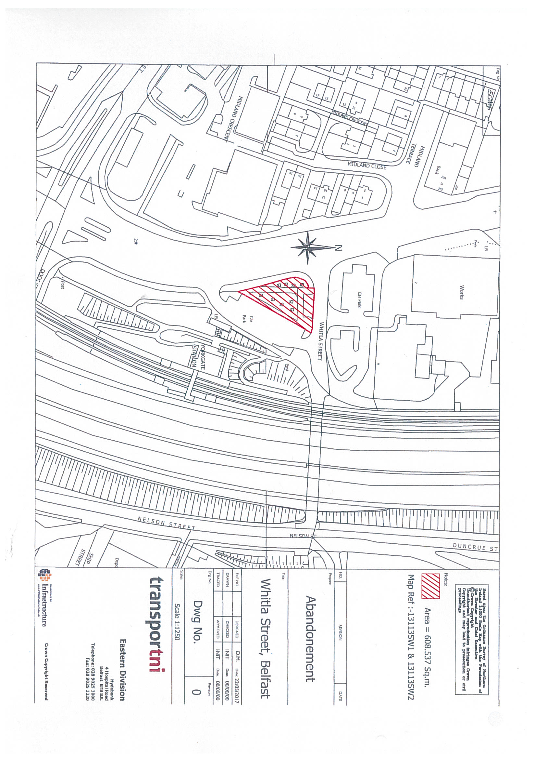
York Street
Area to be abandoned

DEPARTMENT FOR INFRASTRUCTURE
Map No. IN1/19/365321 referred to in “The Whitla Street, Belfast (Abandonment) Order (Northern Ireland) 2020” made by the Department on 18th August 2020 and coming into operation on 7th October 2020.

©Based upon the Ordnance Survey map with the Permission of the Director and the Chief Executive.
Crown Copyright SCALE 1:2500
Abandonment

