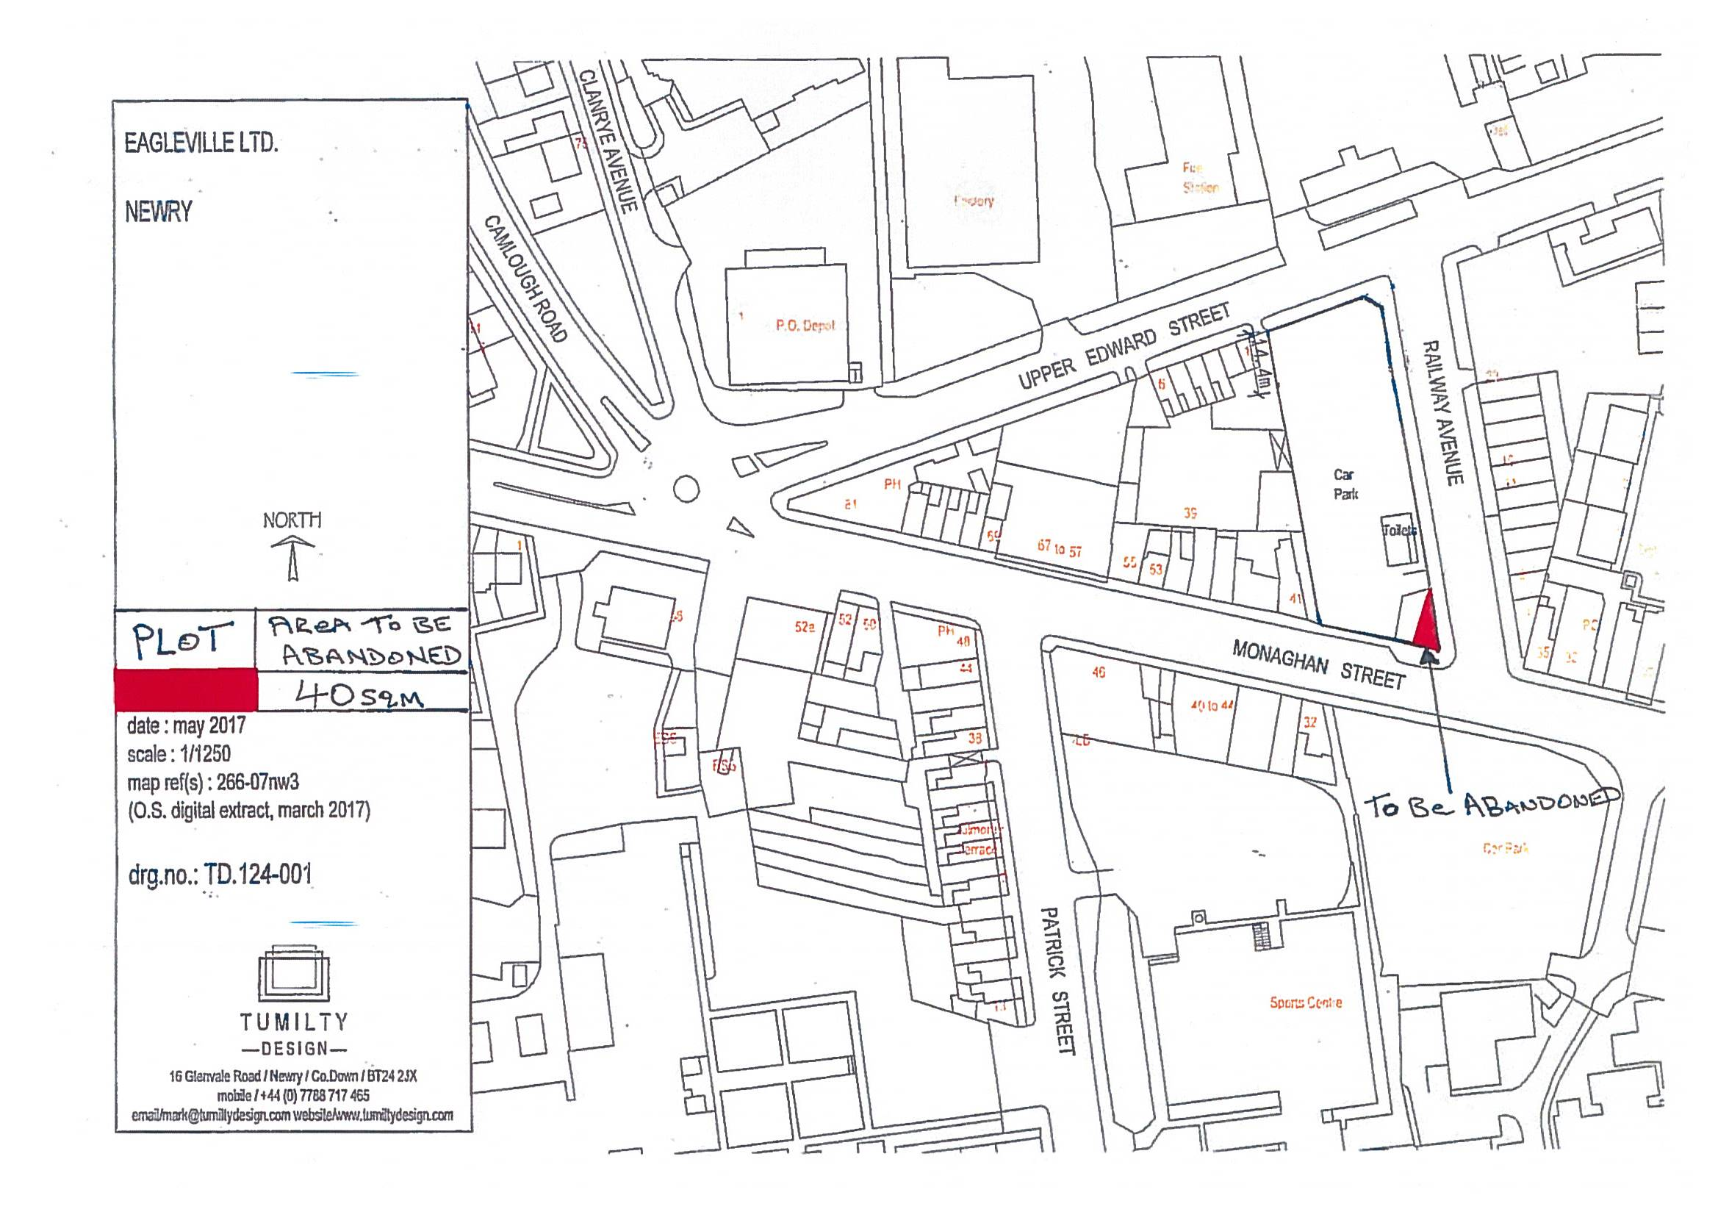

DEPARTMENT FOR INFRASTRUCTURE
Map No. IN1/17/ referred to in “The Academy Street, Belfast (Abandonment) Order (Northern Ireland) 2017” made by the Department on 2017 and coming into operation on 2017.

©Based upon the Ordnance Survey map with the Permission of the Director and the Chief Executive.
Crown Copyright SCALE 1:1250

Area to be abandoned

DEPARTMENT FOR INFRASTRUCTURE
Map No. IN1/17/ referred to in “The Meadow Lane, Portadown (Abandonment) Order (Northern Ireland) 2017” made by the Department on 2017 and coming into operation on 2017.

©Based upon the Ordnance Survey map with the Permission of the Director and the Chief Executive.
Crown Copyright SCALE 1:1250
Crown Copyright SCALE 1:200

Area to be abandoned

DEPARTMENT FOR INFRASTRUCTURE
Map No. IN1/17/ referred to in “The Glenwood Green, Dunmurry (Abandonment) Order (Northern Ireland) 2017” made by the Department on 2017 and coming into operation on 2017.

©Based upon the Ordnance Survey map with the Permission of the Director and the Chief Executive.
Crown Copyright SCALE 1:1250
Crown Copyright SCALE 1:200

Area to be abandoned

DEPARTMENT FOR INFRASTRUCTURE
Map No. IN1/17/ referred to in “The Galway Drive, Belfast (Abandonment) Order (Northern Ireland) 2017” made by the Department on 2017 and coming into operation on 2017.

©Based upon the Ordnance Survey map with the Permission of the Director and the Chief Executive.

Crown Copyright SCALE 1:1250

DEPARTMENT FOR INFRASTRUCTURE
Map No. IN1/19/114134 referred to in “The Railway Avenue, Newry (Abandonment) Order (Northern Ireland) 2020” made by the Department on 18th August 2020 and coming into operation on 7th October 2020.

©Based upon the Ordnance Survey map with the Permission of the Director and the Chief Executive.
Crown Copyright SCALE 1:1250
Area to be abandoned

