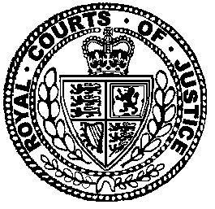

Neutral Citation Number: [2026] EWHC 1234 (Admlty)
Case No: AC 2025 LON 012345
IN THE HIGH COURT OF JUSTICE
BUSINESS AND PROPERTY DIVISION
ADMIRALTY COURT

Royal Courts of Justice
Strand, London, WC2A 2LL

Date: 30 November 2026

Before :

THE HONOURABLE MRS JUSTICE BORIS
- - - - - - - - - - - - - - - - - - - - -
Between :

 | Party One | Respondent
 | - and –
 | P2 | Respondent
- - - - - - - - - - - - - - - - - - - - -
- - - - - - - - - - - - - - - - - - - - -

Boris Smith KC (instructed by Party One) for the Appellant
Horace Doe KC and Toni Singh (instructed by A Society) for the Respondent

Hearing dates: 05 October 2026
Further written submissions: 13 November 2026
- - - - - - - - - - - - - - - - - - - - -
Approved Judgment

This judgment was handed down remotely at 11.15am on 30th November 2026 by circulation to the parties or their representatives by e-mail and by release to the National Archives.

.............................

Mrs Justice Boris :

Introduction
- This is an appeal.
Some factual background
- The Respondent is a person.
The Legislative Framework and relevant legal principles
- There is certain case law.
- For these reasons, had it arisen, it would have failed.
Conclusions
- In the light of my conclusions the appeal is therefore allowed
- Finally I am grateful.

