The Lords Spiritual (Women) Act 2015 (Extension) Act 2025
EXPLANATORY NOTES
What these notes do
These Explanatory Notes relate to the Lords Spiritual (Women) Act 2015 (Extension) Act 2025 which received Royal Assent on 16 January 2025 (c. 1).
- These Explanatory Notes have been prepared by the Cabinet Office in order to assist the reader in understanding the Act. They do not form part of the Act and have not been endorsed by Parliament.
- These Explanatory Notes explain what each part of the Act will mean in practice; provide background information on the development of policy; and provide additional information on how the Act will affect existing legislation in this area.
- These Explanatory Notes might best be read alongside the Act. They are not, and are not intended to be, a comprehensive description of the Act.

Table of Contents
Subject | Page of these Notes
Overview of the Act 3
Policy and legal background 3
Territorial extent and application 4
Commentary on provisions of the Act 4
Commencement 4
Related documents 5
Annex A - Appointment Process 6
Annex B - Hansard References 7

Overview of the Act
- The purpose of this Act is to extend the limited period in which, if a female diocesan bishop is eligible when a Lords Spiritual seat becomes vacant, she will be appointed to the seat.

Policy and legal background
- The two Church of England Archbishops and 24 of its other diocesan bishops are entitled to sit in the House of Lords as the Lords Spiritual. They do so by virtue of ancient usage and statute. Five of the 26 bishops automatically receive writs of summons to attend the House of Lords on the basis of the sees they occupy (Canterbury, York, Durham, London and Winchester; 'the five ex officio sees'). The remaining 21 are issued with writs of summons on the basis of seniority (i.e. length of tenure as a diocesan bishop) when a vacancy arises. This mechanism is set out in section 5 of the Bishoprics Act 1878.
- On 17 November 2014 the General Synod of the Church of England enacted the final legislation necessary to allow women to become bishops. However, due to the arrangements under the Bishoprics Act 1878, it would have taken over seven years before a newly appointed female diocesan bishop would have become sufficiently senior to take a place in the House of Lords (unless she were appointed to one of the five ex officio sees). Consequently, the Archbishop of Canterbury, after consultation with the Lords Spiritual and others, requested on behalf of the Church of England that amendments be made to the arrangements under the Bishoprics Act 1878 to enable the accelerated entry of female bishops to the House of Lords.
- Parliament subsequently passed the Lords Spiritual (Women) Act 2015 (‘the 2015 Act’), which came into effect on 18 May 2015. The 2015 Act modified the application of the procedure under the Bishoprics Act 1878 for a time-limited period so that vacancies among the 21 places, which are normally filled by seniority, are filled as they arise by eligible female bishops, if there are any available at that point (an eligible bishop is a bishop of a diocese in England who is not already entitled as such to a writ of summons). If there is more than one eligible female bishop then the one whose election as a bishop of the diocese was confirmed first will receive the writ. In practice, for a period of 10 years between 2015 and 2025, the most senior eligible female bishop at any time now fills a vacant Lords Spiritual seat in preference to the most senior eligible male bishop.
- The effect of the 2015 Act has been that six bishops who are women have sat in the House of Lords sooner than would have been possible under the procedure in place prior to the 2015 Act. Five of these bishops still sit in the House; one has retired.
- Male bishops have continued to enter the Lords under the 2015 Act, in accordance with the arrangements under the Bishoprics Act 1878 for determining seniority of precedence, if there were no eligible female bishops at the time a Lords Spiritual vacancy arose.
- The relevant provisions of the 2015 Act were due to expire on 17 May 2025. The Lords Spiritual (Women) Act 2015 (Extension) Act 2025 extends the provisions of the 2015 Act for a further five-year period so that the appointment process in the 2015 Act will now expire on 17 May 2030. This is designed to increase the number of female bishops sitting in the House of Lords more quickly.
- After the end of this period, the provisions made by the 2015 Act and extended by this Act will come to an end, and the arrangements under the Bishoprics Act 1878 for determining which bishops are to fill vacancies among the Lords Spiritual will be restored. The arrangements in relation to the five ex officio sees are left unchanged since any woman appointed to one of those sees will in any event become a Lord Spiritual immediately. For example, Sarah Mullally became Bishop of London in March 2018 and took her seat in the House of Lords in April 2018, outside of the provisions of the 2015 Act.

Territorial extent and application
- The Act extends to England and Wales, Scotland and Northern Ireland.
- The Act relates to the reserved matter of the Parliament of the United Kingdom in the Scottish and Welsh devolution settlements, and the excepted matter of the Parliament of the United Kingdom in relation to Northern Ireland. As such, legislative consent motions are not required.

Commentary on provisions of the Act
Section 1: Amendment of Lords Spiritual (Women) Act 2015
- Section 1 amends section 1 of the Lords Spiritual (Women) Act 2015 Act so that its provisions are extended and continue to have effect for all vacancies arising before 18 May 2030, rather than ceasing to have effect on 17 May 2025. This means that a vacancy within the 21 Lords Spiritual who do not hold an ex officio see will be filled by the most senior eligible female diocesan bishop in England, who is not already entitled to sit in the House of Lords, for a further five years, if one is available. The vacancy will be filled by the issue of a writ of summons to that bishop. She will be entitled to a writ in subsequent Parliaments until she ceases to be a diocesan bishop or is appointed to one of the five ex officio sees. The most senior eligible bishop will be the person whose election as a bishop of a diocese was confirmed first (this reflects the arrangements under the Bishoprics Act 1878 for determining seniority of precedence). If there is no eligible female bishop, the most senior male bishop will become a member of the House of Lords, as per the 1878 Act. A summary of how these arrangements operate can be found at Annex A.
Section 2: Extent, commencement and short title
- Section 2 sets out the territorial extent of the Act, as per the ‘Territorial Extent and Application’ section above; and the commencement of the Act, as per the ‘Commencement’ section below.

Commencement
- The Act commenced on Royal Assent. Given that the 2015 Act - if left unamended - would have effect until 17 May 2025, the provisions of this Act only have substantive effect from 18 May 2025.

Related documents
- The following documents are relevant to the Act and can be read at the stated locations:
- Bishoprics Act 1878,
https://www.legislation.gov.uk/ukpga/Vict/41-42/68/contents
- Bishops and Priests (Consecration and Ordination of Women) Measure 2014,
https://www.legislation.gov.uk/ukcm/2014/2
- Lords Spiritual (Women) Act 2015,
https://www.legislation.gov.uk/ukpga/2015/18/contents/enacted

Annex A - Appointment Process

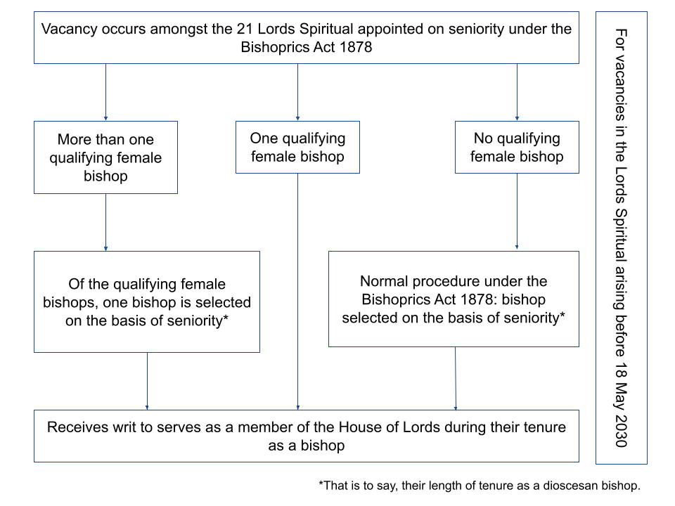

Annex B - Hansard References
- The following table sets out the dates and Hansard references for each stage of the Act's passage through Parliament.
Stage | Date | Hansard Reference
House of Lords
Introduction | 30 July 2024 | Vol. 839 Col. 877
Second Reading | 10 September 2024 | Vol. 839 Col. 1521
Public Bill Committee (discharged) | 16 October 2024 | Vol. 840 Col. 202
Third Reading | 22 October 2024 | Vol. 840 Col. 527
House of Commons
Introduction | 23 October 2024 | Votes and Proceedings, No.33
Second Reading | 14 November 2024 | Vol. 756 Col. 952
Committee of Whole House |  | Vol. 759 Col. 389
Third Reading | 18 December 2024 | Vol. 759 Col. 391
Commons Consideration of Lords Amendments | N/A | N/A
Royal Assent | 16 January 2025 | House of Commons: Vol. 760 Col. 543
 |  | House of Lords: Vol. 842 Col. 1300

