**Impact Assessment of**

**The Industrial Training**

**Levy (Construction**

**Industry Training Board) Order 2021**

**September 2020**

**Contents**

Table of figures 3

Problem under consideration 4

Background 4

Challenges 4

Rationale for intervention 6

Policy objective 7

Description of options considered 8

Option 1 - approve the levy proposals 8

Option 2 - reject the levy proposals 10

Monetised and non-monetised costs and benefits of each option  11

Costs 11

Benefits 14

Direct costs and benefits to business calculations 20

Wider impacts 20

Equalities 20

Small Businesses 21

Appendix A: Development of the 20212018 – 2020 Levy Proposal 21

Appendix B: Evidence of Industry Support for the Levy and Grant System 28

# 

# **Table of figures**

Table 1: Difference between the current levy arrangements and the Levy Proposals........ 9

Table 2: Forecast amounts to be raised from Levy Proposals……………………............... 11

Table 3: Estimated CITB levy payable by employer size ................................................... 12

Figure 4: Estimated CITB Levy payable by employer size ................................................. 13

Figure 5: Estimated CITB Levy payable by employers in England, Scotland and Wales .. 13

Figure 6: Estimated CITB Levy by construction activity ..................................................... 14

Table 7: Grant payments made by size of employer (2019/20) .......................................... 16

Table 8: Priority based intervention funding allocated in 2021/22…………………………... 17

Table 9: Estimated funding for CITB’s Other Support. ……………..................................... 18

Table 10: Estimated CITB funding to support industry in 2021-22………………………….. 18

Table 11: Monetary impact of achieving vocational qualifications, 10-year period ............. 19

Table 12: Effect of achieving vocational qualifications on earnings compared to the next highest achievement, by construction sector ...................................................................... 20

Table 13: List of main options considered by the Levy Working Party to change the current Levy arrangements……………………………………………………….…………….. 22

Table 14: Summary of main options considered by the Levy Working Party against the principles…………………………………………………………………………………………… 23

Table 15: RAG rating of main options against the principles ..……………………………….24

Table 16: Small Business Exemption Threshold 1971-2020 compared to average sector salary……………………………………………………………………………………………..... 26

Figure 17: Employer responses regarding the proposed increase to the Small Business Exemption Threshold…………………………………………………………………………….. 27

Figure 18: Yes / No Employer responses regarding the proposed increase to the Small Business Exemption Threshold…………………………………………………………………. 27

Table 19: Summary of engagement with the 14 Prescribed Organisations………………... 25

Figure 20: CITB survey of employers on the importance of the levy/grant system ............ 26

Figure 21: CITB survey of employers on what would happen without the CITB ................ 26

Figure 22: CITB survey of employers on whether the Levy, grant and funding system should continue .................................................................................................................. 27

**Problem under consideration**

**Background**

1. The Construction Industry Training Board (CITB) is the non-departmental public body of the Department for Education which is currently authorised by Parliament (pursuant to the [Industrial Training Act 1982](https://www.legislation.gov.uk/ukpga/1982/10)) to impose a statutory levy on employers in the construction industry to fund its operations. CITB receives no grant-in-aid funding from Government. Section 11 of the Industrial Training Act 1982 enables CITB to submit proposals to the Secretary of State for the raising and collection of a levy on employers in the construction industry over a period of up to three years. If certain conditions are met, the Secretary of State may give effect to the Levy Proposals by way of a Levy Order.

2. The Industrial Training Act 1982 in conjunction with a Levy Order empowers CITB to collect the Levy from employers in the construction industry and then distribute training grants and other support to those employers that undertake training considered eligible by CITB to receive support. CITB is dedicated to ensuring the construction workforce has the right skills for now and the future based on three strategic priorities – Careers, Standards and Qualifications, and Training and Development. The construction industry has had a levy and grant arrangement for 55 years. CITB is authorised to impose a levy on employers that are ‘wholly or mainly’ engaged in construction activities throughout England, Scotland and Wales. [The Industrial Training (Construction Board) Order 1964 (Amendment) Order 1992](https://www.legislation.gov.uk/uksi/1992/3048/schedule/1/made) (“the Scope Order”) defines what is classed as a construction activity.

3. CITB is currently funded by the Levy raised under [The Industrial Training Levy (Construction Industry Training Board) Order 2018](https://www.legislation.gov.uk/uksi/2018/432/made) (“the 2018 Order”). The 2018 Order enabled CITB to raise and impose a Levy on employers in the construction industry for levy periods in 2018, 2019 and 2020. In order for CITB to raise a Levy for subsequent Levy Periods, CITB is required to make proposals to industry and ultimately government on the rate and exemption arrangements that apply to the Levy they propose to raise. Levy Proposals are subject to Ministerial and Parliamentary approval. This Impact Assessment is concerned with the Levy arrangements for a one-year levy Order in 2021.

**Challenges**

4.COVID-19 has had an enormous impact on employees and businesses in the construction industry. CITB, with industry and Government has responded quickly to these challenges, ensuring employers had the support to get back on site safely and retain their apprentices. The Coronavirus Job Retention Scheme has helped ensure we avoided catastrophic job losses in the sector.

5. Now, construction will be crucial in recovery, employing over 2 million people and contributing 8.6% of GDP a year to the economy. The Construction Leadership Council’s “Roadmap to Recovery”1, that CITB is a key partner in, provides a clear path to address the skills issues that need to be overcome to help industry realise its potential in recovery. This includes addressing critical challenges, such as recruiting the future workforce, helping industry adapt to change, building a more professional industry, embedding high standards of site safety and improving occupational and mental health.

6. This will be a big challenge for an industry that faces a number of long-term systemic issues in training a skilled workforce. As evidenced by, and in addition to Mark Farmer’s 2016 report “Modernise or Die”2 and the 2017 “Review of the Industry Training Boards”3 for the UK Government, the industry has a reduced incentive to train due to:

* The complex and fragmented nature of construction and the large proportion of small and micro-businesses (over 98% of all CITB registered businesses) and long supply chains within it;
* Heavy reliance on subcontracting and self-employment (around 70% of labour is not directly employed), reflecting the project-based nature of much of the work;
* The cyclical nature of the industry, with drops in output and employment when there is an economic downturn and skills-lags in an upturn;

7. As the industry seeks to recover from the pandemic, it will additionally have to deal with a range of other complex challenges that include:

1. The potential impact of the UK’s upcoming departure from the European Union (35% of the construction workforce in London was born overseas4);
2. Ambitious plans to increase homebuilding (300,000 new homes p/a in England5) and infrastructure development such as HS2, Crossrail and Tideway;
3. Changing skills needs arising from greater modernisation in the industry. including advancements in On-line Learning, Digitisation, Environmental and Sustainable Construction, Covid-19 related Health and Safety and increasing diversity within the Sector.
4. Weak investment and productivity levels, further impacted by the pandemic; and
5. An ageing workforce, with one in every five UK-born construction workers nearing retirement4.

_______________

1.CLC’s Roadmap to Recovery (2020) Skills Challenges <http://www.constructionleadershipcouncil.co.uk/wp-content/uploads/2020/06/CLC-Roadmap-to-Recovery-01.06.20.pdf>

2.Farmer Review (2016), <https://www.constructionleadershipcouncil.co.uk/wp-content/uploads/2016/10/Farmer-Review.pdf>

3.Review of the Industry Training Boards (2017), <https://assets.publishing.service.gov.uk/government/uploads/system/uploads/attachment_data/file/657350/Building_Support-the_review_of_the_Industry_Training-Boards.pdf>

4. ONS document on migrant workers, age etc. release date:19th June 2018

<https://www.ons.gov.uk/peoplepopulationandcommunity/populationandmigration/internationalmigration/articles/migrantlabourforcewithintheconstructionindustry/2018-06-19>

5. Planning for the Future Doc. August 2020 – MHCLG – ambition for 300k new homes p/a pg.14

<https://assets.publishing.service.gov.uk/government/uploads/system/uploads/attachment_data/file/907647/MHCLG-Planning-Consultation.pdf>

**Rationale for intervention**

8. There remains a serious and distinct market failure in the development of skills in the construction industry: the trading conditions, incentives and culture do not lead to a sufficient level of investment in skills by employers. The evidence for this was set out in the Farmer Review2 and Government’s own review of Industry Training Boards3: employers will often be reluctant to invest in skills (including apprenticeships), because they cannot be confident that they will get a return on that investment over the long term. Skilled workers are often not directly employed, and even where they are, there is a risk that they will be poached by a competitor who is not investing in skills (what economists call the “free-riding” problem), or that they will have to be laid off during an economic downturn. Training is often left to small employers and individuals, who can find it hard to fund and access training.

9. Fundamentally the UK construction industry will need to attract more young people to replace its ageing workforce as it recovers from the pandemic and seeks to reinvent itself. This will need to be through a mixed approach of growing apprenticeship numbers, increasing the number of people entering the industry from Further Education, and retraining people through their lives. It’s also important that the new points-based migration system is responsive to industry’s skills needs. Employers will need to be properly incentivised to recruit and train the next generation of workers, to provide more work-placement and training opportunities.

10. There is a strong public interest in a high-performing, efficient and safe construction industry. The construction contracting sector in the UK accounts for an annual output of £163.7bn6, with GVA of £114.5bn7 and employs around 2.7 million people. The country’s economic success and social progress rely on building more homes and delivering key infrastructure. There is a further economic benefit from the large number and wide range of employment opportunities that these industries provide, many of them well-paid, highly skilled and offering good progression opportunities.

_______________

6. ONS, Output in the Construction Sector, 2019, seasonally adjusted volume, 2016 price basis

<https://www.ons.gov.uk/businessindustryandtrade/constructionindustry/datasets/outputintheconstructionindustry>

7. ONS, Regional gross value added (balanced) by industry, 2018, chained volume 2016 money value

<https://www.ons.gov.uk/economy/grossvalueaddedgva/datasets/nominalandrealregionalgrossvalueaddedbalancedbyindustry>

**Policy objective**

11. The objective of the CITB Levy is to raise funds to meet CITB’s expenditure on training the workforce across the construction industry in order to secure an adequate supply of skilled labour. CITB provides a wide range of services and training initiatives including: setting occupational standards; promoting career opportunities, funding strategic industry initiatives; and paying direct grants to employers who carry out training to approved standards.

12. Only employers wholly or mainly engaged in construction industry activities (as defined by the Scope Order), with a wage bill that is £80,000 or more per annum, are required to pay a Levy. Although, it should be noted that under the 2021 Levy Proposals this threshold will increase to £120,000, if approved. Consequently, around 51% of the smallest businesses currently registered with CITB are not required to pay the Levy, and the proposed increase will remove a further 5,000 micro sized employers increasing this figure to 58%. Where an employer’s annual wage bill is above this exemption threshold but falls below £400,000, CITB operates a small business levy reduction band meaning approximately 28% of small businesses currently benefit from a 50% discount off standard Levy rates. The number of employers in this bracket will reduce from 28% to 21% in line with higher levels of small employers becoming exempt from paying Levy. The remaining 21% of employers with an annual wage bill of £400,000 or more pay standard Levy rates.

13. All employers registered with CITB, regardless of whether they are liable to pay Levy, can claim grants towards training, subject to the conditions of the relevant Grants Scheme Terms & Conditions being met. In general, large employers pay more of the Levy, but medium and smaller businesses receive the majority of the funding paid out because they train more of the industry’s workforce, particularly new entrant trainees. The Grants Scheme and the Skills and Training Fund supports and incentivises investment in training, particularly for smaller businesses which generally have greater constraints in their financial and organisational capacity to invest. A detailed breakdown of the number and value of grants claimed by employers in 2019/20, the most recent year available for comparison, can be found in Table 7 (para 43).

14. Employers in the construction industry have consistently supported the statutory underpinning of their training arrangements. This is evidenced by consistent majority support from the industry for previous CITB proposals for Levy Orders to meet one of the requirements in the Industrial Training Act 1982. The CITB successfully achieved Consensus every year until 2008 (when the levy duration changed to 3 years), and every three years since. CITB needs to demonstrate that the Levy Proposals have support from employers and/or organisations representing employers who are likely to be liable for Levy payments. Industry has argued that without collectively funded training, paid for by a statutory Levy applied to all but employers with the smallest number of employees, there is a serious risk that insufficient training will be carried out.

**Description of options considered**

15. CITB planned to consult with industry across England, Scotland and Wales over Levy Proposals that had been developed to fund its activities in 2021, 2022 and 2023 between 16th March and 17th May 2020. Unfortunately, this industrywide engagement coincided with the commencement of the Covid-19 lockdown. The consultation was designed to seek views from industry over the Levy Proposals prior to the summer 2020 Consensus. All engagement events were cancelled and following discussions with industry representatives and DfE, the CITB Board took the unprecedented decision to both withdraw the Consensus process and deliver to industry a reduction in Levy liability. This decision reflected the immediate economic impact of Covid-19 on the industry and the reality that employers were focused entirely on ensuring the survival of their businesses.

16. Appendix A provides details of the various options considered before deciding on the final 2021 Levy Proposals and the steps CITB took to engage with industry prior to approval by the CITB Board in August 2020.

17. CITB submitted Levy Proposals to the Secretary of State in September 2020 for Levy to be collected in 2021. In accordance with S11(6)(b) of the Industrial Training Act 1982 the Secretary of State has the power to make a one-year Levy Order and has confirmed such proposals will be considered.

18. This Impact Assessment considers the cost and benefits of approving the 2021 Levy Proposals against a counterfactual baseline of rejecting the Levy Proposals and CITB having no Levy assessed in 2021/22. Two policy options are therefore examined:

* Option 1 - approve the Levy Proposals
* Option 2 - reject the Levy Proposals (no CITB Levy raised in 2021)

The two policy options examined in this Impact assessment were initially part of a shortlist of 8 options, including no change. A summary and assessment of each option is described in Table 13 (page 22) and Table 14 (page 23) of Appendix A.

**Option 1 - approve the Levy Proposals**

19. It is for CITB to develop Levy Proposals for how the statutory Levy should operate to finance their activities. In 2019, CITB established a Levy Working Party (LWP), a small group of industry representatives, to examine the current Levy arrangements (put in place by the 2018 Levy Order) and advise on how the Levy should operate in 2021, 2022 and 2023 by seeking industry’s views and taking into account the external environment and the evolving needs of industry.

20. With the LWP’s guidance, CITB scoped out a range of possible options before agreeing on the Levy Proposals which were due to be consulted on during the spring of 2020. There was a far lower response rate than expected due to the onset of the nationwide lockdown, with just 420 responses received from employers registered with CITB (approximately 0.5% of employers registered with CITB). However, 85% of employers who did respond were in favour of the option to increase the small business exemption threshold from £80,000 to £100,000.

21. After considering feedback from industry during the lockdown, The CITB Board, supported by the LWP agreed that these proposals had to be revised to reflect the prevailing economic conditions and skills needs of the industry created by Covid-19. It was decided that a 50% reduction to Levy rates in the subsequent Levy Order covering 2021 along with an increase to the number of small businesses who will be exempt from paying Levy will provide immediate support to industry.

22. The Industrial Training Act 1982 sets out at S11(6)(b) that the Secretary of State has the power to make a one-year Levy Order without being satisfied that the proposals have the support of the industry, provided that (i) he/she is satisfied that the proposals are necessary to encourage adequate training in the industry, and (ii) the proposals for the prior Levy Order achieved Consensus. The Secretary of State must also consider, that the Levy periods are appropriate in the circumstances and that employers who ought to be exempted in view of their small numbers of employees are exempted from Levy payments.

23. The 2021 Levy Proposals propose that the Levy arrangements set out in the 2018 Levy Order remain the same but a 50% reduction in rates should be applied and the small business Levy exemption threshold should increase from £80,000 to £120,000. Under the 2018 Levy Order CITB Levy is calculated on the wage bill of in-scope employers which includes payments made to directly paid employees (PAYE) and payments made to indirectly employed sub-contractors who are Net paid under the HMRC Construction Industry Scheme (CIS). Under the 2018 Levy Order, the PAYE element is charged at 0.35% and the liability for indirect employment at a rate of 1.25%. The 2021 Levy Proposals are a straight 50% reduction in the rate of PAYE and Net CIS as set out in Table 1 below:

|  |  |  |  |
| --- | --- | --- | --- |
|  | **Current Levy Arrangements** | **2021**  **Levy Proposals** | **Difference** |
| Pay-As-You-Earn  (PAYE) rate | 0.35% | 0.175% | 0.175%  (50% reduction) |
| Net CIS sub-contract rate | 1.25% | 0.625% | 0.625%  (50% reduction) |
| Small Business  Levy Exemption | Below £80,000  (40k employers) | Below £120,000  (51k employers) | +£40,000 increase  (+11,000 employers) * |
| Small Business Levy Reduction | Between £80,000 - £399,000  (15k employers) | Between £120,000 - £399,000  (10k employers) | -£40,000 decrease  (-5,000 employers) |
| Standard Levy Rates | Over £399,999  (10k employers) | Over £399,999  (10k employers) | No change |

* 5k relate to increased exemption threshold; approx.6k relate to newly registered employers assessable for the first time in 2021 and assumed to be below £120k.

**Table 1: Difference between the current levy arrangements and the Levy Proposals**

24. Under the 2018 Levy Order, all in-scope employers are required to complete an annual Levy Return, but only those with a wage bill of £80,000 or more per annum are required to pay the Levy. This threshold currently exempts around 51% of in-scope employers. In addition, employers with a wage bill of £80,000 or more, but below £400,000, receive a 50% reduction in their Levy Assessment. The increase to £120,000 will exempt 58% of in-scope employers; and employers with a wage bill of £120,000 or more, but below £400,000 will continue to receive a 50% reduction in their Levy Assessment.

**Option 2 - reject the Levy Proposals**

25. The 2021 Levy Proposals are expected to raise around £85.9m from the construction industry for CITB to invest in training and skills. Rejecting the 2021 Levy Proposals and not seeking revised proposals, would mean CITB would have no Levy income to invest after August 2021. If the Levy were to cease, employers would need to determine their own training needs without support, make their own arrangements regarding training and qualification standards, procure their own training directly and, would need to cover the full cost of training; which is currently subsidised through CITB grants. Small and micro-businesses (over 98% of all registered businesses) carry out a disproportionate amount of apprenticeship and other training and would be particularly affected by having no CITB grant support. Without the Grants Scheme, it is expected that many small businesses would not be able to afford to train their staff. CITB is also a participating employer in the ITB Pension Fund which was predominately operated through a defined benefit scheme until 31 December 2016. Any pension obligations pertaining to this scheme would potentially need to be funded by either industry or by HM Treasury.

26. Due to the particular structure and culture of the UK construction industry, it is difficult to forecast how construction employers would react to not having a Levy in comparison to other industries or other countries’ construction sectors. However, in 2019, 71% of employers surveyed felt that the Levy and Grant system was important in maintaining the level and quality of training across the construction industry as detailed in Appendix B. It is therefore expected that rejecting the 2021 Levy Proposals would lead to a significant reduction in the volume of training carried out, although it is difficult to quantify by how much.

27. Maintaining employer investment in skills is essential in order to produce a pipeline of domestically trained construction workers who can deliver key national infrastructure and build many more homes. This is a crucial period for industry which is responding to an ageing workforce, new skills needs from the modernisation of the industry, the impact of the UK’s upcoming departure from the European Union, and the Government’s plans for a substantial increase in home-building and infrastructure, as well as the significant impact of the Covid-19 pandemic.

28. The Industry Training Board Review3 published in November 2017, which is still very relevant in the current climate, considered the need for the CITB Levy in addressing the market failure in the industry following the introduction of the Apprenticeship Levy in April 2017. It determined that any removal of the CITB Levy would mean less funding was available overall, at a time when levels of training are needed to increase, because relatively few employers in the construction industry pay the Apprenticeship Levy. More significantly, the CITB Levy has consistently served to support the wider construction sector through providing non-apprenticeship training, as well as high quality apprenticeships. Contrary to the Apprenticeship Levy, the CITB Levy further supports employers with the costs of having an apprentice through subsiding costs for travel, wages and mentoring etc.

29. The CITB Levy plays a vital role in promoting long-term careers within construction, through encouraging investment in construction skills, as well as through the development of occupational standards and qualifications. The CITB Levy further focuses funding on wide-ranging research programmes to address and understand challenges within the industry. The role of the CITB Levy, in conjunction with the Apprenticeship Levy, continues to be essential in the development of key skills and the stability of the sector.

30. The Industry Training Board Review3 supported the CITB Levy being retained but recommended that CITB work with employers to make sure the Levy provides value for money. In response to this review CITB has amongst other things:

* streamlined the organisation by outsourcing products and services and centralising operations within a new Head Office;
* reformed governance structures by expanding the board to be more representative of small employers, along with the introduction of 3 Nation Councils;
* built stronger and closer links with CLC and is planning together to support the skills agenda;
* working more closely with stakeholder groups such as the 14 Prescribed Organisations; and
* Implemented clearly defined funding channels that are specifically targeted to industry needs;

The CITB Levy also supports the distinct policies and systems in Scotland and Wales.

**Monetised and non-monetised** **costs and benefits of**

**each option**

**Costs**

31. The total costs to industry of the 2021 Levy Proposals are both the direct costs arising from the amount levied and indirect administration costs associated with complying with the levy assessment arrangements. In terms of direct costs, Table 2 (below) shows the amount CITB expect to raise from the 2021 Levy Proposals.

|  |  |  |  |
| --- | --- | --- | --- |
| **Levy**  **Period** | **Current Levy Arrangements** | **Option 1:**  **Approve 2021 Levy Proposals** | **Option 2:**  **Reject 2021**  **Levy Proposals** |
| 2021 | £172.5m | £85.9m | £0m |
| **Total** | **£172.5m** | **£85.9m** | **£0m** |

**Table 2: Forecast amounts to be raised from Levy Proposals**

32. Table 2 also shows the amount CITB would have expected to raise if the current arrangements under the 2018 Levy Order were to remain in place for 2021. The 50% rate reduction shown in Table 1 for the 2021 Levy Proposals will reduce CITB’s Levy income by around £86m and the increase to the Small Business Exemption will reduce Levy income by a further £0.6m. Consequently, CITB will have less income to spend on activities to support the construction industry in 2021. During the development of the 2021 Levy Proposals, CITB agreed to reduce the amount levied on industry and concluded that this reduction in Levy income was at a level that would not inhibit the delivery of its strategic objectives.

33. Table 3 (page 12) provides an estimate of the amount the 2021 Levy Proposals will raise from employers of different sizes and compares this to how much they would be paying if the current Levy arrangements were to continue. These figures are indicative based on average projections across in-scope construction employers.

|  |  |  |  |  |
| --- | --- | --- | --- | --- |
| **Size of employer** | **Number of employers of each size on 2019 Levy Returns** | **Estimated Levy payable under current Levy arrangements** | **Estimated Levy payable under 2021 Levy proposal** | **Average annual decrease of Levy payable per employer under 2021 Levy Proposals** |
| Micro (0-9 employees) | 60,713  (estimated 41,479 to be exempt from paying Levy) | £29.5m | £14.4m | -£749 |
| Small (10-49 employees) | 8,170 | £43.4m | £21.7m | -£2,656 |
| Medium (50-249 employees) | 1,609 | £46m | £23.0m | -£14,295 |
| Large (250+ employees) | 291 | £53.6m | £26.8m | -£92,096 |
| Total | 70,783 | £172.5 | £85.9m |  |

**Table 3: Estimated CITB levy payable by employer size**

34. Under the 2021 Levy Proposals, it is expected around 58% of in-scope employers will be exempt from paying Levy due to being below the £120,000 Small Business Exemption threshold. In comparison 48% of in-scope employers were exempt from paying Levy in 2018. It is likely that all Levy paying employers will see a reduction in their Levy bills as a result of the 2021 Levy Proposals. No employers will see an increase in their Levy payments as a direct result of the 2021 Levy Proposals compared to payments due under the 2018 Levy Order.

35. CITB estimates that around 900 out of the 29,304 CITB Levy paying employers will pay both the CITB Levy and Apprenticeship Levy. The Apprenticeship Levy is only paid by those businesses with wage bills of over £3 million a year. However, this is very much an estimate as it was not possible to be confident about the number of connected companies that would be captured by the Apprenticeship Levy.

36. Figures 4, 5 and 6 (page 13) demonstrate (based on 2019 Levy Returns) CITB’s estimate of CITB Levy payable under the current rates and thresholds compared to the 2021 Levy Proposals. These comparatives illustrate in-scope employers of different size, location and construction activity.

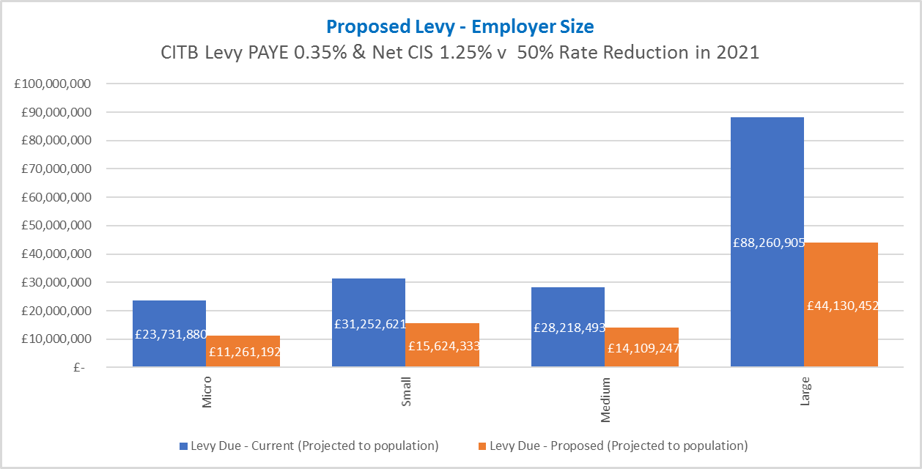

**Figure 4: Estimated CITB Levy payable by employer size**

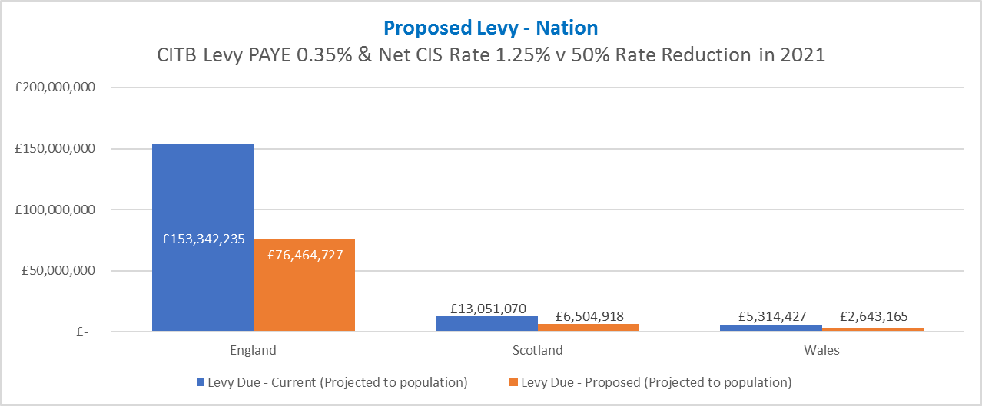

**Figure 5: Estimated CITB Levy payable by employers in England, Scotland and Wales**

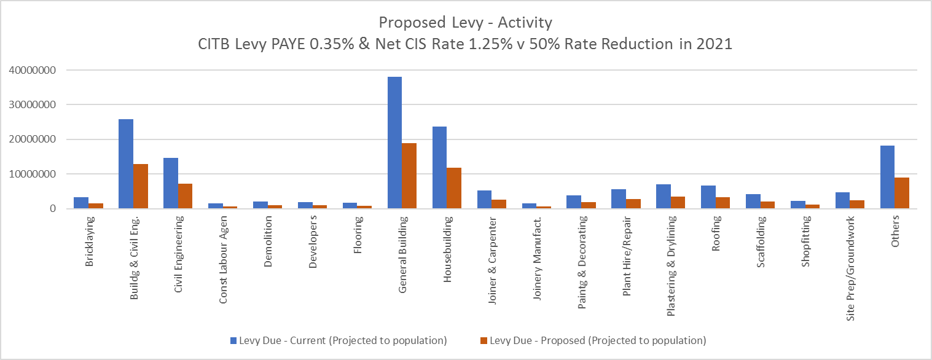

**Figure 6: Estimated CITB Levy by construction activity**

37. Indirect costs from the 2021 Levy Proposals include the cost of employers completing their annual Levy Returns, providing details of the number of employees on their payroll and the size of their wage bill. It is a requirement of all in-scope construction employers to allow CITB to calculate their Levy bill. The compliance costs relate to staff time or using third parties (e.g. accountants) in completing the Levy Return. Compliance costs depend upon the size of an employer’s payroll and use of subcontractors.

38. All employers who are registered with CITB, both Levy payers and small firms exempt from paying Levy, can claim grants subject to Grants Scheme terms and conditions. Until 2018 grants could only be claimed via completion of physical grant application forms. CITB has now introduced an automated grant system designed to remove this administrative burden.

39. The monetised direct and indirect administration costs of rejecting the Levy Proposals (option 2) would be zero as no Levy regime would be in place for 2021. This, however, needs to be weighed against the benefits of the Levy described below and the serious risk that insufficient training would be carried out in the absence of the Levy.

**Benefits**

40. The money raised by the Levy is used to fund CITB’s functions to support the construction industry to make sure it has the skilled workforce it requires. CITB’s core function is providing direct grants to employers to train new staff or develop the skills of their existing workforce. CITB also delivers a range of other functions, such as funding for skills initiatives, industry wide work on research, developing standards and qualifications, and promoting construction as a career.

41 The Levy and Grant system supports employers of all sizes to train their workforce. This is especially crucial for smaller businesses and for longer term commitment training. For example, many of the apprentices employed in the industry are taken on by small and micro businesses. Many of these businesses have said that without the CITB apprenticeship Grants they would not be able to take on the trainees. For larger employers, it impacts the number of apprentices they may take on. This also applies to the scale of longer-term qualifications such as HND and degrees that employers are willing to support.

42 In October 2020 CITB commissioned Pye Tait to undertake a survey of construction employers to understand their awareness, perceptions and use of the grants scheme. Pye Tait interviewed 615 UK construction employers sampled from CITB’s Levy database. The results of this survey showed that:

* Smaller companies are reliant on grants for training apprentices. 68% of micros and half of small companies who trained apprentices with a grant would have reduced or not done any apprenticeship training if it wasn’t for grant funding.
* 56% of grant users say that the grants have enabled them to address skills gaps in their organisation and that they wouldn’t have been able to do that without the grant.
* 1 in 5 grant users have stated that the grant they received helped them prevent skilled staff from leaving the industry.
* 45% of micro companies who have claimed a CITB grant in the last 12 months thought that the grant has enabled them to undertake training which would not otherwise have been affordable.

43. The monetised benefits of the Levy can be described in terms of how CITB plans to invest the Levy income to support the construction industry and in terms of the estimated economic benefits of the additional quality and quantity of training which occurs as a result of the investment by CITB in relation to higher earnings for learners and higher profits for employers, as a consequence of the impact of training on workers’ productivity.

44. CITB’s Grants Scheme provides employers with grants for a wide range of training courses and qualifications. In 2019/20, around 60% of the grants were provided to support employers with the additional costs of employing an apprentice in construction. Government funding generally covers apprenticeship training costs with CITB’s grants supporting employers with the costs of having an apprentice such as wages, travel and tools. The Grants Scheme therefore incentivises employers to take on apprentices in a sector that has inherent disincentives for doing so. Grants are also provided for a range of Vocational Qualifications (VQs) at Levels 2 and above and for the achievement of plant tests (e.g. theory and practical tests required to work safely with plant). By 2022 all CITB Grants Scheme eligible courses will be backed by a standard to ensure that the industry is investing in quality, transferable learning.

45. In 2019/20, the CITB Grants Scheme supported the creation of 27,987 apprentices, exceeding the target of 22,000 for the year. CITB Apprenticeships directly supported the creation of 4,528 new apprenticeships and provided support for 15,844 apprentices with an investment of £35.3m, part funded via ESFA, Welsh Government and Skills Development Scotland. The Grants Scheme also supported 18,989 worker qualifications, 214,497 upskilled workers through short duration accredited courses, 17,202 VQ achievements, and 18,718 plant tests. The total number of employers in receipt of grant in 2019/2020 was 15,916 (2018/2019: 16,121). Further information on the economic benefits of apprenticeships and other vocational qualifications can be found in the Further education: measuring the net present value in England report - [Further education: measuring the net present value in England - GOV.UK (www.gov.uk)](https://www.gov.uk/government/publications/further-education-measuring-the-net-present-value-in-england).

46. Looking at the distribution of grants across different employer groups, Table 7 (below) provides details of the number and value of grants claimed by employers in 2019/20, the most recent year available for comparison. It demonstrates that micro, small and medium employers received around 69% of grants support. Large employers also received grants for training, but the balance of grants paid reflects the nature of the construction industry: that smaller employers carry out a substantial amount of training. CITB expected the number of firms receiving grants and the proportion going to smaller employers to rise as a result of the reforms introduced in April 2018, in particular the automation of grant payments and a 9% increase between 2015/16 and 2019/20 shows that this is coming to fruition.

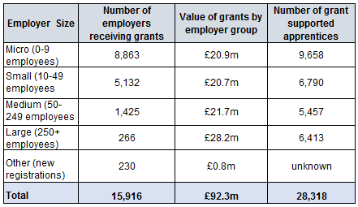

**Table 7: Grant payments made by size of employer (2019/20)**

Source: Draft 2019/20 Annual Report

47. In 2019/20, CITB also supported:

* 1,700 small and micro firms through the Skills and Training Fund, totalling a £10.1m investment;
* £20m investment through the Construction Skills Fund (including £17m of DfE funds), which delivered 13,200 site-ready workers; £4.9m of the DfE investment was delayed and is accounted for in 2020/21;
* the Go Construct website engaged 70,755 prospective entrants to explore construction career opportunities.

In terms of CITB’s wider offer, £19.6m was also allocated in 2019/20 across other Funded Activities.

48. Table 8 (below) provides details of Company Specific Funds and Funded Programmes allocated in 2021/22 totalling £34.2m. This is funding that is available for Levy registered employers along with other eligible construction stakeholder groups to apply for. Only projects that meet CITB’s priorities for skills and training and demonstrate value for money will receive this funding, ensuring all projects deliver the best economic returns for the construction industry.

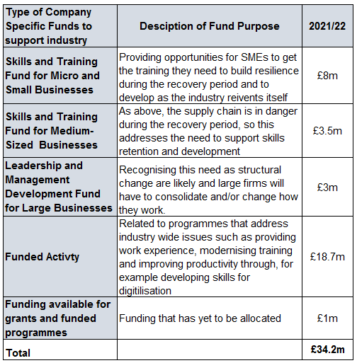

**Table 8 – Priority based intervention funding allocated in 2021/22**

Source 2021/22 figures: CITB Strategic Plan

<https://www.citb.co.uk/documents/strategic_plan/citb_strategic_plan_2021-25.pdf>

49. CITB also provides a variety of areas of indirect support which are not necessarily attributable to an individual employer but provide a wider benefit to industry. A description of these and the areas are set out in Table 9 (page 18). Just over £18m has been allocated by CITB which is linked to the 2021 Levy Proposals for this purpose.

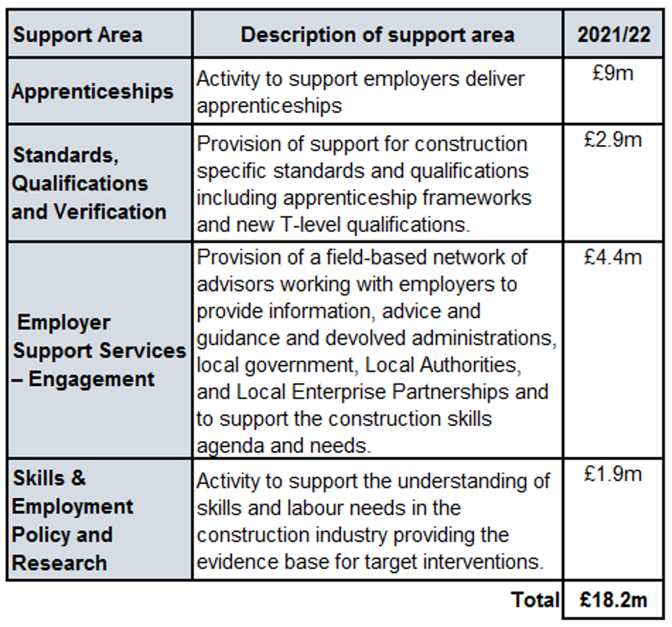

**Table 9 – Estimated funding for CITB’s Other Support 2021-22**

Source 2021/22 figures: CITB Strategic Plan

<https://www.citb.co.uk/documents/strategic_plan/citb_strategic_plan_2021-25.pdf>

50. Most of the ‘Other Support’ detailed in Table 9 (above) encourages recruitment into the industry and helps it set industry standards and deliver training and therefore the direct impact of these interventions cannot be calculated in isolation.

51. CITB’s planned expenditure to directly support industry in 2021/22 is set out in Table 10 (below). Due to the delay in collecting Levy in 2020 over £80m 2020/21 Levy is expected to be carried forward and used to support industry in 2021/22. Despite delayed levy collection CITB continued to fund training and qualifications in the industry, thereby significantly depleting their reserves. Therefore, the return on levy is lower in 2021/22 partly as a result of £25m being planned to be diverted to enable a partial replenishment of these reserves.

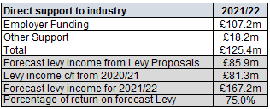

**Table 10: Estimated CITB funding to support industry in 2021/22**

52. Table 11 (below) shows the economic benefits of apprenticeships and other vocational qualifications at Levels 2, 3 and 4 or above. The estimated monetary value of vocational qualifications in the sector range from £36,500 (level 2) to £68,400 (level 4 and above) over a ten-year period. The monetary value of the qualification generally increases as the level of the qualification increases. Employers receive the largest proportion of the benefit of the qualification through increased output. The value of the qualification to individuals comes from increased wages and an increased probability of being employed.

53. Table 11 also gives a sense of the benefits which additional training, in the construction and build environment, funded by the CITB Levy is likely to generate in the form of additional taxation linked to these wage increases. It is not possible for the CITB to calculate **total** benefits as there is no way to ascertain, upfront, exactly how many additional workers will do which types of training as a result of the levy. The Further education: measuring the net present value in England report, provided by BIS, clearly demonstrates the strong economic benefits from apprenticeships and other vocational qualifications.

Since 2018 the Grants Scheme has narrowed its focus to training that is specific to the construction industry and that which meets industry agreed standards. For apprenticeships and qualifications these standards were already in place, but for many of the short duration training courses there were no industry agreed standards. Leading up to 2018, and on-going now, CITB has worked with the industry to identify areas of training specific to construction where standards don’t exist and to develop them. Once Standards are in place, training courses are then only eligible for CITB Grants if they meet these standards.



**Table 11: Monetary impact of achieving vocational qualifications, 10-year period**

Source: <https://www.citb.co.uk/documents/value%20of%20vq%20report%20citb%20template%20(2).pdf>

54. Table 12 (below) shows an average percentage increase in worker earnings who achieved a given qualification level compared to workers with the next highest level of qualification. There are increases in marginal returns for all qualification levels, within all subsectors and the achievement of a level 2 qualification in the civil engineering subsector stands out as being particularly beneficial.

|  |  |  |  |
| --- | --- | --- | --- |
| **Table 12: Effect of achieving vocational qualifications on earnings compared to the next highest achievement, by construction subsector** | | | |
|  | **Level 4+** | **Level 3** | **Level 2** |
| Construction Sector Overall | 14%* | 9%* | 12% |
| Construction of Buildings | 14% | 12%* | 9%* |
| Civil Engineering | 19%* | 10%* | 55%* |
| Specialist Construction Activities | 9%* | 10%* | 17%* |
| **Table 12: Increased earnings by construction subsector at Level 2, 3 and 4+**  *Source: ONS LFS data; ICF regression analysis. Note: *p<0.1. The percentages in this table were obtained through exponential transformation of the original regression coefficients. They can be interpreted as an average percentage increase in earnings of a worker who achieved a given qualification compared to a worker with the next highest qualification.* | | | |
|
|
|

Source:

<https://www.citb.co.uk/documents/value%20of%20vq%20report%20citb%20template%20(2).pdf>

**Direct costs and benefits to business calculations**

55. Taxes, levies and other charges on businesses do not count as regulatory provisions and are therefore not subject to the regulatory framework13. The proposed Industrial Training Levy (Construction Industry Training Board) Order 2021 is therefore out of scope of the regulatory framework. As this Impact Assessment is out of scope, an Equivalent Annual Net Direct Cost to Business (EANDCB) has not been calculated for this Order. In addition, a NPV (the difference between the Present Value of a stream of costs and a stream of benefits) has not been calculated for this Impact Assessment.

**Wider impacts**

**Equalities**

56 We have reviewed the equalities implications of the 2021 Levy Proposals and have provided the required PSED Assessment. We do not believe that the CITB levy order 2021 will disadvantage some people or groups more than others either through direct and indirect discrimination, discrimination arising from disability and need to make reasonable adjustments, victimisation and harassment or any other forms of discrimination. No forms of discrimination are considered to arise. The 2021 levy is payable by industry employers mainly engaged in construction work which fall within the scope of the CITB. It is not a levy on individuals. s.

57. The CITB is however very conscious of the issues around diversity and inclusion within the industry and that there are some significant equality issues generally in this sector now - the most visible issues being the under-representation of women and people from BAME backgrounds in the industry. Analysis of Office for National Statistics (ONS) data suggests the percentage of BAME representation in UK construction is just 7.4%. ONS data also shows that, with only a 13% female workforce, UK construction has materially worse gender diversity than any other UK industry. The UK construction’s 13% female workforce compares with 20% in transportation and 21% in energy and mining – the other two worst sectors.

58. These issues are not directly attributable or related to the levy proposals, however the CITB is aware of the important role it must play to address these equality issues. The CITB has historically played a key role in addressing the equality issues in the industry and have confirmed, to the department, their intention to continue to support and fund several equality and diversity initiatives.

**Small Businesses**

59. The Levy Proposals provide a full exemption for any employer whose labour costs are less than £120,000 (58% of total in-scope employers, up from 48% in 2018). Small businesses are, however, eligible to claim grants towards the cost of training their employees. Employers with labour costs of £120,000, but below £400,000, receive a 50% reduction in their Levy assessment. Circa 15,000 small businesses out of the 70,000 assessable employers will benefit from this Levy reduction.

**Appendix A: Development of the 2021 Levy Proposals**

60. The industry-led LWP and CITB initially developed the 2021 – 2023 Levy Proposals over a 6-month period from June 2019 to November 2019. CITB provided the LWP with an impact analysis model that estimated the economic impact of any changes to the current Levy rates and thresholds on different construction sub-sectors, geographies and employer sizes. The LWP used the impact model to access each of the options against eleven desirable principles:

* The option meets the requirements for Levy Proposals set out in the Industrial Training Act (ITA)
* The option should deliver, within £2m, the required Levy value to support the Future Funding Arrangements
* The option should not add complexity to the calculation of the Levy
* The percentage of employers impacted is no more than (+ or -) 10%
* No individual employer should be impacted (+ or -) by more than 10%
* The Levy payable by any employer size group does not alter by more than 10%
* Large employers continue to be the group making the largest contribution
* Micro employers continue to be the smallest contributing group of employers
* The option should not incur more than minimal costs to update CITB systems
* The option should have the potential for positive reputational impact
* The option should support the Construction Leadership Council’s policy of encouraging direct employment

61. The LWP agreed on a shortlist of 8 options including no change. A summary and assessment of each option against the eleven principles is described in Table 13 (below) and Table 14 (page 23).

|  |  |
| --- | --- |
| **Description of options considered** | **LWP Assessment of each option** |
| No change to the current Levy arrangements | |
| No Change (PAYE 0.35%, Net CIS 1.25%) | This option would provide continuity after several years of change, it would be simple to communicate, and it received 77% support during the 2017 Consensus. However, as no additional income is being generated, this option would provide no additional benefits and does not address any changes to the external environment. With no extra funding available the CITB would not be able to widen or increase the support it provides to industry. |
| Raise the Exemption Threshold to £100,000 (from £80,000) | |
| No Change (PAYE 0.35%, Net CIS 1.25%) | This option would also provide continuity and be simple to communicate. In addition, this option would mean 2,000 of CITB’s smallest employers would no longer pay Levy and would be minimal impact to Levy income (estimated <£300,000). |
| Add a further Levy reduction band between £400,000 to £600,000 | |
| No Change (PAYE 0.35%, Net CIS 1.25%  New reduction band to include a 25% reduction | This option would taper the impact of transitioning from the 50% reduction band to paying full Levy and benefit approximately 6% of micro and small employers. This option would reduce Levy income by £1.7m and structural changes to CITB’s systems would be required which would come at a cost. |
| Reduce Differential between PAYE and Net CIS Levy rates | |
| PAYE increased to 0.5%, Net CIS reduced to 0.9% | This option would reverse the PAYE reduction from 0.5% to 0.35% included in the 2018 Levy Order, provide more parity between the contributions of PAYE compared to Net CIS and reflect the fact that some employers do not train subcontractors. The largest increase in Levy for a single employer would be £343,000, 51% of employers would see a high impact and the option would potentially counter government’s approach to false self-employment |
| Reduce the Levy rate Differential and Raise Thresholds | |
| PAYE increased to 0.5%, Net CIS reduced to 1%  Levy exemption threshold increased to £100,000  Levy reduction band increased to £600,000 | This option would also reverse the PAYE reduction from 0.5% to 0.35% included in the 2018 Levy Order, provide more parity between the contributions of PAYE compared to Net CIS and reflect the fact that some employers do not train subcontractors. The largest increase in Levy for a single employer would be £367,000, 51% of employers would also see a high impact and the option would potentially counter government’s approach to false self-employment. The main benefit would be to micro and small employers. |
| Increase Differential between PAYE and Net CIS Levy rates | |
| PAYE reduced to 0.3%, Net CIS increased to 1.4% | This option would factor in the additional costs involved with employing staff against paying subcontractors and may encourage a switch to PAYE. 51% of employers would see a high impact and trades that use high levels of subcontractors e.g. brickwork, carpentry, dry-lining and plastering would be hardest hit. Some significant increases in Levy for single employers. |
| Increase Differential with decreased thresholds | |
| PAYE reduced to 0.25%, Net CIS increased to 1.45% | Large employers paying the apprenticeship Levy would mainly benefit. This option would also factor in the additional costs involved with employing staff against paying subcontractors and may encourage a switch to PAYE. 59% of employers would see a high impact and trades that use high levels of subcontractors e.g. brickwork, carpentry, dry-lining and plastering would be hardest hit. Some significant increases in Levy for single employers. |
| Adopt a Single Levy rate for both PAYE and Net CIS | |
| PAYE increased to 0.65%, Net CIS reduced to 0.65% | The two rates would align creating simplicity and micro and small employers would benefit as well as trades that are highly dependent upon subcontract labour. Large employers would be hardest hit with the largest increase in Levy for a single employer estimated at £710,000. 51% of employers would see a high impact, the option could encourage the use of subcontract labour and there would be a significant change to the way Levy is distributed between employer size groups. |

**Table 13 – List of main options considered by the LWP to change the current Levy arrangements**

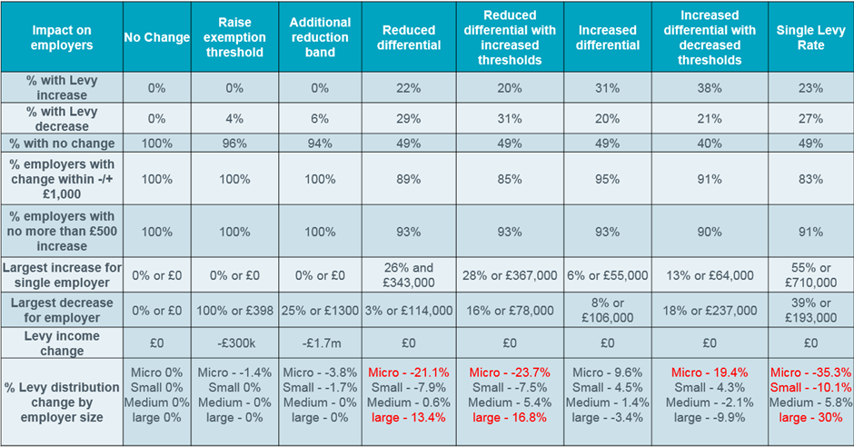

**Table 14 – Summary of the main options considered by the LWP against the principles**

62. From the start of their deliberation, there was a general feeling from the LWP that they felt the need to a period of stability and continuity with regards Levy for the next three years. This was reflected in the principles they came up with which included not adding complexity, minimising any redistribution of who paid Levy, for example between employer size groups and that individual employers should not be impacted by any more than 10%. The LWP used the eleven principles that had previously been established to narrow the options down to a short-list of three by way of RAG rating the options against the principles. The RAG rating of each option can be found in Table 15 (below). This process identified the three options below as best meeting the LWP’s principles and were put to the CITB Board in November 2019. These were:

* **Option 1** - No Change
* **Option 2** - No Change, except to increase the small business exemption threshold from £80,000 to £100,000
* **Option 3** - Add a further Levy reduction threshold between £400,000 and £600,000 which provided a 25% reduction to standard rates



**Table 15 – RAG rating of the main options against the principles**

63. Prior to submitting these proposals to the Board, they were sense-checked with the three Nation Councils who ratified the desire for minimal change and stability. The culmination of discussions at the LWP in consultation with the CITB Board produced two preferred options which were ‘no change’ and ‘no change, except to increase the Levy exemption from £80,000 to £100,000’. The third option to add a further reduction threshold was discounted by the CITB Board because of the anticipated cost and complexity associated with it.

64. An on-line consultation channel was open between 16th March and 17th May 2020. On the 23rd March England, Scotland and Wales went into lockdown and CITB cancelled all face to face plans to engage with industry over the 2021, 2022 and 2023 Levy Proposals. These plans included a series of sixteen nationally supported roadshows, plus additional forums and webinars.

65. In April 2020 the LWP reconvened and considered the potential impact of Covid-19. The eleven original principles were subsequently updated to the following shortened list:

* The option meets the requirements of Levy Proposals set out in the ITA
* The option should deliver the required Levy to support the Strategic Recovery Plan over the duration of the Levy Order
* The Levy payable by any employer size group does not alter by more than 10% as a direct result of changes to the Levy
* Limited change to Levy distribution between contributing groups (Micro, SME & Large) as a direct result of changes to Levy
* The option should not incur more than minimal costs to update CITB systems
* The option should have the potential for positive reputational impact
* The option is responsive to industry needs as a result of the Covid-19 crisis
* The option enables a slow rebuilding of CITB reserves to ensure CITB can continue to support necessary training

66 In May 2020, the LWP considered feedback that was later published in the 2020 [Consultation Report](https://www.citb.co.uk/documents/consultation/citb_consultation_report.pdf)9. There was a far lower response rate (420 responses received from employers registered with CITB) due to the onset on Covid-19 and CITB’s subsequent decision not to promote it. 85% of participating employers agreed that the small business exemption should be increased from £80,000 to £100,000.

67. Consideration was also given to the movement in Construction salaries since 1970 as detailed in Table 16 (below), the assumption that micro employers were likely to be the group of employers most impacted by Covid-19 and the fact that the Small Business Exemption Threshold (SBET) had remained at £80,000 for twelve years. Based on their desire to make minimal changes, but to also support smaller businesses due to the Pandemic, and the overwhelming result of the consultation, the LWP recommended to the CITB Board that the SBET should be increased to £120,000 and no change to the Levy rates.

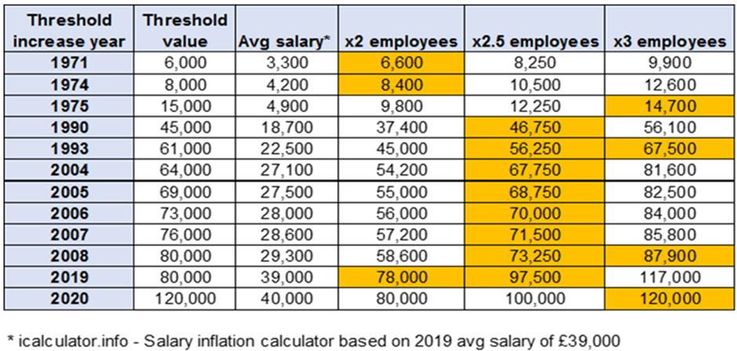

**Table 16 - Small Business Exemption Threshold 1971-2020 compared to average sector salary**

68. Collection of the 2020 Levy would have normally commenced in May 2020 but this was initially delayed for three months as a support measure during the initial stages of Covid-19. As part of further support efforts CITB decided to delay Levy collection for a further month until September 2020 and extend the end of the usual ten-month collection period to twelve months ending in August 2021.

________________

9. Consultation Report (2020), <https://www.citb.co.uk/documents/consultation/citb_consultation_report.pdf>

69. By the end of July 2020 CITB had engaged with the key stakeholders, industry leaders, a cross section of employers and the 14 Prescribed Organisations over the LWP’s recommendations. As part of this engagement Figure 17 (below) provides the results of 324 conversations held with employers across a variety of employer types, sizes and locations. These employers were asked the following question “Do you agree that the Small Business Levy Exemption should be increased from £80k to £120k in 2021”? The employer was able to select from three options, Yes, No or Don’t know or different opinion and a clear majority (74%) agreed that the threshold should be increased to £120k.

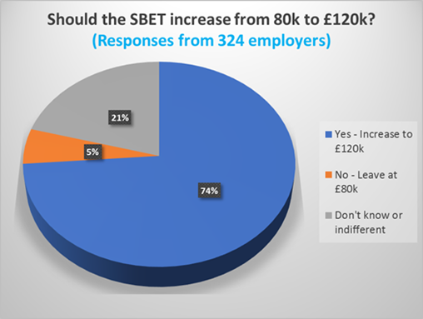

**Figure 17 –** **Employer responses regarding the proposed increase to the SBET**

70. It was established that typical comments from employers with a ‘Don’t know or a different opinion’ were “we are indifferent to the proposal because our wage bill is over £120k”. Figure 18 (below) excludes any employers who did not have a firm opinion or were indifferent to this Levy Proposal. In terms of employers that did have a firm opinion on this issue, 93% agreed that the threshold should be increased to £120k.

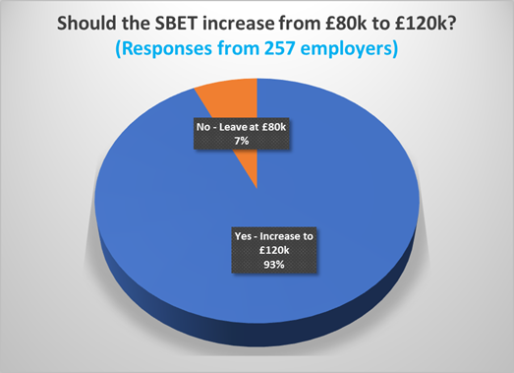

**Figure 18 – Yes/No Employer responses regarding the proposed increase to the SBET**

71. In addition to increasing the SBET to £120k, the CITB Board recognised that a 50% Levy reduction for one year would provide immediate support to industry. The preferred option was to apply this reduction to the 2020 Levy but there was insufficient time to make the required retrospective amendments to the 2018 Levy Order. Table 19 (below) summarises the feedback received from all 14 Prescribed Organisations and shows that there was almost unanimous support for both Levy Proposals.

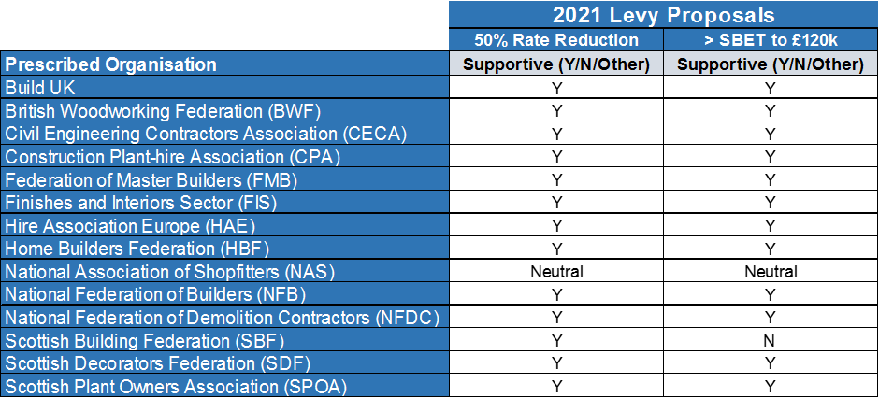

**Table 19 – Summary of engagement for the 14 Prescribed Organisations**

72. Against the revised recommendations from the LWP for the 2021 Levy Proposals, industry feedback and applying the agreed 50% reduction in Levy rates the final Levy Proposals approved by the Board in August 2020 were agreed as:

* Assessments payable in 2021 would use information about PAYE payments to determine liability for direct employment and the rate would be 0.175%;
* Assessments payable in 2021 would use information about Net CIS payments to determine liability for indirect employment and the rate would be 0.625%;
* Small Business Levy Exemption Threshold would increase from £79,999 to £119,999;
* Small Business Levy Reduction Threshold would be applied to employers with a wage bill between £120,000 and £399,999. The reduction rate would remain at 50% of Levy liability.

73. The evidence shows that the Levy Proposals are supported by Industry and are necessary to encourage adequate training in the industry during this period of recession. Furthermore, the conditions of S11(6)(b) of the Industrial Training Act 1982 are met and accordingly the Secretary of State is invited to approve and instruct such steps as are necessary to bring into force by no later than late Spring 2021 a one-year Levy Order in these terms.

**Appendix B – Evidence of Industry Support for the Levy and Grant System**

74. CITB’s annual survey of stakeholders and Levy registered employers shows the importance of the Levy and grant system to the industry. These surveys show that this continues to be strongly supported by employers in the construction industry, who recognise its value. The result of a survey CITB conducted in 2019/20, showed that 71% of employers felt the Levy and grant system was important to maintaining training within the industry, and 55% of employers felt that the system was important to their own firm as shown in Figure 20 (below). Figure 20 also demonstrates a year on year improvement for both measures since 2017/18.

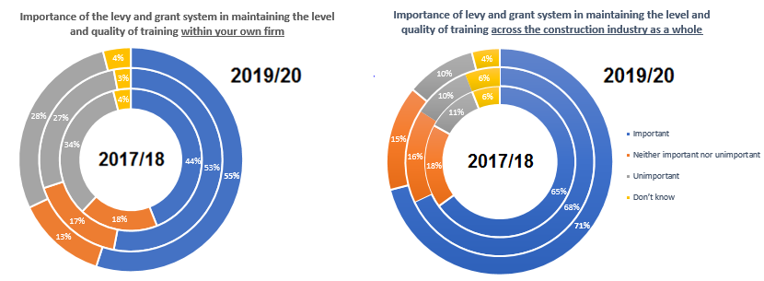

**Figure 20: CITB survey of employers on the importance of the levy/grant system**

*ESR research; responses from 1,500 companies, and a representative sample of the levy register.  Results from all respondents are reported at a 95% confidence level and a confidence interval of +/- 2.5%*

Source: CITB Employers and Stakeholder Survey 2019/20 (Corporate Performance)

75. CITB’s annual survey of Levy registered employers also provides self-reported evidence of what would happen without CITB. In 2019/20, 1,500 Levy registered employers were surveyed about what would happen, if there was no CITB, to levels of training, apprentice recruitment and progress towards a qualified workforce; the largest response from Levy registered employers in each case is that the situation would worsen as illustrated in Figure 21 (below).

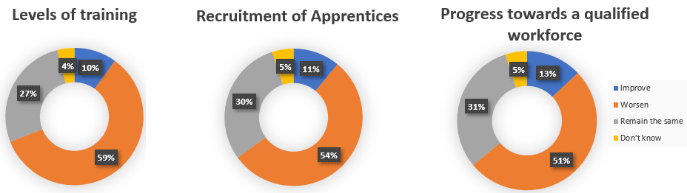

**Figure 21: CITB survey of employers on what would happen without CITB**

*ESR research; responses from 1,500 companies, and a representative sample of the levy register.  Results from all respondents are reported at a 95% confidence level and a confidence interval of +/- 2.5%*

Source: CITB Employers and Stakeholder Survey 2019/20 (Corporate Performance)

76. This annual survey also provides self-reported evidence on responses to the question ‘Do you think the statutory Levy, grant and funding system should continue’. In 2019/20, 1,500 Levy registered employers were surveyed and consistent with the previous 2 years, the majority of surveyed employers answered yes as shown in Figure 22 (below).

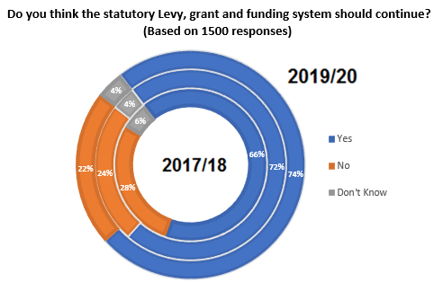

**Figure 22: CITB survey of employers on whether the Levy, grant and funding system should continue**

*ESR research; responses from 1,500 companies, and a representative sample of the levy register.  Results from all respondents are reported at a 95% confidence level and a confidence interval of +/- 2.5%*

Source: CITB Employers and Stakeholder Survey 2019/20 (Corporate Performance)