­<TEAM LOGO/NAME>

<YEAR> Security Assessment Report Prepared For

<REPLACE WITH CLIENT LOGO - CHANGE COLORS TOO>

Report Issued: <TEST DATE>

## Confidentiality Notice

*This report contains sensitive, privileged, and confidential information. Precautions should be taken to protect the confidentiality of the information in this document. Publication of this report may cause reputational damage to <CLIENT NAME> or facilitate attacks against <CLIENT NAME>. <TEAM NAME> shall not be held liable for special, incidental, collateral or consequential damages arising out of the use of this information.*

## Disclaimer

*Note that this assessment may not disclose all vulnerabilities that are present on the systems within the scope of the engagement. This report is a summary of the findings from a “point-in-time” assessment made on <CLIENT NAME>’s environment. Any changes made to the environment during the period of testing may affect the results of the assessment.*

# 

# EXECUTIVE SUMMARY

<TEAM NAME> performed a security assessment of the internal corporate network of <CLIENT NAME> on <TEST DATE>. <TEAM NAME>’s penetration test simulated an attack from an external threat actor attempting to gain access to systems within the <CLIENT NAME> corporate network. The purpose of this assessment was to discover and identify vulnerabilities in <CLIENT NAME>’s infrastructure and suggest methods to remediate the vulnerabilities. <TEAM NAME> identified a total of <VULN TOTAL NUM> vulnerabilities within the scope of the engagement which are broken down by severity in the table below.

|  |  |  |  |
| --- | --- | --- | --- |
| **CRITICAL** | **HIGH** | **MEDIUM** | **LOW** |
| **1** | **2** | **2** | **1** |

The highest severity vulnerabilities give potential attackers the opportunity to <BAD ACTIONS THAT COULD OCCUR HERE - FULL PARAGRAPH WITH HIGH-LEVEL DETAIL>. In order to ensure data confidentiality, integrity, and availability, security remediations should be implemented as described in the security assessment findings.

Note that this assessment may not disclose all vulnerabilities that are present on the systems within the scope. Any changes made to the environment during the period of testing may affect the results of the assessment.

## <Optional - Big Issue> Recommendation

This is an optional paragraph that discusses a very critical series of business failures (e.g. failure to adhere to applicable legal regulations) that isn’t a technical vulnerability but still should be brought to the attention of the executive team.

# CLASSIFICATION DEFINITIONS

## Risk Classifications

|  |  |  |
| --- | --- | --- |
| **Level** | **Score** | **Description** |
| **Critical** | **10** | The vulnerability poses an immediate threat to the organization. Successful exploitation may permanently affect the organization. Remediation should be immediately performed. |
| **High** | **7-9** | The vulnerability poses an urgent threat to the organization, and remediation should be prioritized. |
| **Medium** | **4-6** | Successful exploitation is possible and may result in notable disruption of business functionality. This vulnerability should be remediated when feasible. |
| **Low** | **1-3** | The vulnerability poses a negligible/minimal threat to the organization. The presence of this vulnerability should be noted and remediated if possible. |
| **Informational** | **0** | These findings have no clear threat to the organization, but may cause business processes to function differently than desired or reveal sensitive information about the company. |

## Exploitation Likelihood Classifications

|  |  |
| --- | --- |
| **Likelihood** | **Description** |
| **Likely** | Exploitation methods are well-known and can be performed using publicly available tools. Low-skilled attackers and automated tools could successfully exploit the vulnerability with minimal difficulty. |
| **Possible** | Exploitation methods are well-known, may be performed using public tools, but require configuration. Understanding of the underlying system is required for successful exploitation. |
| **Unlikely** | Exploitation requires deep understanding of the underlying systems or advanced technical skills. Precise conditions may be required for successful exploitation. |

## Business Impact Classifications

|  |  |
| --- | --- |
| **Impact** | **Description** |
| **Major** | Successful exploitation may result in large disruptions of critical business functions across the organization and significant financial damage. |
| **Moderate** | Successful exploitation may cause significant disruptions to non-critical business functions. |
| **Minor** | Successful exploitation may affect few users, without causing much disruption to routine business functions. |

## Remediation Difficulty Classifications

|  |  |
| --- | --- |
| **Difficulty** | **Description** |
| **Hard** | Remediation may require extensive reconfiguration of underlying systems that is time consuming. Remediation may require disruption of normal business functions. |
| **Moderate** | Remediation may require minor reconfigurations or additions that may be time-intensive or expensive. |
| **Easy** | Remediation can be accomplished in a short amount of time, with little difficulty. |

## 

# ASSESSMENT FINDINGS

|  |  |  |  |  |
| --- | --- | --- | --- | --- |
| **Number** | **Finding** | **Risk Score** | **Risk** | **Page** |
| 1 | Example Vulnerability Finding | **9** | **High** | 11 |
| 2 | Firewall Rule Set Not Best Practice | **8** | **High** | 12 |
| 3 | Outdated Software | **6** | **Medium** | 69 |
| 4 | Multiple XYZ Vulnerabilities | **5** | **Medium** | 420 |
| 5 | Fake Finding | **2** | **Low** | 6969 |

TEMPLATE NOTE: (Sorting by descending risk score)

**1 - Example Vulnerability Finding**

|  |  |
| --- | --- |
| **HIGH RISK (8/10)** | |
| **Exploitation Likelihood** | **Possible** |
| **Business Impact** | **Severe** |
| **Remediation Difficulty** | **Easy** |

**Security Implications**

This is where you give a 1-2 sentence description about the major impact of the finding. This finding is very important because it can destroy the entire business if left unchecked.

**Analysis**

Longer discussion of the finding. Includes screenshots. Lorem ipsum dolor sit amet, consectetur adipiscing elit, sed do eiusmod tempor incididunt ut labore et dolore magna aliqua. Ut enim ad minim veniam, quis nostrud exercitation ullamco laboris nisi ut aliquip ex ea commodo consequat. Duis aute irure dolor in reprehenderit in voluptate velit esse cillum dolore eu fugiat nulla pariatur. Excepteur sint occaecat cupidatat non proident, sunt in culpa qui officia deserunt mollit anim id est laborum (see Appendix 1).

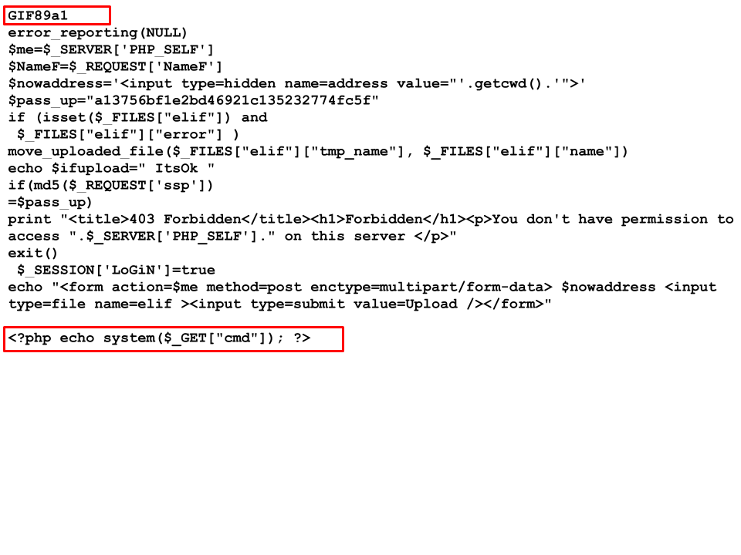

***Figure 2.3.1****: A php webshell uploaded to XYZ Application*

**Recommendations**

* Remove XYZ to make things more secure
* If you can not remove XYZ do this…

**References (opt)**

* <https://github.com/Sevaarcen/RADAR/tree/master/radar/playbooks>
* <https://owasp.org/www-project-top-ten/>