Communications Team (Homework - Review)
- Branding: Must use All Ports Tours brand; identify team only by number & region (e.g., “Team 10 – US West”). No institution names (university or firm)
- Appendix
Constantly Remind Engineering to Capture Supporting evidence, logs, screenshots, data tables, etc.
- Classify data into the following categories: Confidential, Internal Use Only, and Public.
- Create folders for everyone’s name in OneDrive so all team members can upload and access their files. On the day of the event, use these folders to organize, collect, and securely share evidence or updates in real time.
- Think about encrypting your documents or identifying a secure method of delivery for sensitive files.
- Comms Bonus Points:
1. Incident Response
When the Incident is reported, submit an incident response form for submission to the dedicated shipboard personnel AND shoreside security team.
2. The client is moving from AD to Entra and may move into a hybrid mode.
See below Recommendation Write Up to add to the report
3. Client wants external confirmation to remain effective against today's threats.
Write Up about Ransomware Being Today's biggest threats. See below

4. Add a Section to the Report for what the client did well first!!!

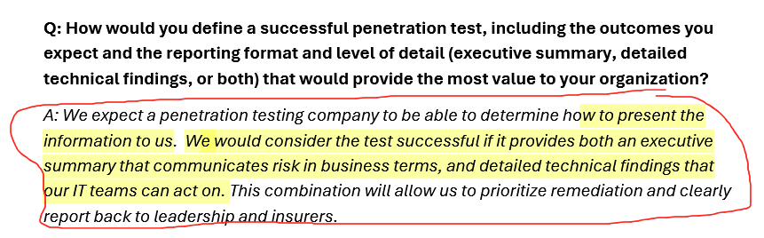
Review Below and Take Note to the Verbiage

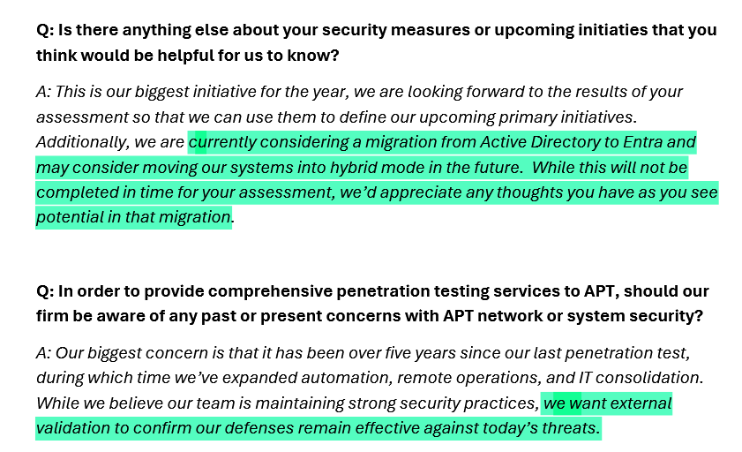

It's possible we could add the following …..

1. Migration to Microsoft Entra and Hybrid Identity Planning
The client is currently planning a migration from Microsoft Entra ID (Entra) — moving away from traditional Active Directory (AD) — and may adopt a hybrid identity model (on-premises + cloud). This transition represents a strategic move towards a more scalable, flexible identity and access management (IAM) structure. According to Microsoft documentation, hybrid identity “creates a common user identity for authentication and authorization to all resources, regardless of location.” Microsoft Learn+1
By moving to Entra, the organization can strengthen its security posture through advanced capabilities such as Conditional Access, MFA, and consolidated identity governance. A recent commissioned study by Forrester Research found that organisations adopting the Entra Suite achieved a 240 % ROI and significantly reduced identity-related risks and vendor sprawl. Microsoft+1
When adopting a hybrid model, the client retains on-premises infrastructure where needed (e.g., legacy apps) while leveraging Entra’s cloud-native identity services for newer applications and remote access scenarios. For this migration to be successful, it’s recommended that the team assesses existing identity footprints (users, groups, privileges, dependencies), plans synchronization strategies (e.g., Azure AD Connect), and enables security-centric features such as Entra Identity Protection and Privileged Identity Management (PIM). These steps help mitigate credential-based risks and over-privileged access. Kocho
Modern identity platforms also tie directly into threat-monitoring and detection capabilities. For example, Entra’s integration with broader Defender tools enables real-time visibility across cloud and on-premises identity systems. Microsoft

2. Ransomware as a Major Threat and the Value of External Validation
Ransomware continues to impose one of the most pervasive threats in today’s cybersecurity landscape. According to the Sophos “State of Ransomware 2025” report, the average cost to recover from a ransomware incident (excluding any ransom paid) reached approximately US $1.53 million globally. Bright Defense+1
In a separate global study by CrowdStrike, 78 % of respondent organisations reported being hit by ransomware in the past year, yet only 22 % of victims who believed they were “very well prepared” managed to recover within 24 hours. CrowdStrike
In terms of identity and access risk, a 2024 report by SpyCloud found that 91 % of organisations reported an identity-related breach in the past year—highlighting how identity remains a major attack vector. SpyCloud
Given these trends, external validation of security controls (penetration testing, red-team exercises, third-party audits) becomes critical to maintain resilience. External validation helps confirm that identity controls, detection capabilities, and recovery processes are working as intended—not just configured. This aligns with best practices for defending against highly targeted ransomware campaigns that exploit identity weaknesses, lateral movement opportunities, and mis-configured access.
By pairing the migration to Entra with external validation, the organisation can:
- Ensure the new hybrid identity architecture is configured securely and supports modern threat-detection.
- Confirm that identity-based access controls (MFA, least-privilege, conditional access) are enforced and effective.
- Validate recovery and incident-response capabilities in the event of a ransomware or identity-compromise incident.

