Finding RAKMSXXX: Vulnerability Name
Affected Hosts | IP Range
CVSS: #.# | Low, Medium, High, Critical | Likelihood: Low | Medium | High  Notes about the likelihood of exploitation, including the difficulty, credentials needed, etc.  Technical Impact: Low | Medium | High  Notes about the effect on RAKMS’s systems and infrastructure if this vulnerability is exploited, including access gained, or damage to systems done
Vulnerability Description | A description of how the vulnerability works and what it allows an attacker to do
Business Impact | A description of the negative effects to RAKMS from a business standpoint
Requirements to exploit | A list of requirements that may include tools, credentials needed, internal access, etc.
Remediation | General steps to correct any deficiencies specific to this instance of the exploit
References | Optional materials for additional reading
Proof of Concept
An explanation of what steps were taken as well as what the screenshots are indicating. Be concise while still giving enough details for replication.

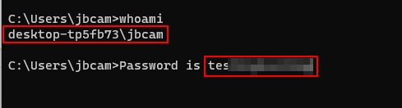

Ensure there is a newline before and after a screenshot and that the screenshot is centered and the text is left aligned. In addition, use Blue Accent 1 with 2 ¼ pt thickness for the border and try to leave room around the edges of the screenshot.



