QAQC - SITES
September 22, 2020
Table of Contents

COMMUNITY CODE & COMMUNITY GROUP ASSIGNMENT
Data Notes:
- For each classification, there is also a ‘fit’, where 1=confident and 2,3=not confident about the classification
- This is a required field
- NA/NA is a MISMATCH

Community Code summary In the row headings, 1 means fit=1; + means fit=2 or 3. In the column headings, FALSE means Community Code (CC) did not match between the two surveys and TRUE means CC did match. The numbers in cells are numberes of QAQC pairs.
 | FALSE | TRUE
11 | 2 | 17
1+/+1 | 4 | 8
++ | 7 | 4
Community Group summary Same as above, but for Community Group instead of Community Code.
 | FALSE | TRUE
11 | 1 | 18
1+/+1 | 2 | 10
++ | 6 | 5
Community Group PSA Proportion of specific agreement. For example, for Community Group G031… there were 3 QAQC pairs in which the site was classified as G031 by BOTH the QAQC surveyor and the non-QAQC surveyor (numerator=2 X number of matches for that CG). There were 7 instances total in which a site was classified as G031 by either the QAQC surveyor or the non-QAQC surveyor.
Grp | Num | Denom | PSA | 5% | 95%
G015 | 4 | 6 | 67 | 0 | 100.00
G020 | 0 | 1 | 0 | NA | NA
G030 | 10 | 14 | 71 | 43 | 90.00
G031 | 6 | 7 | 86 | 33 | 100.00
G034 | 2 | 2 | 100 | NA | NA
G159 | 38 | 41 | 93 | 85 | 98.00
G165 | 0 | 1 | 0 | NA | NA
G552 | 0 | 1 | 0 | NA | NA
G553 | 0 | 1 | 0 | NA | NA
G583 | 2 | 2 | 100 | NA | NA
G601 | 4 | 7 | 57 | 0 | 88.05
XXX | 0 | 1 | 0 | NA | NA
Community Group PSA plot 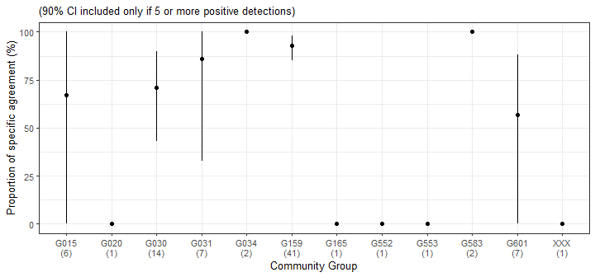

STAND HEIGHT
Data Notes:
- This metric was added to the protocol late
- NA/NA is OMITTED
- Summary excluded plot-surveys in which only one survey recorded a stand height

Cumulative distribution table for absolute % differences in stand height, (q - n)/mean Table should be read as, e.g., X% of stands (second column) have an absolute % difference in recorded stand height of Y% or less (first column).
Max. absolute % difference | Cumulative % of stands
< = 0% | 17
< = 5% | 30
< = 10% | 57
< = 15% | 91
< = 20% | 91
< = 25% | 91
< = 30% | 96
< = 35% | 96
< = 40% | 100
< = 45% | 100
Histogram of % differences in stand height, (q - n)/mean 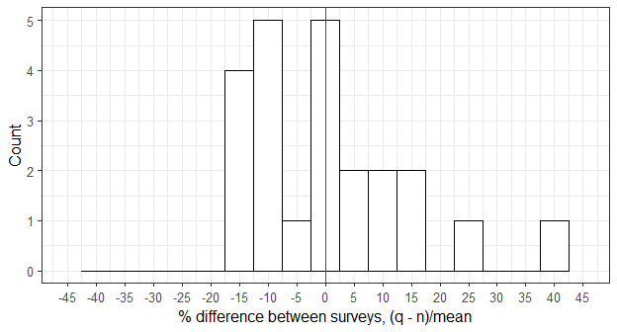

Stand height absolute % differences, empirical cumulative distribution function
Vertical red lines at 5% & 10% 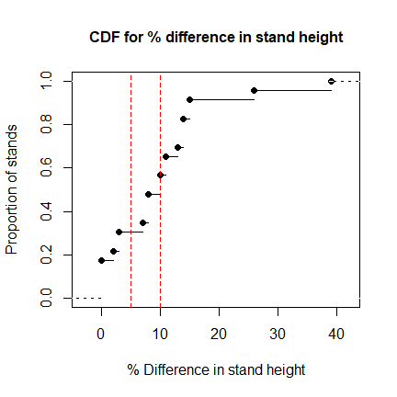
Bland-Altman plot for stand height
Darker points represent more data values 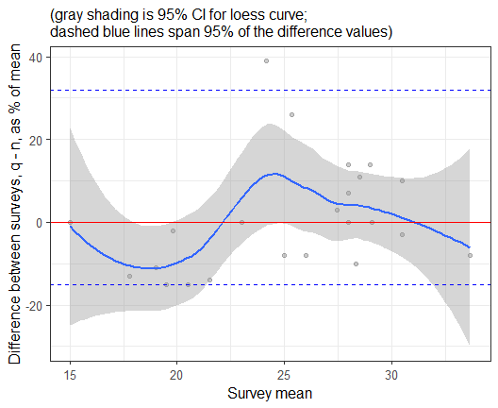

SITE DISTURBANCE
Data Notes:
- The datasheet had a checkbox for each disturbance, so this is essentially a required field (unchecked means FALSE; checked means TRUE for each disturbance type)
- NA/NA is a MISMATCH

Site disturbance summary & PSA
SD | FALSE-FALSE | TRUE-FALSE | TRUE-TRUE | PSA | 5% | 95%
Deer_Browse | 37 | 5 | 0 | 0 | 0.00 | 0
Erosion | 38 | 3 | 1 | 40 | 0.00 | 80
Fire_Historic | 31 | 6 | 5 | 62 | 32.95 | 82
Fire_Recent | 42 | 0 | 0 | NA | NA | NA
Homesite | 38 | 2 | 2 | 67 | 0.00 | 100
Logging | 38 | 4 | 0 | 0 | NA | NA
Open_Grown | 40 | 2 | 0 | 0 | NA | NA
Pasture | 39 | 2 | 1 | 50 | NA | NA
Plowing | 40 | 2 | 0 | 0 | NA | NA
Site disturbance PSA plot

COARSE WOODY DEBRIS COUNT BY PLOT
Data Notes:
- If transect information (x or y) is missing, data are used for plot-level counts, but not included for transect-level counts because no information on which transect to assign counts to
Frequency table for absolute differences in number of CWD by plot
Difference Category | Freq
0 | 13
1 | 15
2 | 3
3 | 4
4 | 2
5 | 2
6 | 3
Histogram of differences in CWD counts by plot 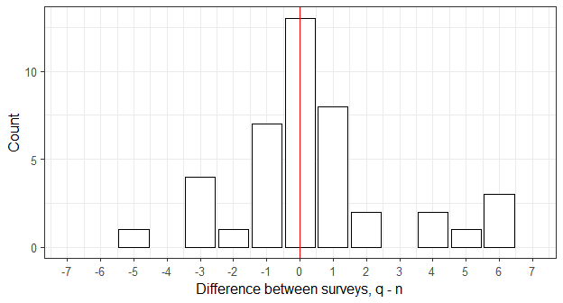

Absolute differences in CWD counts by plot, empirical cumulative distribution function
Vertical red lines at 0 & 1 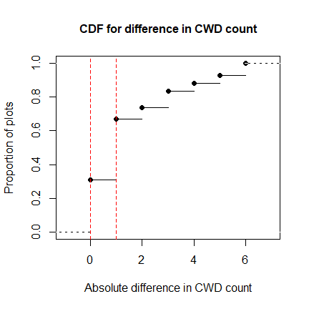
Bland-Altman plot for CWD counts by plot
Darker points represent more data values 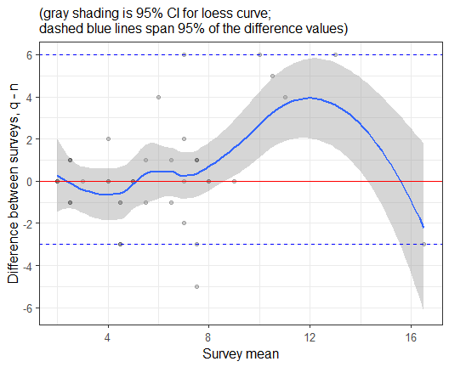

COARSE WOODY DEBRIS COUNT BY TRANSECT
Frequency table for absolute differences in number of CWD by transect
Difference Category | Freq
0 | 40
1 | 26
2 | 11
3 | 3
4 | 1
5 | 3
Histogram of differences in CWD counts by transect 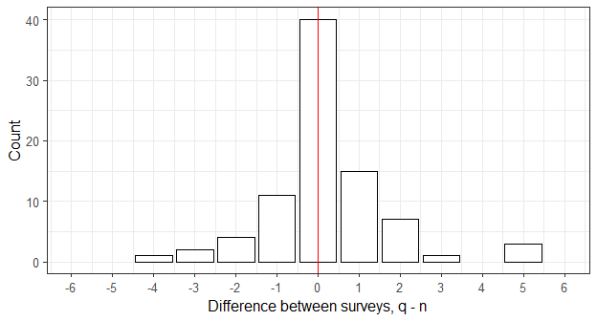

Absolute differences in CWD counts by transect, empirical cumulative distribution function
Vertical red lines at 0 & 1 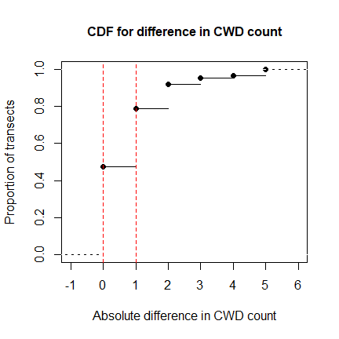
Bland-Altman plot for CWD counts by transect
Darker points represent more data values 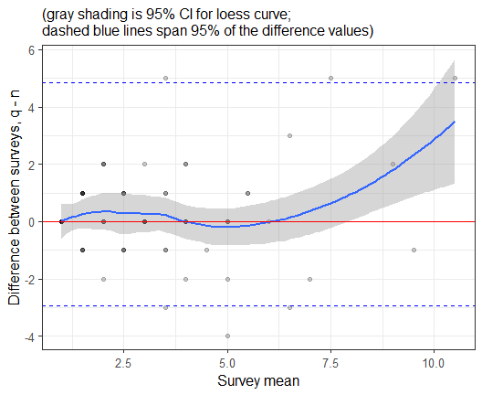
Distribution of decay class
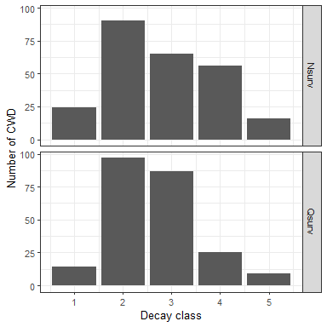
Distribution of diameter


