Geothermal Renewable energy system
Uses: In a desert region planting a geothermal is very challenging task for the conditions in the open sun shine set area , and in condition of running whether becomes very crucial for work done,
In the initial first of state small amount of deploying geothermal energy 5 to 8 MW supplying that gives to all over houses training to build with small amount of populations , later slowly growth of population begins and other places for deploying takes 5 to 8 MW supply with millions of treaties can make use of significance enough power supply for the science technology, industrial areas.
Planting them close to the water system is becomes very important to function that works significant electric power supply with the heat conditions. Geothermal plants should be located near water sources to ensure efficient cooling and stable electricity generation in hot desert regions. Taking this to the house’s and working area has to maintains requires significant spatial planning for heat management. in a harsh heating weather conditions maintenance must keep checking one after a time proper,
Cooling system that works balancing the machines that getting over heating and can also be used for the electric functioning .
Definition : Geothermal energy, derived from the Earth's internal heat, offers
a promising and sustainable alternative to fossil fuels. As the world
grapples with the urgent need to transition to renewable energy sources,
geothermal power stands out for its reliability, low emissions, and
minimal land footprint. However, despite its potential, the geothermal
energy sector faces several significant challenges that hinder its
growth and widespread implementation. High upfront capital costs,
technological barriers, and regulatory complexities pose obstacles for
developers and investors alike. Additionally, environmental concerns
related to land use, water consumption, and induced seismicity can
complicate project approvals and public acceptance.

Few calculations that proves how geothermal will be necessity according to it available todays technology.
How convert energy → continuous power
1 kW continuous = 8,760 kWh/year.
So required continuous power (MW) = (population × kWh/person/year) ÷ 8,760 ÷ 1,000.
Here are compact scenario numbers (average continuous power required):
- Per-person 1,000 kWh/year (basic modern minimum):
  - 100 people → 0.011 MW (≈11 kW)
  - 1,000 people → 0.11 MW
  - 5,000 people → 0.57 MW
  - 10,000 people → 1.14 MW
- Per-person 3,000 kWh/year (moderate/urban):
  - 1,000 people → 0.34 MW
  - 5,000 people → 1.71 MW
  - 10,000 people → 3.42 MW
- Per-person 10,000 kWh/year (high-consumption / industrialised lifestyle + business load):
  - 1,000 people → 1.14 MW
  - 5,000 people → 5.71 MW
  - 10,000 people → 11.4 MW
(These follow directly from the conversion above; see general MW→homes discussion for context about “how many homes per MW”.)
What this means for 5–8 MW of geothermal
- Good for: an initial settlement and community (hundreds-to-a-few-thousand people) with moderate living standards and light businesses, plus some critical infrastructure (water pumps, communications, lights, small manufacturing). Example: 5 MW continuous could comfortably support several thousand people at modest-to-moderate per-capita electricity use.
- Borderline for heavy use: if plan energy-intensive industry (cement, large desalination, heavy manufacturing), or want to host a town of >10,000 people with high per-capita consumption, then 5–8 MW will be insufficient; would need multiple plants or tens of MW. (Example: 10,000 people at 3,000 kWh/person requires ~3.4 MW ,but add desalination/industry and I have jump past 5–8 MW.)
- Scalability: geothermal is usually developed in phases — single or a few wells now, more wells/units later. Individual well outputs vary, so an initial 5–8 MW plant is a reasonable starter if the resource permits, with capacity to expand if a resource assessment supports more wells.
Important non-electrical considerations (they affect how much power actually need)
- Water / desalination: desert settlements need fresh water — desalination is energy-hungry (adds MWs for large capacity).
- Cooling and HVAC: desert climate increases cooling loads (AC increases consumption).
- Transport, mining, manufacturing: these can multiply demand.
- Grid vs microgrid: in an isolated site you’ll need storage/backup and distribution — geothermal is good as baseload but pairing with solar + batteries is common.
Small footprint—Geothermal power plants and geothermal heat pumps are compact. Geothermal power plants use less land per gigawatt-hour (404 m2) than comparable-capacity coal (3,642 m2), wind (1,335 m2), and solar photovoltaic (PV) power stations (3,237 m2) (source). GHPs can be retrofitted or integrated in new buildings.

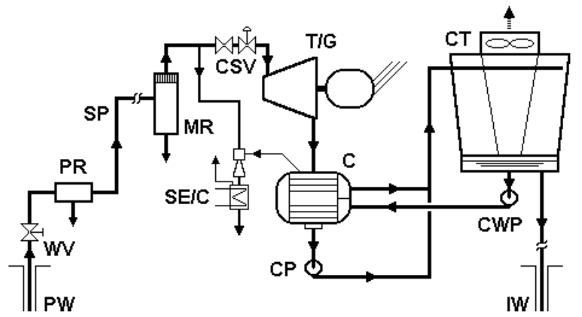
Diagram Steam Geothermal power plant.

Lists major the equipment typically used in the four basic types of geothermal powerplants
Equipment Type of energy conversion system
Steam and/or brine supply | Dry steam | Single flash | Double flash | Basic binary
Downhole pumps | No | No(poss) | No(poss) | Yes
Wellhead valves and controls | Yes | Yes | Yes | Yes
Silencers | Yes | Yes | Yes | No
Sand/particulate remover | Yes | No | No | Yes
Steam piping | Yes | Yes | Yes | No
Steam cyclone separators | No | Yes | Yes | No
Flash vessels | No | No | Yes | No
Brine piping | No | Poss | Poss | Poss
Final moisture separator | Yes | Yes | Yes | No
Heat exchangers:
Evaporators | No | No | No | Yes
Condensers | Yes(no) | Yes(no) | Yes | Yes
Turbine-generator and controls:
Steam turbine | Yes | Yes | Yes | No
Organic vaopr turbine | No | No | No | Yes
Dual-admission turbine | No | No | Yes | no
Control system | Yes | Yes | Yes | Yes
Plant pumps:
Condensate | Yes(no) | Yes(no) | Yes | Yes
Cooling water circulation | Yes(no) | Yes(no) | Yes | Yes
Brinc injection | No | No(poss) | Yes(no) | Yes
Noncondensable gas removal system:
Steam-jet ejectors | Yes | Yes | Yes | no
Compressors | Poss | Poss | Poss | no
Vaccum pumps | Poss | Poss | Poss | No
Cooling towers
Wet type | Yes(no) | Yes(no) | Yes | Poss
Dry type | No | No | No | poss
GP TOTAL CAPATICY | MW | No.Units | Plants types
 | Overa all 10MW or more depending upon population | Approx 200 | DS,IF,2F,B,H
Note: Yes=Generally used, No=generally not used, Poss=possibly used under certain circumstances.
Firm and Flexible—Geothermal power plants produce electricity consistently and can run essentially 24 hours per day/7 days per week, regardless of weather conditions. They can also ramp generation up or down to respond to changes in electricity demand.

Electricity Generation
Deep underground, the presence of hot rocks, fluid, and permeability (the ability for that fluid to move among the rocks) offer conditions from which electricity can be generated. Using natural or human-made permeability and fractures, the fluid flows through the hot rocks, absorbing heat from the rocks that can be drawn up through wells to Earth’s surface. That heat energy is then converted to steam, which drives turbines that produce electricity

Heating and Cooling
Geothermal resources such as naturally occurring underground reservoirs of hot water or the stable temperature of the subsurface can be used to heat and cool buildings. Geothermal heat pumps provide heating and cooling using the ground as a heat sink, absorbing excess heat when the aboveground temperatures are warmer, and as a heat source when aboveground temperatures are cooler. District heating and cooling systems use one or more types of geothermal systems, such as a series of geothermal heat pumps, in order to heat and cool groups of buildings, campuses, and even entire communities.

