Sprint 1 – Winter 2026
Due Date: February 27,2026 @ 4:00 PM
HTML, CSS, and JavaScript

Hello everyone, and welcome to Sprint 1.
For this sprint, you may form teams of up to three members (in some cases, four members with prior approval). Please inform Noman of your preferred teammates by adding their names to the file (Midterm Sprint Teams.xlsx)[shared by Vanessa] as soon as possible if you haven’t already done so. If you'd like to be placed in a randomly assigned team of three, please indicate that as well, and we will organize it. Enter your name as Solo if you prefer to work solo on your sprint.
You have two options for this sprint:
- Work on a project of your own idea.
- Implement the project we have described below.
If you choose to work on your own idea, please send a written proposal to Noman via private message. The proposal will be reviewed to ensure that the project scope is appropriate and feasible within the available time.

Project Requirements
- Have a Figma design done up for your project following the design principles that Levin taught you in UI/UX. [Send source figma files to Levin as well – you can discuss with Levin about it]
- Implement the project in HTML, CSS & JavaScript
- Use proper Semantic HTML tags where applicable
- Comment on your code for clear representation of its purpose
- CSS code that approximates the design in the Figma mockup.
- Must use DOM manipulation. [By keeping all the work done thus far in DOM, it is expected that you come up with some nice manipulations of webpages based on different user interactions etc.]
- Upload the finished project to GitHub
Beyond that, the possibilities are endless. Be creative and pursue what you find fun and interesting. Replicating popular apps is also a great option if one appeals to you and your team.

Default Project - "Sunny Bites Café" Website
Here is a default project if you want to go with it:
Sunny Bites Café is a cozy, family-owned café that specializes in healthy, organic meals and beverages. The café owner, Sarah, wants to create a website to attract more customers and provide them with essential information about the café, its menu, and an online ordering system.
- Home Page:
  - Purpose: Welcome visitors and provide quick information about the café.
  - Content:
    - A welcoming main section with a high-quality image of the café (e.g., a cozy interior or a delicious meal).
    - A brief introduction about the café (e.g., "Welcome to Sunny Bites Café, where taste meets healthy!").
    - Key information: Location, hours of operation, and contact details.
    - A section for customer reviews or testimonials. Use the same technique as was done in our class for displaying all the cats’ pictures as carousal. [You need to save the reviews maybe in a separate js file and access them every after 3 seconds and display them as carousal]
    - Links to the menu and online ordering page.
Sample Image for Home Page: [Just for reference purpose, yours should be much better and professional with some nice pictures and color schemes of your choice]
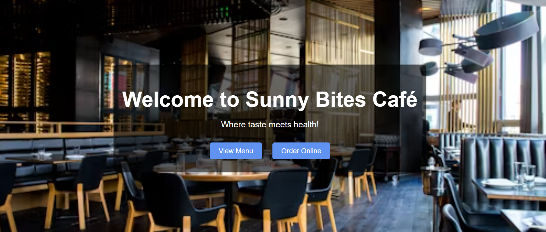
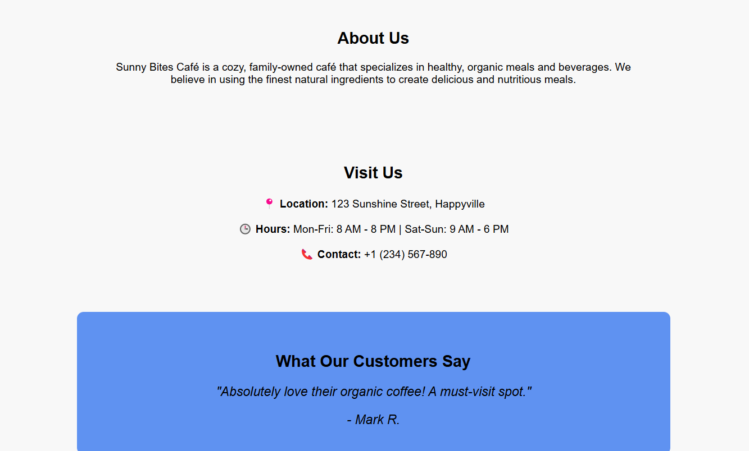

- Menu Page:
  - Purpose: Showcase the café's menu items with descriptions and images.
  - Content:
    - A list of menu items categorized into sections (e.g., Breakfast, Lunch, Beverages).
    - Each item should have a title, description, and price.
    - Use high-quality images for each dish (you can source these from Unsplash.com).
    - Add a "Add to Order" button for each item, which will store the selected items in localStorage.
Sample Image for Menu Page: [Just for reference purpose, yours should be much better and professional with some nice pictures and color schemes of your choice]
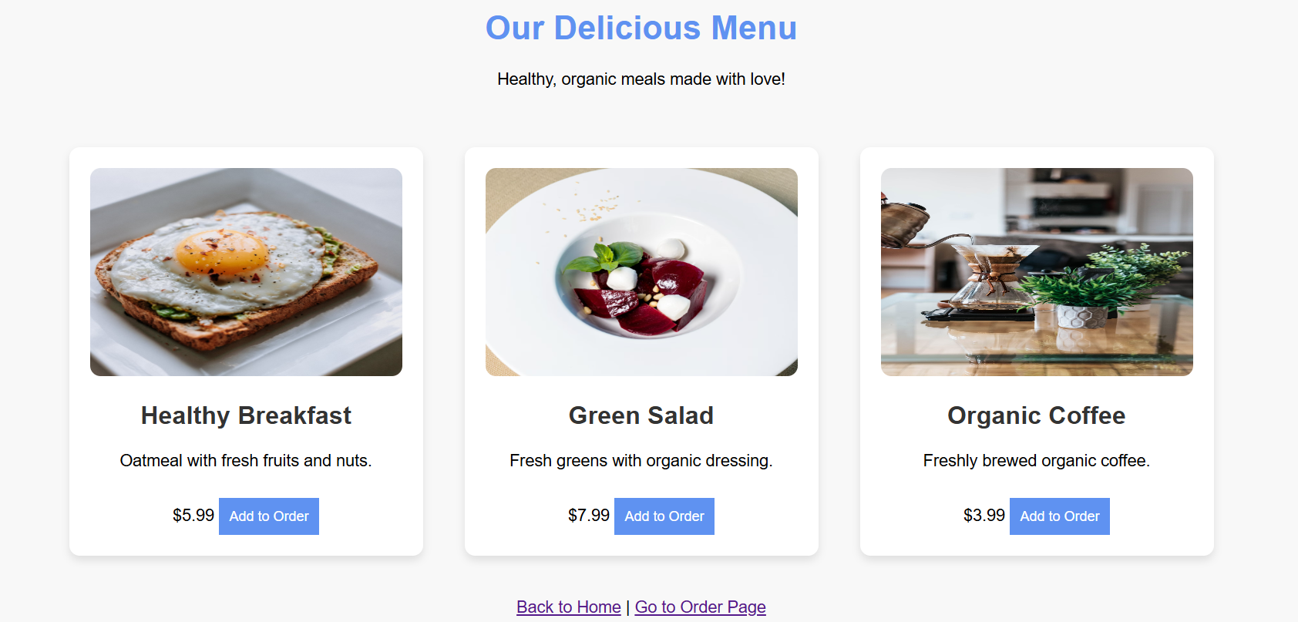

- Order Online Page:
  - Purpose: Allow customers to place orders online.
  - Content:
    - A form where customers can select items from the menu, specify quantities, and enter their details (name, phone number, address, etc.).
    - Validation for the form fields (e.g., no negative quantities, valid phone number format, etc.).
    - A "Calculate Total" button that calculates the total cost of the order.
    - A "Place Order" button that displays a confirmation message (e.g., "Thank you for your order!"– use showAlert( ) type of function as we made in library and display a 2 second popup message) and clears the form.
    - Use localStorage to store the selected items temporarily.
Sample Image for Order Online Page:
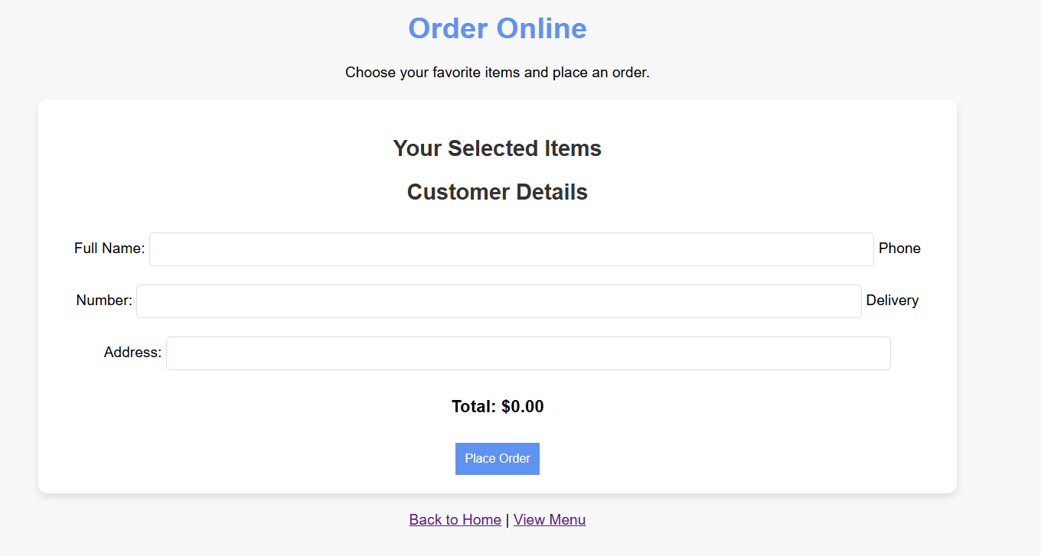

Technical Requirements:
- Figma Design:
  - Create a Figma design for the website, following UI/UX principles.
  - Ensure the design is responsive and works well on both desktop and mobile devices.
- HTML:
  - Use semantic HTML tags (<header>, <section>, <article>, <footer>, etc.).
  - Ensure the HTML is validated using an online validator.
- CSS:
  - Use CSS to style the website according to the Figma design.
  - Ensure the design is visually appealing and matches the café's branding (e.g., warm colors, clean typography).
- JavaScript:
  - Use DOM manipulation to dynamically update the webpage based on user interactions (e.g., updating the order summary, displaying confirmation messages).
  - Implement at least three JavaScript functions (e.g., calculating the total cost, validating the form, handling the order submission).
  - Use localStorage to store selected menu items.
- GitHub:
  - Upload the project to GitHub and share the repository link for submission.

Additional Notes:
- Creativity: Feel free to add extra features, such as a gallery section, a blog, or a loyalty program.
- Responsiveness: Ensure the website is fully responsive and works well on all devices (desktop, tablet, mobile).
- Accessibility: Follow accessibility best practices (e.g., use alt tags for images, ensure proper contrast for text).

Special Instructions:
- Write your own code.
- Seeking occasional help from ChatGPT or other AI tools is fine, but do not copy entire code solutions.
- The code generated by AI bots tends to be repetitive and predictable.
- Relying heavily on such methods may not only affect your grades but also hinder your ability to adapt and solve problems in different scenarios.

Submission:
- One member of the group can submit the files, but it must be clearly stated who the other group members are.
- Along with the submission, provide a one-page document that lists the group members and outlines the work distribution for each member.
- Remember to validate your HTML document through an online validator before submitting (No red elements/attributes should be in your HTML)
- Also, as mentioned in the class, always give comments in the beginning mentioning your group member names and assignment details.
- When you are finished, save all the resources in a folder with your first names of all group members followed by underscore and sprint1.
- Example: Alan Smith, Bob Woolmer, and Christina group’s folder will look like “alan_bob_christina_sprint1”, zip it and submit it OR upload it on GitHub repository and share the link.
Enjoy coding!

