**Complete Sales Report**

Generated on: January 01, 2025

Author: Colab2Word Demo

# Sales Report

Overview of product sales performance

This report shows our product sales data with both tabular and visual representations.

# Sales Data

Detailed sales figures

|  |  |  |  |
| --- | --- | --- | --- |
| **index** | **Product** | **Sales** | **Price** |
| 0 | A | 100 | 10.99 |
| 1 | B | 150 | 15.99 |
| 2 | C | 80 | 8.99 |

# Sales Visualization

Bar chart of product sales

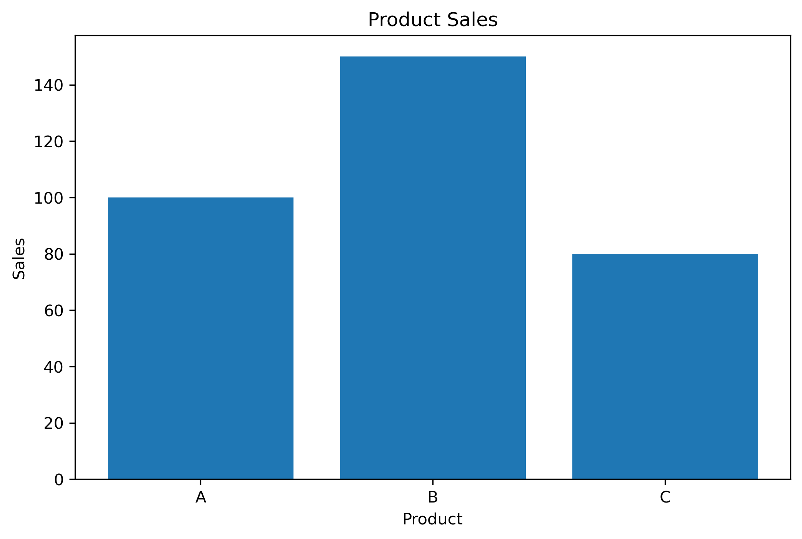

# Sales Report

Overview of product sales performance

This report shows our product sales data with both tabular and visual representations.

# Sales Data

Detailed sales figures

|  |  |  |  |
| --- | --- | --- | --- |
| **index** | **Product** | **Sales** | **Price** |
| 0 | A | 100 | 10.99 |
| 1 | B | 150 | 15.99 |
| 2 | C | 80 | 8.99 |

# Sales Visualization

Bar chart of product sales

