**Plot Example**

Generated on: January 01, 2025

# Sales Chart

Visual representation of product sales

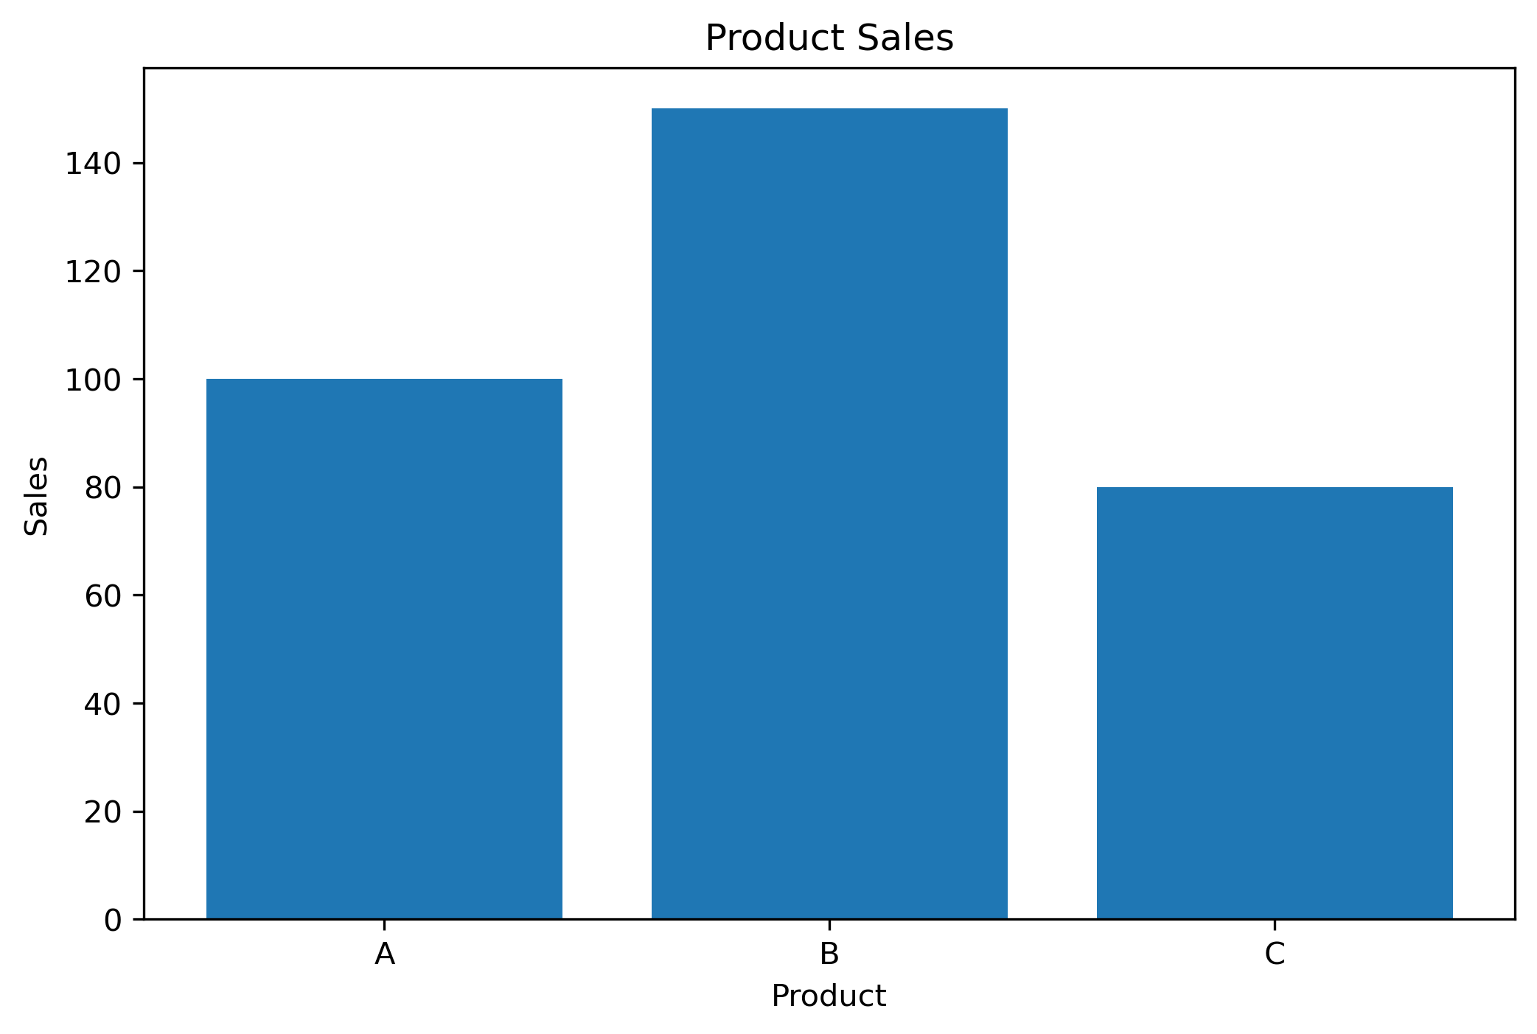

# Sales Chart

Visual representation of product sales

