**Monthly Financial Report**

Generated on: January 01, 2025

Author: Finance Team

# Executive Summary

Monthly Financial Performance Report  
   
 This report presents key financial metrics including revenue, expenses, and profit analysis.  
 The data covers the period from January 2024 to December 2024.

# Monthly Financial Data

Detailed breakdown of monthly financial metrics

|  |  |  |  |  |
| --- | --- | --- | --- | --- |
| **index** | **Revenue** | **Expenses** | **Units_Sold** | **Profit** |
| 2024-01-31 00:00:00 | $100,993.43 | $80,362.94 | $1,189.11 | $20,630.48 |
| 2024-02-29 00:00:00 | $104,723.47 | $80,130.08 | $1,252.22 | $24,593.39 |
| 2024-03-31 00:00:00 | $111,295.38 | $83,412.62 | $1,276.98 | $27,882.75 |
| 2024-04-30 00:00:00 | $118,046.06 | $88,156.57 | $1,357.51 | $29,889.49 |
| 2024-05-31 00:00:00 | $119,531.69 | $90,480.75 | $1,387.99 | $29,050.94 |
| 2024-06-30 00:00:00 | $124,531.73 | $95,471.37 | $1,444.17 | $29,060.36 |
| 2024-07-31 00:00:00 | $133,158.43 | $96,637.96 | $1,487.97 | $36,520.46 |
| 2024-08-31 00:00:00 | $136,534.87 | $98,881.54 | $1,587.05 | $37,653.33 |
| 2024-09-30 00:00:00 | $139,061.05 | $106,198.47 | $1,599.73 | $32,862.58 |
| 2024-10-31 00:00:00 | $146,085.12 | $106,661.34 | $1,628.85 | $39,423.78 |
| 2024-11-30 00:00:00 | $149,073.16 | $110,101.29 | $1,716.45 | $38,971.87 |
| 2024-12-31 00:00:00 | $154,068.54 | $110,862.88 | $1,725.58 | $43,205.66 |

# Revenue and Expenses Trends

Monthly comparison of revenue and expenses

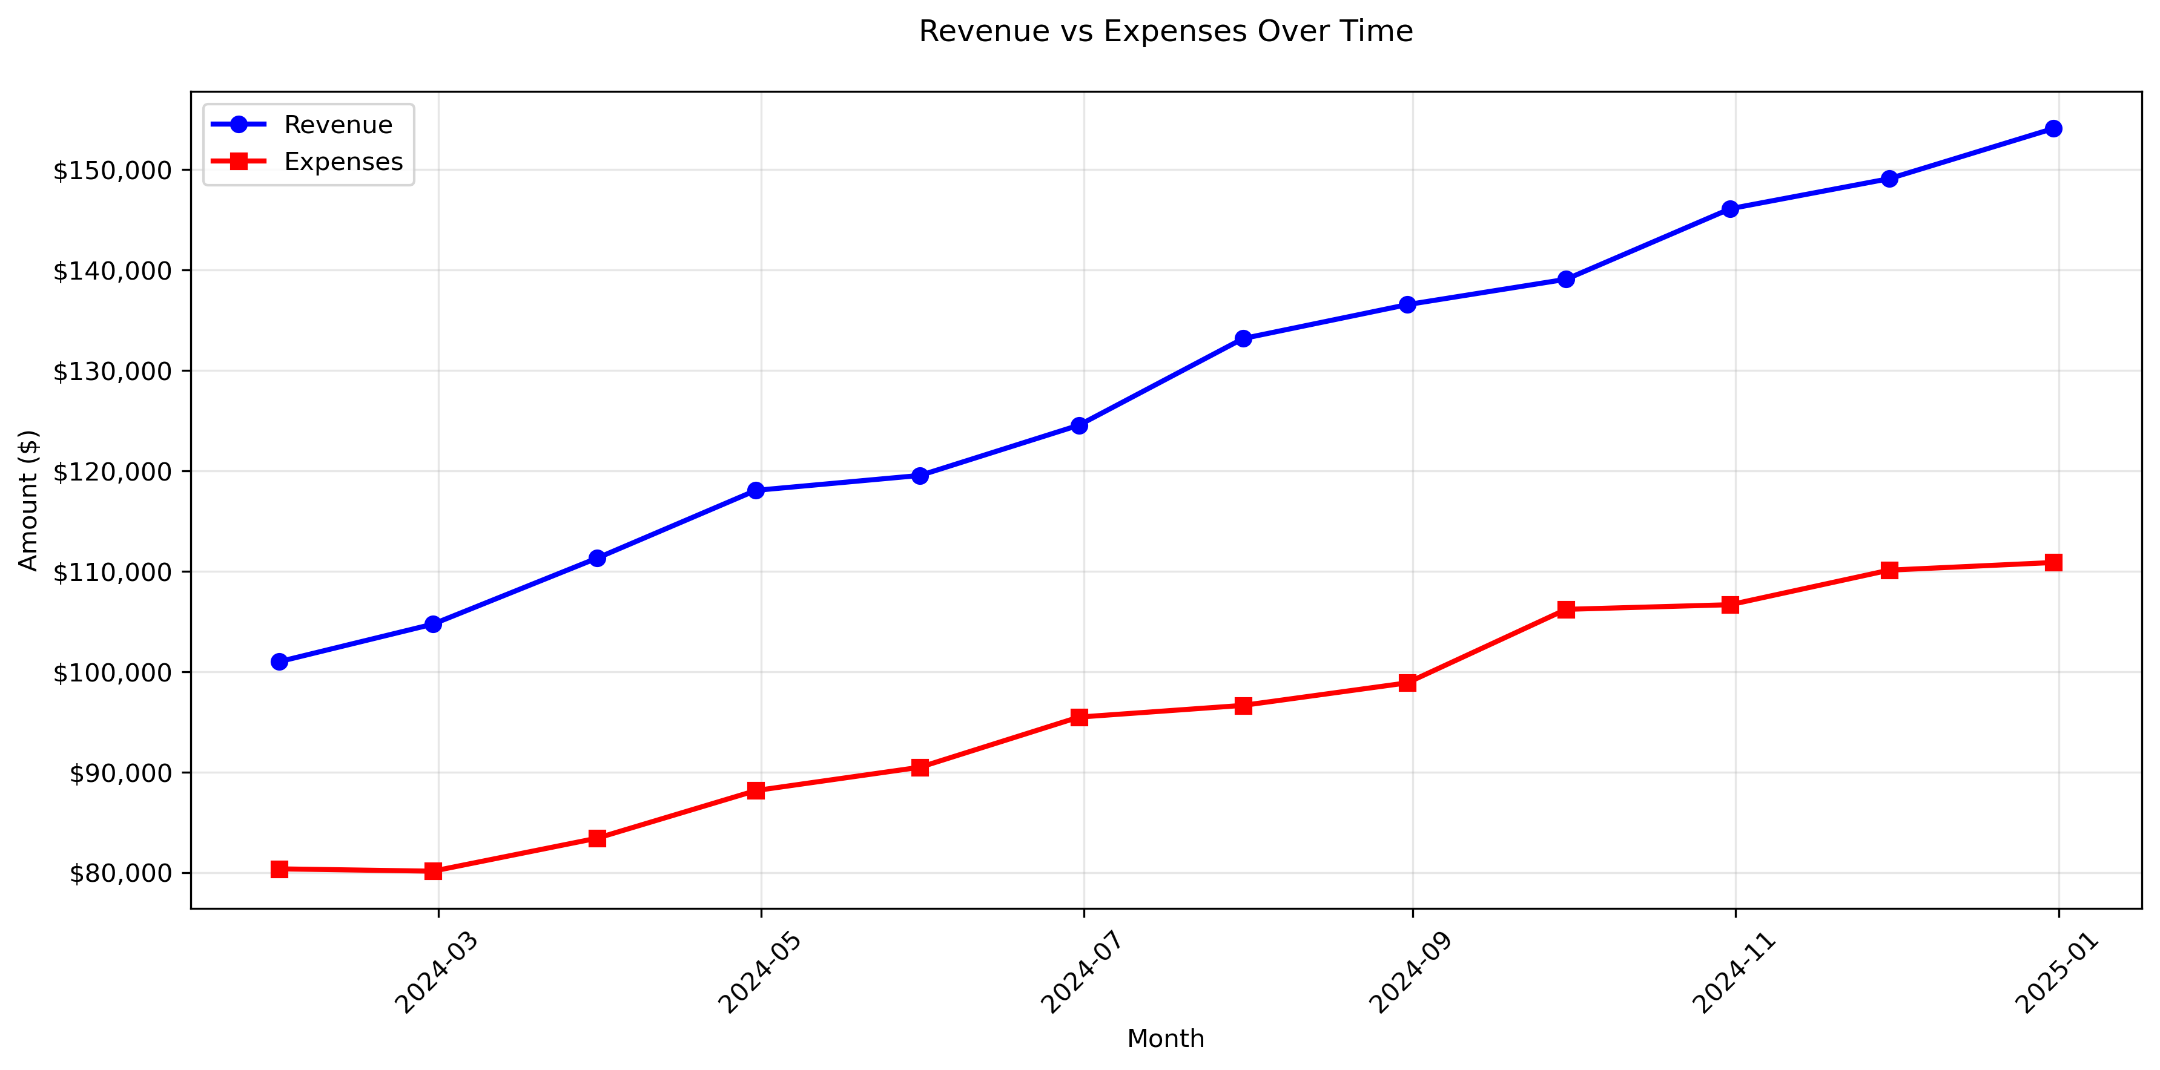

# Monthly Profit Analysis

Visual representation of monthly profits

