**Advanced Visualization Report**

Generated on: January 01, 2025

Author: Seaborn Analysis

# Data Analysis Report

Analysis of multivariate relationships and distributions

# Advanced Data Visualization Analysis  
  
This report demonstrates complex statistical visualizations using Seaborn.

# Distribution Analysis

Violin plot showing value distributions across categories and groups

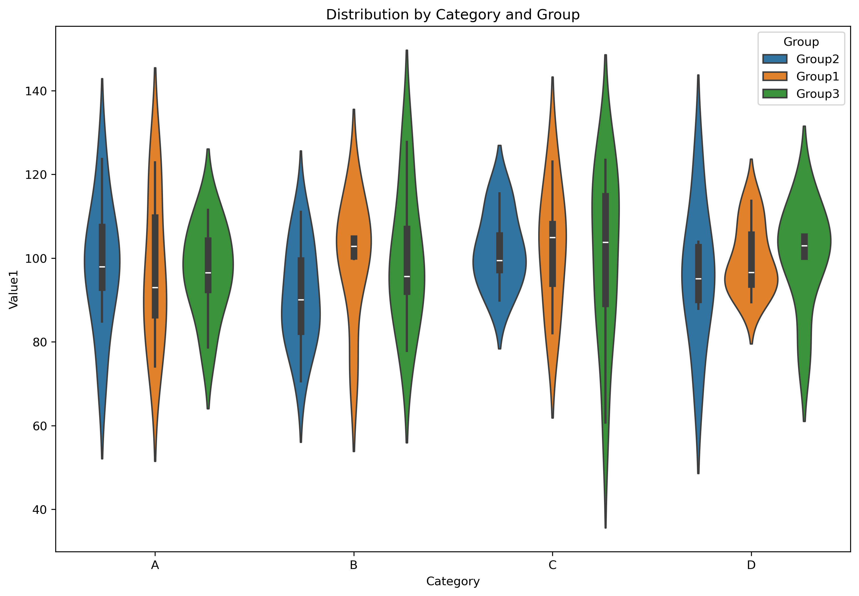

# Time Series Analysis

Temporal trends across different groups

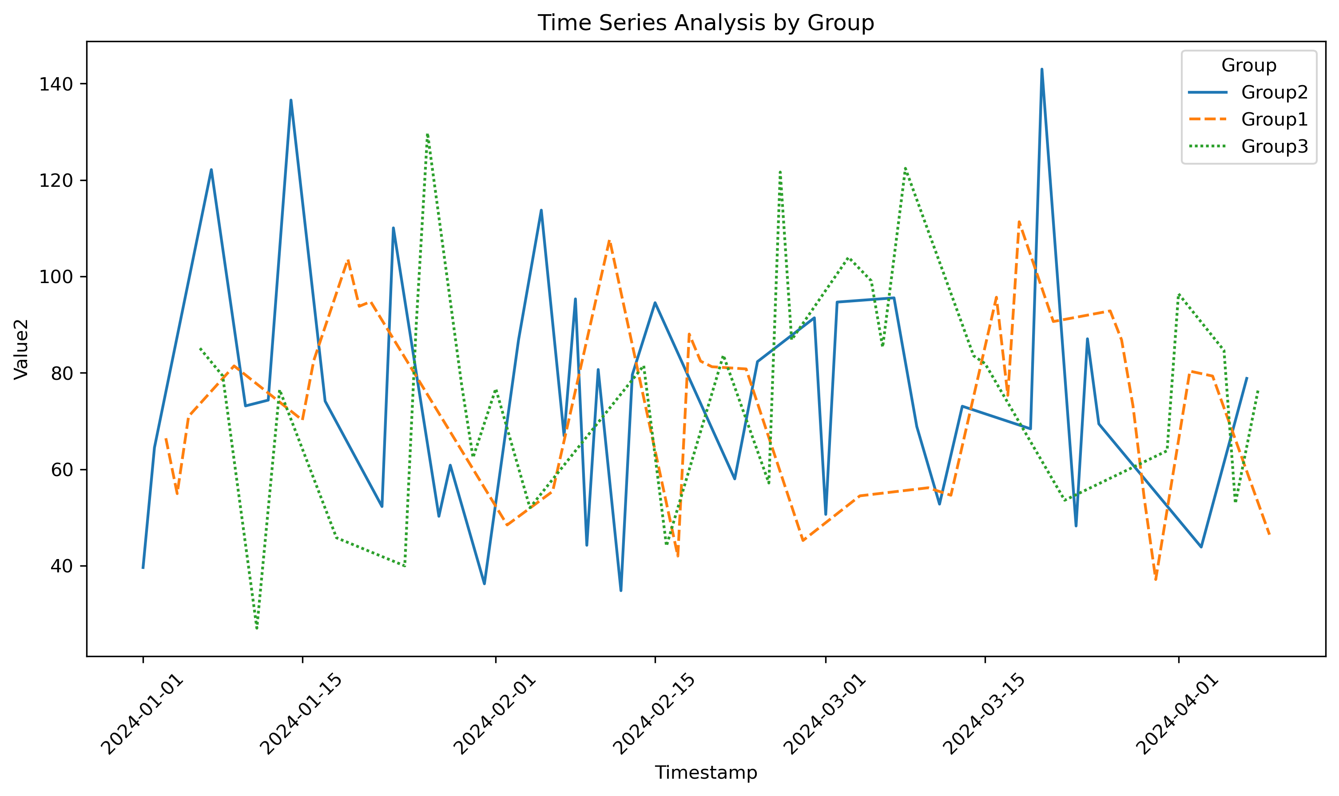

# Correlation Analysis

Joint distribution of Value1 and Value2 with group distributions

