**Plot Orientation Test**

Generated on: January 01, 2025

Author: Data Science Team

# Portrait Plot

A simple sine wave plot

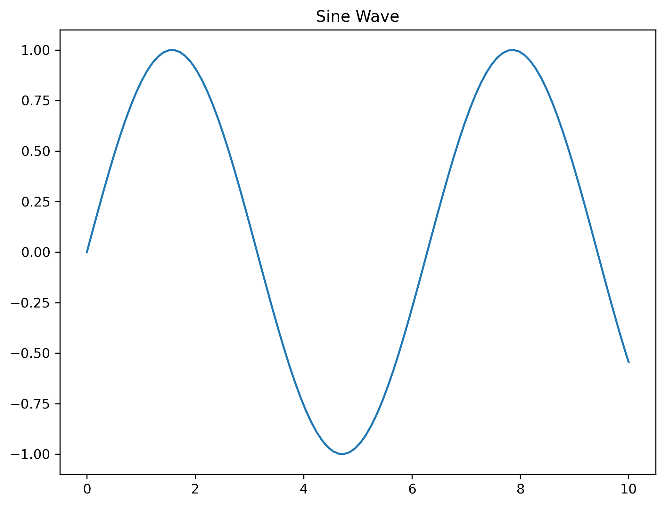

**Comments:** This plot uses portrait orientation and shows a single period of a sine wave.

# Landscape Plot

A simple cosine wave plot

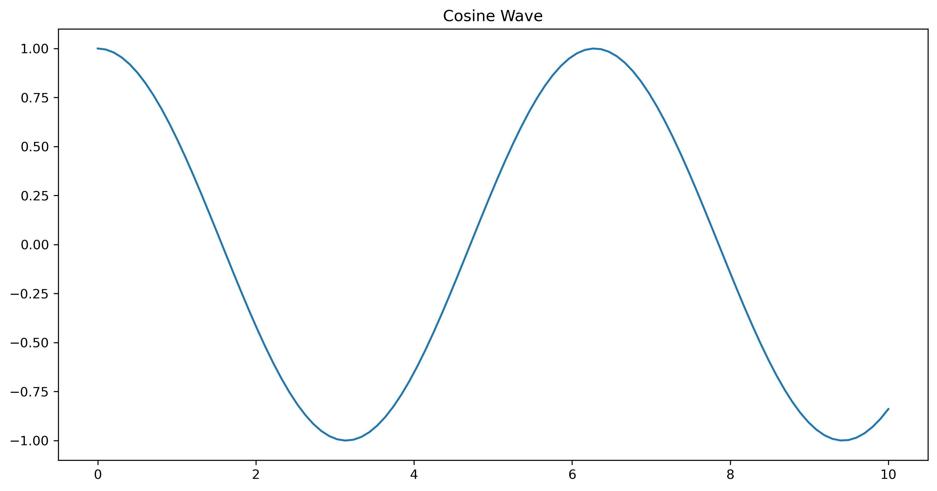

**Comments:** This plot uses landscape orientation for better visibility of the wide data.