Rate My Landlord
COSC 341 - Group 40
Bao Pham
Nat Scott
Neeha Chowdhury
Sami Alumallim

Introduction
Rate My Landlord is the “Rate My Professor” of the rental industry. We hope that in providing a platform for renters to discuss their experience with different landlords and property management companies, they will be empowered to hold landlords accoutnable.
Renters can use Rate My Landlord to explore properties by the experiences of fellow renters. Landlords can use Rate My Landlord to increase transparency of their operations and to facilitate communication between themselves, their companies, and the people who rent their properties.

Tasks

Task 1 – Locating a property geographically
Description: The user presses the map button from the main page and is brought to a map. They can then select a pin corresponding to a particular property, which pulls up that property’s page
Changes: No significant changes

Task 2 – Locating a property by address
Description: The user is presented with a search field from the main page. As they type into this field, options will be visible in a drop down as predictive-search. Having sufficiently refined their search, they can select an available option to be brought to that property’s page
Changes: We dropped the “advanced search” route, as it felt out of the scope of this task.

Task 3 – User Verification
Description: The landlord states they will be using the app as a landlord, and is invited to email supporting documentation to the account verification team. Once they have composed and sent an email, they are returned to the app and asked to wait while the team reviews their documents. Once the team has reviewed their documents, they are finally told whether their application has been accepted.
Changes: Originally, they would upload their documents and they could start using the platform immediately with some restrictions. We decided against this and expanded the interface to include more feedback, more documentation, and more direct involvement in the process.

Task 4 – Leaving a review
Description: The user can select 1-5 stars and write about their experience living on the selected property. After they hit publish, they are asked to review and confirm that they want the review published. If they press publish again, the review is published.
Changes: We dropped an intermediary screen where the user can attach refined tags to make their review more searchable. We decided this was too complicated, and that this information could be gleamed from the text of their review automatically

Application of Design Principles
Visibility  We sought to make important artifacts visible by maintaining an uncluttered interface where key artifacts are the focal point | 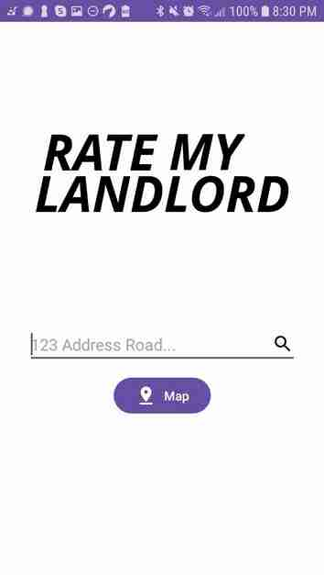  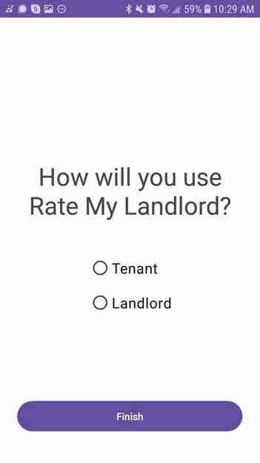
Feedback  During the landlord verification process, we ensured the user was constantly aware of how the process was going on the backend.  While a user is searching, if their query doesn’t match any known results, they are prompty notified by a text view stating “No results!” | 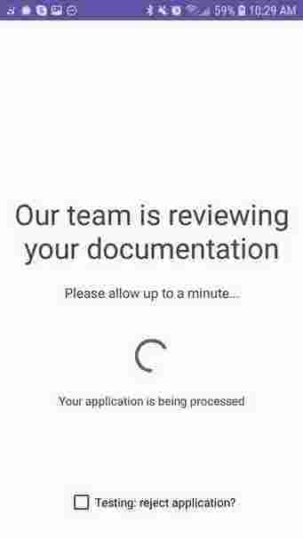  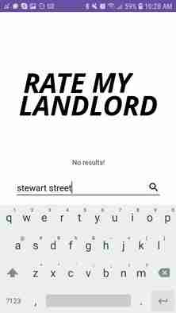
Constraints  Review ratings are constrainted to 1-5 stars  During “registration” (i.e. the user verification task), a user must be either a tenant or a landlord. This choice is constrained through the use of radio buttons. | 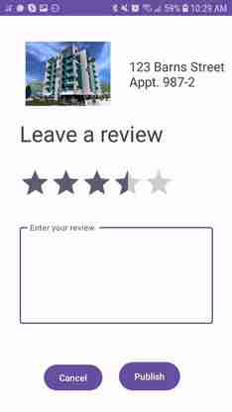

Consistency
When a task requires you to move forward, we’ve consistently used one button at the bottom-center of the screen

When a task is cancellable, the left button is always the negative option and the right is always the positive option. This is consistent with how English-speakers read, and how most Western UIs work.
Affordance  We’ve chosen to create fewer branching paths through our interface so that what matters is always readily available and obvious to the user  The map gives users a more natural way to select a property (i.e. spatially) | 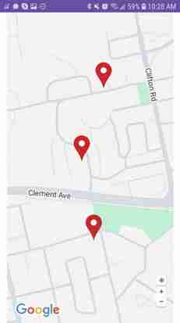

Simplicity
We’ve applied simplicity in all major tasks by focusing on maintaining only a few key interactable artifacts on each screen.

Matching  We made use of meaningful icons in several places (map button, compose email button, etc.)  We revised the “Proof of ownership” explanation to use natural, familiar language to explain the procedure | 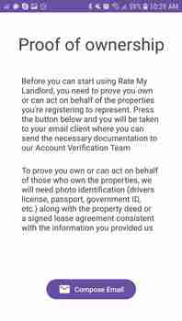

Providing Help
The interface provides a detailed explanation of how a landlord can have their identity verified.
The documentation is context sensitive; the information you recieve depends on what kind of user you are and what you will likely use the app for. Users aren’t forced to read information irrelevant to them.

Heuristic Evaluation Summary
Some issues were reported more than once. This list contains all the unique issues reported
Problem: You cannot cancel creating a review  Location: “Leave a review” main page  Heuristic: User Control & Freedom  Severity: 4  Solution: Add a cancel button | Problem: Unable to retry rejected application  Location: “Verify user” final page  Heuristic: User Control & Freedom  Severity: 4  Solution: Add a retry button
Problem: No feedback while awaiting approval  Location: “Verify user” waiting page  Heuristic: Visibility of System Status  Severity: 2  Solution: I should recieve updates while waiting | Problem: No feedback when no results found  Location: “Locate a property by address”  Heurisitc: Visibility of System Status  Severity: 2  Solution: Show a “not found” message
Problem: No matches for less than 3 characters  Location: “Locate a property by address”  Heuristic: Visibility of System Status  Severity: 3  Solution: Show predictive results immediately | Problem: Technical language while “verifiying”  Location: “Verify user” documentation page  Heuristic: Matching  Severity: 1  Solution: Speak of “proof of ownership” instead
Problem: Unclear what documentation is needed  Location: “Verify user” documentation page  Heuristic: Help and documentation  Severity: 3  Solution: Give explicit examples | Problem: Missing iconography for email  Location: “Verify user” documentation page  Heuristic: Consistency & Standards  Severity: 1  Solution: Add mail icon to button

Adjustments following the Heuristic Evaluation
We accepted all of the feedback we recieved from the Heuristic Evaluation and implemented it as suggested, except for one case.
Instead of adding another button to the “application rejection” page at the end of the verification flow, we decided to change the “Finish” button to a “Retry” button. Originally, we thought that a landlord may be able to use their account without having been verified with certain functionality limited, but later decided that it would make more sense to forbid them from using the app until they are verified.

Video Demonstration
Click here to watch the video demonstration on YouTube

