In the ungraded lab, you created and executed a series of queries for Lucky Shrub to help them extract the data that they required from the Orders table in their database. You executed these queries using your new knowledge of functions and procedures.

Now it's time to review your understanding of the tasks you completed by answering the questions that follow.

A screenshot of the Orders table is included for reference.

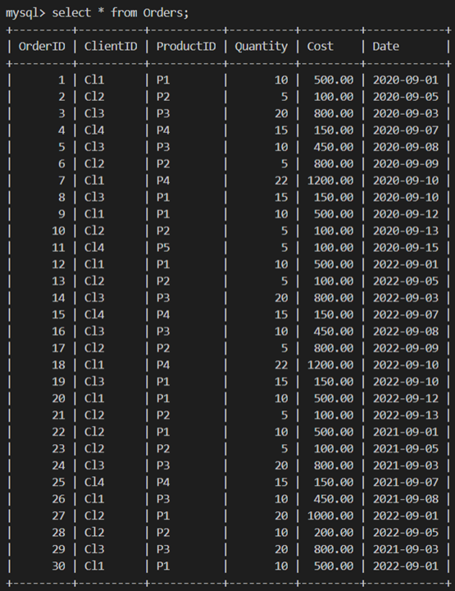

1.

Question 1

In the first task you created a function that output the cost value of a specific order based on the user input of the OrderID. Which keyword did you add to your function to ensure that it always returns the same result once the same input is provided?

CREATE FUNCTION FindCost(order_id INT)

RETURNS DECIMAL(5,2) ________ RETURN

(

SELECT Cost

FROM Orders

WHERE OrderID = order_id

);

DETERMINISTIC

Correct

Correct! DETERMINISTIC is the missing keyword. This keyword ensures that the function always returns the same result once the same input is provided.

### 2.

Question 2

Identify the command name that you used to call the FindCost() function in thte following statement?

______ FindCost();

SELECT

Correct

Correct! SELECT is the missing keyword to call the FindCost() function.

3.

Question 3

Identify which of the following commands you could have used to define the variables in the stored procedure. Select all that apply.

1 / 1 point

CREATE

SET

Correct

Correct! You could have used the SET command to define the variable in the procedure.

DECLARE

Correct

Correct! You could have used the DECLARE command to declare the variable in the procedure.

### 4.

Question 4

Which of the following SQL statements could you have used to declare a variable in your SELECT statement when creating the GetDiscount procedure? Select all that apply.

SELECT @order_quantity = Quantity

FROM Orders

WHERE OrderID = 3;

SELECT @order_quantity := Quantity

FROM Orders

WHERE OrderID = 3;

Correct

Correct! This is a correct way to declare the variable in a SELECT statement.

SELECT Quantity

INTO @order_quantity

FROM Orders

WHERE OrderID = 3;

Correct

Correct! This is a correct way to declare the variable in a SELECT statement.