In the ungraded lab, you completed a series of tasks in which you helped Lucky Shrub to implement triggers. This was done to impose some business rules.

Now it's time to review your understanding of the tasks you completed by answering the questions that follow. A screenshot of the Products table is included for your reference.

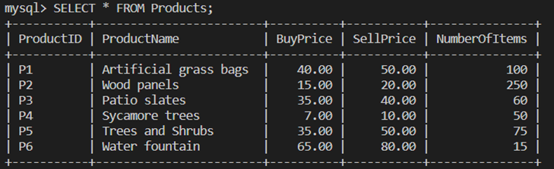

1.

Question 1

In the first task, you helped Lucky Shrub to implement a trigger that checks if the SellPrice of the product is less than the BuyPrice after a new product is inserted.

Which type of trigger did you create to complete this task?

1 / 1 point

AFTER INSERT

BEFORE INSERT

Correct

Correct! You implemented an AFTER INSERT trigger to check if the SellPrice of the product is less than the BuyPrice after a new product is inserted.

2.

Question 2

In the second task, you implemented an AFTER UPDATE trigger to ensure that a product is not updated with a SellPrice that is less than or equal to the BuyPrice. Which keyword did you use to access the SellPrice value after the update operation?

1 / 1 point

NEW

Correct

Correct! You used the NEW keyword to access the SellPrice value after the update operation in the AFTER UPDATE trigger.

3.

Question 3

In the third task you implemented a trigger that inserts a notification about deleting an existing product. This action was performed in the Notifications table, after a product was deleted from the Products table.

What happened when you executed the following SQL DELETE statement on the Product table?

DELETE FROM Products WHERE ProductID='P7';

A new record was added to the Notifications table. The product with a product ID of P7 was deleted from the Products table.

A new record was added to the Notifications table. The product with a product ID of P7 was not deleted from the Products table.

Correct

Correct! The trigger adds a notification about the deletion of product P7 to the Notifications table and deletes that product from the Products table.

4.

Question 4

In the third task you wrote the following SQL statement to implement a trigger that inserts a notification about deleting an existing product. This happens after a product was deleted from the Products table.

What keyword did you add to the DELETE trigger?

CREATE TRIGGER NotifyProductDelete

______ DELETE

ON Products FOR EACH ROW

INSERT INTO Notifications(Notification, DateTime)

VALUES (CONCAT('The product with a ProductID ', OLD.ProductID,' was deleted'), NOW());

AFTER

Correct

Correct! You used the AFTER keyword.