As a database engineer, you helped the managers of Lucky Shrub to develop optimized queries to extract relevant data from their database.

Now it’s time to review your understanding of the tasks you completed in the lab by answering the questions that follow. The ER-Diagram of the Lucky Shrub database used in the lab is included for reference.

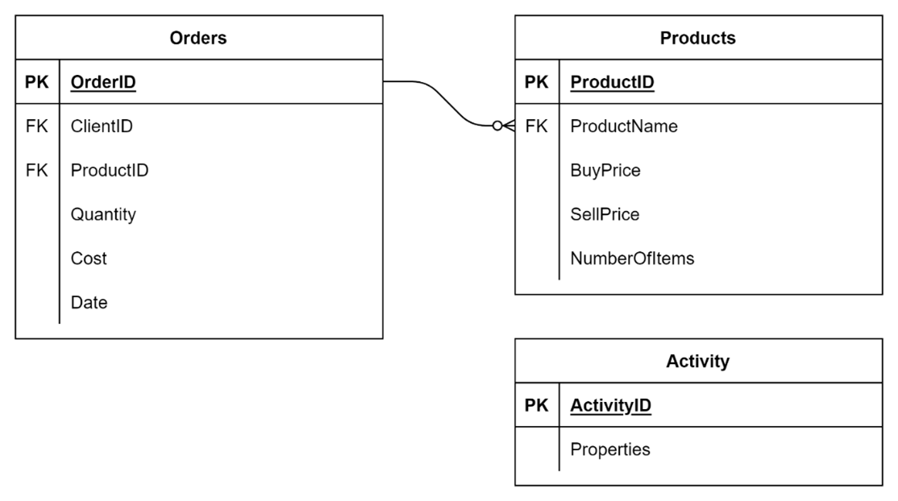

### 1.

Question 1

In the first task you optimized the following query by creating a common table expression (CTE):

WITH

CL1_Orders ________ (SELECT CONCAT("Cl1:", COUNT(OrderID), "orders") AS "Total number of orders" FROM Orders WHERE YEAR(Date) = 2022 AND ClientID = "Cl1"),

CL2_Orders ________ (SELECT CONCAT("Cl2:", COUNT(OrderID), "orders") FROM Orders WHERE YEAR(Date) = 2022 AND ClientID = "Cl2"),

CL3_Orders ________ (SELECT CONCAT("Cl3:", COUNT(OrderID), "orders") FROM Orders WHERE YEAR(Date) = 2022 AND ClientID = "Cl3")

SELECT * FROM CL1_Orders

UNION

SELECT * FROM CL2_Orders

UNION

SELECT * FROM CL3_Orders;

Which keyword can you use to associate the SELECT statements with the related expressions?

1 / 1 point

AS

IN

ON

Correct

Correct! AS is the missing keyword to associate the query with the related expression.

2.

Question 2

In the second task you created the following prepared statement called GetOrderDetail to help Lucky Shrub extract information from the Orders table based on ClientID and Year values:

PREPARE GetOrderDetail

FROM 'SELECT OrderID, Quantity, Cost, Date

FROM Orders

WHERE ClientID = ________ AND YEAR(Date) = _______ ';

Which symbol Is used to capture the required arguments ClientID and Year values?

?

Correct

Correct! You need to use the question mark ? symbol to capture the arguments values.

3.

Question 3

In the third task, you helped Lucky Shrub to access the ClientID and the ProductID data in a JSON Properties column in the Activity table. The screenshot below shows the data inside the Activity table.

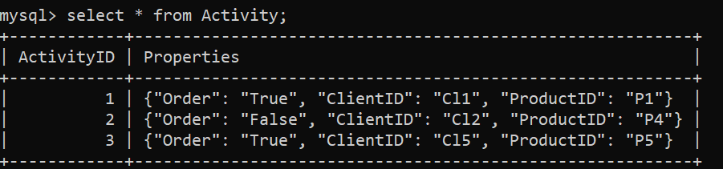

To access the ProductID data within the Properties column you can use the following syntax:

Activity.Properties =>'$.ProductID'

True

False

Correct

Correct! You should use -> to access the Properties data.