1.

Question 1

In the first task, you created the following query to return the total quantity of all products with the ID of P4 sold in years 2020, 2021 and 2022:

SELECT CONCAT(SUM(Quantity), "(2020)") AS "P4 product: Quantity sold" FROM Orders WHERE YEAR(Date) = 2020 AND ProductID = "P4"

_________

SELECT CONCAT(SUM(Quantity), "(2021)") FROM Orders WHERE YEAR(Date) = 2021 AND ProductID = "P4"

_________

SELECT CONCAT(SUM(Quantity), "(2022)") FROM Orders WHERE YEAR (Date) = 2022 AND ProductID = "P4";

Identify the missing operator that you used to combine all required results?

1 / 1 point

UNION

Correct

Correct! UNION is the missing operator to combine all required results.

2.

Question 2

In the second task, you extracted information from the Clients, Orders, Products and Addresses tables to view orders placed by clients in years 2021 and 2022. The data from this query is shown in the following screenshot. Which type of JOIN did you use to create the query?

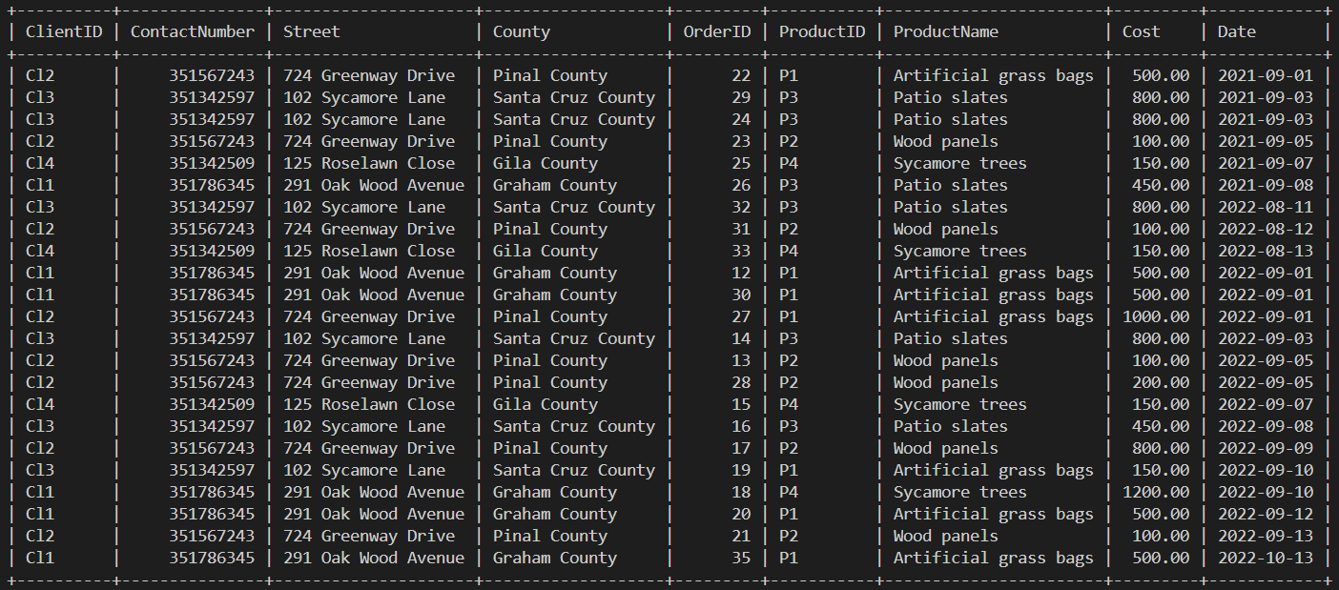

RIGHT JOIN

LEFT JOIN

INNER JOIN

FULL OUTER JOIN

Correct

Correct! This query was created using the INNER JOIN.

3.

Question 3

In the third task, you helped Lucky Shrub to analyze the sales performance of their products by developing a function called FindSoldQuantity.

They can use this function to input a ProductID and a specific year as arguments from which they can capture data to display the total quantity of the product sold in that given year.

CREATE FUNCTION FindSoldQuantity (product_id VARCHAR(10), YearInput INT)

RETURNS INT DETERMINISTIC

RETURN (

SELECT SUM(Quantity)

FROM Orders

WHERE ProductID = _______ AND YEAR(Date) = YearInput

);

Write the missing argument to create the function as expected.

1 / 1 point

product_id

Correct

Correct! You need to write the product_id to match it with the ProductID column values.