## Scenario

The Lucky Shrub database contains a lot of data about their business. The data is increasing continuously. This database consists of many tables including Clients, Orders, Products, Addresses, Employees, Audit, Notifications and Activity as shown in the following ER-Diagram.

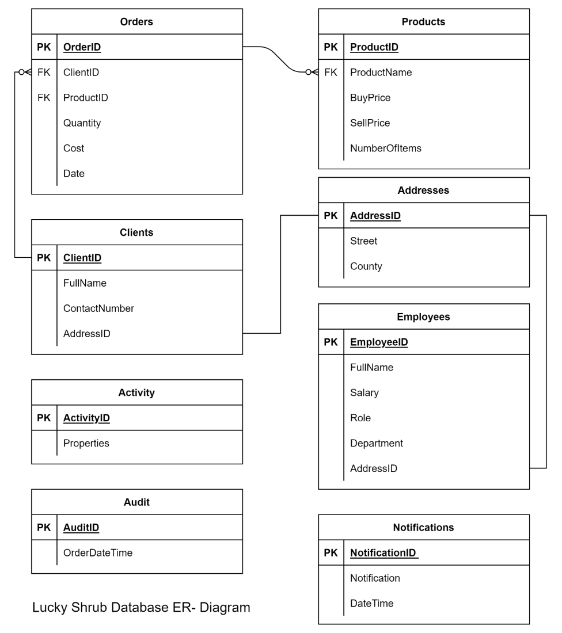

Lucky Shrub want to analyze and summarize their data so that they can evaluate the business’ performance. You can help Lucky Shrub to perform a database analysis by using a range of different optimization methods.

Note: Before you begin, make sure you know how to access [MySQL environment](https://www.coursera.org/learn/advanced-mysql-topics/supplement/Xp5Mg/how-to-access-mysql-environment).

## Instructions

To complete this lab, you must have access to the Lucky Shrub database and tables in MySQL. The database's tables must be populated with the relevant data. Follow these steps to create and populate the database:

Execute the following code to create the database, tables and insert data:

CREATE DATABASE IF NOT EXISTS Lucky_Shrub;

USE Lucky_Shrub;

**Clients table**

CREATE TABLE Clients (ClientID VARCHAR(10) primary key, FullName VARCHAR(100), ContactNumber INT, AddressID INT);

**Products table**

CREATE TABLE Products (ProductID VARCHAR(10) primary key, ProductName VARCHAR(100), BuyPrice DECIMAL(6,2), SellPrice DECIMAL(6,2), NumberOfItems INT);

Create table Addresses(AddressID INT PRIMARY KEY, Street VARCHAR(255), County VARCHAR(100));

**Employees table**

CREATE TABLE Employees (EmployeeID INT primary key, FullName VARCHAR(100), JobTitle VARCHAR(50), Department VARCHAR(200), AddressID INT);

**Activity table**

CREATE TABLE Activity( ActivityID INT PRIMARY KEY, Properties JSON );

CREATE TABLE Audit(AuditID INT AUTO_INCREMENT PRIMARY KEY, OrderDateTime TIMESTAMP NOT NULL );

**Orders table**

CREATE TABLE Orders (OrderID INT NOT NULL PRIMARY KEY,

ClientID VARCHAR(10), ProductID VARCHAR(10), Quantity INT, Cost DECIMAL(6,2), Date DATE,

FOREIGN KEY (ClientID) REFERENCES Clients(ClientID),

FOREIGN KEY (ProductID) REFERENCES Products(ProductID));

**Notifications table**

CREATE TABLE Notifications (NotificationID INT AUTO_INCREMENT PRIMARY KEY, Notification VARCHAR(256), DateTime TIMESTAMP NOT NULL);

**Inserting data to all tables**

INSERT INTO Employees (EmployeeID, FullName, JobTitle, Department, AddressID) VALUES

(1, "Seamus Hogan", "Manager", "Management", 7),

(2, "Thomas Eriksson", "Assistant ", "Sales", 8),

(3, "Simon Tolo", "Head Chef", "Management", 9),

(4, "Francesca Soffia", "Assistant ", "Human Resources", 10),

(5, "Emily Sierra", "Accountant", "Finance", 11),

(6, "Greta Galkina", "Accountant", "Finance", 12);

INSERT INTO Activity(ActivityID, Properties) VALUES

(1, '{ "ClientID": "Cl1", "ProductID": "P1", "Order": "True" }' ),

(2, '{ "ClientID": "Cl2", "ProductID": "P4", "Order": "False" }' ),

(3, '{ "ClientID": "Cl5", "ProductID": "P5", "Order": "True" }' );

INSERT INTO Clients(ClientID, FullName, ContactNumber, AddressID) VALUES

("Cl1", "Takashi Ito", 351786345, 1),

("Cl2", "Jane Murphy", 351567243, 2),

("Cl3", "Laurina Delgado", 351342597, 3),

("Cl4", "Benjamin Clauss", 351342509, 4),

("Cl5", "Altay Ayhan", 351208983, 5),

("Cl6", "Greta Galkina", 351298755, 6);

INSERT INTO Products (ProductID, ProductName, BuyPrice, SellPrice, NumberOfITems) VALUES

("P1", "Artificial grass bags ", 40, 50, 100),

("P2", "Wood panels", 15, 20, 250),

("P3", "Patio slates", 35, 40, 60),

("P4", "Sycamore trees ", 7, 10, 50),

("P5", "Trees and Shrubs", 35, 50, 75),

("P6", "Water fountain", 65, 80, 15);

INSERT INTO Addresses(AddressID, Street, County) VALUES

(1, ",291 Oak Wood Avenue", "Graham County"),

(2, "724 Greenway Drive", "Pinal County"),

(3, "102 Sycamore Lane", "Santa Cruz County"),

(4, "125 Roselawn Close", "Gila County"),

(5, "831 Beechwood Terrace", "Cochise County"),

(6, "755 Palm Tree Hills", "Mohave County"),

(7, "751 Waterfall Hills", "Tuscon County") ,

(8, "878 Riverside Lane", "Tuscon County") ,

(9, "908 Seaview Hills", "Tuscon County"),

(10, "243 Waterview Terrace", "Tuscon County"),

(11, "148 Riverview Lane", "Tuscon County"),

(12, "178 Seaview Avenue", "Tuscon County");

INSERT INTO Orders (OrderID, ClientID, ProductID , Quantity, Cost, Date) VALUES

(1, "Cl1", "P1", 10, 500, "2020-09-01" ), (2, "Cl2", "P2", 5, 100, "2020-09-05"),

(3, "Cl3", "P3", 20, 800, "2020-09-03"), (4, "Cl4", "P4", 15, 150, "2020-09-07"),

(5, "Cl3", "P3", 10, 450, "2020-09-08"), (6, "Cl2", "P2", 5, 800, "2020-09-09"),

(7, "Cl1", "P4", 22, 1200, "2020-09-10"), (8, "Cl3", "P1", 15, 150, "2020-09-10"),

(9, "Cl1", "P1", 10, 500, "2020-09-12"), (10, "Cl2", "P2", 5, 100, "2020-09-13"),

(11, "Cl4", "P5", 5, 100, "2020-09-15"), (12, "Cl1", "P1", 10, 500, "2022-09-01" ),

(13, "Cl2", "P2", 5, 100, "2022-09-05"), (14, "Cl3", "P3", 20, 800, "2022-09-03"),

(15, "Cl4", "P4", 15, 150, "2022-09-07"), (16, "Cl3", "P3", 10, 450, "2022-09-08"),

(17, "Cl2", "P2", 5, 800, "2022-09-09"), (18, "Cl1", "P4", 22, 1200, "2022-09-10"),

(19, "Cl3", "P1", 15, 150, "2022-09-10"), (20, "Cl1", "P1", 10, 500, "2022-09-12"),

(21, "Cl2", "P2", 5, 100, "2022-09-13"), (22, "Cl2", "P1", 10, 500, "2021-09-01" ),

(23, "Cl2", "P2", 5, 100, "2021-09-05"), (24, "Cl3", "P3", 20, 800, "2021-09-03"),

(25, "Cl4", "P4", 15, 150, "2021-09-07"), (26, "Cl1", "P3", 10, 450, "2021-09-08"),

(27, "Cl2", "P1", 20, 1000, "2022-09-01" ), (28, "Cl2", "P2", 10, 200, "2022-09-05"),

(29, "Cl3", "P3", 20, 800, "2021-09-03"), (30, "Cl1", "P1", 10, 500, "2022-09-01" );

## **Task 1:**

Lucky Shrub need to find out what their average sale price, or cost was for a product in 2022.

You can help them with this task by creating a FindAverageCost() function that returns the average sale price value of all products in a specific year. This should be based on the user input.

## Solution

CREATE FUNCTION FindAverageCost(YearInput INT)

RETURNS DECIMAL(10,2) DETERMINISTIC

RETURN (SELECT AVG(Cost) FROM Orders WHERE YEAR(Date) = YearInput);

## **Task 2:**

Lucky Shrub need to evaluate the sales patterns for bags of artificial grass over the last three years. Help them out using the following steps:

Step 1: Create the EvaluateProduct stored procedure that outputs the total number of items sold during the last three years for the P1 Product ID. Input the ProductID when invoking the procedure.

Step 2: Call the procedure.

Step 3: Output the values into outside variables.

## **Solution**

DELIMITER //

CREATE PROCEDURE EvaluateProduct(IN product_id VARCHAR(10), OUT SoldItemsIn2020 INT, OUT SoldItemsIn2021 INT, OUT SoldItemsIn2022 INT)

BEGIN

SELECT SUM(Quantity) INTO SoldItemsIn2020 FROM Orders WHERE ProductID=product_id AND YEAR(Date)=2020;

SELECT SUM(Quantity) INTO SoldItemsIn2021 FROM Orders WHERE ProductID=product_id AND YEAR(Date)=2021;

SELECT SUM(Quantity) INTO SoldItemsIn2022 FROM Orders WHERE ProductID=product_id AND YEAR(Date)=2022;

END //

DELIMITER ;

Call the procedure:

CALL EvaluateProduct('P1', @sold_items_2020, @sold_items_2021, @sold_items_2022);

Output the variables values:

SELECT @sold_items_2020, @sold_items_2021, @sold_items_2022;

## **Task 3:**

Lucky Shrub need to automate the orders process in their database. The database must insert a new record of data in response to the insertion of a new order in the Orders table. This new record of data must contain a new ID and the current date and time.

You can help Lucky Shrub by creating a trigger called UpdateAudit. This trigger must be invoked automatically AFTER a new order is inserted into the Orders table.

Remember: The AuditID is an auto increment key. Therefore, you don't need to insert it manually.

## Solution

CREATE TRIGGER UpdateAudit AFTER INSERT

ON Orders

FOR EACH ROW INSERT INTO Audit (OrderDateTime) VALUES (Current_timestamp);

## **Task 4:**

Lucky Shrub need location data for their clients and employees. To help them out, create an optimized query that outputs the following data:

* The full name of all clients and employees from the Clients and Employees tables in the Lucky Shrub database.
* The address of each person from the Addresses table.

## **Solution**

SELECT Employees.FullName, Addresses.Street, Addresses.County

FROM Employees INNER JOIN Addresses

ON Employees.AddressID = Addresses.AddressID

UNION

SELECT Clients.FullName, Addresses.Street, Addresses.County

FROM Clients INNER JOIN Addresses ON Clients.AddressID = Addresses.AddressID

ORDER BY Street;

## **Task 5:**

Lucky Shrub need to find out what quantities of wood panels they are selling. The wood panels product has a Product ID of P2. The following query returns the total quantity of this product as sold in the years 2020, 2021 and 2022:

SELECT CONCAT (SUM(Cost), " (2020)") AS "Total sum of P2 Product" FROM Orders WHERE YEAR (Date) = 2020 AND ProductID = "P2"

UNION

SELECT CONCAT (SUM(Cost), "(2021)") FROM Orders WHERE YEAR (Date) = 2021 AND ProductID = "P2"

UNION

SELECT CONCAT (SUM (Cost), "(2022)") FROM Orders WHERE YEAR (Date) = 2022 AND ProductID = "P2";

You are tasked to optimize this query by recreating it as a common table expression (CTE).

**Solution**

WITH

P2_Sales_2020 AS (SELECT CONCAT(SUM(Cost), " (2020)") AS "Total sum of P2 Product" FROM Orders WHERE YEAR(Date) = 2020 AND ProductID= "P2"),

P2_Sales_2021 AS (SELECT CONCAT(SUM(Cost), " (2021)") AS "Total sum of P2 Product" FROM Orders WHERE YEAR(Date) = 2021 AND ProductID= "P2"),

P2_Sales_2022 AS (SELECT CONCAT(SUM(Cost), " (2022)") AS "Total sum of P2 Product" FROM Orders WHERE YEAR(Date) = 2022 AND ProductID= "P2")

SELECT * FROM P2_Sales_2020

UNION

SELECT * FROM P2_Sales_2021

UNION

SELECT * FROM P2_Sales_2022;

## **Task 6:**

Lucky Shrub want to know more about the activities of the clients who use their online store. The system logs the ClientID and the ProductID information for each activity in a JSON Properties column inside the Activity table. This occurs while clients browse through Lucky Shrub products online.

Utilize the Properties data to output the following information:

* The full name and contact number of each client from the Clients table.
* The ProductID for all clients who performed activities.

### Tip:

Use the following code to access the property value with double quotations from the JSON datatype: ->'$.PropertyName

Use the following code to access the property value without double quotations from the JSON datatype: ->>'$. PropertyName

## **Solution**

SELECT Activity.Properties ->>'$.ClientID'

AS ClientID, Activity.Properties ->>'$.ProductID'

AS ProductID, Clients.FullName, Clients.ContactNumber

FROM Clients RIGHT JOIN Activity

ON Clients.ClientID = Activity.Properties ->>'$.ClientID';

## **Task 7:**

Lucky Shrub need to find out how much revenue their top selling product generated.

Create a stored procedure called GetProfit that returns the overall profits generated by a specific product in a specific year. This should be based on the user input of the ProductID and Year.

## **Solution**

Use the following code to create the procedure:

DELIMITER //

CREATE PROCEDURE GetProfit(IN product_id VARCHAR(10), IN YearInput INT)

BEGIN

DECLARE profit DEC(7,2) DEFAULT 0.0;

DECLARE sold_quantity, buy_price, sell_price INT DEFAULT 0;

SELECT SUM(Quantity) INTO sold_quantity FROM Orders WHERE ProductID = product_id AND YEAR(Date) = YearInput;

SELECT BuyPrice INTO buy_price FROM Products WHERE ProductID = product_id;

SELECT SellPrice INTO sell_price FROM Products WHERE ProductID = product_id;

SET profit = (sell_price * sold_quantity) - (buy_price * sold_quantity);

Select profit;

END //

DELIMITER ;

Use the following code to call the procedure:

CALL GetProfit('P1', 2020);

## **Task 8:**

Lucky Shrub need a summary of their client's details, including their addresses, order details and the products they purchased. Help them out by creating a virtual table called DataSummary that joins together the four tables that contain this data. These four tables are as follows:

* Clients,
* Addresses,
* Orders,
* and Products.

The virtual table must display the following data:

* The full name and contact number for each client from the Clients table.
* The county that each client lives in from the Addresses table.
* The name of the product they purchased from the Products table.
* The ProductID, cost and date of each order from the Orders table.

The virtual table should show relevant data for year 2022 only. Order the data by the cost of the highest order.

## Solution

CREATE VIEW DataSummary AS SELECT Clients.FullName, Clients.ContactNumber, Addresses.County, Products.ProductName, Orders.ProductID, Orders.Cost, Orders.Date FROM Clients INNER JOIN Addresses ON Clients.AddressID = Addresses.AddressID INNER JOIN Orders ON Clients.ClientID = Orders.ClientID INNER JOIN Products ON Orders.ProductID = Products.ProductID WHERE YEAR(Orders.Date) = 2022 ORDER BY Orders.Cost DESC;