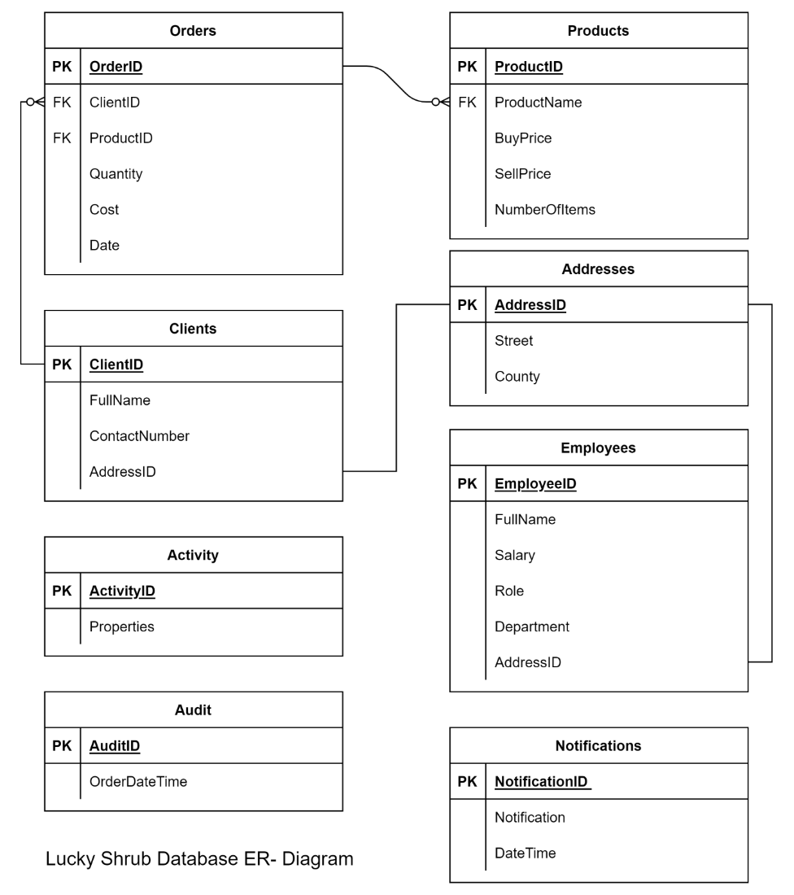

1.

Question 1

The first task involved the creation of a FindAverageCost function to return the average sale of all products sold in a specific year based on the user input of the year. Write the missing term used to pass the year value to the FindAverageCost function.

CREATE FUNCTION FindAverageCost(YearInput INT) returns DECIMAL (10,2) DETERMINISTIC RETURN (SELECT AVG (Cost) FROM Orders WHERE YEAR(Date) = _____________);

YearInput

Correct

Correct! YearInput is the missing term to create the FindAverageCost function.

2.

Question 2

In the second activity you helped Lucky Shrub optimize the following query, which they use to evaluate sales patterns, by rewriting it as simpler blocks of code.

SELECT CONCAT(SUM(Cost), "(2020)") AS "Total sum of P1 Product"

FROM Orders

WHERE YEAR(Date) = 2020 AND ProductID = "P1"

UNION

SELECT CONCAT(SUM(Cost), "(2021)")

FROM Orders

WHERE YEAR(Date) = 2021 AND ProductID = "P1"

UNION

SELECT CONCAT(SUM(Cost), "(2022)")

FROM Orders

WHERE YEAR(Date) = 2022 AND ProductID = "P1";

This query can be optimized by using a stored procedure.

1 / 1 point

True

False

Correct

Correct! This query can be optimized by recreating it as a Common Table Expression, which makes it easier to read and maintain.

3.

Question 3

In the third task, you helped Lucky Shrub to create the UpdateAudit query. This query must be invoked automatically AFTER the insertion of a new order in the Orders table. Select the correct keyword to create the query.

CREATE ___________ UpdateAudit

AFTER INSERT ON Orders

FOR EACH ROW

INSERT INTO Audit (OrderDateTime)

VALUES (Current_timestamp);

TRIGGER

VIEW

PROCEDURE

FUNCTION

Correct

Correct! You need to use the TRIGGER keyword to create the TRIGGER query.

4.

Question 4

In another activity, Lucky Shrub needed to extract JSON data on the activities of clients who shopped for products using their online store. This data is stored in the Activity table using the JSON data type in the Properties column as shown in the following screenshot.

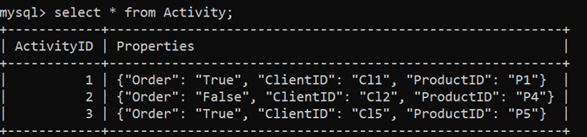S

Which of the following methods can be used to access the elements within the Properties column?

1 / 1 point

-> '$. PropertyElementName’

= '$.PropertyElementName’

<= '$. PropertyElementName’

>= '$.'PropertyElementName’

Correct

Correct! You need to access these elements using -> '$. PropertyElementName’

5.

Question 5

In the final activity, you created the following virtual table called DataSummary to show data from four different tables: Clients, Addresses, Orders and Products.

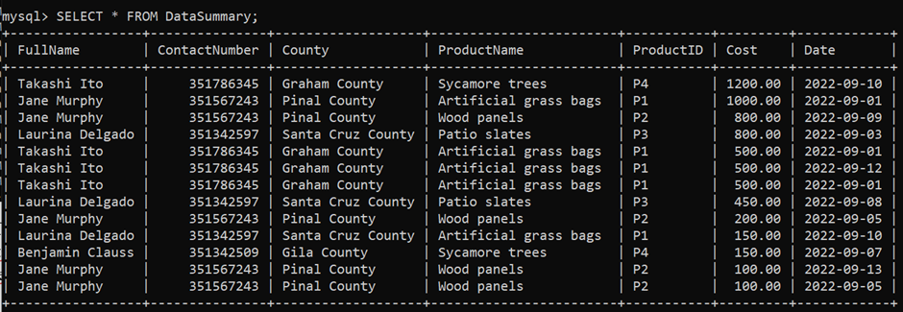

Which type of joins are used in this table’s syntax to ensure that only matching records are included in the data?

1 / 1 point

FULL OUTER JOIN

INNER JOIN

LEFT JOIN

RIGHT JOIN

Correct

Correct! You need to use the INNER JOIN to ensure that matching records only are included in the ‘DataSummary’ table.