# Solution: Design a database model in MySQL Workbench

In this reading, you will receive step-by-step guidance on how to complete the "Design a database model in MySQL Workbench" exercise. Below, you will find a breakdown of each step.

## **Breakdown of individual steps**

### **Step 1: Create an ER diagram**

Your first step is to use the visual data modeling tool in MySQL Workbench to create the proposed ER diagram for M&G. Your data model should resemble the following diagram.

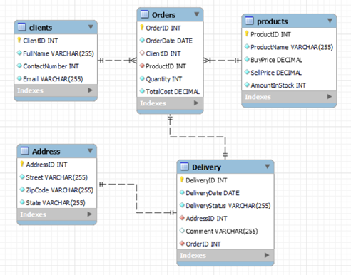

To create this diagram, access the MySQL Workbench home screen.

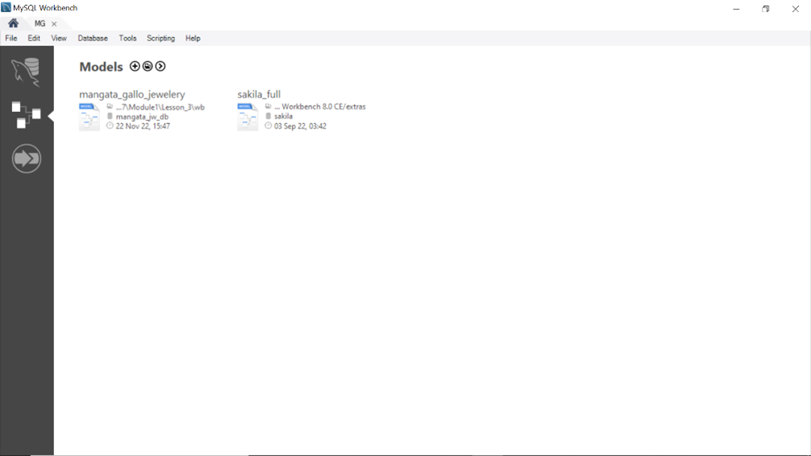

Select data model option.

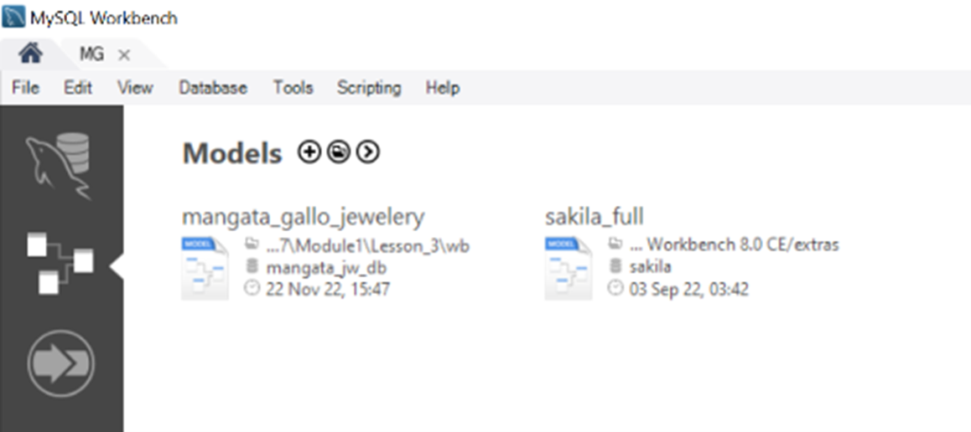

Click on the (+) icon.



Click on Add diagram as shown below:

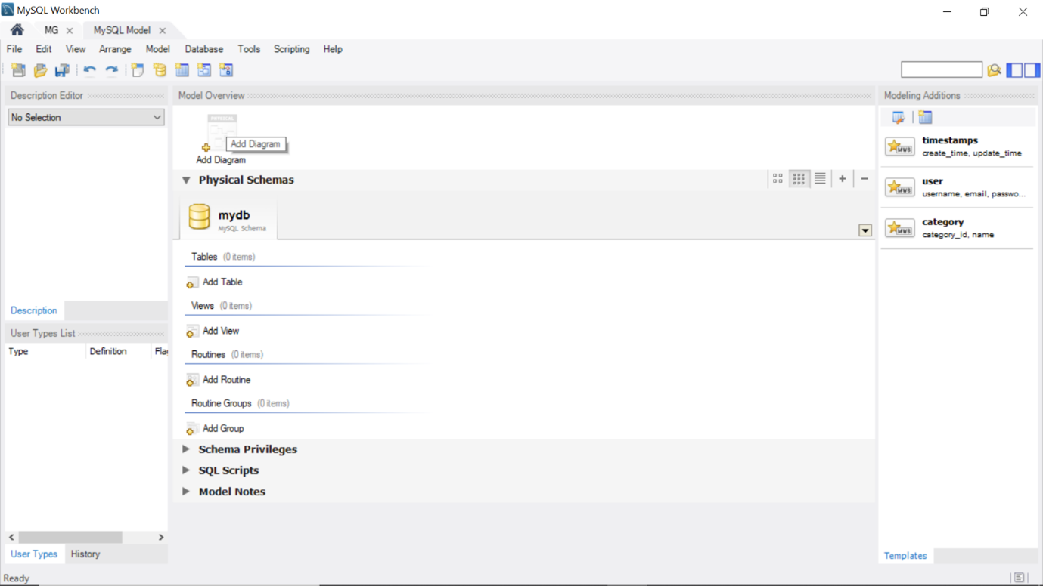

Begin building your data model in the MySQL Workbench Designer.

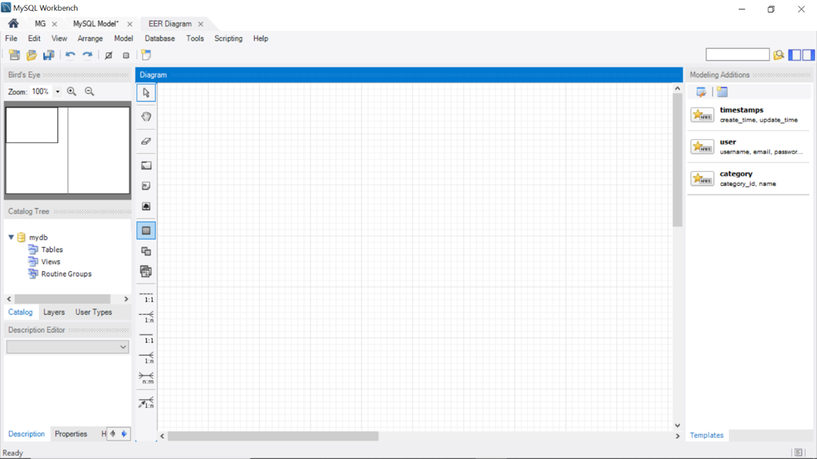

Save your model once completed. For further guidance, please view [Database modeling in MySQL Workbench](https://www.coursera.org/learn/advanced-data-modeling/lecture/bIYwL/database-modeling-in-mysql-workbench) for more details.

### **Step 2: Implement the internal schema**

Use MySQL Workbench’s forward engineer feature to implement the physical data model that you created.

* In MySQL Workbench, select the right model, then select the Database tab and the Forward Engineer option.
* In the Connection Options, select the MySQL connection and click Next.
* The Options step lists optional advanced options. You can ignore these and click Next.
* Make sure that the “Export MySQL Table Objects” check box is ticked and click Next.
* The Review SQL Script step displays the SQL script to be executed on the live server to create your schema in MySQL. Click Next to execute the forward-engineer process.
* The Commit Progress step confirms that each task has been executed. Click Close to close the wizard.
* The new database schema is now created in MySQL server as shown below.

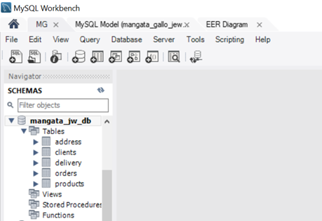

Step 3: Populate the M&G database

After you have successfully completed the previous task, you then need to populate the M&G database with data using the SQL Workbench editor.

Use the following SQL statements to create the virtual table:

CREATE VIEW orders_view AS SELECT orders.OrderID, clients.ClientID, clients.FullName, products.ProductName, orders.Quantity, orders.TotalCost, delivery.DeliveryStatus, delivery.DeliveryDate, address.Street

FROM clients INNER JOIN orders

USING (ClientID)

INNER JOIN products using (ProductID)

INNER JOIN delivery using (OrderID)

INNER JOIN address using (AddressID);

To query this virtual table, execute the following SQL statement:

SELECT * FROM orders_view;

The following output result is printed:

