### **Step 1: Identify key information**

You should already know that creating a dimensional model must start with identifying the business process you want to deal with. In this scenario, this is the sales process.

To perform data modeling, you need to identify the grain, the dimensions and the measures that you must be used to build the dimensional model.

This will help the Global Super Store to analyze the sales data in an appropriate way. In this part of the task, you should identify the following information:

* Grain: Provide the granularity level required to build the dimensional data model.
* Facts: Determine the key measures required in the model.
* Dimensions: Identify the key entities to set a suitable context for the measures.

## **Solution: Breakdown of individual steps**

### Step 1: Identify key information

Identify the grain: Global Super Store is an international company that has been operating for several years. So, they need to investigate their sales at the following levels of granularity:

* Region, country and city.
* Year, quarter, month, day or event levels.
* Category, subcategory and items.

Identify the facts: Global Super Store must investigate all the measures that impact the sales including:

* The buy and sale prices of all products.
* The quantity sold of each product.
* The shipping cost of each product.

Identify the dimensions: Global Super Store must examine the measures against the following key dimensions:

* Location.
* Time.
* Product.
* And customers.

### Step 2: Create a star schema

Once you have completed the first part of the task, carry out these next steps:

* Create a Star Schema based on the dimensions and facts identified in the first part of the task.
* Create the dimensions and the fact tables. Include relevant attributes and data types in each table.
* Define the primary and the foreign keys in the data model.

**Solution:** Step 2: Create a star schema

The following ER diagram illustrates a suitable Star schema for the Global Super Store dimensional model.

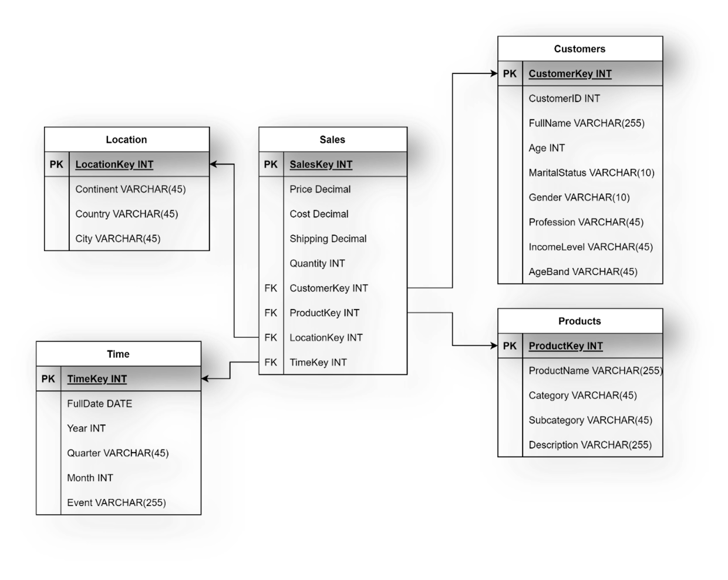

### Step 3: Create a snowflake schema

Extend the Star Schema that you developed in the second part of the task by creating a suitable Snowflake Schema with a particular focus on the products dimension.

**Solution:** Step 3: Create a snowflake schema

The following ER diagram illustrates a suitable Snowflake schema for Global Super Store dimensional model.

