In the lab exercises, you completed a series of tasks where you established a connection with MySQL database using Python. You also explored methods for retrieving the error codes along with error messages in case the connection failed.

The solution code for all tasks is provided below:

Task 1 solution:

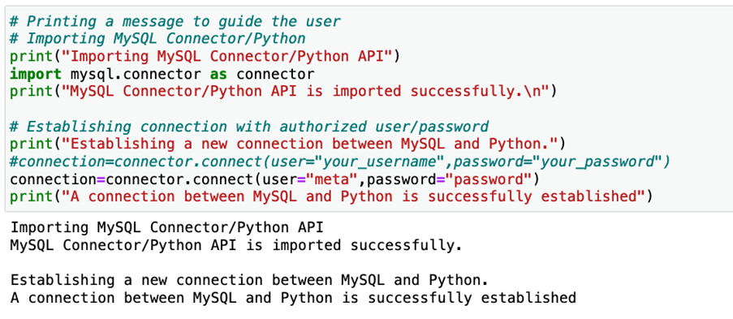

Task 2 solution:

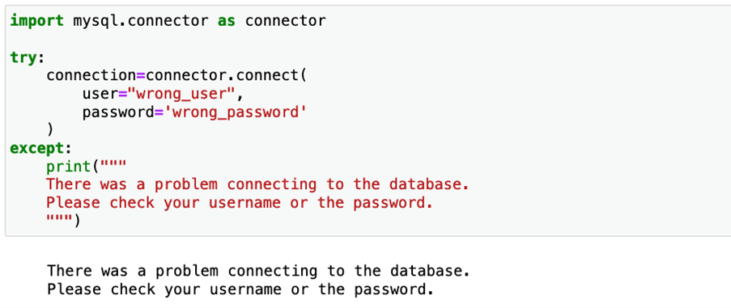

Task 3 solution:

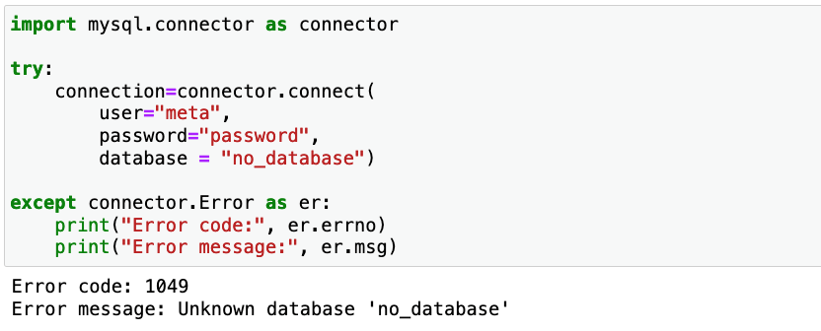

It's now time to review your understanding of the tasks you completed in the lab exercises by answering the following questions.

1.

Question 1

In the first task, you established a connection with MySQL database using MySQL Connection/Python API in a Python-based application. What are the steps you followed to complete this task?

1 / 1 point

You imported the MySQL Connector/Python, accessed the connect module, and passed authenticated user and password parameters to establish a connection.

You imported the MySQL Connector/Python, accessed the cursor module, and passed authenticated user and password parameters to establish a connection.

You import the MySQL Connector/Python API, access the connector module and pass the authentication to the .execute( ) method.

You imported MySQL Connector/Python and Python automatically established a connection between MySQL and the application.

Correct

Correct! You accessed the connect module after importing the MySQL Connector/Python API and passed the required arguments [user, password] to establish a connection.

2.

Question 2

In the second task, the argument [database] is missing in the connect module. To connect to MySQL, you must pass the database argument along with an authenticated user and password to establish a connection.

1 / 1 point

True

False

Correct

Correct. The database argument is optional for establishing a connection between Python and MySQL. The database can be set after establishing a connection.

3.

Question 3

In the third task, your code returns an error as it could not locate the database. Under what circumstances does the connect module throw an access denied error with the code 1045 while establishing a connection?

1 / 1 point

If the database argument is missing.

If the module is provided with the wrong username or password.

If the host argument is missing.

If the module is provided with the wrong database name.

Correct

Correct! The connect module throws an error Access denied for user with an error code 1045 if it encounters an unauthenticated user [wrong user and/or password].