Task 1 solution:

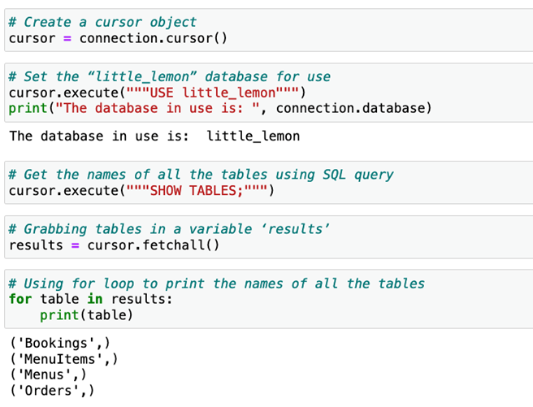

Task 2 solution:

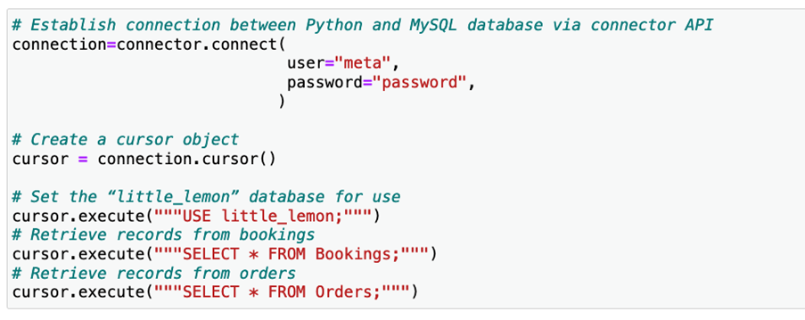



Buffered

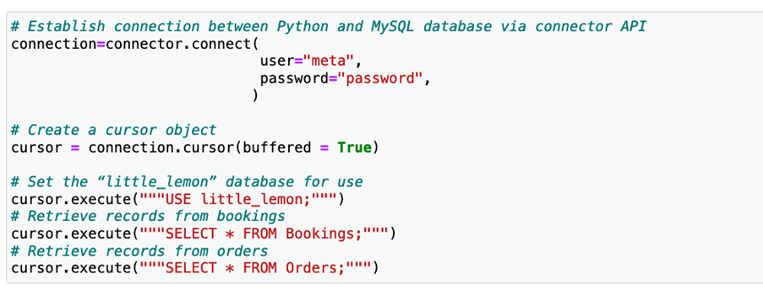

Task 3 solution:

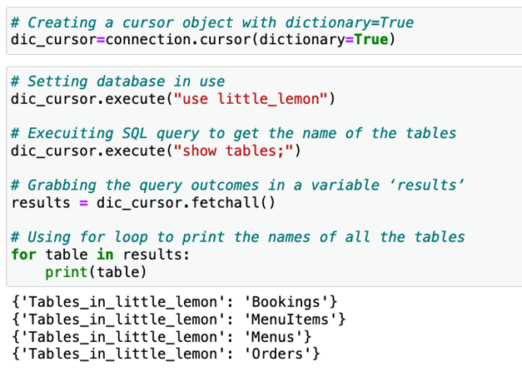

It's now time to review your understanding of the tasks you completed in the lab exercises by answering the following questions.

1.

Question 1

In the first task, you created a cursor object to communicate with the MySQL database using Python. How can you run a query on the MySQL database using Python via MySQL Connector/Python API?

1 / 1 point

Set the database for use, establish a connection between MySQL and Python, execute the query and create a cursor.

Establish a connection between MySQL and Python, create a cursor, set the database for use and execute the query.

Create a cursor, set the database for use, establish a connection between MySQL and Python and execute the query.

Set the database for use, establish a connection between MySQL and Python, create a cursor and execute the query.

Correct

Correct! You can establish a connection and create a cursor to communicate with the database to accomplish any required task.

2.

Question 2

In the first task, you created a cursor object using the default value of its parameter. Your query returned the names of all four tables. What happens to the cursor if you only fetch the first two records from the cursor and attempt to run another query?

1 / 1 point

The cursor loses access to all other records but works as normal for the next query.

The cursor must be recreated because it does not work unless you fetch all records first.

The cursor is still in use and holds access to the remaining records. It will raise an error.

The cursor works as required and runs the next query passed to its execute module.

Correct

Correct! You must fetch all the query results before you use the same cursor for any other query. You can’t even close the cursor in this situation.

3.

Question 3

In the second task, you set buffered = True as a parameter to the cursor module while creating a cursor object. This means that you can now execute subsequent queries without fetching all the records from the cursor.

1 / 1 point

True

False

Correct

Correct! With the parameter buffered=True, the cursor stores the data in the buffered memory and works for subsequent queries without fetching all the records.

4.

Question 4

In the third task, you created a cursor with the parameter [dictionary=True]. This type of cursor cannot be used to read data from tables in the MySQL database.

1 / 1 point

True

False

Correct

Correct! The dictionary approach has its own strengths and weaknesses. However, it will successfully read records from tables in the MySQL database.