Task 1 solution

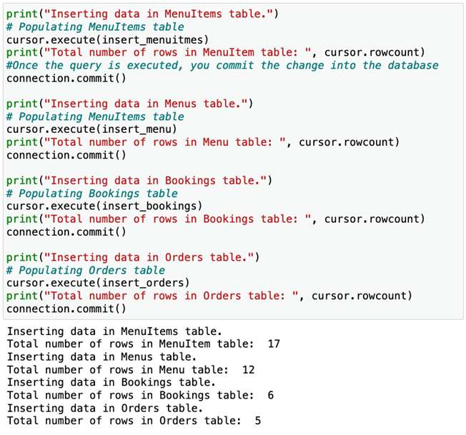

Task 2 solution

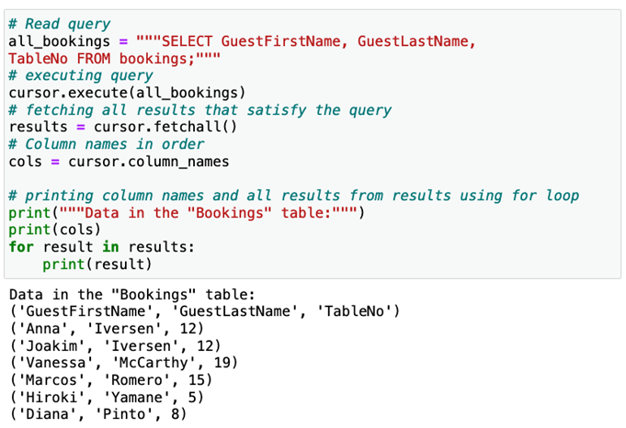

Task 3 solution

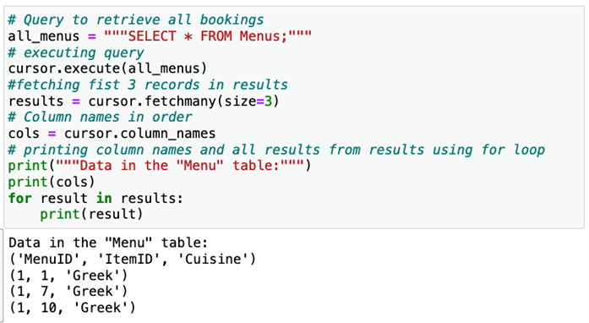

It's now time to review your understanding of the tasks you completed in the lab exercises by answering the following questions.

1.

Question 1

In the first task, while inserting data into the tables, you executed the SQL statement as a Python string and then invoked the commit module. What happens when you invoked the commit module?

1 / 1 point

The commit module makes sure that the connection is working.

The commit module executes the INSERT operation to store the data.

The commit module makes sure that the right data is inserted.

The commit module modifies the data for the respective table.

Correct

Correct! The commit module makes sure that the appropriate table is updated with the new data once the SQL query is executed using Python.

2.

Question 2

In the second task, you fetched the records from the cursor and stored them in a Python variable called results. Storing records in a new variable means that you can use them as needed within your Python application without performing the same operation on the database.

1 / 1 point

False

True

Correct

Correct! The cursor only moves in a forward direction. Once it has fetched all records, it’s empty. If you need to use the records again but haven’t stored them in the variable, then you’ll need to execute the query once more.

3.

Question 3

In the third task, you executed the SELECT query to read all 12 records from the Menu table. You then used the fetchmany(size=3) module on the cursor to grab only the first 3 records in the variable results. Where are the other 9 records?

1 / 1 point

All remaining records are lost. The cursor is also closed, preventing the execution of any further queries.

The records can be accessed by invoking the fetchmany module again on the cursor.

The records are in the cursor but are inaccessible as you cannot invoke the fetchmany module again.

All remaining records are inaccessible, as the cursor can only retain those targeted with the fetchmany module.

Correct

Correct! The cursor moves to the fourth record once the first three are fetched. The remaining records can be fetched using the fetchone() fetchmany(), fetchall() modules.