Task 1 solution

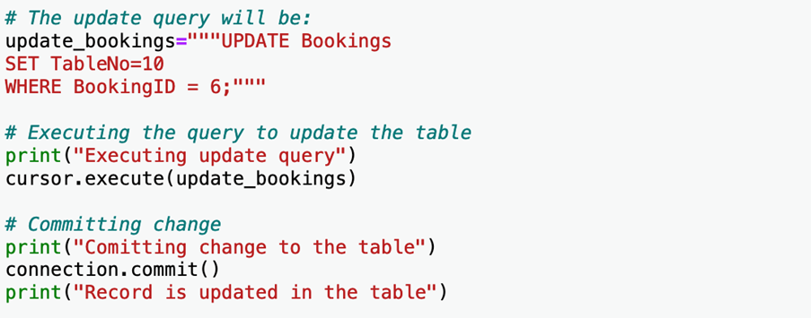

Task 2 solution

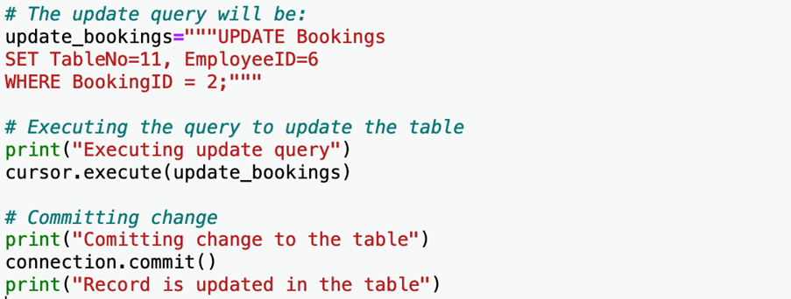

Task 3 solution

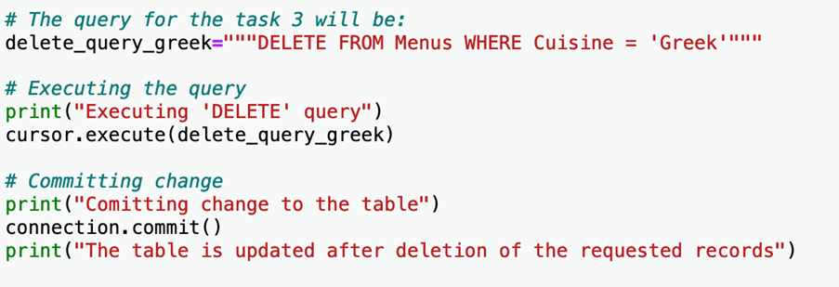

It's now time to review your understanding of the tasks you completed in the lab exercises by answering the following questions.

1.

Question 1

In the first task, you modified a record in the Bookings table. How can you make use of the update query to modify the record in the table once it's executed using Python via MySQL Python/Connector API?

1 / 1 point

You can use the execute module to run the SQL update query and modify the record in the respective table.

You must invoke the commit module from the cursor object after the successful execution of the SQL query to modify the record in the respective table.

You must invoke the commit module from the connection after the successful execution of the SQL query to modify the record in the respective table.

You must invoke the commit module before the query is executed to modify the record in the respective table.

Correct

Correct! The commit module makes sure that the record in the table is modified, and the appropriate table is updated after the execution of the SQL query operation using Python.

2.

Question 2

In the second task, when using Python to interact with MySQL database to modify multiple columns in a single record, you performed each update separately and committed the change individually to make sure that each column was updated individually.

1 / 1 point

True

False

Correct

Correct! You can use a typical SQL UPDATE query to modify multiple columns in a record. However, individual columns can also be updated individually using multiple queries.

3.

Question 3

In the third task, you deleted all records associated with Greek cuisine in the Menu table. How did you perform this operation using Python?

1 / 1 point

You executed a SQL query to update all records with NULL values. Python then automatically deleted these records. You then used commit to modify the table.

You executed a SQL query to delete all records that have a value of Greek in the cuisine column. You then used commit to modify the table.

You executed an individual query for each record with a value of Greek in the cuisine column. You didn’t need to make use of the commit module because the columns were empty.

You executed the query by selecting each menu ID with a value of Greek in the cuisine column. You then used commit to modify the table.

Correct

Correct! The most efficient method is to separate all records containing a value of Greek in the cuisine column using the WHERE clause and then delete them. The use of the commit module ensures that all instances of these records are permanently deleted from the table.