# Exercise: Set up the Tableau Workspace for data analysis

## **Scenario**

Little Lemon have an Excel sheet file with thousands of records of data on orders made between 2019 and 2023. They want to analyze the sales data to examine how they can increase their profits. They need you to help them to prepare the existing data before they start analyzing it.

## **Prerequisites**

Check that you have the following before you begin these tasks:

* Tableau already installed on your machine
* Little Lemon DB Excel Sheet should be downloaded on your machine

## **Task instructions**

Complete the following tasks to help Little Lemon set up their Tableau Workspace for data analysis.

## **Task 1**

In this first task, you need to connect to Little Lemon data stored in the Excel Sheet called LittleLemonDB. Then filter data in the data source page and select the United States as the country.

Here’s some guidance for completing this task:

* Open Tableau. In the Connection Pane select Excel, then navigate to the data source.
* In the data source page, select Filter Tab.

## **Task 2**

In the second task, you need to create two new data fields called First Name and Last Name. Related values should be extracted from the Full Name field.

Here’s some guidance for completing this task:

* You can use the Split feature in Tableau.
* Rename the new fields.

## **Task 3**

For your third task, you need to create a new data field that stores the profits for each sale, or order as shown in the screenshot below.

Here’s some guidance for completing this task:

* Select Sales field in the Data Pane, then select Create Calculated field.
* Name the calculated field Profit.
* Write a formula that deducts Cost from Sales.

Once you complete these tasks you should be ready to perform data analytics and to create visual charts.

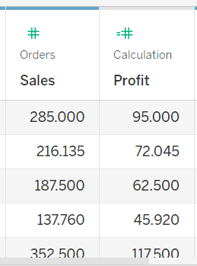

## **Conclusion**

You have now prepared Little Lemon’s data in Tableau. You can now begin analyzing it and providing relevant visualized charts.