Candidate Profile

I. Academic Background
Highest Relevant Degree Earned:
- Degree Name: Master of Science
- Field of Study: Computer Science
- Institution Name: University of XYZ
- -Graduation Year: 2021
Relevant Certifications & Licenses:
- - Name of Certification/License: Certified Cybersecurity Specialist
- - Issuing Body: Global Cybersecurity Institute
- - Year Obtained/Valid Through: 2022–2025
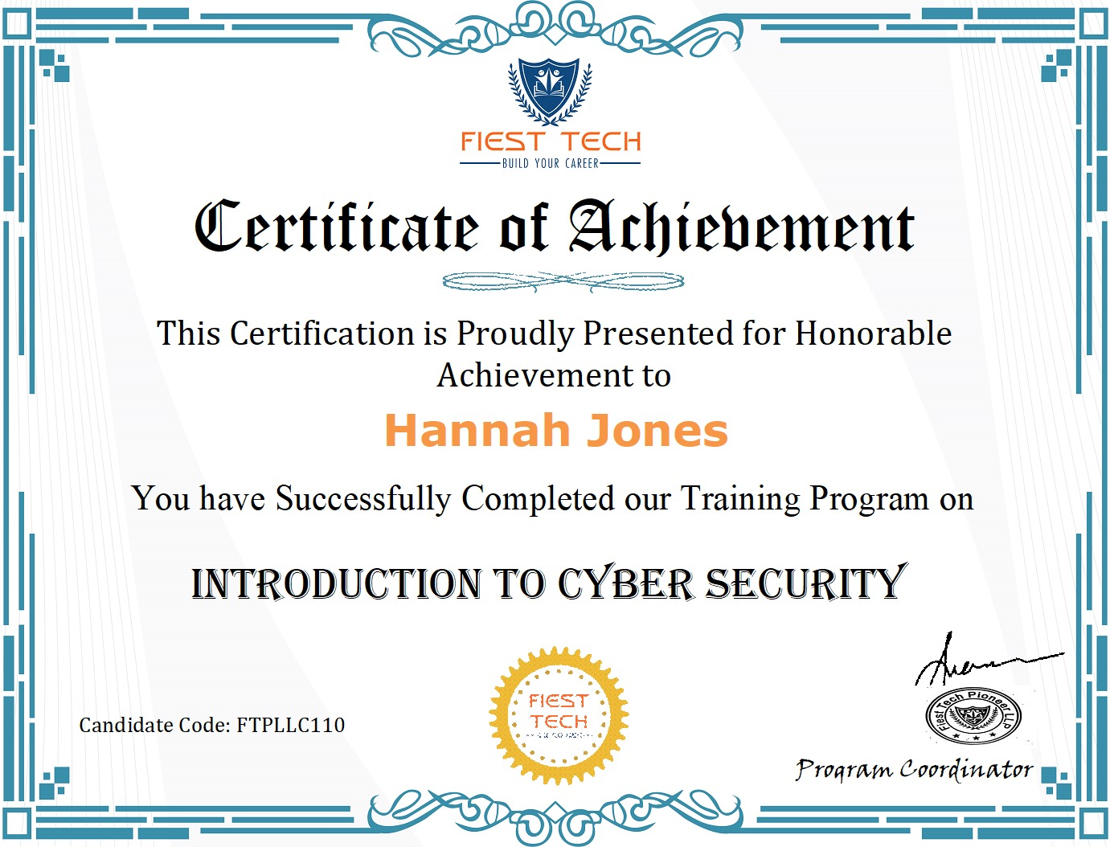

Key Academic Achievements:
- - Graduated with Distinction
- - Received Arbaminch University Research Grant for AI Security

II. Professional Experience
Current or Most Recent Relevant Position:
- - Job Title: IT Security Manager
- - Organization/Company: SecureTech Solutions
- - Dates of Employment: March 2022 – Present
- - Key Responsibilities & Accomplishments:
- Led a cybersecurity team of 8 professionals
- Reduced incident response time by 50%
- Developed internal training programs for threat prevention
Previous Relevant Position:
- - Job Title: Network Security Analyst
- - Organization/Company: CyberSafe Inc.
- - Dates of Employment: June 2019 – February 2022
- - Key Responsibilities:
- Monitored and analyzed network traffic
- Implemented firewalls and intrusion detection systems

Leadership Roles Beyond Formal Employment
- - Role Title: Chair, Local Cybersecurity Awareness Committee
- - Organization: City Tech Forum
- - Dates: 2020–2023
- - Description: Organized public workshops and training sessions on online safety

III. Relevant Skills Summary
Cybersecurity Strategy, Network Defense, Risk Assessment, Incident Response, Public Speaking

IV. Volunteer Work & Community Involvement
- Role: Volunteer Mentor
- Organization: Code4Youth
- Impact: Mentored 15 high school students in coding and digital security awareness

V. Candidate Statement
"With a strong foundation in computer science and hands-on experience in cybersecurity, I am committed to advancing digital safety and transparency. I aim to bring a strategic, technology-informed approach to governance, ensuring our systems remain secure and effective for all stakeholders."

