Maximum Clique
Natnicha Titiphanpong

Contents
1. Problem Statement 2
2. User Requirements 2
3. Software Requirements 2
4. Software Design 3
5. Results 7
6. Discussion 10
7. User Instructions 12

Problem Statement

The goal of the maximum clique problem is to identify the maximum clique within the supplied graphs. It is advised that a randomised greedy search is implemented with any additional heuristics thought of.

User Requirements

The following outlines the user requirements for the program:

- The user should be able to select a file by inputting the file name in main
- The user should be able to input a number of trials into the command line
- The user is able to input whether they want to run a pure greedy search or a greedy search with a heuristic by supplying True or False as an argument when calling the find_maximal() function
- The user is able to view the result of the program: maximal clique, mean maximal and mean execution time

Software Requirements

The following outlines the software requirements for the program:

- The program shall accept a maximum number of trials as arguments from the command line.
- The program shall find a maximal clique of the graph
- The program shall output results and statistics such as mean score and time taken to execute each trial

Software Design

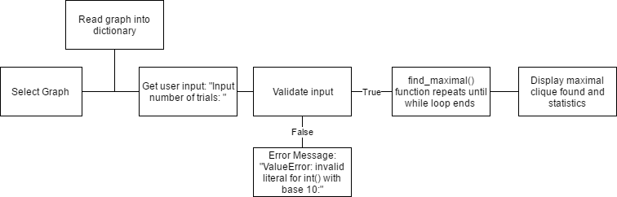
High Level Design – Logical Block Diagram

UML Diagram
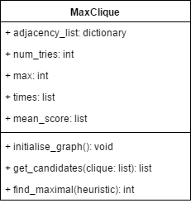

List of all functions in the software.
Initialise_graph:
This function reads in the graph file in as a list then starting with ‘e’ appends the first element separated by whitespace as node1 and all elements after it as node2 into a dictionary
- Input parameters: None
- Side effects: Populates the adjacency_list dictionary
- Return value: Void
Get_candidates:
This function compares all the nodes in the clique and builds a list of all nodes common to all adjacency lists of the nodes in the clique.
- Input parameters: Clique list
- Side effects: None
- Return value: returns a list of nodes which are adjacent to all clique elements
Find_maximal:
This function grabs a random node from the dictionary using the randrange method from the random package then gets all the values of that node by using the dictionary’s get( ) method. It then appends this initial node to the clique. The function has a while loop that if you choose to use the heuristic, looks through the list of candidates and appends the node with the greatest degree of freedom and appends that to the current clique. Otherwise, without the heuristic, it selects a random node within the range of the length of the candidates list and appends that to the clique. At the end of the while loop it then rebuilds the candidates list and the function returns an integer, which refers to the length of the clique.
Side effects: Does not modify any global variables
Input parameters: Heuristic (Boolean) that toggles the heuristic on and off depending on True or False

List of all data structures in the software
Adjacency_list:
Python dictionary
It is used to store elements from the file that contain nodes(key) and a list of all nodes (value) that are connected to that node
Used by (functions): initialise_graph
Adjacency_sets:
Set
It is used for comparison of sets when finding the intersection of the values in the adjacency_list
Used by: get_candidates function
Clique:
List
Used to store the nodes in the current clique
Used by: find_maximal and get_candidates functions
Times:
List
Used to store the CPU time of all trials
Mean_score:
List
Used to store the maximal clique of all trials

Detailed Design – Pseudocode

Def get_candidates(clique):
Adjacency_sets = [ ]
For a node in clique list:
Get value of node from adjacency_list, assign to set and append to adjacency_sets
Return list of all nodes that intersect in adjacency_sets

Def find_maximal(heuristic):
Clique = [ ]
Initial_node ← a random key from adjacency_list
Candidates ← values of initial_node from adjaceny_list
Append initial_node to clique
While len(candidates) > 0:
If heuristic:
Max_node ← candidates[1]
Size ← length of value of candidates[1]
For node in candidates:
Temp ← length of the value of node
If temp > size:
Size ← temp
Max_node ← node
Append max_node to clique
Else:
Append random key in range of candidates to clique
Candidates ← get_candidates(clique)
Return length of clique

Results

table 1: output vs actual maximum
Graph | Output Maximal Clique | Actual Maximum Clique | Successful Trials | Difference (actual – output)
Brock800_1 | 18 | 23 | 100 | 5
Brock800_2 | 18 | 24 | 100 | 6
Brock800_3 | 18 | 25 | 100 | 7
Brock800_4 | 18 | 26 | 100 | 8
C2000.9 | 61 | 78 | 100 | 17
C4000.5 | 16 | 18 | 100 | 2
MANN_a45 | 342 | 344 | 100 | 2
P_hat1500-1 | 11 | 12 | 100 | 1

Figure 1: greedy with heuristic vs. pure greedy search
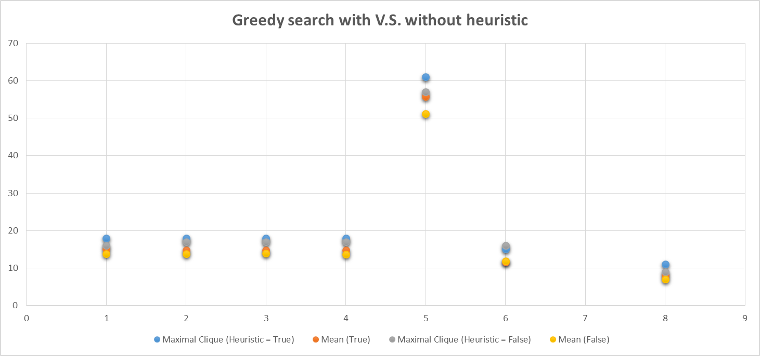
Note** MANN_a45 has been omitted from graph to show a clearer correlation

table 2: greedy with heuristic vs. pure greedy search

Graph No. | Graph | Maximal Clique (Heuristic = True) | Mean score | Maximal Clique (Heuristic = False) | Mean score | Successful Trials
1 | Brock800_1 | 18 | 15.01 | 16 | 13.75 | 100
2 | Brock800_2 | 18 | 14.75 | 17 | 13.85 | 100
3 | Brock800_3 | 18 | 14.79 | 17 | 13.92 | 100
4 | Brock800_4 | 18 | 14.74 | 17 | 13.73 | 100
5 | C2000.9 | 61 | 55.75 | 57 | 51.23 | 100
6 | C4000.5 | 16 | 11.82 | 15 | 11.65 | 100
7 | MANN_a45 | 342 | 341.74 | 335 | 331.92 | 100
8 | P_hat1500-1 | 11 | 7.94 | 9 | 6.99 | 100

table 3: greedy with heuristc VS. Number of trials
Graph | 10 Trials (MC) | Mean | 50 Trials (MC) | Mean | 100 Trials (MC) | Mean | 500 Trials (MC) | Mean
Brock800_1 | 17 | 15.0 | 17 | 15.1 | 18 | 15.01 | 19 | 14.98
Brock800_2 | 16 | 14.6 | 17 | 14.7 | 18 | 14.75 | 19 | 14.94
Brock800_3 | 16 | 14.7 | 17 | 14.72 | 18 | 14.79 | 18 | 14.8
Brock800_4 | 16 | 14.2 | 17 | 14.62 | 18 | 14.74 | 19 | 14.76
C2000.9 | 59 | 55.3 | 60 | 55.86 | 61 | 55.75 | 62 | 56.15
C4000.5 | 13 | 12.5 | 14 | 12.14 | 15 | 12.05 | 15 | 12.07
MANN_a45 | 342 | 341.4 | 342 | 341.46 | 342 | 341.74 | 342 | 341.58
P_hat1500-1 | 9 | 8.3 | 9 | 7.84 | 11 | 7.94 | 11 | 8.02

discussion
The maximum clique problem was implemented in two ways; first by doing a pure greedy search and secondly by doing a greedy search with an added heuristic. The two algorithms are plotted in figure 1, with the higher mean score being consistent when the heuristic was added. The maximal clique in the two cases however, are quite similar, with one lower maximal clique score for the non-heuristic search otherwise the results are the same. The heuristic is implemented to guide the algorithm to explore nodes with the highest degree of freedom first. This is done so that the algorithm will explore the nodes that are more likely to be in the maximum clique. Once these nodes are explored first then the algorithm will search through the more unlikely nodes which have less elements in their list of nodes attached to them. Without the heuristic, the algorithm chooses its next node by random, it first picks a random node then looks through the list of possible candidates and appends a random element from that list to the clique and the whole process repeats again. By adding the heuristic, the maximal clique found was not always improved after 100 trials however, the mean score did. If the number of trials were lower, the greedy with heuristic would most likely always find a greater maximal given the same number of trials which are less than 100.
The number of trials and its effect on the maximal clique and mean score was tested to see if the algorithm could improve its own result over a gradual increase of trials. When tested, the algorithm did not only increase its current maximal clique by an increase in trials but also its mean score. Table 3 displays the results of the relationship between number of trials, maximal clique output and mean score.
When comparing the results output by the program against the actual maximum clique value (in table 1), the algorithm seems to scale well with a larger clique size having an output of 342 size clique with the actual maximum of 344 (MANN_a45). However, the algorithm does not work as well with a larger file such as C2000.9 with 2000 nodes to search through. The smallest maximum clique graph to find was P_hat1500-1 where the difference of the output to the maximum was only one node away.
Unfortunately, the maximum clique cannot be found with a pure randomised greedy search or even one with an added heuristic. However, multiple additions such as a taboo list, a swap implementation, a level implementation will improve the current algorithm.

User Instructions

- Open the file MaxClique.py in PyCharm.
- Have a folder named “graph_files” in same directory as MaxClique.py
- Make sure all files are in “graph_files” folder.
- Run the program in console mode in PyCharm.
- Uncomment one file name in MaxClique.py as file to be read.
- When prompted, enter a maximum number of trials as command line arguments.
- Results will appear: maximal clique of selected file and after input number of trials, time taken to execute and also mean maximal clique result.

