## Data Description

### NATO Ukraine IED Incidents Data

This is a NATO Unclassified IED events spreadsheet from the NATO C-IED COE. It contains 665 events, with 15 in 2001-2013, about 230 in 2014 and the rest in 2015. It contains the following column headers: Date, Type, KIA (Killed in Action), WIA (Wounded in Action), City, Region, Country, Details, Group, Remarks. There are missing values in the dataset. Table 1 below provides a sample of the data for December 2015.

*Table 1: Sample of the Ukraine IED incidents data for December 2015.*

|  |  |  |  |  |  |  |  |  |  |
| --- | --- | --- | --- | --- | --- | --- | --- | --- | --- |
| **DATE** | **TYPE** | **KIA** | **WIA** | **CITY** | **REGION** | **COUNTRY** | **DETAILS** | **GROUP** | **REMARKS** |
| 2015 DEC 09 | CACHE/FOUND | 0 | 0 | Kramatorsk | DONETSK | UKRAINE | IEDs were found and disposed by Combat Engineers |  | TBC if they were just landmines |
| 2015 DEC 09 | UNKNOWN | 0 | 0 | Kharkiv | KHARKIV | UKRAINE | An IED was blown up in front of a ROSHEN shop |  | Shopping Center |
| 2015 DEC 08 | UNKNOWN | 0 | 0 | Kiev | KIEV | UKRAINE | A device was detonated against a restaurant (L'Kafa) |  | Boulevard Lesi Ukrainian |
| 2015 DEC 07 | HOAX/FALSE | 0 | 0 | Ivano-Frankivsk | IVANO-FRANKIVSK | UKRAINE | Call reporting IED - First Responders action - no explosive |  | Central Metro/bus station |
| 2015 DEC 02 | CACHE/FOUND | 0 | 0 | Krasnoarmiisk | DONETSK | UKRAINE | An IED was found and disposed by EOD |  |  |
| 2015 DEC 02 | CACHE/FOUND | 0 | 0 | Avdeevka | DONETSK | UKRAINE | A cache with 3 IEDs with TNT was found and cleared |  | Inside an abandoned house |
| 2015 DEC 02 | UNKNOWN | 0 | 0 | Uzhgorod | ZAKARPATS'KA | UKRAINE | An IED was detonated against a store in Franko Street |  |  |

### Ukraine Map Data

We will a geojson/topojson data about the various regions of Ukraine as we expect some of this information might be displayed on a map. We have found two potentially suitable Ukraine map data files.

### Ukraine Census Data

We also want to include various statistics about Ukraine to see if we can find patterns between the IED events and these statistics. So far, we found the population of each district, as per Jan 2013 (<http://ukrstat.gov.ua/operativ/operativ2013/ds/kn/kn_e/kn0113_e.html>), as well as the monthly wages by region from 1995 to 2015 (<http://ukrstat.gov.ua/operativ/operativ2006/gdn/prc_rik/prc_rik_e/dszpR_e2006.htm>).

We are considering using the output of the 2011 Ukraine census as another data source for this project (<http://database.ukrcensus.gov.ua/MULT/Database/Census/databasetree_en.asp>). We could extract more dimensions like education, sources of livelihood and especially native language. The data seems to be at region level, similar in grain to the NATO data. Also, derived from the census, we have the number of Russians in Ukraine, by province, in 2001: (<https://en.wikipedia.org/wiki/Russians_in_Ukraine>).

**Ukraine 2010 Presidential Elections Data**

Since the Ukraine started with the removal from power of the previously elected president Viktor Yanukovych, we wish to provide the user with an underlying political map, based on the 2010 presidential elections. The source data has the same geographical grain as our main data set (region). Source: <https://commons.wikimedia.org/wiki/User:DemocracyATwork>

**Ukraine Conflict Timeline**

As we believe the IED incidents are closely related to the Ukraine conflict, we will use

this timeline of the conflict’s major events to try to explain any spikes or patterns of the number of IED incidents as well as enhance the overall narrative. Source: <http://www.bbc.co.uk/news/world-middle-east-26248275>

**Ukraine Conflict Casualties and Injuries Data**

We will consider using this UN report in order to provide additional key facts about the Ukraine conflict (number of casualties and injuries by month), as well as to try to establish a relation between the number of casualties and injuries and the number if IED explosions. Source: <http://www.ohchr.org/Documents/Countries/UA/12thOHCHRreportUkraine.pdf>

## Exploratory Data Analysis

### Tableau Data Analysis

Using Tableau, we explored the number of events, of persons killed and of persons wounded by region. The events are colored by type, which also highlights the presence of data errors like the “UNKKNOWN” label. We also explored the number of events happening in the 2014-2015 time period for each event type.

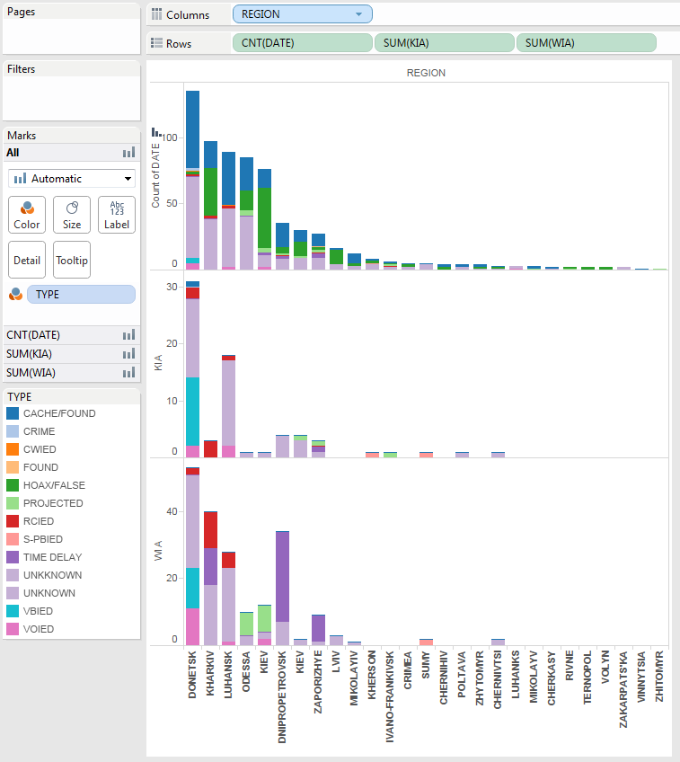

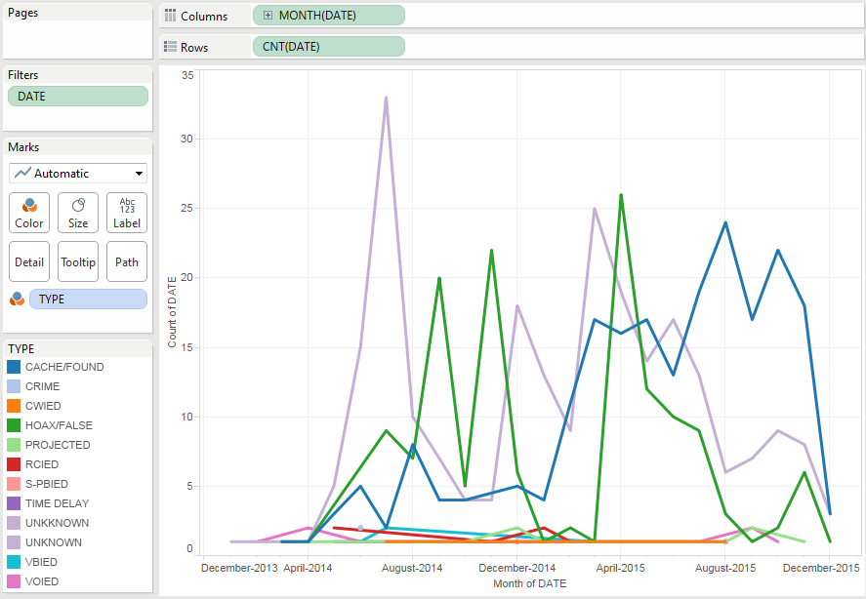

### Text Exploration

We produced a force layout to find relationships between the various IED event texts (details and remarks fields) and see the ones which have most unusual words in them.

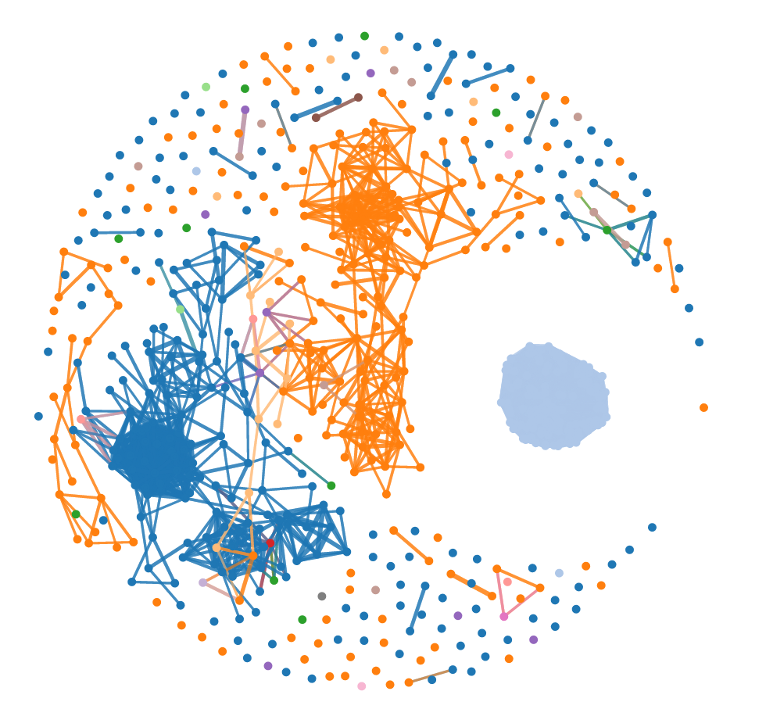

### Power BI

Using Power BI, we visualized the number of IED events by city and by regions.

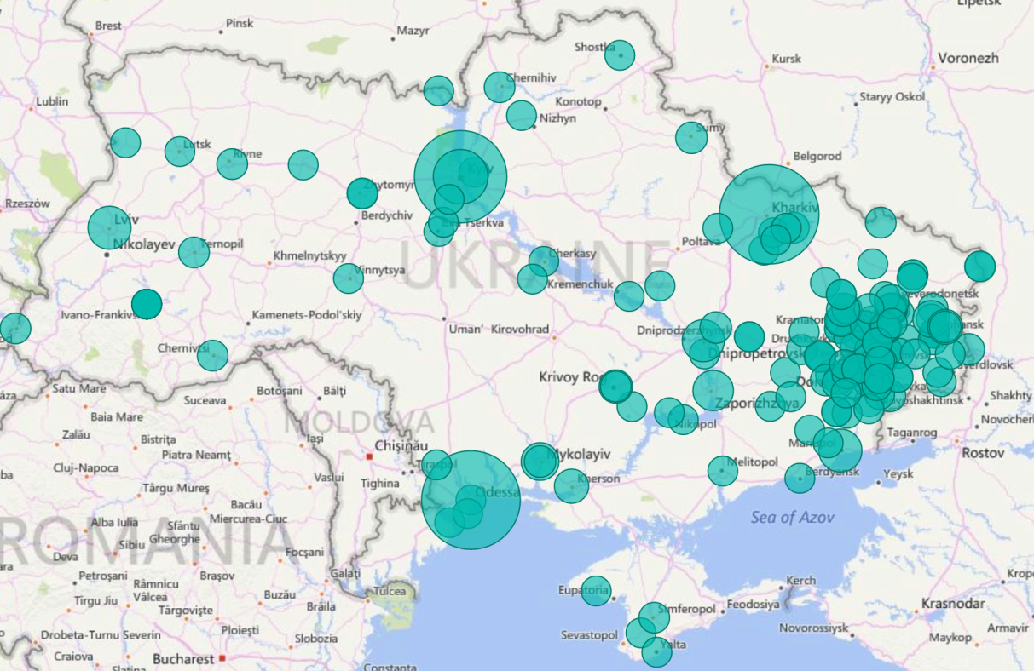

IED events by city

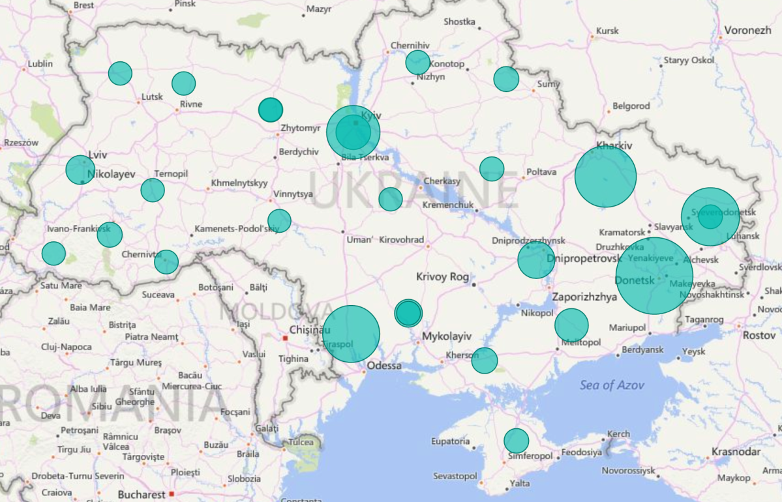

IED events by region

### Other Sources

Directly on the web, we found a Ukraine map showing the percentage of Russian speakers by regions. This should correspond to the data on language that is available in the Ukraine census data.

<http://www.cnn.com/interactive/2014/02/world/ukraine-divided/>

