# Introduction Page

An IED can be almost anything with any type of material and initiator. It is a "homemade" device that is designed to cause death or injury by using explosives alone or in combination with toxic chemicals, biological toxins, or radiological material. IEDs can be produced in varying sizes, functioning methods, containers, and delivery methods. IEDs can utilize commercial or military explosives, homemade explosives, or military ordnance and ordnance components.

They are unique in nature because the IED builder has had to improvise with the materials at hand. Designed to defeat a specific target or type of target, they generally become more difficult to detect and protect against as they become more sophisticated.

<http://www.globalsecurity.org/military/intro/ied.htm>

IEDs can be hidden anywhere: on animals, planted in roads or strapped to a person. They can be detonated via cell phones or trip wires, among other methods. They can be deployed everywhere: in a combat environment or in the middle of a busy city. The adaptability of IEDs to almost any situation makes them difficult to detect.

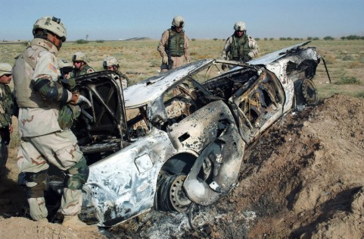IEDs, or Improvised Explosives Devices, are one of the main causes of causalities among troops and exact a heavy toll on local populations.

<https://www.sofmag.com/49000-ieds-in-ukraine-and-counting/>

+ Text on the Ukraine conflict to be added?

# Map Page

Ukraine regions are not equally affected by IED incidents. Incidents were concentrated in three cities: Kiev, Kharkiv and Odessa. There were over 80 incidents in each. However, although there was a much higher number of incidents reported for these cities than for any other city (almost 100), less than 10 persons were killed in those 360 incidents.

Most of the remaining IED incidents are spread in the Donetsk and the Luhansk regions, representing 136 and 92 incidents respectively. These two areas are also the most active regions for IED incidents at the end of 2015.

# Sankey Page

There are many types of reported IEDs. If we take a look at the relationship between the IED types and the number of people who were killed or wounded shows that for most of these victims, the type of IED involved was not reported. Obviously, fake IED did not cause any casualties. On the other hand, Vehicle Based IEDs are the most deadly type, with only 4 incidents killing a total of 12 victims. Radio-Controlled IEDs caused the highest number of wounded persons.

Changing the view to explore the relationship between the IED types and the number of incidents, we see that most unidentified, false and found IEDs did not result in casualties.

# Text Page

Descriptive remarks were logged for each of the reported IED incidents. By comparing the words used in those descriptions, we can discover links between incidents that are described using similar terms. Interestingly, it is found that the IEDs that refer to “Station” or “Metro” are mostly false alarms or of unidentified types.

Indeed, if we switch to the casualties representation, we rapidly notice that only one of those incidents reports wounded victims.

# IED Types

|  |  |
| --- | --- |
| CACHE/FOUND | In some cases, the authorities discovered the IED before it could cause damage. |
| CWIED | A Command-Wire IED uses an electrical firing cable that affords the user complete control over the device right up until the moment of initiation. |
| HOAX/FALSE | Some of the reported incidents turned out to be fake. |
| PROJECTED | Thrown or projected IEDs are used mostly from overhead passes. |
| RCIED | The trigger for a Radio-Controlled IED (RCIED) is controlled by radio link. |
| S-PBIED | Suicide Person-Borne IED usually refers to an individual wearing explosives and detonating them in order to kill others including themselves. |
| TIME DELAY | This type of IED uses a time delay fuse to detonate at a later time. |
| UNKNOWN | For many incidents, the type of IED was not identified |
| VBIED | A Vehicle Borne IED (VBIED) is a device that uses a vehicle as the package or container of the device. |
| VOIED | Victim-Operated IEDs, also known as booby traps, are designed to function upon contact with a victim. Switching methods include tripwire, pressure mats, spring-loaded release, push, pull or tilt. |

# More Material

<http://www.globalsecurity.org/military/intro/ied-vehicle.htm>

