**Machine learning t**

**Abstract:**

**Intro:**

* Introduction paragraph
  + Biologists seek to change
* Explain what hemocytes are and why they matter

An insect’s primary immune response against small viral particles is the use of hemocytes. Hemocytes primary function is to phagocytize or encapsulate any small foreign object within the host’s body. In lepidopteran species like the fall armyworm, multiple uniquely shaped hemocytes are found to aid in immune response (Lavine and Strand, 2002). Hemocyte counting is a vital step in understanding how the immune system of the fall armyworm and other arthropod species react to pathogens. When insects are infected with a pathogen, hemocyte numbers are usually lower than healthier individuals (Smilanich et al., 2018). Additionally, hosts infected with high viral concentrations are expected to have fewer hemocyte counts when compared to healthy or individuals with a low dose.

The current method for counting hemocytes requires manual tallying the presence of hemocytes by hand. This method is very tedious taking up to 60 seconds per image to process counts. Additionally, these methods are not always accurate due to the high potential for user error when counting due to fatigue and the presence of hemocytes out of focus. Programs like ImageJ are commonly used for counting objects in photos (Schneider et al., 2012) However, due to the unique and varied shape of hemocytes, other miscellaneous cells present in samples, and the placement of cells onto hemocytometer grids, ImageJ often struggles to give correct counts. In addition, camera quality and contrast are more likely to skew results and lead to further inaccuracies in counts. Hemocytes clustered together are also often miscounted due to their unusual shape and potential for partial overlap within clusters.

Primary methods for machine learning are often separated based on the complexity of the model and the steps required for detection. Single-stage detectors start by directly feeding image data into a convolutional network to detect the location and classification of the objects. Common single-stage detectors include You Only Look Once (YOLO) and Single Shot Multibox Detector (SSD) (Redmon et al., 2016; Liu et al., 2016). Two-stage detectors add an additional region proposal step during detection before classifying and drawing bounding boxes. Fast R-CNN and Faster R-CNN are both common example of two-stage detectors. Generally, two-stage detectors tend be more accurate at the sacrifice of time and computational resources required while single-stage are faster to train, but less accurate overall.

Deep learning methods have been used in other previous studies to aid in the detection of cells other than hemocytes. For example, many studies have performed analysis of blood smears to aid in the detection of infected white blood cells (Poostchi et al., 2018). However, these studies often aim to detect large objects taking up a majority of the photo. One current struggle with machine learning algorithms is the difficulty in predicting small objects. This is in part due to the limited data for use in training and the low resolution that often occurs due to the objects small size (Nguyen et al., 2020). Additionally, many CNN-based architectures rely on hierarchy feature mapping in predicting objects. While this may work for large and medium sized objects, small objects can easily be lost in the latter layers of these models due to the down sampling required (Liu et al., 2021). Therefore, it is important to consider how to account for the small size of hemocyte cells and compare multiple models including both single-stage and two-stage detectors.

The fall armyworm (*Spodoptera frugiperda*) is a major agricultural pest thought to originate from the tropical environments of Central and South America. The larvae feed primarily on corn, rice, and grasses, but have been known to destroy crops like tobacco and cotton (Wang et al., 2022). In the last 10 years, fall armyworms have spread into Western and Central Africa causing massive agricultural damage to maize plots within the area (Goergan et al, 2016). Fall armyworms thrive in warmer climates, often most active in the late summers in North America (Ali et al., 1990). While pesticides are often used to help cull outbreaks and were successful in the past, development of resistance to common pesticides like carbamates and organophosphates has emerged making it harder to control the populations (Tay et al, 2023). Biocontrol practices like the use of predators, parasitoids, and pathogens have shown to be successful in reducing the number of larvae. Compared to pesticides, biocontrol methods are unique in they can evolve to overcome host resistances themselves, leading to a more long term control option. However, few studies have investigated the use of biocontrol agents to control populations of the fall armyworm (source?).

* Lil summary

**Materials and Methods:**

* Caterpillar rearing and generation stuff

The first generation of fall army worms were purchased from Benzon Research Incorporated (cite?). Caterpillars were reared on a mix of corn-based diet until fourth instars. For the first generation, caterpillars were split into three treatments: 26° C, 31° C, and 34° C. For each treatment, a dose response was initially performed to calculate the lethal dose of virus that 50% of the population dies at (LD50). We isolated and starved 180 caterpillars for 24 hours to ensure consumption of virus. Caterpillars were then transferred to individual cups containing small cubes of diet laced with 3 **μl** virus. The dosage of virus ranged from 100 units of virus to 106 units of virus, increasing by a factor of 10 for each virus treatment. The control tray was dosed with DI water containing no virus to account for aversion to wet diet. We left caterpillars on with the virus (or water) laced cubes for another 24 hours to ensure full consumption of diet. Once the 24 hours had passed, caterpillars were transferred back into individual containers half full of the corn-based diet.

The date of mortality or pupation was recorded for each individual for use in calculating the LD50 for the subsequent generation. Once all caterpillars had pupated or died, individuals infected with virus were processed to collect remaining viral particles. This processed virus was then used to infect the next generation of caterpillars. HOW DID WE CALCULATE VIRUS. DO WE NEED THIS? PROBABLY NOT

For individuals that survived infection and pupated, caterpillars were transferred to cages containing forty to sixty individuals to ensure reproduction. Eggs were collected every 24 hours and labeled as the next subsequent generation. Neonates that emerged from the new generation were isolated into 1 oz cups filled with ½ ounces of diet. Once the neonates grew into fourth instars, they were then starved, and another dose response was performed to calculate the LD50 for that generation. This was repeated ever generation infecting each subsequent generation with virus collected from the previous generation.

* Hemocyte extraction

As per USDA protocol for extracting hemocytes, larvae were initially placed at 4°C for 30 minutes. Once the insects were mostly immobile, they were transferred on ice for extraction. The fourth abdominal prolegs were sterilized with ethanol and then amputated using surgical needles. Hemolymph from the incision was allowed to pool for collection. Two additional caterpillars were bred per treatment and hemolymph from each caterpillar was mixed per treatment. Once hemolymph was extracted, the solution was mixed with a chilled anti-coagulant saline solution in a ratio to insure at least 10 µl of solution were present (usually a ratio of 1 hemolymph: 2 anticoagulants. The solution was then placed on a Hemocytometer for counting under a 40x magnification lens. A (MODEL OF CAMERA) was used to photograph 5 of the 25 squares for estimating the total number of hemocytes. The number of hemocytes present in each of the 5 square was counted and multiplied by WHAT to estimate the total number of hemocytes.

To gather data used in training the model, the same approach was used for collecting and gathering hemolymph. Nine photos were taken on the hemocytometer grid. Additional photos were taken off of the grid if hemocytes exhibited a unique shape or was in a large cluster. Light intake and camera zoom was varied for each set of photos to account for differences when capturing photos. 500 photos were collected taken for use in training and validating the model. Each photo was manually annotated using the program LabelImg (<https://github.com/qaprosoft/labelImg>) to ensure annotation accuracy. Halos of light present around hemocytes were included in boxes to increase the size of detection and give more context to the objects when training. Hemocytes out of focus were not included in the annotations.

* Data augmentation
* Machine learning/use of model?

Two versions of YOLO (YOLOV5 and YOLOV8) were compared to Faster-RCNN model with a resnet152 backbone to determine the most accurate algorithm. YOLO models were allowed to run until no improvement had been made in the past 50 runs. Faster-RCNN models were run until 10000 steps were performed and no significant changes in loss rates were observed. Models were validated during and after training to help avoid overfitting noting recall and mean average precision (mAP). Once been training and validation of models had occurred, detection was performed on a subset of the data. This test data was then compared to the counts performed by hand to estimate the accuracy of our counting models.

**Results:**

Initial comparison of models showed YOLOv8

**Discussion:**

Here we sh

Figs:

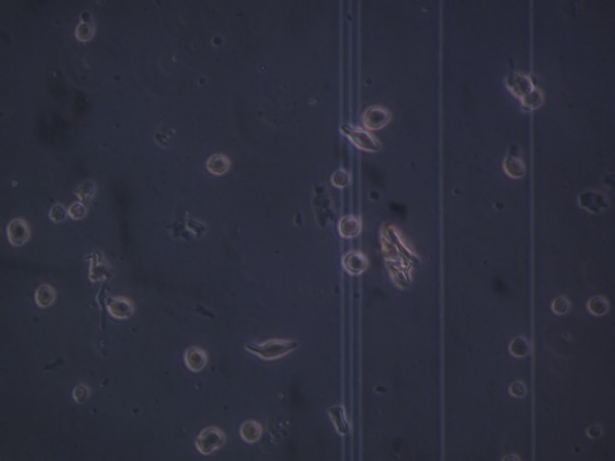

Figure 1. Two examples of hemocytes placed on hemocytometer grids at different levels of brightness and saturation. Uniquely shaped cells can be seen in a. A cluster of hemocytes can be seen in B.

**Figure 2.** The comparison between the hemocyte counts obtained by hand and the hemocyte counts as per Yolo8. The solid line represents a perfect count.

**Table 1.**

|  |  |  |  |  |
| --- | --- | --- | --- | --- |
| Architecture | Map | Map (data Augmentation) | Time to train | Detection time |
| Yolov5 | .973 | .975 |  |  |
| Yolov8 | .983 | .985 |  |  |
| FasterRcnn | .952 (Huh) |  |  |  |
|  |  |  |  |  |

References: