

Program of the
North Sea International Bottom Trawl Survey Q1 2018

Participation

country | ship | dates
Denmark | Dana | 01-Feb –19-Feb
France | Thalassa II | 21 Jan – 12-Feb
Germany | Walther Herwig III | 22-Jan – 23-Feb
Netherlands | R.V. Tridens II | 22-Jan – 23-Feb
Norway | G.O. Sars | 04-Feb – 02-Mar
Scotland | Scotia III | 23-Jan – 12-Feb
Sweden | Dana | 17-jan – 30-Jan

Survey methods
The most recent version of the IBTS Manual is SISP 10 revision nr IX:
http://www.ices.dk/sites/pub/Publication%20Reports/ICES%20Survey%20Protocols%20(SISP)/SISP%2010%20-%20Manual%20for%20the%20International%20Bottom%20Trawl%20Surveys%20-%20Revision%20IX.pdf

The most recent version of the MIK-manual is SISP 13-MIK 3.0:
http://www.ices.dk/sites/pub/Publication%20Reports/ICES%20Survey%20Protocols%20(SISP)/2017/SISP%2013%20MIKeyM-net.pdf

Deviations from manual
- See heading 4, for changes in sampling area.
- See heading 6, for changes in biological samples
- See heading 12, for changes in marine litter
- The Netherlands will be using Simrad net geometry system instead of the Marport.

Allocation of sampling areas

As decided during and shortly after the IBTSWG2017, the allocation of rectangles has changed compared to previous years (and thus differs from the manual). The new allocation map is presented at the end of this document, along with the maps for each individual country.

Each country mentioned in a rectangle executes a single GOV-haul and two MIK-hauls per rectangle. In cases where the abbreviation for a country occurs twice (or in the by country maps is followed by a 2) that country executes two GOV-hauls and four MIK-hauls in that rectangle.

Allocation of sampling locations
Every country is free to choose its fishing position with the rectangles allocated to them. However, to increase the randomisation of sampling, sampling locations are proposed in advance. The proposed locations are based on a random selection from valid tows with start and end position executed in the period 2000-2017 in all quarters by all countries. The random selection for 2018 results in the map below. The exact towing positions will be provided as Excel-file.

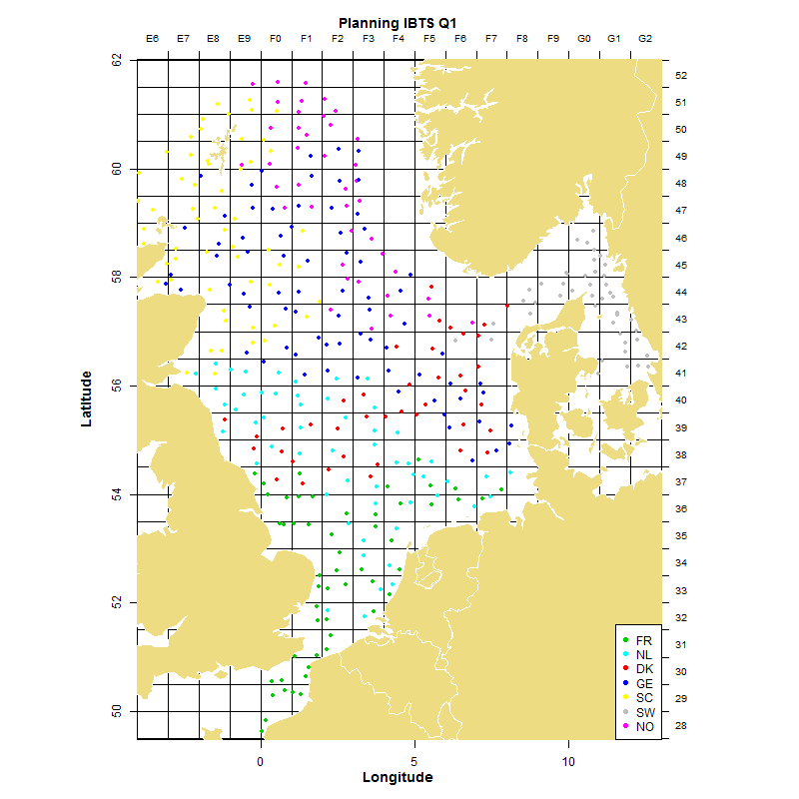

Biological samples
Biological samples should be collected of the target species as described in the manual.

In addition biological information on several other fish species can be collected. There is no formal request and every country can decide by itself which (if any) additional samples need to be collected. Unless someone has a specific request to organize a North Sea wide collection.

It is advised by IBTSWG 2015 to change the otolith sampling scheme in the latest manual. Analysis to show the validity of this change were executed in IBTSWG 2016, however the available data was not sufficient to actually support the validity. Therefore, it is requested to collect the otoliths in each tow, following the scheme below rather than by round-fish area.

For Whiting and Haddock the advice is to collect 2 otoliths per each 5 cm length class per haul for the length ranges 11-15, 16-20, 21-25, 26-30 cm, and to collect 2 otoliths per each 1 cm length class above 30 cm.

For Norway Pout the advice is to collect 2 otoliths per each 5 cm length class per haul for the length ranges 5-10 and 11-15 cm, and 2 otoliths per cm length class above 15 cm.

If capacity allows it feel free to collect additional otoliths, especially from larger specimens.

Communication at sea
The Netherlands, Ralf van Hal at IMARES or on board of the RV Tridens II will be the Q1 coordinator. To ensure coverage of the whole survey area as complete as possible, all vessels are urgently requested to report their fishing activities regularly to him. In case of any issues communicate directly to Ralf and the vessel most likely able to assist you. If help can be offered there is no need to get a confirmation from the Q1 coordinator. Rather explain (and possibly apologise) your decision afterward than taking no action.

A list on how to contact all vessels is given in section 12.

Exchange of data during the survey

All participants are asked to update on a regular basis (as often as possible) the preliminary catch data sheet during the survey. The most important part is to update the rectangles in which GOV and/or MIK with MIKeyM hauls are done. The catch data is of less importance as is the information on the number of larvae. The priority information enables other vessel to propose rectangle swaps or help in coverage.

The xls-sheet is placed in the cloud:
https://1drv.ms/x/s!AqMHFCPS2BkIgXOR67DmbhSICqhb

The sheet can be edited online. Each country has its own input sheet. If the format below is followed, adding the data should be easy. Preferably the GOV and MIK data are entered separately. However, they can be in one row.

The Q1-coordinator will check the data on a regular basis and will refresh the various pivot tables.
In case contact with the cloud fails or costs too much effort, the data can be sent by email to the coordinator. The coordinator will distribute the Excel-file to people unable to look at the cloud on a regular basis.

Data to be exchanged for each fish haul are:
Ship, haul number, ICES rectangle code, and the number per hour of:

Herring < 20 cm
Cod < 25 cm
Haddock < 20 cm
Whiting < 20 cm
Norway pout < 15 cm
Sprat < 10 cm
Mackerel < 25 cm

Please use the following template in your data-exchange (make sure you fill in the zero catches as well):

ship | haul | rect | herr | cod | had | whi | Npout | sprat | mack | MIK | MIKeyM
TRI | 1 | 33F4 | 1194 | 12 | 0 | 34 | 0 | 140 | 0 | 1 | 2
TRI | 2 | 34F4 | 236 | 2 | 0 | 2 | 0 | 332 | 0 | 1
TRI | 3 | 37F6 | 858 | 2 | 0 | 26 | 0 | 134 | 0
… | … | … | … | … | … | … | … | … | …

This is the easiest way to insert the data into the xls document in the cloud.

Data to be exchanged for each MIK haul are:
For the MIK data report:

Ship; haul number; ICES rectangle code and if possible the number of herring larvae caught in n/m².

ship | hauls | rect | Herring larvae

Exchange of data after the survey

The Excel-file in the cloud should be updated at the end of the survey to ensure all the data is available. The Excel sheet will be used to report on at IBTSWG 2018.

GOV-data (length data and ALK's) on herring and sprat should be submitted to ICES as soon as possible after your survey, but the deadline is set on March 5th, to enable the datacenter and secretariat to prepare the data for the HAWG-meeting (currently planned to start on 12 March 2018).

One should upload the data through DATRAS, use the latest DATRAS exchange format, and check the data with the checking program you will find at the DATRAS website.

The Final GOV results should be submitted to ICES before March 15th, to enable the datacenter and secretariat to prepare the data for the IBTSWG 2018 (planned to start on March 19th).

MIK-data should be sent to Matthias Kloppmann, before March 5th, also to enable preparing the data for the HAWG-meeting (currently planned to start on 12 March 2018).

Hydrographic data and litter data should be submitted to ICES separately from the fish data before April 16.

Summary of data to be exchanged
type of data | contact | address | deadline
Preliminary catch data of young target species and number of MIK hauls | Ralf van Hal | Ralf.vanHal@wur.nl | Regularly during survey
Exchange file with preliminary length data and ALK’s on herring and sprat | Vaishav Soni | vaishav@ices.dk | 5 March
Preliminary MIK data (at least for herring, but all other larvae data are welcome) | Matthias Kloppmann | matthias.kloppmann@thuenen.de | 5 March
Final results GOV catches | Vaishav Soni | vaishav@ices.dk | 15 March
Hydrographical data | ICES | ocean@ices.dk | 16 April
Litter | ICES | vaishav@ices.dk | 16 April

IBTSWG, deadline for cruise summary

The IBTSWG will take place from 19 till 23 March in Oranmore, Ireland. A week before the meeting all the data from the survey should be submitted to specified location or person.

March 14th a summary of the Q1 survey by country should be submitted to the Q1 coordinator Ralf van Hal. The summary should follow the guidelines used in the report of the 2016 IBTSWG. It should minimally contain the number of GOV and MIK hauls, number of biological samples collected and a map of the sampling locations.

If relevant all other samples, e.g. stomachs, litter etc, should be reported as well. Preferably a separate csv-file containing the coordinates of the sampling locations of the MIK should be submitted, enabling the creation of a combined survey map prior to the meeting of the IBTSWG.

Special requests

- Continuation of the fish egg collection: WGEGGS2 has requested that all participating countries continue the collection of egg samples with a small mesh net attached to the ring of the MIK-net (also called ‘MIKeyM’ net). As far as known, none of the countries made an objection against this request.
- Collecting litter data from the MIK-samples, guidelines by Bastian Huwer.
- Sepiolidae collection (same as past years) – Some countries (Norway) are still being asked to collect samples for Naturalis.
- Deployment and retrieval time: See IBTSWG2017-report (page 132). A protocol template spreadsheet will be provided.
- Zero-minute trawls: explanation in IBTSWG2017-report and method described in Kingsley (2001) and Battaglia et al. (2006). Preferably multiple zero-minute trawls on the same location.

Marine litter
All litter items need to be counted, thus not only registering the presence of a litter subcategory but also counting the number of items in that category.
The categorization has changed compared to the manual, and the latest version is shown below (in the ICES litter database this is LTREF=C-TS-rev). The old categorization can still be used, but be aware of that, when submitting the data.

A: Plastic | B: Metals |  | Related size category
A1. Bottle | B1. Cans (food) |  | A: <5*5 cm= 25 cm²
A2. Sheet | B2. Cans (beverage) |  | B: <10*10 cm= 100 cm²
A3. Bag | B3. Fishing related |  | C: <20*20 cm= 400 cm²
A4. Caps/ lids | B4. Drums |  | D: <50*50 cm= 2500 cm²
A5. Fishing line (monofilament) | B5. appliances |  | E: <100*100 cm= 10000 cm²= 1 m²
A6. Fishing line (entangled) | B6. car parts |  | F: >100*100 cm = 10000 cm2= 1 m2
A7. Synthetic rope | B7. cables
A8. Fishing net | B8. other
A9. Cable ties
A10. Strapping band
A11. crates and containers
A12. diapers
A13. sanitary towel/tampon
A14. other
C: Rubber | D: Glass/ Ceramics | E: Natural products | F: Miscellaneous
C1. Boots | D1. Jar | E1. Wood (processed) | F1. Clothing/ rags
C2. Balloons | D2. Bottle | E2. Rope | F2. Shoes
C3. bobbins (fishing) | D3. piece | E3. Paper/ cardboard | F3. other
C4. tyre | D4. other | E4. pallets
C5. Glove |  | E5. other
C6. other

Contacts with research vessels and laboratories

Denmark:
Dana (OXBH) Iridium phone: + 88 16 314 50 453
Inmarsat B phone: + 871 32 19 384 20
fax: + 871 32 19 384 23
e-mail kw@aqua.dtu.dk
hr@aqua.dtu.dk
Hirtshals Lab phone: + 45 35 88 33 00
fax: + 45 35 88 32 60

France:
Thalassa (FNPF) GSM N° Standard +33 6 07 32 44 87
Fax Standard +33 6 19 49 72 78
e-mail : yves.verin@thalassa.ifremer.fr

Boulogne Lab phone : + 33 3 21 99 56 00
fax: + 33 3 21 99 56 01

Germany:
Walther Herwig III (DBFR): Inmarsat phone: + 870 773236187
mobile: + 49 171 5327587
fax: + 870 783209565
VOIP telephone: +1 904 414 8670 0

e-mail: matthias.kloppmann@thuenen.de (primary address) wherwig.fahrtleiter@fischereiforschung.eu

Hamburg Lab phone: + 49 40 38905 178
fax + 49 40 38905 263

Netherlands:
Tridens (PBVO) phone: + 31 20 717 88 25
e-mail: ralf.vanhal@wur.nl

IJmuiden Lab phone: + 31 317 480 900
fax: + 31 317 487 326

Norway:
G.O. Sars phone: + 47 55 90 64 40
email: erik.olsen@imr.no (04.02.-15.02.)
rupert@imr.no (16.02.-02.03.)

Bergen Lab phone: + 47 90 25 92 01
fax: + 47 55 238 531

Scotland:
Scotia (GOWS) cellular phone: + 44 7775 835 096
fax: + 44 7921 249 323
satellite phone: + 870 764 596 084
fax: + 870 764 596 086
e-mail Part 1 dreweryj@marlab.ac.uk
Jim.Drewery@gov.scot

Aberdeen Lab phone: + 44 131 24 42897

Sweden:
e-mail joakim.hjelm@slu.se
e-mail barbara.bland@slu.se
Lysekil Lab phone: + 46 10 478 4064 (J.Hjelm)
phone: +46 10 478 4013 (B Bland)

International Bottom Trawl Survey 2018- Q1
the first country mentioned in each rectangle, has first responsibility for sampling
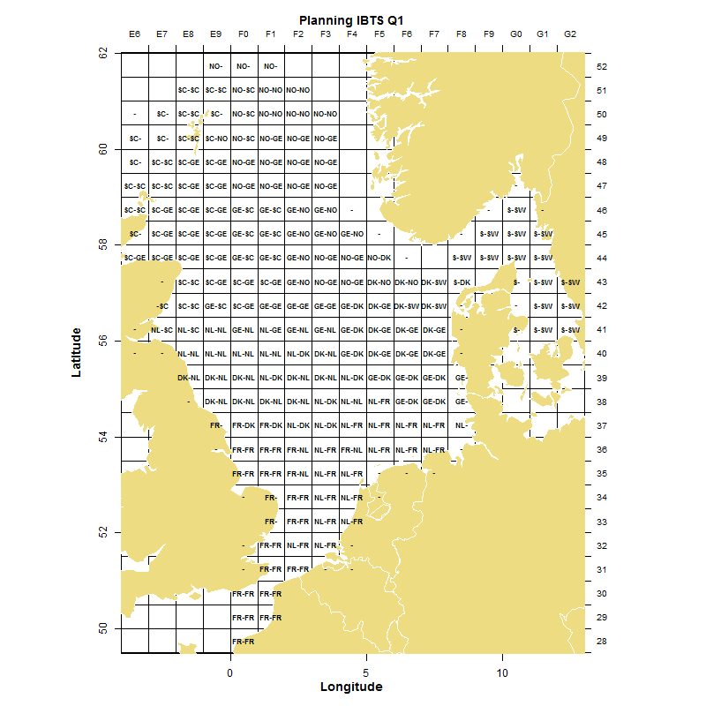
SC=Scotland, GE= Germany, NO= Norway, DK= Denmark, FR= France, NL= The Netherlands, S & SW=Sweden.

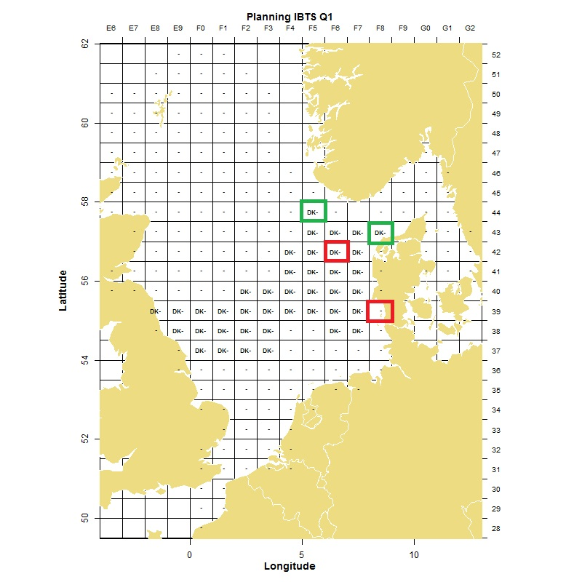
DK= Denmark: Green squares additional tow compared to 2017, red square reduction in number of tows.
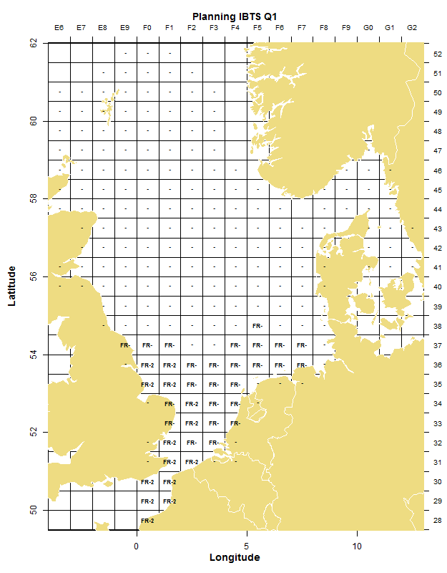 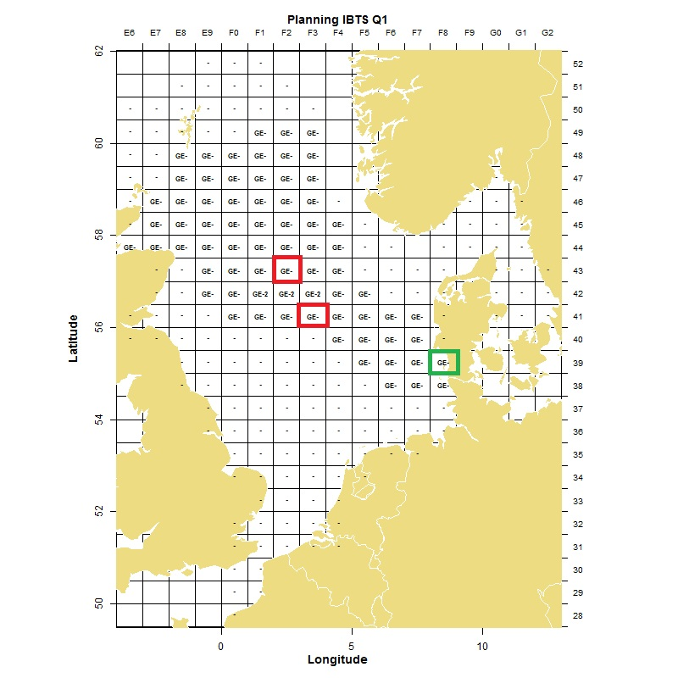GE= Germany: Green squares additional tow compared to 2017, red square reduction in number of tows.
