**Simple Calculator**

**Requisites:**

* Eclipse Oxygen IDE/STS
* Java 1.6+

**Description:**

As an user, I will be entering two numbers as asked with an operation like add/subtract to perform on them. The desired operation should be performed and displayed.

**Demo/Output:**

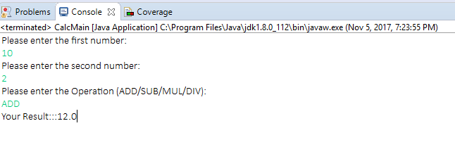

Project Implementation Description:

There is a main() (CalcMain.java) written to accept user’s inputs which are the following:

* First Number
* Second Number
* Type of Operation

There is a POJO class (InputVO.java) written which have the below attributes:

* firstNumber (double)
* secondNumber (double)

At service layer, lies the implementation class which accepts all the above and perform operation based on SWITCH statement – DoCalculations.java

Junits:

I have written functional junits using junit 4 and also code coverage junits using power Mockito. Please refer to below classes:

* TestDoMath.java
* DoMathTest.java

Pending Task – Trying to write junits for the main function.

Junit Screenshots:

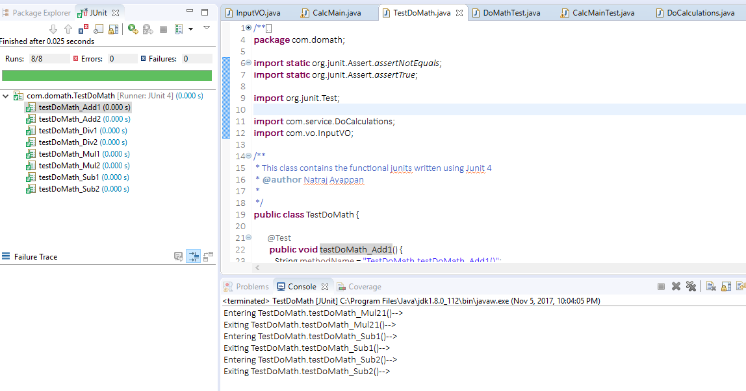

Code Coverage:

