**BuzzGuardian**

**Emergency message delivery system for Georgia Tech students**

Nataraj Mocherla (nmocherla3)

Sandeep Manchem (smanchem3)

**Motivation and Objectives**

**Safety is of great importance to Georgia Tech students**, especially the ones who work late at night and have to head home through some unsafe (as measured by greater number of crime incidents over time [6]) areas like HomePark. In case there is an emergency, there alarm buttons installed on posts [Fig.1] at certain areas near the campus to send emergency messages to Georgia Tech/Atlanta police.

Figure 1 : Georgia Tech Emergency Posts

However, these posts are not really useful when the student is not in the vicinity of one of them. To solve this problem, we propose the idea of a **portable emergency button to be worn by the student at all times**. If you happen to encounter a robber, most likely you will be robbed of your mobile phone as well. So it might take a lot of time for you to find another phone to call the police. You cannot obviously call the police using your smart phone while you are being robbed or just before being robbed as you don’t have enough time. If you have a panic button on yourself, such as around your arm or neck, it can be pressed to send an SMS message to the police including your location details. This would definitely bring the police to your help way sooner to be able to assist you in case of a medical emergency and probably even go after the robbers. We propose to create a wearable panic button using Arduino microcontroller, which could be worn as a wristband which we shall call as a Personal Security Bracelet from here on.

**System Components**

The system shall consist of the following components

1. **Wearable Personal Security Bracelet** (PSB) [Fig.2] built using an Arduino Microcontroller [7] with Bluetooth module [8].
2. Android Mobile Service which listens to signals from the PSB via Bluetooth
3. Backend servers to process the incoming panic messages and routing them to the police (Gatech or Atlanta police depending on location of crime scene)
4. Web based visualization of data for Police.

Figure 2 : Wearable Personal Security Bracelet

**Proposed System Architecture and Operation**

Our system will have the following operation scheme [Fig.3]

1. We propose a simple mechanism of operation. **Single press of button would send an emergency signal**. Double press would cancel the previous signal sent in case the single press was accidental. We propose a window of 30 seconds after which the backend processes the emergency request.
2. Button press translates to Bluetooth signal which is transmitted to the user’s mobile phone on which the BuzzGuardian service is constantly running which receives and processes the signal.
3. The BuzzGuardian mobile service is responsible for **determining the location of the device using GPS, WIFI, Cell-Tower** or a combination of any of these.
4. The BuzzGuardian mobile service then sends an SMS to a Google Voice number dedicated for receiving these emergency messages.
5. The BuzzGuardian backend uses Google Voice API to process the received panic SMS messages and **routes them to appropriate police agency (Gatech Police or Atlanta police) depending on location of crime scene.**
6. The mobile service **continues to send location updates (tracking)** to the police. This serves two purposes. In case the **mobile phone is stolen** by the assailant, it would help in tracking him down. In the case that the victim is moving in a certain direction and requires medical assistance, the continuous location tracking lets the police to **reach his precise location as quickly as possible.**
7. The web based user interface for the police enables them to easily visualize the location of crime and subsequent tracking of victim/assailant.

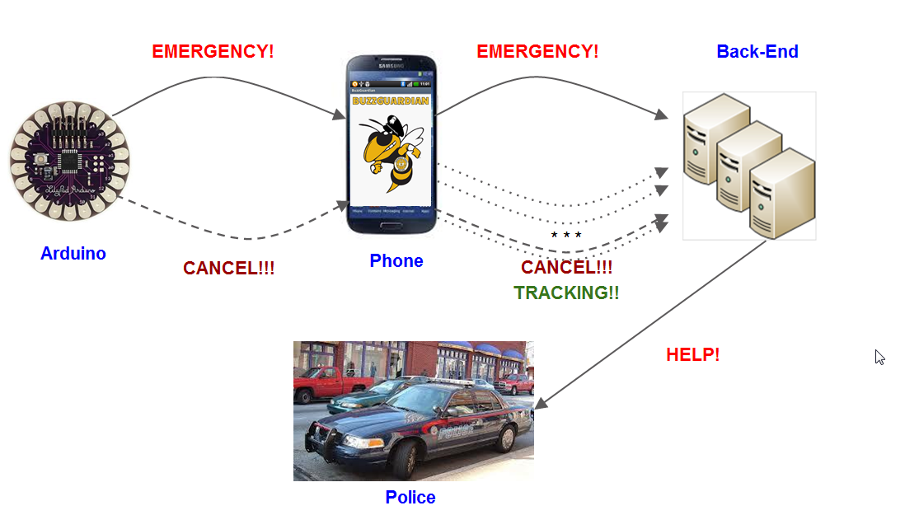

Figure 3 : Basic System Architecture

The Personal Security Bracelet and its Bluetooth module will be programmed using the Arduino SDE Toolkit. The mobile service will be, at this point of time implemented only on Android phones. The backend processing servers will be written in either Java or Ruby on Rails.

Figure 4 : Visualization of crime location and subsequent tracking

Figure 4 : Visualization showing location of crime and subsequent tracking

Crime location tracking visualization will be provided to the police through a web interface [Fig.4]. The data for the visualization will be provided by a web service in the backend server.

**Benefits of System**

1. Having panic button on a bracelet around the arm lets user to **quickly signal for emergency.**
2. This button based approach is superior to a mobile application because in case of emergency, there is **not enough time** (especially in the case of a mugging) to remove mobile phone from pocket, unlock it and then send the emergency signal.
3. **Continuous location updates** sent after initial panic message lets police track down the assailant or help the victim faster.
4. User can **cancel accidental messages** sent via the emergency button.
5. Most students **normally carry smartphones** with them which have Bluetooth capabilities which we are utilizing to create this emergency system. The only cost that the student has to pay is for the Personal Security Bracelet.

**Related Work**

There are two main categories of solutions that are already available in the market in the area of emergency applications.

1. Emergency Mobile Applications
2. Panic Buttons

There are emergency mobile applications like the “In Case of Crisis” [1] and [2] which let the user set up specific lists of emergency contacts for specific scenarios and enables the user to send them emergency messages. The problem with this approach is the time it takes for someone to reach for the mobile phone which makes it useless in case of incidents like mugging.

There are systems like Alert 1 [3] which is a **PERS (Personal Emergency Response System)** designed for elderly people in case of medical emergencies. This system is quite expensive since it requires monthly plans. Also, the technology is designed for home use only since it requires to be connected to a base station. Other systems like the Geoskeeper Personal Cellular Security Communication Bracelet [4] solve some of the issues of Alert 1. The Geoskeeper tries to go beyond traditional PERS systems. Geoskeeper can be used anywhere and it doesn’t require a monthly service. It also has the advantage of being fully self-contained. But it is also quite expensive, priced at $299, and it is bulky and it doesn’t look fashionable either. Another interesting related technology is the Up [5] by Jawbone. Up is a lightweight bracelet for life tracking functionality that connects to iPhone smart phones. It tracks statistics such as number of steps taken during the day and which time the person fell asleep. This device looks very comfortable, fashionable and lightweight. It’s price is more reasonable than the previous technologies surveyed, $129.99, but the price is still not that affordable. This still a luxury item. It’s biggest downfall, however, is that it doesn’t provide any PERS functionality at all.

**Work Division**

We will follow an equal distribution of workload and divide up the project components as follows

|  |  |
| --- | --- |
| **Module** | **Members** |
| Arduino Module | Nataraj (nmocherla3) and Sandeep (smanchem3) |
| Android Service | Nataraj (nmocherla3) |
| Backend Module | Sandeep (smanchem3) |
| Visualization Module | Sandeep (smanchem3) and Nataraj (nmocherla3) |

**Planned Schedule**



Figure 5 : Schedule of work. Each unit represents 1 week.

**Forseen Risks**

1. There are many components in the system ranging from the Arduino device to the backend engine which processes incoming emergency SMS via Google Voice API. There is a considerable risk in making all these components **work in synchronization.**
2. This system needs hard **real time system guarantees** as it an emergency application. It must work correctly and on time for sending, receiving, processing and dispatching emergency messages.
3. Bluetooth modules in some mobile phone sets are **not robust** and our mobile service must be able to handle these issues.
4. Total size of the Arduino controller + Bluetooth module must not be too large so that it can be integrated into a bracelet.

**Future Work**

Work with the Georgia Tech police department to start **production of Personal Security Bracelets on scale** which can be made available to the students at **low/reasonable costs**. Another possible extension of the work is to store and learn from the data gathered from this system to **generate safe routes** which can then be used by students.

**Deliverables**

1. Demo of the whole system
2. Project source code
3. Final Report

**References**

[1] Georgia Tech – In Case of Crisis application. Retrieved 19 Sep 2013 from <https://play.google.com/store/apps/details?id=com.iba.incaseofaca>

[2] Emergency Panic Button for Android. Retrieved 19 Sep 2013 from <https://play.google.com/store/apps/details?id=com.incorporateapps.emergency&hl=en>

[3] Alert1 : Medical Alert Systems . Retrieved 18 Sep 2013 from <http://www.alert-1.com/>

[4] Geoskeeper Personal Cellular Security Communication Bracelet. Retrieved 18 Sep 2013 from <http://www.locationbasedgps.com/geoskeeper-personal-cellular-security-communication-bracelet/>

[5] Jawbone Wristband. Retrieved 19 Sep 2013 from <https://jawbone.com/up>

[6] Crime Alerts from Georgia Tech Police. Retrieved 20 Sep 2013 from <http://police.gatech.edu/crimeinfo/crimealerts/>

[7] Arduino. Retrieved 19 Sep 2013 from <http://www.arduino.cc/>

[8] Arduino Bluetooth Module. Retrieved 19 Sep 2013 from <http://arduino.cc/en/Guide/ArduinoBT>