Sensation & Perception: Crash Course Psychology #5
Available at https://youtu.be/unWnZvXJH2o or just youtube/google “Crash Course Psychology 5”

- Sensation is the _______________________ by which our senses, like vision, hearing and smell, ______________________________________________________________.
- Perception is the _______________________ way our brains organize and interpret that information and _________________________________________.
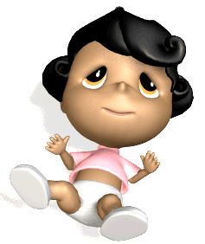
- The Absolute Threshold of sensation is the _________________________ needed to register a particular stimulus 50% of the time.
- Signal Detection Theory is a model for predicting how and when a person
will detect weak stimuli, partly based on context. What example does Hank
Green give to demonstrate this concept?
- What’s a time in your life where you’ve experienced sensory adaptation?
- While discussing Difference Threshold, what does Hank Green mean when he says that we perceive differences on a “logarithmic, not linear scale”?
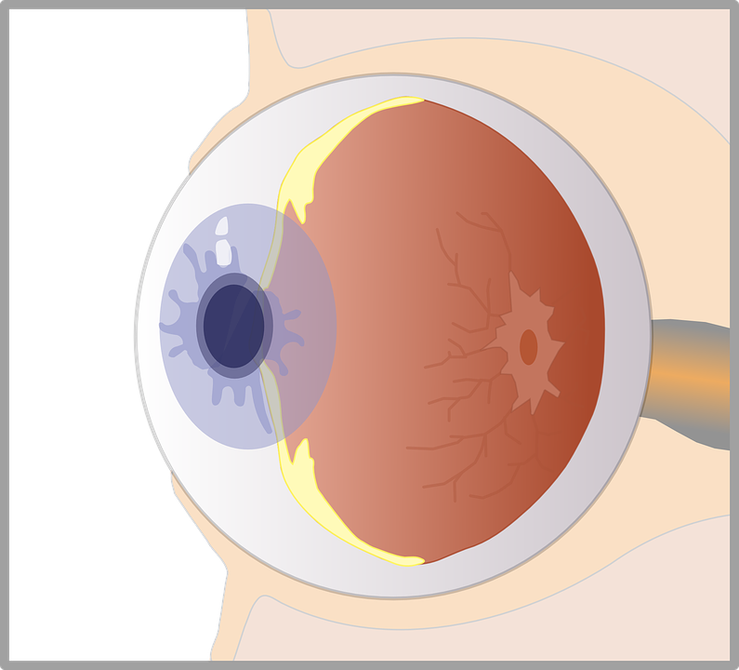
- For light rays, short wavelengths = ______ colors and long wavelengths = ______ colors.
For light rays, great amplitude = ______ colors and small amplitude = ______ colors.
- On the eye diagram to the right, label the following
structures:
- cornea
- pupil
- lens
- retina
- fovea (shown at the 8:06 mark)
- optic nerve (shown at 8:18)
- How does the Trichromatic Color Vision Theory differ from the Opponent-Process Color Vision Theory?
- What example does Hank Green give to demonstrate feature detectors and parallel processing?

Psychology Crash Course Answer Keys

Psychology Crash Course 5 – Sensation & Perception
- The bottom-up process by which our senses, like vision, hearing, and smell, receive and relay outside information
- The top-down way our brains organize and interpret that information and put it into context
- Minimum stimulation
- Parents may notice their baby’s tiny whimper but not notice the passing of a train
- Answers will vary
- The difference between being able to notice two things is based on a % difference rather than an absolute difference
- Short is blue and long is red; great is bright and small is dull
- 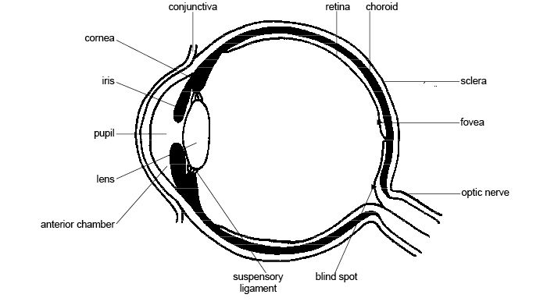
- For trichromatic, color cones of red, green, and blue activate to see all the different shades of color; in the opponent-process theory, receptor cells are stimulated by certain colors and inhibited by others
- Your brain detects the features of a clown chasing you and does so all at the same time

