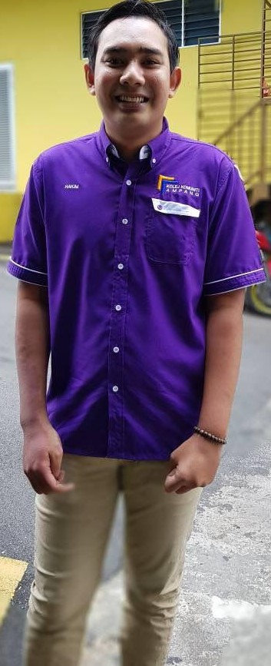

Excellent communication,interpersonal and observational

     

Ability to work with advanced tools and equiment

    

In seek of a challenging position that enable me to utilize my skill. Practice my knowledge and contribute towards organizational excellent that in return enriches me in personal and professional progression.

### Work Experience

2015-10 – **Junior** **Technician**

2016-09 *Intel Pulau Pinang*

**Responsibilities :**

* Handled machine operation and maintenance.

### Education

**Diploma**

Diploma In Mobile Technology 2018 Ampang Community Collage

**Certificate**

Certificate in Electrical Installation Bandar Darulaman Community Collage (CGPA 3.3)

**Certificate**

Sijil Pelajaran Malaysia 2013 Sek. Men. Kebangsaan Tengku Abdul Malik

### Skill

**Language Spoken Written**

* English Fair Fair
* Malay Good Good

**Competent in :**

* Mobile device repairing
* App developer
* Software programming
* Electronic maintenance

**Computer Skill :**

* Microsoft Word 7/10
* Microsoft Exel 7/10
* Microsoft Power Point 7/10
* Adobe Photoshop 7/10

**Other**

Wiring Installation

Installation CCTV

### Achievement

**Description Date achieved**

Pertadingan : Pendawaian Litar Elektrik Disember 2014

Seminar Jutawan Siswa December 2014

Building Wiring Installation(BWI) Tahap 1 Mei 2015

### References

**Name Designation Contact No**

Nur Ariana Binti Abu Bakar Lecturer 013-278 6760

En Mohd Faisal Bin Ishak Lecturer 012-626 0202

Skills

Address

1137 Taman Aman

Anak Bukit

06550 Alor Setar

Kedah

Phone

0175631077

E-mail

[hakimnorizal96@gmail.com](mailto:hakimnorizal96@gmail.com)

Date of birth

1996-08-14

Personal Info

Mohd Hakim Bin Norizal