# Curriculum Vitae

|  |  |
| --- | --- |
| Nabila Tsurayya Silmi | Perumahan ITS BLOK U Jl. Teknik Komputer 2/61 Surabaya |
| Kediri, 10 Mei 1994 | 085655353477 |

## Riwayat Pendidikan

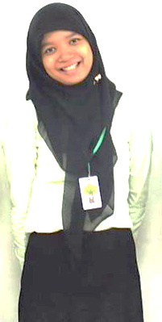

|  |  |
| --- | --- |
| SD Integral Luqman Al-Hakim Surabaya  2000 – 2006  SMPN 19 Surabaya  2006 – 2009 | SMAN 15 Surabaya  2009 – 2012  Jurusan Teknik Informatika, Fakultas Teknologi Informasi, ITS  2012 - sekarang |

## Riwayat Pelatihan

|  |  |
| --- | --- |
| LKMM Pra TD FTIf  2012  LKMM TD XIX HMTC  2013 | PP LKMM VI FTIf  2013  SCS (Social development Community School)  2014 |

## Riwayat Organisasi

|  |  |
| --- | --- |
| Sie Kerohanian Islam SMAN 15 SBY  2011 - 2012  Staff Kaderisasi Keluarga Muslim Informatika  2013 - sekarang | Staff Departemen HUBLU HMTC Bersahabat  2013 - sekarang  Staff Badan Koordinasi Pemandu BEM FTIf  2013 - sekarang |