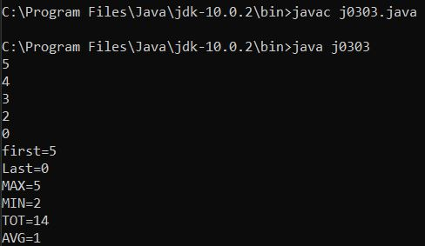

**5.1**

import java.io.*;

class J0303

{

public static void main(String args[]) throws java.io.IOException

{

BufferedReader stdin = new BufferedReader(new InputStreamReader(System.in));

String buf; int i =0;

String c[] = new String[5];

do {

buf = stdin.readLine();

c[i++] = buf;

} while (!buf.equals("0"));

int max=0;int min=999;

int tot=0;int avg=0;

for(int j=0;j<4;j++)

{

System.out.println(c[j]);

if(max<Integer.parseInt(c[j])) max=Integer.parseInt(c[j]);

if(min>Integer.parseInt(c[j])) min=Integer.parseInt(c[j]);

tot += (Integer.parseInt(c[j]));

avg = tot/(c.length-1);

}

System.out.println("MAX="+max);

System.out.println("MIN="+min);

System.out.println("TOT="+tot);

System.out.println("AVG="+avg);

}

}

**5.2**

import java.io.*;

class j0303

{

static int max=0;

static int min=999;

static int tot=0;

static int avg=0;

public static void main(String args[]) throws java.io.IOException

{

String c[] = new String[10];

sub1(c);

sub2(c);

sub3(c);

}

static void sub1(String c[])throws java.io.IOException {

BufferedReader stdin = new BufferedReader(new InputStreamReader(System.in));

String buf;int i =0;

do {

buf = stdin.readLine();

// System.out.println("Last="+buf);

c[i++] = buf;

} while (!buf.equals("0"));

System.out.println("first="+"5");

System.out.println("Last="+buf);

}

static void sub2(String c[])throws java.io.IOException {

for(int j=0;j<4;j++){

//System.out.println(c[j]);

if(max<Integer.parseInt(c[j])) max=Integer.parseInt(c[j]);

if(min>Integer.parseInt(c[j])) min=Integer.parseInt(c[j]);

tot += (Integer.parseInt(c[j]));

avg = tot/(c.length-1);

}

}

static void sub3(String c[])throws java.io. IOException

{

System.out.println("MAX="+max);

System.out.println("MIN="+min);

System.out.println("TOT="+tot);

System.out.println("AVG="+avg);

}

}