B_1 = IZZY Triangle bikini top 1200



**DESCRIPTION**The plunging neckline reveals a nice lacing in this triangle with removable pads. Let the summer begin!

**CONTENT & CARE**      
Back links Your swimsuit is precious, take care! Rinse it with cold water after each use. Hand wash with Marseille soap, or machine wash on gentle cycle.

B_2 = BORNEO Triangle bikini top 1200



**DESCRIPTION**The essential of your beach holiday is here, this bandeau will sublimate all necklines, and can be worn with or without straps.

**CONTENT & CARE**      
Back links Your swimsuit is precious, take care! Rinse it with cold water after each use. Hand wash with Marseille soap, or machine wash on gentle cycle.

B_3 = BLUEBAY Triangle bikini top 1200



**DESCRIPTION**The plunging neckline reveals a nice lacing in this triangle with removable pads. Let the summer begin!

**CONTENT & CARE**      
Back links Your swimsuit is precious, take care! Rinse it with cold water after each use. Hand wash with Marseille soap, or machine wash on gentle cycle.

B_4 = SOLAIRE Light padded bikini top 1200

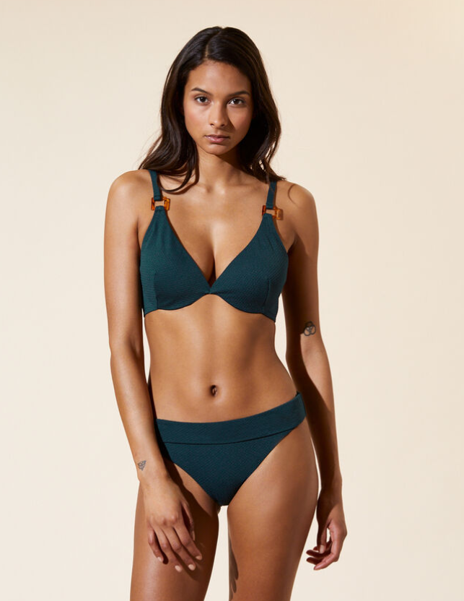

**DESCRIPTION**Elegance on the beach ... Soft cups and underwire, the ideal shape for D to E cups because it provides support and a nice neckline.

**CONTENT & CARE**      
Back links Your swimsuit is precious, take care! Rinse it with cold water after each use. Hand wash with Marseille soap, or machine wash on gentle cycle.

B_5 = EDDY Triangle bikini top, removable pads 1200



**DESCRIPTION**The plunging neckline reveals a nice lacing in this triangle with removable pads. Let the summer begin!

**CONTENT & CARE**      
Back links Your swimsuit is precious, take care! Rinse it with cold water after each use. Hand wash with Marseille soap, or machine wash on gentle cycle.