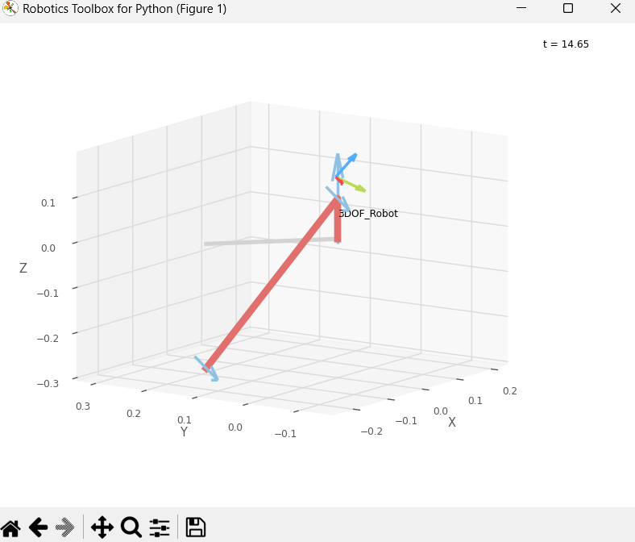

test case q is [2.3583025606236205, 1.0313739175293895, 3.0744794095723083]

my function flag is 1

robotics toolbox flag is 1

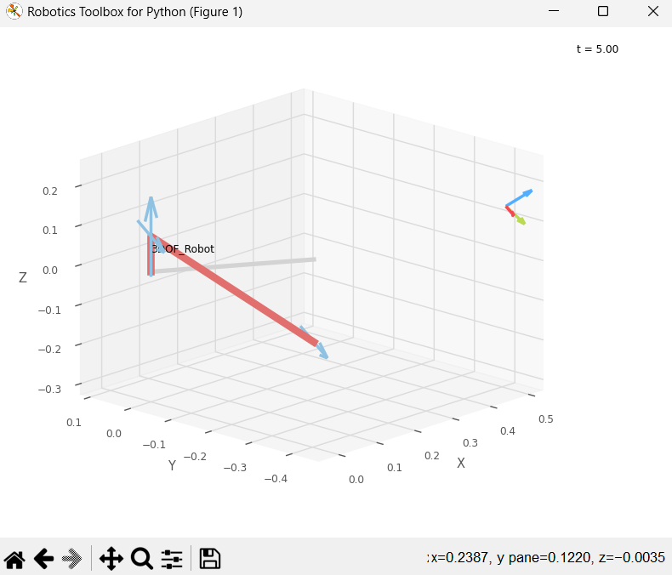

test case q is [2.5720901579093858, 2.36576728403569, 1.4015132164329407]

my function flag is 0

robotics toolbox flag is 0

