15 Puzzle
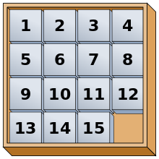
Time limit: 1 sec
15 Puzzle is a sliding puzzle where there are 15 tiles, numbered 1 to 15, lying in a frame of size 4 x 4 tiles. The frame has an empty space of 1 tile size. The goal of the puzzle is to slide the tiles until they are arranged as the figure on the right. (The figure is from Wikipedia.) In the figure, the empty space is at the lower right corner of the frame.
In this problem, you are given a starting frame with 15 tile and have to calculate the minimum number of sliding moves that get the starting frame to the required frame. We define one move as a slide of one tile to a nearby empty space.

Input
- There are four lines of input. Each line represents each row of tiles in the frame, starting from the topmost row to the bottom row.
  - In each line, there are four integer from 0 to 15. The number represent each tile where number 0 indicates the empty space.

Output
The output must contain exactly one line containing the minimal number of step to solve the given puzzle.

Example
Input | Output
1 2 3 4  5 6 7 8  9 10 11 0  13 14 15 12 | 1

