Tiling
Time limit: 1 sec
This story is not true.
Ettan is a lecturer in an unnamed university. Office of Ettan has a very old ceiling that cannot protect his office from a heavy rain. In rainy season, his office is always flooded. such that during this rainy season, it is always flooded. In trying to renovate his office, Ettan bought several ceramic tiles of strange shape. All tiles have the same dimension; it is three unit square bricks of same size bound together forming a wedge shape as shown in the following figure. The office is also a square of size where . However, as brainless as usual, Ettan cannot manage to tile his room using these tiles.

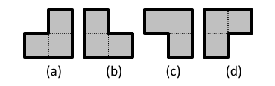

Luckily, as Ettan is a lecturer in an algorithm class, he disguises his problem as an assignment for his student. The student has to write a program to tile a floor by giving commands of tile placement. Each command is defined by orientation and position for placing a tile. The format of commands is as follows.
- The orientation is given by an integer value 0, 1, 2 and 3 – each corresponds to a distinct brick orientation shown in Fig 1(a), (b), (c) and (d), respectively.
- The position is given as two integers given the X and Y coordinate of the area containing the tile.
However, Ettan learned from his brainless trial that, no matter how hard he tried, it is not possible to fully tile the floor. There always is a hole of a unit square size in his floor. He then requires the program to be able to place the tile such that he can choose the missing position as he sees fit.
The coordination system in his assignment is that the north-west corner of the room is labeled as position

Input
- The single line of input contains three integers , and . is the size of the room and it is governed by . and are the required position of the missing square

Output
The first line of output must give the number of commands. It is followed by that many lines, each describes one command. Each command must have three integers; the first integer gives the orientation of the tile while the remaining integer gives the position of the tile.
There are several possible answer. You can output any that is correct.
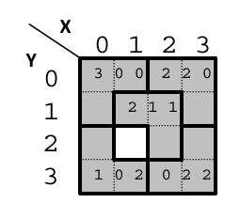

Example
Input | Possible Output
4 1 2 | 5  2 1 1  2 2 0  0 2 2  1 0 2  3 0 0
4 1 2 | 5  0 2 2  1 0 2  2 1 1  2 2 0  3 0 0

