IX | ELEC70126 - Internet of Things and Applications
Module Exam

Module code and Name | ELEC70126 - Internet of Things and Applications
Student CID | 06043088
Assessment date | 2pm 25/03/2026

Code & Data (publicly accessible link):
- Github link to code
- Link to data

PART 1. SENSING

Introduction and Objectives
Mung bean sprouts (Vigna radiata) are a widely cultivated crop known for their rapid germination and vigorous growth in dark conditions. This experiment investigates how exposure to different wavelengths of visible light, specifically blue (~450 nm) and green (~520 nm) affects the rate of sprout growth compared to a dark control group within a controlled environment of the same temperature and humidity.

Objectives:
- Quantify the growth deceleration (or acceleration) of mung bean sprouts under blue and green light relative to a dark control.
- Design and deploy an end-to-end IoT sensing system using ESP32, photoresistors, and environmental sensors.
- Collect continuous time-series data over a week-long experiment with automated cloud-based storage.
- Identify any unexpected plant behaviours (e.g., phototropic movement) observable through the sensor data.

Hypothesis: Blue light is expected to induce a stronger growth response than green light, while the dark control should exhibit uninhibited growth.

Data Sources and Sensing Set-Up

Physical Setup
The experiment uses a divided cardboard enclosure partitioned into three isolated chambers:

Chamber | Condition | Light Source
Left | Blue light (continuous) | Blue LED
Centre | Control / Dark | No light (5s red pulse every 15 min for measurement)
Right | Green light (continuous) | Green LED

Each chamber contains a small plastic container with mung beans placed on wet cotton wool as the growth medium. Cardboard dividers prevent light contamination between chambers.
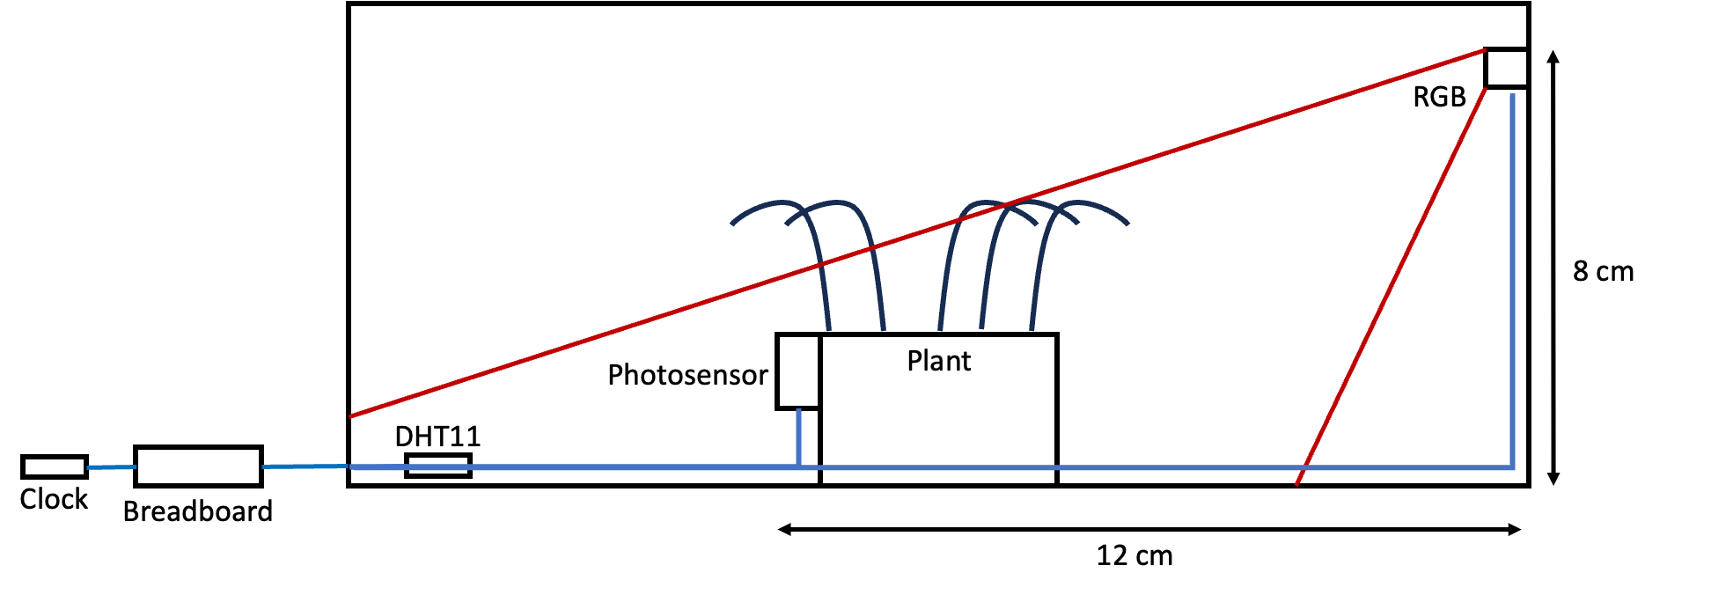
Figure 1. Environment sketch planning

Sensor Configuration

The system employs two types of time-series data sources of different nature:

- Photoresistors (LDRs) - 3 units
Connected to ESP32 ADC pins (GPIO 1, 2, 4). As sprouts grow and obstruct the optical path, the ADC reading increases. For control environment, the red LED is activated for 5 seconds every 15 minutes, with ADC sampling 2 seconds into the pulse.

- DHT11 Temperature and Humidity Sensor - 1 unit
Connected to GPIO 5, monitoring ambient temperature (°C) and relative humidity (%). Provides environmental context and enables future hydration-based actuation.

- RGB LED – 3 units
Connected to GPIO 20, 47 and 48. Used to shine light of different colors to measure the data from photoresistor.

- Real Time Clock (RTC) module – 1 unit
Connected to GPIO 6 and 7 to capture real world timestamp data in a specified format.
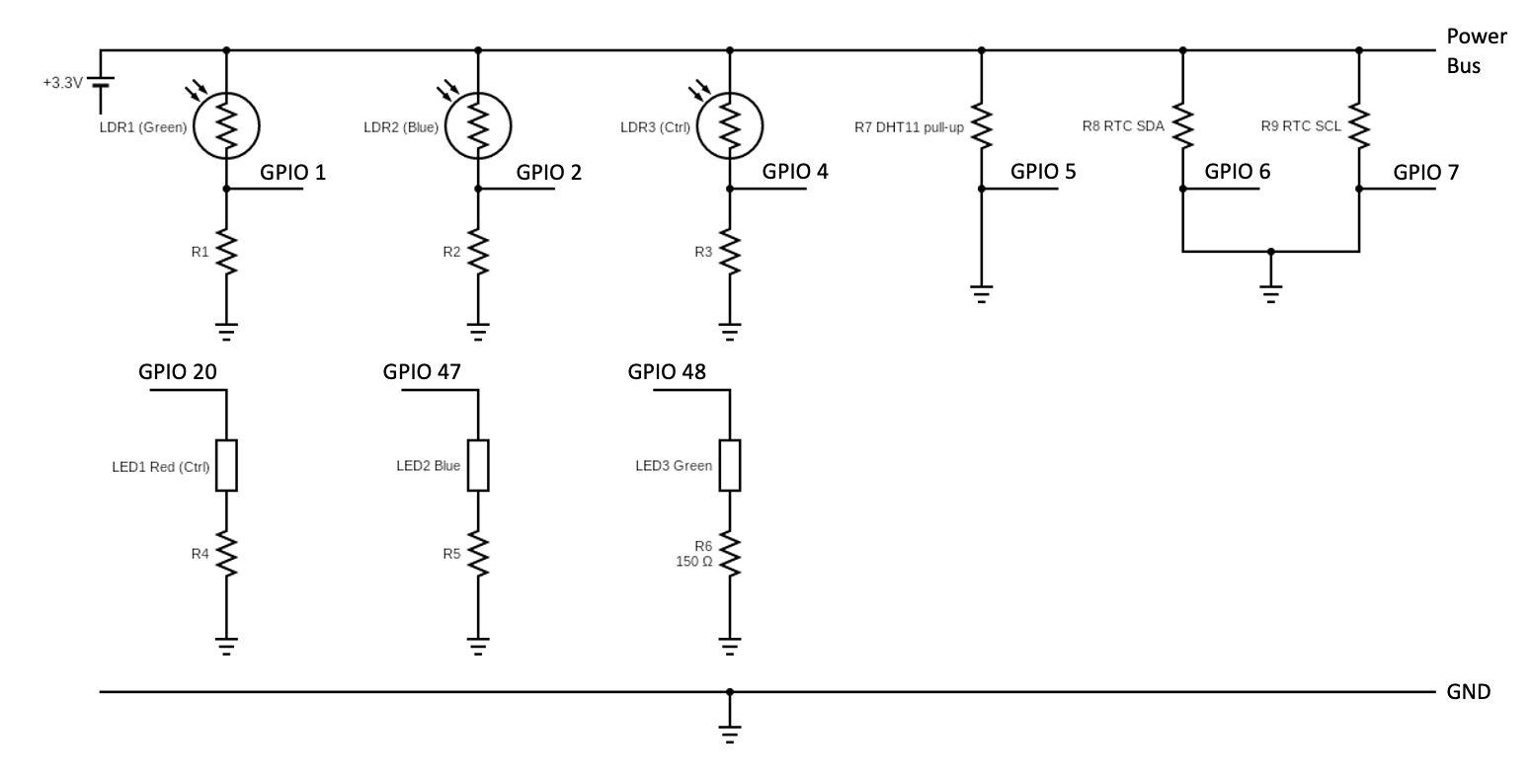
Figure 2. Circuit diagram of bean sprout sensors

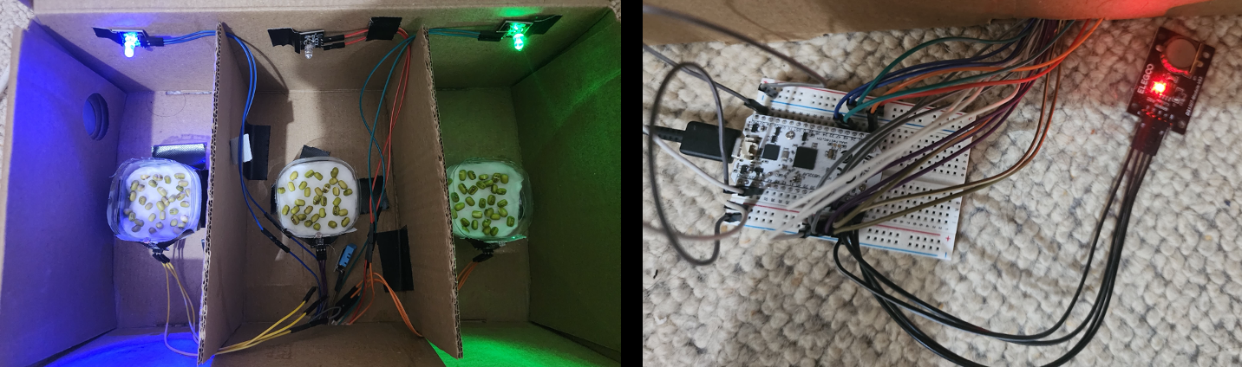
Figure 3 Experiment setup, (left) three chambers with mung beans on cotton wool. (right) breadboard and sensors cabling

2.3 Design Choices

Decision | Choice | Justification
Measurement interval | 15 minutes | Balances resolution (96 samples/day) with minimal light exposure
Measurement LED | 5s pulse | 5s pulse on has minimal effect on growth
ADC read timing | 2s into pulse | Allows photoresistor to stabilize
Environmental sensor | DHT11 | Adequate for trend detection (±2°C, ±5% RH) and low cost
Microcontroller | ESP32 | Integrated Wi-Fi, sufficient ADC channels, able to send data to cloud storage

Data Sources and Sensing Set-Up

Data Pipeline Architecture:


Figure 4. Data pipeline

Every 15 minutes, the ESP32 activates the red measurement LED, waits 2 seconds, reads all 3 photoresistors and the DHT11, then sends the data via HTTP GET to a Google Apps Script endpoint. I use GET here because the POST request was returning 400 Bad Request errors and GET works more reliably because the data is sent as URL parameters which are simpler. The script appends each data point as a new row in Google Sheets, providing cloud-based persistent storage with real-time accessibility.

Data Cleaning
The type of anomalies was addressed is a physical sensor disturbance, sudden simultaneous drops in all three channels caused by opening the enclosure for watering. These were detected when |Δ| > 200 occurred in all three channels simultaneously and replaced via linear interpolation.

Parameter | Value
Sampling interval | 15 minutes
Total data points | 1779
Duration | 18 days (and counting)
Channels | 5 (Green, Blue, Control ADC + Temp + Humidity)
Data size | ~30 KB (CSV)

Basic Characteristics of the End-to-End Setup

Metric | Value
Sampling rate | 1 sample / 15 min (96/day)
Throughput | ~4.8 KB/day
Latency (sensor → cloud) | 2–5 seconds
Power | ~150 mA (USB-powered)
Uptime | >99%
ADC resolution | 12-bit (0–4095)

4.1. Trade-Off Analysis:

Trade-Off | Decision | Rationale
Local vs Cloud | Cloud (Google Sheets) | Allows remote monitoring with only ~5 KB/day
Sampling vs Exposure | 15-min interval | Higher rates increase red light LED exposure to control
Accuracy vs Cost (Plant Growth) | Light Dependent Resistor over camera sensor | Cheaper and fortunately able to work well with the current topic of measuring plant growth. Alternative would be camera sensor, but it cost much more expensive.
Accuracy vs Cost (Temp and Humidity) | DHT11 | Trend detection sufficient for the temperature and humidity in a small, controlled environment with a low-cost sensor.
Reliability vs Simplicity | No local buffer | Acceptable for stable Wi-Fi environment

Limitations:
- Ambient green light interference: the continuously-on green LED can reach the photoresistor even when sprouts partially obstruct the measurement path, underrepresenting green group growth.
- The photoresistor max ADC value for green is different and capped at 3804 instead of 4905 like the other two. Which means the analysis needs a bit of adjustment.
- Phototropic bending in the control group confounds growth readings, sprouts move out of the sensor path, causing apparent decreases that reflect movement, not reduced growth.
- Single environmental sensor micro-climate may vary between chambers.
- No local buffering, Wi-Fi dropouts cause data loss.
- Breadboard connections are fragile, disturbances during watering cause anomalies.

- Introduction and objectives

- Data Sources and sensing set-up

- Data collection and storage/communications process

- Basic characteristics of the end-to-end data acquisition setup

Part 2: Internet of Things (up to 5 pages)

1. Data Interaction and Visualisation Platform
The data is presented through an interactive Streamlit web dashboard (bean_sprout_dashboard.py) designed with a plant-themed green UI. The dashboard pulls live data from Google Sheets every 5 minutes via the public CSV export endpoint and computes all derived metrics on-the-fly. It provides four interactive views: Harvestability (the main view showing percentage readiness with gauge indicators), Plant Length (estimated sprout length in centimetres), Environmental (temperature and humidity time series), and Correlation & Stats (per-chamber correlation matrices and statistical tests).
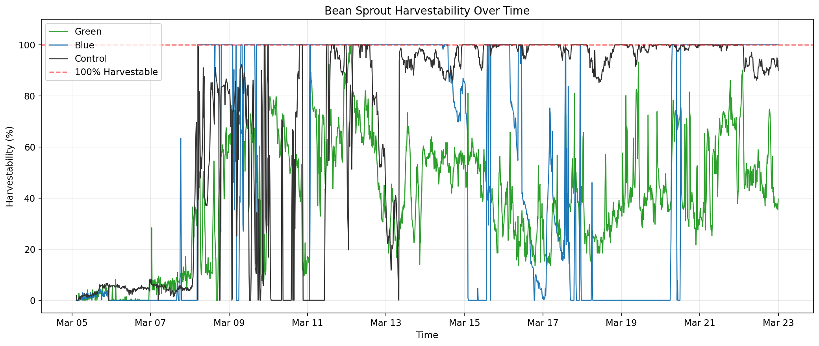
Figure 5. Streamlit dashboard — Harvestability view showing all three chambers reaching 100%
The dashboard is built with Streamlit for rapid prototyping within the Python data science ecosystem, using Plotly for interactive charts with zoom, pan, and hover tooltips. Users can filter data by time range, toggle raw versus cleaned data, and navigate between views via a sidebar. Key metrics (duration, data points, estimated plant lengths) are displayed as card widgets at the top for at-a-glance monitoring.
The system currently operates as a sensing-only platform with no closed-loop actuation. The red LED activates for 5 seconds every 15 minutes purely as a measurement pulse for the control chamber’s photoresistor. However, the architecture supports future actuation: the DHT11 humidity readings could trigger a relay-controlled water pump when humidity drops below a threshold, closing the sense-decide-actuate IoT feedback loop via an MQTT broker.

2. Time Series Data Analysis and Insights
The analysis pipeline (analysis/data_analysis.ipynb) processes 1,714 data points collected at 15-minute intervals between 5–22 March 2026. After cleaning simultaneous-drop anomalies caused by physical disturbance during watering, three derived metrics are computed: harvestability, estimated plant length, and per-chamber correlation.
Harvestability quantifies growth readiness as a percentage scaled from the ADC baseline to a manually-determined threshold: 4000 ADC for blue and control chambers (sensor cap: 4095) and 3700 ADC for the green chamber (sensor cap: 3804). The blue chamber reached 100% harvestability first in approximately 3 days (8 March), followed by the control at 4.7 days (10 March) and green at 7 days (12 March). This ranking — blue fastest, dark second, green slowest — was the central finding of the experiment.
Plant length is estimated using a constant linear growth model derived from the harvestability threshold crossing. When a chamber first reaches 100%, the plant is estimated at 10 cm (the minimum height to fully block the LED-to-sensor light path). The growth rate is rate = 10 cm / N, where N is the number of data points from start to threshold. This rate applies uniformly from the first data point, producing a linear curve capped at 30 cm (manual measurement on 24 March). Blue grows at 0.034 cm/point, control at 0.022 cm/point, and green at 0.015 cm/point.
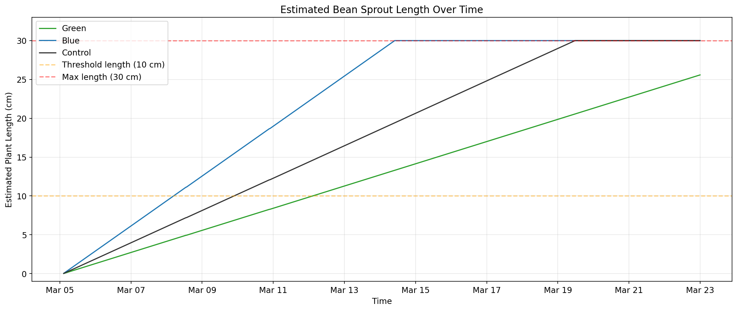
Figure 6. Estimated plant length over time using constant linear growth model
Correlation analysis uses separate 4×4 matrices per chamber to reflect their independence. Each matrix correlates the chamber’s ADC reading, estimated plant length, temperature, and humidity. ADC values are capped at the harvestability threshold after first crossing to prevent post-saturation oscillations (caused by plant movement) from creating spurious negative correlations with the monotonically increasing plant length. Results confirm weak environmental correlation (|r| < 0.15), indicating light treatment is the primary growth driver.
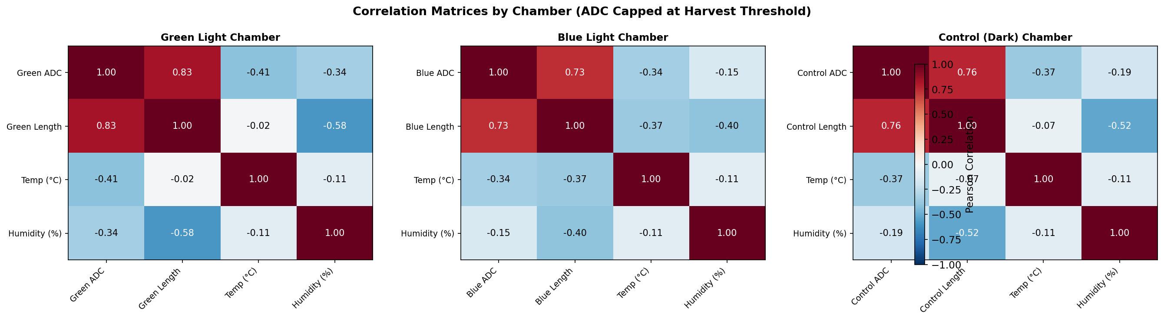
Figure 7. Per-chamber correlation matrices (ADC capped at harvest threshold)

3. Innovation, Scalability and Complexity
The IoT architecture uses HTTP GET requests from the ESP32 to a Google Apps Script endpoint, with Google Sheets as both data store and human-readable log. This trades scalability for simplicity and zero infrastructure cost. For production deployment, an MQTT pub/sub broker with InfluxDB time-series storage and Grafana dashboarding would support higher sampling rates, multiple concurrent experiments, and real-time push notifications (e.g., alerting when harvestability reaches 100%).
The plant length estimation model demonstrates how domain knowledge (chamber geometry, manual observation) can bridge sensor limitations. The photoresistor is fundamentally a binary blocked/unblocked sensor with a noisy transition zone; the linear growth model and harvestability threshold transform this into a continuous, physically meaningful metric. This approach is transferable to other indirect sensing scenarios in IoT agriculture.
Key trade-offs in this system include: (1) Local vs. cloud processing — all computation happens cloud-side in the dashboard, keeping the ESP32 firmware simple but requiring internet connectivity; (2) Latency vs. cost — the 15-minute HTTP polling interval sacrifices real-time responsiveness for battery life and free-tier API compatibility; (3) Accuracy vs. simplicity — the linear growth model is a first-order approximation (real mung bean growth is sigmoidal) but correctly ranks chambers and aligns with manual observations; (4) Price vs. functionality — the entire BOM costs approximately £10 (ESP32, photoresistors, DHT11, LEDs), making it accessible for small-scale urban farming applications.
Sensor asymmetry is the most significant limitation: the green chamber’s photoresistor caps at 3804 ADC instead of 4095, caused by the continuously-on green LED reaching the sensor. A pulsed measurement protocol would eliminate this interference. Additionally, a single DHT11 sensor monitors all chambers, leaving per-chamber micro-climate differences unmeasured.
Future extensions include: adding a TCS34725 colour sensor to quantify leaf chlorophyll content (blue light produced visibly greener leaves vs. yellow etiolated control); automated irrigation using humidity-triggered relay pumps to close the IoT feedback loop; and machine learning models to predict harvestability dates from early growth trajectories, enabling just-in-time harvest scheduling in commercial microgreen production.

