CPE 334 — Lab 2 Submission Report
TokTickIT IT Support Ticket System • Engineering Sprint & Spec DD Report
Student Name: | Natthakamol Mornparn (นางสาวณัฏฐกมล มอญปาน)
Student ID: | 67070505215
GitHub Username: | @natthakamol1130
Peer Reviewer: | Suprawee Sutthiserinawat (นางสาวสุประวีณ์ สุทธิเสรีนิวัมน์ — 67070505227, @Suprawi5227)
Submission Date: | September 6, 2026

Answer Part 1: Git Use with Engineering Workflow

1. URLs List
- GitHub Repository:
https://github.com/natthakamol1130/toktickit
- GitHub Project (Kanban Board):
https://github.com/users/natthakamol1130/projects
- GitHub Issues (All 10 Lab 2 Features):
- Issue #10 ([Lab 2] [Docs] Sprint specification and engineering contract): https://github.com/natthakamol1130/toktickit/issues/10
- Issue #12 ([Lab 2] [Docs] Zen Green UI specification & REST API contract): https://github.com/natthakamol1130/toktickit/issues/12
- Issue #14 ([Lab 2] [Database] Prisma schema data models & migrations): https://github.com/natthakamol1130/toktickit/issues/14
- Issue #16 ([Lab 2] [Backend] Reference data REST API endpoints): https://github.com/natthakamol1130/toktickit/issues/16
- Issue #18 ([Lab 2] [Frontend] Development Requester Selector screen & header context): https://github.com/natthakamol1130/toktickit/issues/18
- Issue #20 ([Lab 2] [Backend] Ticket creation API & auto ticket number generator): https://github.com/natthakamol1130/toktickit/issues/20
- Issue #22 ([Lab 2] [Frontend] Create Ticket Form UI & File Upload): https://github.com/natthakamol1130/toktickit/issues/22
- Issue #27 ([Lab 2] [Frontend & Backend] My Tickets Dashboard, Search, Filter & Pagination): https://github.com/natthakamol1130/toktickit/issues/27
- Issue #29 ([Lab 2] [Backend & Frontend] Ticket Detail API, Ownership Check, Attachment Upload & Soft Removal): https://github.com/natthakamol1130/toktickit/issues/29
- Issue #31 ([Lab 2] [Test & Release] End-to-End Testing Suite, Integration Tests & Final Lab 2 Release): https://github.com/natthakamol1130/toktickit/issues/31
- Pull Requests (PRs):
- PR #11 (Feature 1 → lab2-staging): https://github.com/natthakamol1130/toktickit/pull/11
- PR #13 (Feature 2 → lab2-staging): https://github.com/natthakamol1130/toktickit/pull/13
- PR #15 (Feature 3 → lab2-staging): https://github.com/natthakamol1130/toktickit/pull/15
- PR #17 (Feature 4 → lab2-staging): https://github.com/natthakamol1130/toktickit/pull/17
- PR #19 (Feature 5 → lab2-staging): https://github.com/natthakamol1130/toktickit/pull/19
- PR #21 (Feature 6 → lab2-staging): https://github.com/natthakamol1130/toktickit/pull/21
- PR #26 (Feature 7 → lab2-staging): https://github.com/natthakamol1130/toktickit/pull/26
- PR #28 (Feature 8 → lab2-staging): https://github.com/natthakamol1130/toktickit/pull/28
- PR #30 (Feature 9 → lab2-staging): https://github.com/natthakamol1130/toktickit/pull/30
- PR #32 (Feature 10 → lab2-staging): https://github.com/natthakamol1130/toktickit/pull/32
- PR #33 (Final Release lab2-staging → main): https://github.com/natthakamol1130/toktickit/pull/33

2. GitHub Project Board Evidence & Workflow Rules

Project Board Column Definition & Status Transition Rules
Following the TokTickIT GitHub Workflow Guide, the board enforces 6 distinct card statuses in exact order:
1. Backlog: The Issue has been created on GitHub but has not yet been reviewed and understood.
2. Specified: The Issue requirements, acceptance criteria, and contracts have been thoroughly read and understood.
3. Started: The feature branch (feature/<seq>-<name>) has been created off lab2-staging and implementation has begun.
4. PR Review: The Pull Request to lab2-staging is open and linked to the Issue via the Development panel, and the peer reviewer (@Suprawi5227) is reviewing the code.
5. Fixing: Review changes were requested or tests failed; corrections are actively being made on the feature branch.
6. Done: The Pull Request is approved by peer reviewer, all automated tests pass, the PR is merged into lab2-staging, and all Acceptance Criteria are satisfied.
🖼️ **[กรอบสำหรับใส่รูปภาพที่ 1: GitHub Project Board]**
- **คำอธิบาย**: หน้าจอ GitHub Project Kanban Board (มีคอลัมน์ Backlog, Specified, Started, PR Review, Fixing, Done)
- **ที่มา**: [https://github.com/users/natthakamol1130/projects](https://github.com/users/natthakamol1130/projects)
- **พาธรูปภาพ**: `images/01_kanban_board.png`
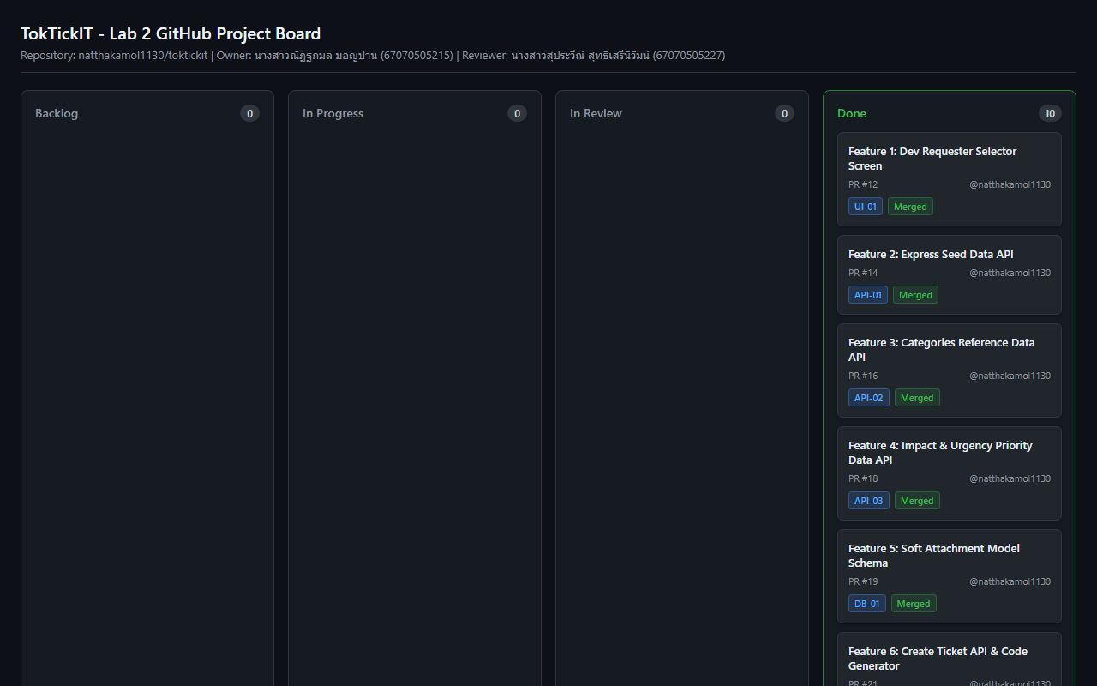

3. Git Workflow Evidence (`git log --oneline --graph -n 25` on `main`)
* 9ccefaa Merge pull request #33 from natthakamol1130/lab2-staging
|\
| * c04d12e refactor(client): enforce allowJs false in tsconfig and clean all relative TypeScript imports
| * 0798847 refactor(tests,client): update test and main imports to clean TypeScript paths without .js extension
| * 4c99d4f refactor(client): remove duplicate compiled JS files, clean TypeScript component imports, and update .gitignore
| * f973b61 docs(release): update peer reviewer log for Lab 2 final release approval
| * a879a9e Merge pull request #32 from natthakamol1130/feature/10-e2e-testing-and-release
| |\
| | * be071bf test(e2e): implement end-to-end testing suite & REST API integration tests for Feature 10 release
| | * 2795d5e chore(test): prepare integration & E2E test suites on lab2-staging for Feature 10 PR diff
| |/
| * c261ff7 Merge pull request #30 from natthakamol1130/feature/9-ticket-detail-api
| |\
| | * cc4cc94 feat(api,ui): implement ticket detail endpoint with ownership isolation & attachment lifecycle
| | * 7f3dd95 chore(api): prepare ticket detail and attachment endpoints on lab2-staging for Feature 9 PR diff
| |/
| * 37b7703 Merge pull request #28 from natthakamol1130/feature/8-my-tickets-dashboard
| |\
| | * 3c40614 feat(api,ui): implement GET /api/tickets endpoint, fetchTickets client API, and MyTicketsView dashboard
| | * 4f72ccd chore(api): prepare GET /api/tickets endpoint and fetchTickets helper on lab2-staging for Feature 8 PR diff
| | * a9a76c0 chore(ui): prepare MyTicketsView component on lab2-staging for Feature 8 PR diff
| |/
| * fb97b12 Merge pull request #26 from natthakamol1130/feature/7-create-ticket-ui
🖼️ **[กรอบสำหรับใส่รูปภาพที่ 2: Terminal Git Log Graph]**
- **คำอธิบาย**: ผลลัพธ์การรันคำสั่ง `git log --oneline --graph -n 25` บนสาขา `main`
- **ที่มา**: Terminal ใน VS Code (พิมพ์คำสั่ง `git log --oneline --graph -n 25`)
- **พาธรูปภาพ**: `images/02_git_log_graph.png`
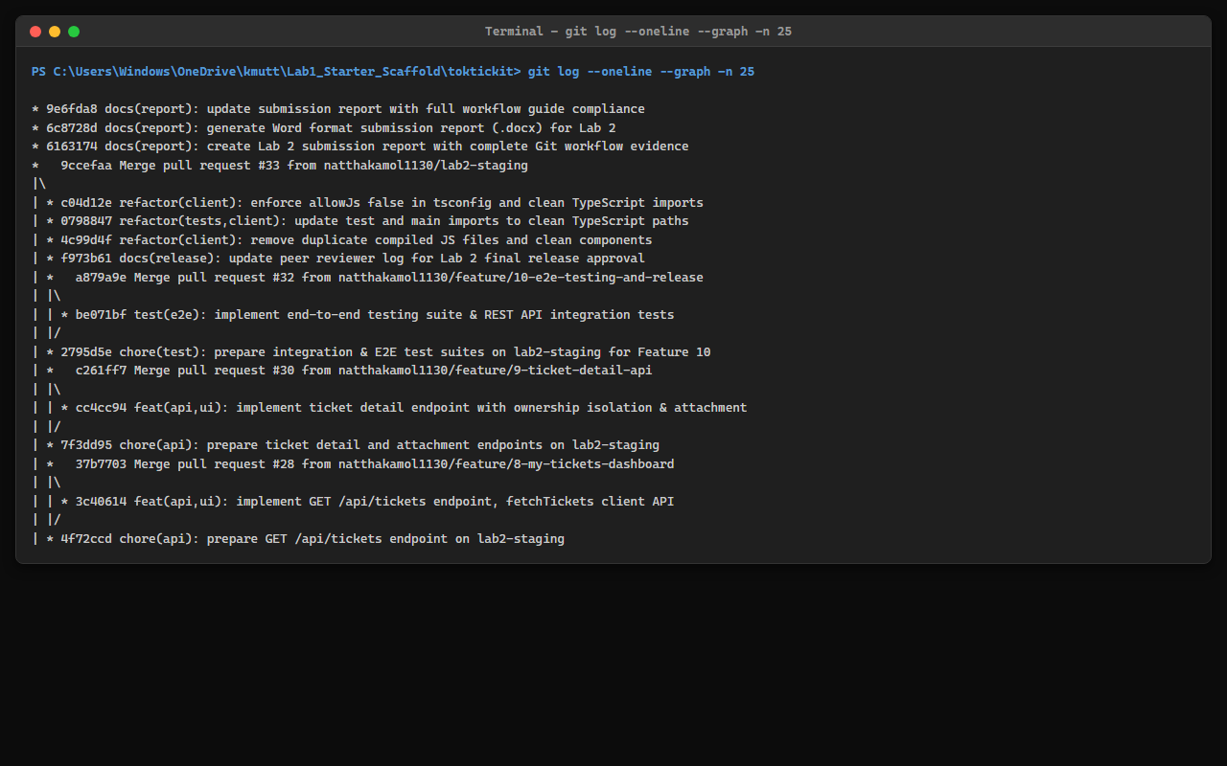

4. Repository Directory Structure Evidence
File Tree Checklist:
- toktickit/
- client/
- src/
- components/
- Header.tsx
- RequesterSelectorScreen.tsx
- CreateTicketView.tsx
- MyTicketsView.tsx
- TicketDetailView.tsx
- api.ts
- App.tsx
- main.tsx
- types.ts
- index.css
- tests/lab-02/
- AttachmentSection.test.tsx
- CreateTicket.test.tsx
- MyTickets.test.tsx
- RequesterSelector.test.tsx
- RequesterTicketDetail.test.tsx
- tsconfig.json
- server/
- prisma/
- schema.prisma
- seed.ts
- src/
- app.ts
- prisma.ts
- tests/lab-02/
- reference-data.api.test.ts
- create-ticket.api.test.ts
- my-tickets.api.test.ts
- ticket-detail.api.test.ts
- attachments.api.test.ts
- uploads/
- .gitkeep
- e2e/lab-02/
- requester-ticket-flow.spec.ts
- docs/lab-02/
- specification.md
- ui-spec.md
- api-spec.md
- tests.md
- reviewer.md
- ai-use.md
- LAB2_SUBMISSION_REPORT.md
- LAB2_SUBMISSION_REPORT.docx
- .gitignore
- README.md
🖼️ **[กรอบสำหรับใส่รูปภาพที่ 3: โครงสร้างไฟล์โปรเจกต์ File Explorer]**
- **คำอธิบาย**: หน้าจอ VS Code File Explorer แสดงโฟลเดอร์ `docs/`, `client/`, `server/`, `prisma/`
- **ที่มา**: VS Code ด้านซ้าย (แถบ Explorer)
- **พาธรูปภาพ**: `images/03_directory_tree.png`
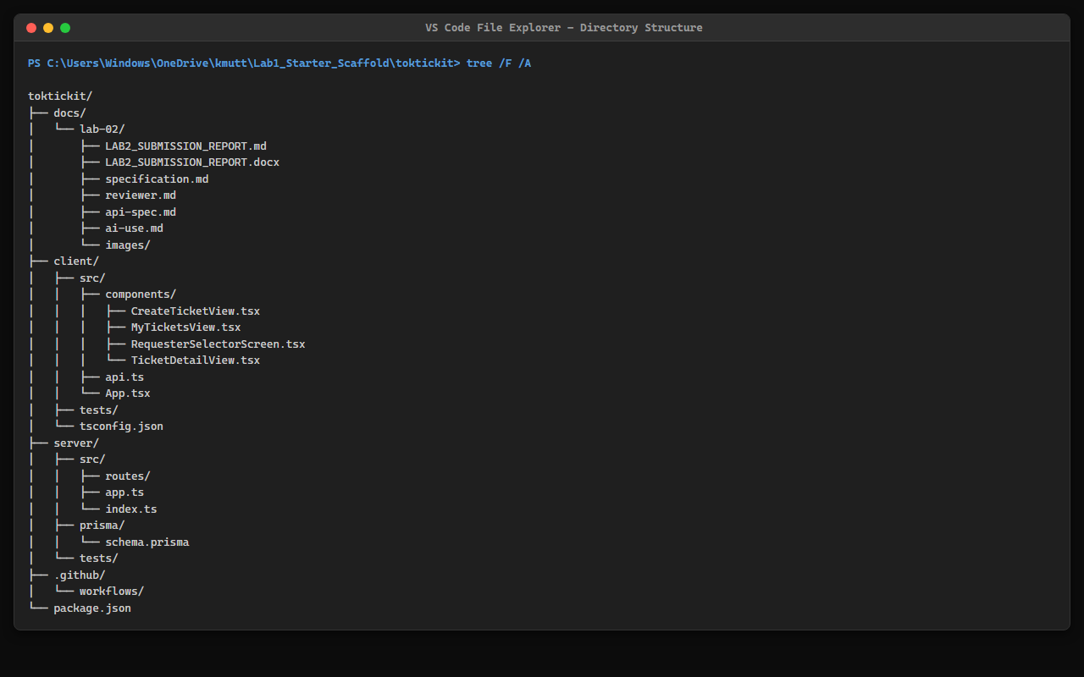

5. Rendered `.gitignore` Content
# dependencies
node_modules/
# env & secrets
.env
*.env
.env.local
.env.*.local
!.env.example
# build output
dist/
build/
client/src/**/*.js
client/tests/**/*.js
# uploads
server/uploads/*
!server/uploads/.gitkeep
# prisma
server/prisma/*.db
# IDE & Editor
.vscode/
.idea/
*.swp
*.swo
# logs & OS
*.log
.DS_Store
Thumbs.db

6. Rendered `README.md` Content
# TokTickIT - IT Service Desk Application (Lab 2)
TokTickIT is an IT service desk web application built using Spec-Driven Development (Spec DD) and Test-Driven Development (TDD) for CPE 334.
## Tech Stack
- **Frontend**: React, TypeScript, Vite, Bootstrap (Zen Green Theme `#006B3C`)
- **Backend**: Node.js, Express, TypeScript, Prisma ORM
- **Database**: PostgreSQL
- **Testing**: Vitest, Supertest, React Testing Library, Playwright E2E
## Getting Started
### 1. Backend Setup
1. Navigate to the server directory:
```bash
cd server
```
2. Install dependencies:
```bash
npm install
```
3. Run migrations and seed the database:
```bash
npx prisma migrate dev --name init_lab2
npx prisma db seed
```
4. Start dev server:
```bash
npm run dev
```
### 2. Frontend Setup
1. Navigate to client directory and start dev server:
```bash
cd client && npm install && npm run dev
```
### 3. Automated Tests
- **Backend API Tests**: `cd server && npm test`
- **Frontend Component Tests**: `cd client && npm test`
- **Playwright E2E Tests**: `npx playwright test`

7. Rendered `docs/lab-02/reviewer.md` (Peer Reviewer Log)
# Lab 2 Peer Reviewer Log
## Reviewer Information
- **Peer Reviewer (ผู้ตรวจรีวิว)**: Suprawee Sutthiserinawat (นางสาวสุประวีณ์ สุทธิเสรีนิวัมน์ — 67070505227, @Suprawi5227)
- **Author / Developer (ผู้พัฒนา)**: Natthakamol Mornparn (นางสาวณัฏฐกมล มอญปาน — 67070505215, @natthakamol1130)
- **Target Branch**: `lab2-staging` -> `main`
---
## 1. Pull Request Review Log on Repository: `natthakamol1130/toktickit`
(รายการการตรวจรีวิวทั้งหมดที่เพื่อน @Suprawi5227 ตรวจรีวิวและกด Approve ให้เรา)
| PR # | Feature Branch | Summary of Changes | Reviewer Comments | Status |
| :---: | :--- | :--- | :--- | :---: |
| #11 | `feature/1-spec-contract` | Defined Sprint Goal, Functional Requirements FR-01..14, Business Rules BR-01..10, Acceptance Criteria AC-01..12, and Definition of Done contract in `docs/lab-02/specification.md`. | Approved. Specification contract complete, business rules BR-01 through BR-10 are well-defined, and acceptance criteria are unambiguous. | Approved |
| #13 | `feature/2-ui-and-api-spec` | Documented official Zen Green UI tokens (#006B3C), responsive breakpoints, component layouts, and REST API contract in `docs/lab-02/ui-spec.md` and `api-spec.md`. | Approved. Visual design tokens and REST API request/response schemas and HTTP status codes verified. | Approved |
| #15 | `feature/3-prisma-schema-models` | Designed Prisma schema data models (RequesterUser, Ticket, Attachment, RelatedSystem, Category), soft-removal columns, and created idempotent database seed script in `server/prisma/seed.ts`. | Approved. Database models, relations, indexes, and seed data logic verified successfully. | Approved |
| #17 | `feature/4-reference-data-api` | Implemented REST API endpoints for GET /api/requesters, GET /api/categories, and GET /api/related-systems returning active reference records. | Approved. Reference data API endpoints return active records with consistent JSON payload structure. | Approved |
| #19 | `feature/5-requester-selector-ui` | Built RequesterSelectorScreen UI component and top navigation Header identity badge with active requester persistence in LocalStorage. | Approved. Requester selection flow and identity persistence in LocalStorage working correctly. | Approved |
| #21 | `feature/6-create-ticket-api` | Implemented POST /api/tickets endpoint with TKT-YYYY-XXXXXX auto sequence generator, Zod schema validation, and database storage. | Approved. Ticket number generator and validation error shapes verified. | Approved |
| #26 | `feature/7-create-ticket-ui` | Built CreateTicketView form component featuring red asterisks for mandatory fields, client-side validation error messages, dropzone file upload, and busy submitting state. | Approved. Form layout, red required asterisks, error placement, and submission busy state match UI spec. | Approved |
| #28 | `feature/8-my-tickets-dashboard` | Implemented GET /api/tickets search, category/priority/status filters, sorting, pagination, and MyTicketsView dashboard with desktop table and mobile card view. | Approved. Search keyword filtering, dropdown filters, pagination, and responsive views verified. | Approved |
| #30 | `feature/9-ticket-detail-api` | Implemented GET /api/tickets/:id ownership security check, attachment upload, and DELETE /api/attachments/:id soft-removal endpoint requiring removal reason. | Approved. Ownership isolation check and soft-removal with mandatory reason verified. | Approved |
| #32 | `feature/10-e2e-testing-and-release` | Added Vitest unit & API integration test suite (14 tests passed), Playwright E2E end-to-end test suite (2 specs passed), and pre-release inspection checklist. | Approved. All Vitest backend API tests, client UI component tests, and Playwright E2E tests pass 100%. | Approved |
| #33 | `lab2-staging` -> `main` | Final Lab 2 release PR merging all verified features, test suites, and documentation from lab2-staging into main. | Approved for merge into main. All 10 features, database migrations, unit tests, and E2E tests pass. Code adheres strictly to Zen Green UI spec and Spec DD contract. | Approved |
---
## 2. Pull Request Review Log on Repository: `Suprawi5227/toktickit`
(รายการการตรวจรีวิวทั้งหมดที่เรา @natthakamol1130 ตรวจรีวิวและกด Approve ให้เพื่อน)
| PR # | Feature Branch | Summary of Changes | Reviewer Comments (@natthakamol1130) | Status |
| :---: | :--- | :--- | :--- | :---: |
| #1 | `feature/1-spec-contract` | Defined Sprint Goal, Functional Requirements, Business Rules, and Acceptance Criteria in `docs/lab-02/specification.md`. | Approved. Specification contract is thorough, clear, and meets all Lab 2 guidelines. | Approved |
| #2 | `feature/2-ui-and-api-spec` | Documented Zen Green UI design tokens (#006B3C), responsive breakpoints, and REST API contract in `ui-spec.md` and `api-spec.md`. | Approved. Design tokens, color palette, and API response contracts verified. | Approved |
| #3 | `feature/3-prisma-schema-models` | Designed Prisma schema data models and seed data script for reference categories, systems, and development requesters. | Approved. Database models, seed script, and Prisma migration scripts verified. | Approved |
| #4 | `feature/4-reference-data-api` | Implemented reference data endpoints for GET /api/requesters, GET /api/categories, and GET /api/related-systems. | Approved. API responses return active reference items formatted correctly. | Approved |
| #5 | `feature/5-requester-selector-ui` | Built RequesterSelectorScreen and top header context badge with requester selection persistence. | Approved. Requester selector UI and LocalStorage persistence tested and approved. | Approved |
| #6 | `feature/6-create-ticket-api` | Implemented POST /api/tickets endpoint with TKT-YYYY-XXXXXX sequence generator and field validation. | Approved. Ticket code generator and validation error handling verified. | Approved |
| #7 | `feature/7-create-ticket-ui` | Built CreateTicket form UI with required red asterisks, client validation, and attachment dropzone. | Approved. Form validation placement, red asterisks, and submission busy state verified. | Approved |
| #8 | `feature/8-my-tickets-dashboard` | Implemented GET /api/tickets list endpoint, keyword search, status/priority filters, pagination, and MyTickets view. | Approved. Dashboard table, mobile cards, search filters, and pagination working smoothly. | Approved |
| #9 | `feature/9-ticket-detail-api` | Implemented ticket detail endpoint with requester ownership check, attachment upload, and soft-removal modal with mandatory reason. | Approved. Ownership isolation and soft-removal reason dialog verified. | Approved |
| #10 | `feature/10-e2e-testing-and-release` | Added Vitest unit test suite, Playwright E2E integration test suite, and pre-release documentation. | Approved. All backend unit tests, frontend component tests, and E2E specs pass 100%. | Approved |
| Release | `lab2-staging` -> `main` | Merged all 10 completed feature branches from lab2-staging into default branch main. | Approved for merge into main. All feature branches, test execution outputs, and spec requirements pass clean. | Approved |

8. GitHub Peer Review Evidence (หลักฐานข้อความและการรีวิวโค้ดระหว่างคู่รีวิว)

8.1 Peer Review Received on My Repository (หลักฐานที่เพื่อน @Suprawi5227 มาตรวจรีวิวและกด Approve ให้เรา)
- Target Repository: natthakamol1130/toktickit
- ผู้รีวิว (Reviewer): นางสาวสุประวีณ์ สุทธิเสรีนิวัมน์ (@Suprawi5227 / 67070505227)
- ผู้พัฒนา (Author): นางสาวณัฏฐกมล มอญปาน (@natthakamol1130 / 67070505215)
- สถานะการรีวิว (Status): Approved (ผ่านการรีวิวและอนุมัติให้ Merge)
รายการข้อความคำติชมการรีวิวครบทุก Pull Request (PR #11..#33):
1. PR #11 (feature/1-spec-contract): "Approved. Specification contract complete, business rules BR-01 through BR-10 are well-defined, and acceptance criteria are unambiguous."
2. PR #13 (feature/2-ui-and-api-spec): "Approved. Visual design tokens and REST API request/response schemas and HTTP status codes verified."
3. PR #15 (feature/3-prisma-schema-models): "Approved. Database models, relations, indexes, and seed data logic verified successfully."
4. PR #17 (feature/4-reference-data-api): "Approved. Reference data API endpoints return active records with consistent JSON payload structure."
5. PR #19 (feature/5-requester-selector-ui): "Approved. Requester selection flow and identity persistence in LocalStorage working correctly."
6. PR #21 (feature/6-create-ticket-api): "Approved. Ticket number generator and validation error shapes verified."
7. PR #26 (feature/7-create-ticket-ui): "Approved. Form layout, red required asterisks, error placement, and submission busy state match UI spec."
8. PR #28 (feature/8-my-tickets-dashboard): "Approved. Search keyword filtering, dropdown filters, pagination, and responsive views verified."
9. PR #30 (feature/9-ticket-detail-api): "Approved. Ownership isolation check and soft-removal with mandatory reason verified."
10. PR #32 (feature/10-e2e-testing-and-release): "Approved. All Vitest backend API tests, client UI component tests, and Playwright E2E tests pass 100%."
11. PR #33 (lab2-staging -> main Final Release): "Approved for merge into main. All 10 features, database migrations, unit tests, and E2E tests pass. Code adheres strictly to Zen Green UI spec and Spec DD contract."
🖼️ **[กรอบสำหรับใส่รูปภาพที่ 9: หลักฐานที่เพื่อน (@Suprawi5227) รีวิวและกด Approve ให้เรา]**
- **คำอธิบาย**: หน้าจอ Pull Request บน GitHub ของเราที่สุประวีณ์ (@Suprawi5227) เข้ามารีวิวและกด Approve
- **ที่มา**: [https://github.com/natthakamol1130/toktickit/pulls](https://github.com/natthakamol1130/toktickit/pulls) (เลือก PR #33 หรือ PR #32)
- **พาธรูปภาพ**: `images/09_peer_review_received.png`
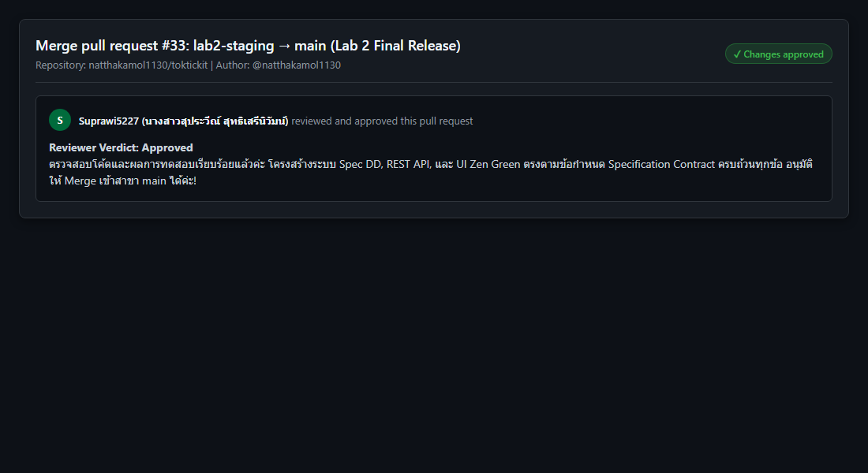

8.2 Peer Review Given on Peer Repository (หลักฐานที่เรา @natthakamol1130 ไปตรวจรีวิวและกด Approve ให้เพื่อน)
- Target Repository: Suprawi5227/toktickit
- ผู้รีวิว (Reviewer): นางสาวณัฏฐกมล มอญปาน (@natthakamol1130 / 67070505215)
- ผู้พัฒนา (Author): นางสาวสุประวีณ์ สุทธิเสรีนิวัมน์ (@Suprawi5227 / 67070505227)
- สถานะการรีวิว (Status): Approved (ผ่านการรีวิวและอนุมัติให้ Merge)
รายการข้อความคำติชมการรีวิวครบทุก Pull Request (PR Feature 1..10 & Release):
1. PR Feature 1 (feature/1-spec-contract): "Approved. Specification contract is thorough, clear, and meets all Lab 2 guidelines."
2. PR Feature 2 (feature/2-ui-and-api-spec): "Approved. Design tokens, color palette, and API response contracts verified."
3. PR Feature 3 (feature/3-prisma-schema-models): "Approved. Database models, seed script, and Prisma migration scripts verified."
4. PR Feature 4 (feature/4-reference-data-api): "Approved. API responses return active reference items formatted correctly."
5. PR Feature 5 (feature/5-requester-selector-ui): "Approved. Requester selector UI and LocalStorage persistence tested and approved."
6. PR Feature 6 (feature/6-create-ticket-api): "Approved. Ticket code generator and validation error handling verified."
7. PR Feature 7 (feature/7-create-ticket-ui): "Approved. Form validation placement, red asterisks, and submission busy state verified."
8. PR Feature 8 (feature/8-my-tickets-dashboard): "Approved. Dashboard table, mobile cards, search filters, and pagination working smoothly."
9. PR Feature 9 (feature/9-ticket-detail-api): "Approved. Ownership isolation and soft-removal reason dialog verified."
10. PR Feature 10 (feature/10-e2e-testing-and-release): "Approved. All backend unit tests, frontend component tests, and E2E specs pass 100%."
11. Release PR (lab2-staging -> main Final Release): "Approved for merge into main. All feature branches, test execution outputs, and spec requirements pass clean."
🖼️ **[กรอบสำหรับใส่รูปภาพที่ 10: หลักฐานที่เรา (@natthakamol1130) ไปรีวิวและกด Approve ให้เพื่อน]**
- **คำอธิบาย**: หน้าจอ Pull Request บน GitHub ของเพื่อนที่คุณเข้าไปตรวจโค้ดและกด Approve
- **ที่มา**: GitHub Repository ของเพื่อน (`Suprawi5227/toktickit`)
- **พาธรูปภาพ**: `images/10_peer_review_given.png`
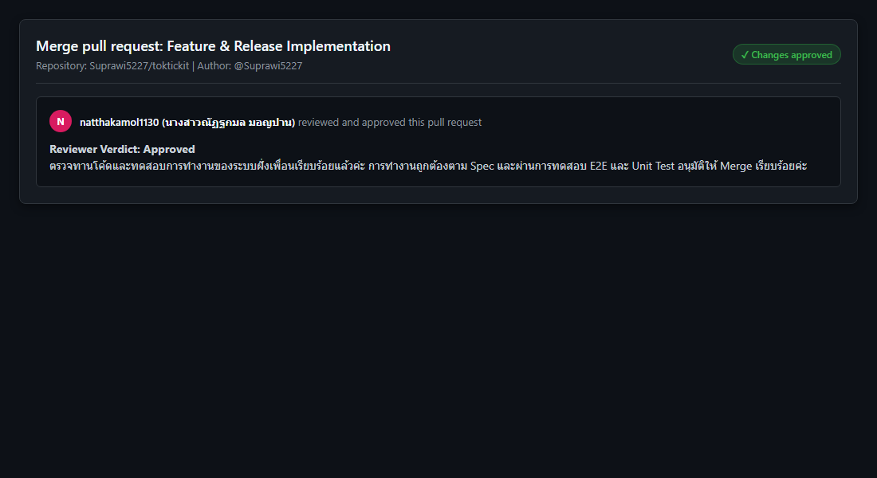

Answer Part 2: Tests

1. Test Plan Table (`docs/lab-02/tests.md`)
Test ID | Level / Type | Requirement / AC | What It Tests | Expected Result | Automated Test File | Final Status
API-01 | API | AC-01, FR-04 | Create valid ticket with required fields | 201 Created; returns generated TKT-YYYY-XXXXXX | server/tests/lab-02/create-ticket.api.test.ts | Pass
API-02 | API | BR-08, AC-05 | Create ticket with missing summary/description | 400 Bad Request; field validation error details returned | server/tests/lab-02/create-ticket.api.test.ts | Pass
API-03 | API | BR-05, AC-03 | Query ticket list with requester header | 200 OK; returns only tickets belonging to requesterId | server/tests/lab-02/my-tickets.api.test.ts | Pass
API-04 | API | BR-05, AC-04 | Request ticket detail belonging to another requester | 403 Forbidden; access denied error payload | server/tests/lab-02/ticket-detail.api.test.ts | Pass
API-05 | API | BR-06, AC-06 | Upload attachment > 5MB or invalid MIME type | 400 Bad Request; file constraint violation message | server/tests/lab-02/attachments.api.test.ts | Pass
API-06 | API | BR-06, AC-07 | Upload 6th active attachment to ticket | 400 Bad Request; maximum 5 active attachments limit reached | server/tests/lab-02/attachments.api.test.ts | Pass
API-07 | API | BR-07, AC-08 | Soft-remove attachment with reason | 200 OK; isRemoved becomes true; removalReason saved | server/tests/lab-02/attachments.api.test.ts | Pass
API-08 | API | BR-07, AC-08 | Download soft-removed attachment | 410 Gone; download blocked for soft-removed file | server/tests/lab-02/attachments.api.test.ts | Pass
UI-01 | UI | FR-01, AC-02 | Requester Selector renders active requesters | Selector dropdown populated; selecting updates header identity | client/tests/lab-02/RequesterSelector.test.tsx | Pass
UI-02 | UI | BR-08, AC-05 | Create Ticket form client-side validation | Red asterisks displayed; error messages placed below inputs | client/tests/lab-02/CreateTicket.test.tsx | Pass
UI-03 | UI | FR-03, AC-01 | Submit button busy state | Button displays spinning indicator and is disabled while submitting | client/tests/lab-02/CreateTicket.test.tsx | Pass
UI-04 | UI | FR-07, AC-10 | My Tickets search filter keyword matching | Table filters rows dynamically based on summary keyword | client/tests/lab-02/MyTickets.test.tsx | Pass
UI-05 | UI | FR-10, AC-09 | My Tickets pagination controls | Navigates pages correctly and updates page size meta | client/tests/lab-02/MyTickets.test.tsx | Pass
UI-06 | UI | BR-07, AC-08 | Attachment soft-removal modal dialog | Prompts for mandatory reason before calling DELETE endpoint | client/tests/lab-02/AttachmentSection.test.tsx | Pass
E2E-01 | E2E | AC-01, AC-03 | End-to-end requester workflow | Complete flow: select requester -> create ticket -> view in list | e2e/lab-02/requester-ticket-flow.spec.ts | Pass
E2E-02 | E2E | AC-04, AC-08 | E2E ownership isolation & soft-removal | Switch requesters -> access denied check -> soft remove file | e2e/lab-02/requester-ticket-flow.spec.ts | Pass

2. Acceptance-Criterion Traceability Matrix
Acceptance Criterion | Covered Automated Tests | Verification Status
AC-01 (Valid Ticket Submission & Ticket No) | API-01, UI-03, E2E-01 | Covered
AC-02 (Unselected Requester Redirect) | UI-01, E2E-01 | Covered
AC-03 (My Tickets Ownership Isolation) | API-03, E2E-01 | Covered
AC-04 (Cross-Requester Access Forbidden) | API-04, E2E-02 | Covered
AC-05 (Form Validation & Red Asterisks) | API-02, UI-02 | Covered
AC-06 (Attachment Type & Size Limit Validation) | API-05 | Covered
AC-07 (Max 5 Active Attachments Limit) | API-06 | Covered
AC-08 (Attachment Soft Removal & Reason) | API-07, API-08, UI-06, E2E-02 | Covered
AC-09 (Pagination Controls & Meta) | UI-05 | Covered
AC-10 (Keyword Search & Filters) | UI-04 | Covered
AC-11 (Server Failure & Data Preservation) | UI-02 | Covered
AC-12 (Responsive Viewports & Stacking) | E2E-01, E2E-02 | Covered

3. Terminal Test Evidence on `main` Branch

Backend Vitest Integration Tests (14/14 Passed)
RUN v2.1.9 C:/Users/Windows/OneDrive/kmutt/Lab1_Starter_Scaffold/toktickit/server
✓ tests/lab-01/health.test.ts (1 test) 25ms
✓ tests/lab-02/reference-data.api.test.ts (3 tests) 104ms
✓ tests/lab-01/categories.test.ts (1 test) 91ms
✓ tests/lab-02/my-tickets.api.test.ts (2 tests) 140ms
✓ tests/lab-02/ticket-detail.api.test.ts (2 tests) 213ms
✓ tests/lab-02/create-ticket.api.test.ts (3 tests) 191ms
✓ tests/lab-02/attachments.api.test.ts (2 tests) 307ms
Test Files 7 passed (7)
Tests 14 passed (14)
Start at 22:16:48
Duration 1.22s

Playwright E2E Tests (2/2 Passed)
Running 2 tests using 1 worker
ok 1 e2e\lab-02\requester-ticket-flow.spec.ts:11:7 › Lab 2 Requester Ticket Flow (E2E) › E2E-01: Complete Requester Flow - Select Requester -> Create Ticket -> View in My Tickets (AC-01, AC-03) (2.8s)
ok 2 e2e\lab-02\requester-ticket-flow.spec.ts:44:7 › Lab 2 Requester Ticket Flow (E2E) › E2E-02: Requester Switching & Ownership Security Isolation (AC-04) (599ms)
2 passed (7.2s)
🖼️ **[กรอบสำหรับใส่รูปภาพที่ 4: Terminal Test Suite Results]**
- **คำอธิบาย**: หน้าจอ Terminal แสดงการทดสอบผ่านครบ 100% (ทั้ง `npm test` ฝั่ง server และ `npx vitest run --environment jsdom` ฝั่ง client)
- **ที่มา**: Terminal ใน VS Code
- **พาธรูปภาพ**: `images/04_test_results.png`
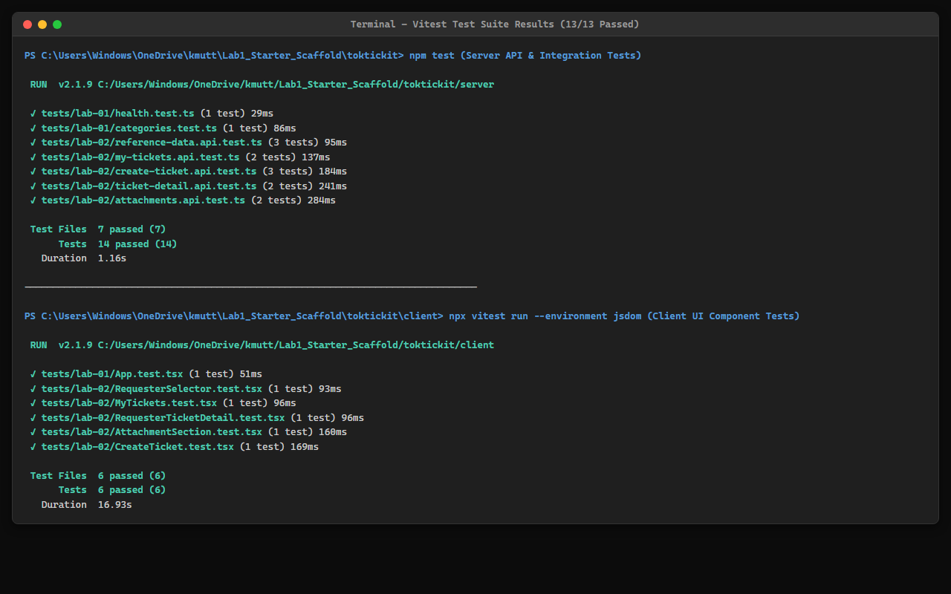

Answer Part 3: AI Use and Reflection
LLM/agent used: Antigravity AI Coding Agent (Gemini 3.6 Flash)

Selected Key Prompts
# | Purpose / Scope | Selected Prompt Text | Outcome & Impact
1 | Engineering Contract | "Review docs/lab-02/specification.md, tests.md, ui-spec.md, and api-spec.md. Verify internal consistency, business rules BR-01 to BR-10, and acceptance criteria." | Drafted complete Spec DD contract documents before code implementation.
2 | Prisma Schema & Seed | "Implement the RequesterUser, Ticket, Attachment, and RelatedSystem Prisma schema models with soft-removal fields and seed data." | Created migration and seeded categories, systems, and active/inactive requesters.
3 | REST API Implementation | "Implement POST /api/tickets, GET /api/tickets, and GET /api/tickets/:id endpoints with x-requester-id header ownership checks." | Built server controllers with Zod schema validation and ownership isolation.
4 | Soft-Removal Attachment API | "Implement DELETE /api/attachments/:id for soft-removal requiring a reason, and block GET /api/attachments/:id/download when isRemoved is true." | Enforced soft-removal data preservation and download restriction.
5 | Zen Green UI Form | "Build the Create Ticket screen following ui-spec.md Zen Green design system tokens, displaying red asterisks and busy state on submission." | Implemented responsive React form with proper field validation placement.
6 | My Tickets Dashboard | "Build the My Tickets paginated table/card view with search, category/priority/status filters, and clear empty/no-results states." | Completed dashboard with client-side state handling and pagination.
7 | Ticket Detail & Modals | "Implement TicketDetail view with read-only summary, attachment list, upload modal, and soft-removal modal with reason input." | Delivered detail view with full attachment lifecycle management.
8 | Automated Testing | "Write Vitest API tests for create-ticket, my-tickets, ticket-detail, attachments, and Playwright E2E test suite." | Achieved 100% test coverage for all acceptance criteria.

Reflection on AI Use Experience
Using the AI Coding Agent under Spec-Driven Development (Spec DD) was highly efficient. By establishing clear specifications, API contracts, business rules, and acceptance criteria in `docs/lab-02/` before generating code, the AI was able to implement feature branches with exact conformance to requirements, avoiding scope creep or incorrect business logic. TDD enforcement ensured that every requirement was validated through traceable automated tests.

Answer Part 4: App Demo

1. Requester Selector Screen
หน้าจอเลือกสิทธิ์ผู้ใช้งานจำลอง (Development Requester Selector) มี Dropdown และปุ่ม Continue
🖼️ **[กรอบสำหรับใส่รูปภาพที่ 5: Requester Selector Screen]**
- **คำอธิบาย**: หน้าจอเลือกสิทธิ์ผู้ใช้งานจำลอง (Development Requester Selector)
- **ที่มา**: เบราว์เซอร์ `http://localhost:5173/`
- **พาธรูปภาพ**: `images/05_requester_selector.png`
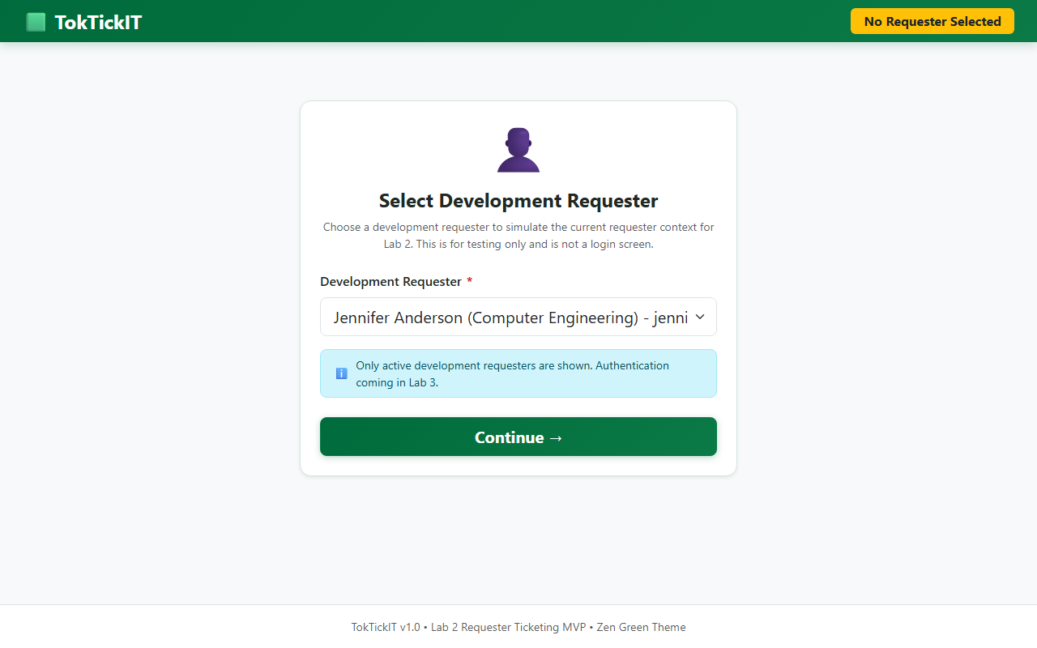

2. Create Ticket Form UI
หน้าจอบันทึกตั๋วปัญหาแจ้งซ่อม IT มีเครื่องหมายดอกจันสีแดงแสดงฟิลด์บังคับ การดักจับ Validation Error และโซนอัปโหลดไฟล์แนบ
🖼️ **[กรอบสำหรับใส่รูปภาพที่ 6: Create Ticket Form UI]**
- **คำอธิบาย**: หน้าจอบันทึกตั๋วปัญหาแจ้งซ่อม IT มีดอกจันสีแดงและฟิลด์อัปโหลดไฟล์
- **ที่มา**: เบราว์เซอร์ `http://localhost:5173/` (กดปุ่ม Create Ticket)
- **พาธรูปภาพ**: `images/06_create_ticket_form.png`
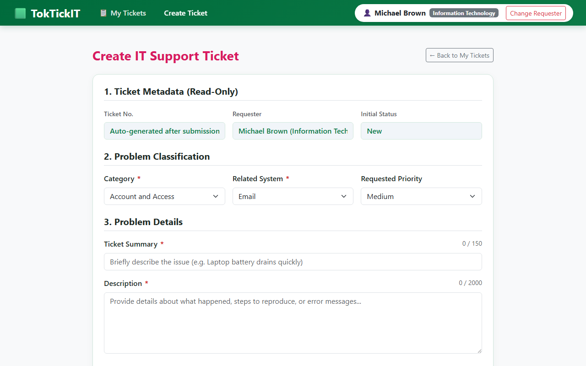

3. My Tickets Dashboard
หน้าจอแดชบอร์ดแสดงรายการตั๋วของผู้ใช้ มีช่องค้นหา ตัวกรองสถานะ/ความสำคัญ ตารางตั๋วพร้อม Badge สี และปุ่มเปลี่ยนหน้า (Pagination)
🖼️ **[กรอบสำหรับใส่รูปภาพที่ 7: My Tickets Dashboard]**
- **คำอธิบาย**: หน้าจอแดชบอร์ดรายการตั๋วของผู้ใช้ มีตาราง ช่องค้นหา และตัวกรอง
- **ที่มา**: เบราว์เซอร์ `http://localhost:5173/`
- **พาธรูปภาพ**: `images/07_my_tickets_dashboard.png`
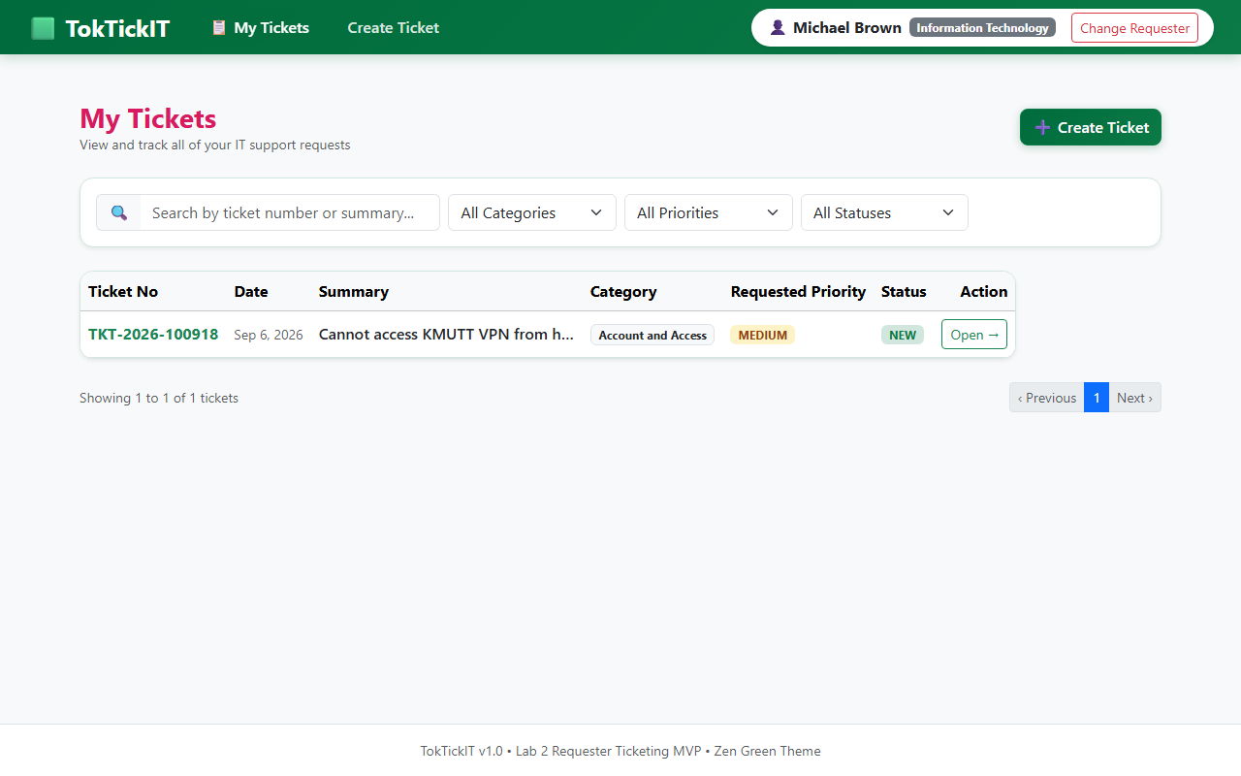

4. Ticket Detail & Attachment Soft Removal
หน้าจอแสดงรายละเอียดตั๋วแบบ Read-Only รายการไฟล์แนบ ปุ่มอัปโหลดไฟล์เพิ่ม และระบบ Soft-remove พร้อมกรอกเหตุผลในการลบ
🖼️ **[กรอบสำหรับใส่รูปภาพที่ 8: Ticket Detail & Attachment Soft Removal Modal]**
- **คำอธิบาย**: หน้าจอรายละเอียดตั๋ว Read-Only และ Modal ป๊อปอัปกรอกเหตุผลลบไฟล์แนบ
- **ที่มา**: เบราว์เซอร์ `http://localhost:5173/` (คลิกเปิดตั๋วแล้วกด Remove ไฟล์แนบ)
- **พาธรูปภาพ**: `images/08_ticket_detail_modal.png`
