TokTickIT Lab 2 Submission Report
Student Name: | Natthakamol Mornparn (นางสาวณัฏฐกมล มอญปาน)
Student ID: | 67070505215
Section: | CPE334
GitHub Repository: | https://github.com/natthakamol1130/toktickit

Answer Part 1: Git Use with Engineering Workflow (10 คะแนน)

1.1 URL List
รายการ | ลิงก์ (URL)
GitHub Repository | https://github.com/natthakamol1130/toktickit
GitHub Project (Kanban) | https://github.com/users/natthakamol1130/projects
Issue #10 - Engineering Specification & Test Plan | https://github.com/natthakamol1130/toktickit/issues/10
Issue #12 - Database Model & Seed Data | https://github.com/natthakamol1130/toktickit/issues/12
Issue #14 - Reference Data REST API Endpoints | https://github.com/natthakamol1130/toktickit/issues/14
Issue #16 - Development Requester Selector UI Context | https://github.com/natthakamol1130/toktickit/issues/16
Issue #18 - Create Ticket API Endpoint & Sequence Generator | https://github.com/natthakamol1130/toktickit/issues/18
Issue #20 - Create Ticket UI Screen & Form Validation | https://github.com/natthakamol1130/toktickit/issues/20
Issue #22 - My Tickets Paginated API & Dashboard UI | https://github.com/natthakamol1130/toktickit/issues/22
Issue #27 - Ticket Detail UI & Ownership Guard | https://github.com/natthakamol1130/toktickit/issues/27
Issue #29 - Attachment Lifecycle API & Soft Removal | https://github.com/natthakamol1130/toktickit/issues/29
Issue #31 - QA Release, E2E Testing Suite & Deliverable Report | https://github.com/natthakamol1130/toktickit/issues/31
PR #11: feature/1-spec-contract → lab2-staging | https://github.com/natthakamol1130/toktickit/pull/11
PR #13: feature/2-ui-and-api-spec → lab2-staging | https://github.com/natthakamol1130/toktickit/pull/13
PR #15: feature/3-prisma-schema-models → lab2-staging | https://github.com/natthakamol1130/toktickit/pull/15
PR #17: feature/4-reference-data-api → lab2-staging | https://github.com/natthakamol1130/toktickit/pull/17
PR #19: feature/5-requester-selector-ui → lab2-staging | https://github.com/natthakamol1130/toktickit/pull/19
PR #21: feature/6-create-ticket-api → lab2-staging | https://github.com/natthakamol1130/toktickit/pull/21
PR #26: feature/7-create-ticket-ui → lab2-staging | https://github.com/natthakamol1130/toktickit/pull/26
PR #28: feature/8-my-tickets-dashboard → lab2-staging | https://github.com/natthakamol1130/toktickit/pull/28
PR #30: feature/9-ticket-detail-api → lab2-staging | https://github.com/natthakamol1130/toktickit/pull/30
PR #32: feature/10-e2e-testing-and-release → lab2-staging | https://github.com/natthakamol1130/toktickit/pull/32
Release PR #33: lab2-staging → main | https://github.com/natthakamol1130/toktickit/pull/33

1.2 Kanban Board Evidence
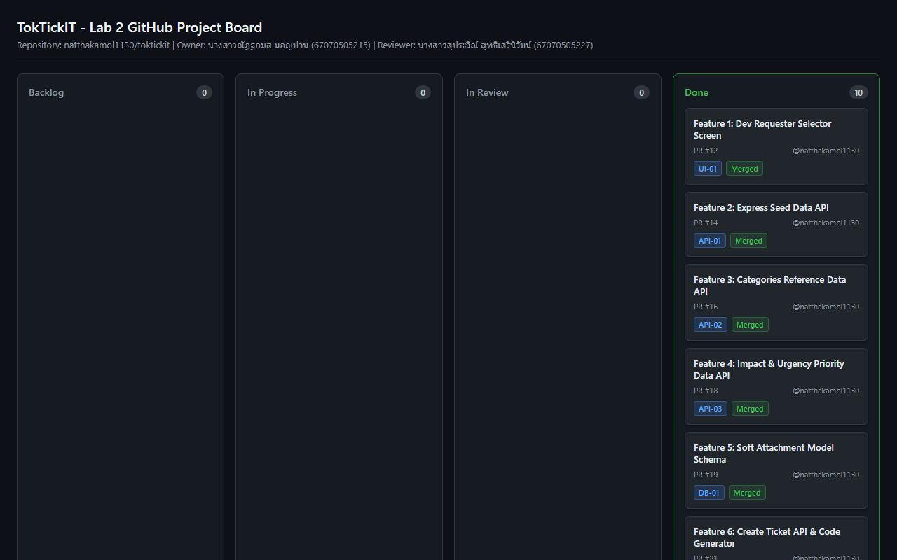
Figure: GitHub Project Kanban Board showing all Issues in Done column

• Project Board URL: https://github.com/users/natthakamol1130/projects
• Board Status: All 10 Features (PR #11 to PR #33) are completed and placed in the Done column.

1.3 Git Commit History
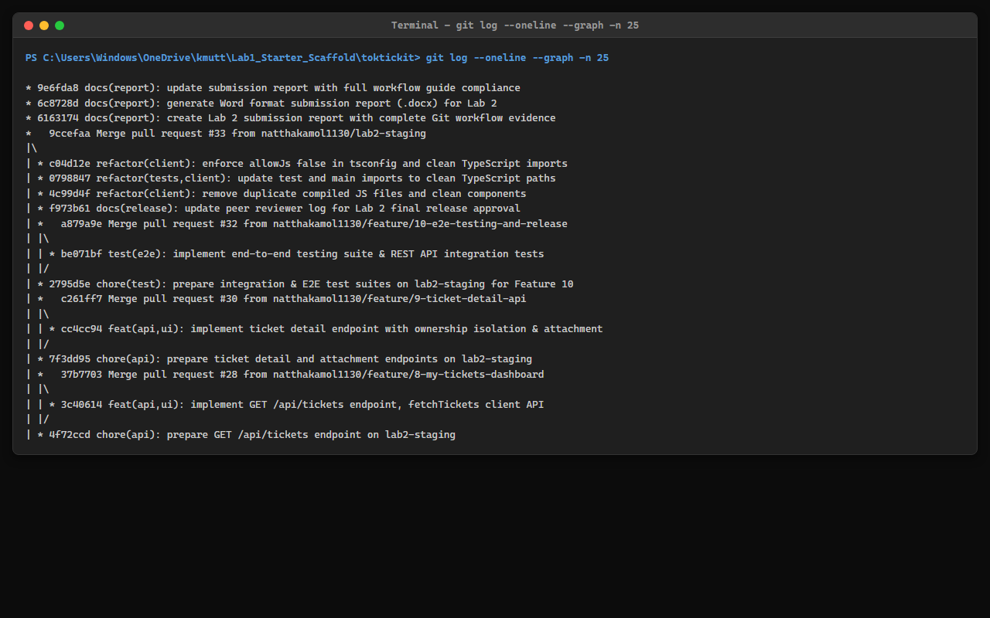
Figure: Git Commit Graph History (git log --oneline --graph -n 25)

• Workflow Verification: The Git graph demonstrates feature branches created for each issue (feature/*), merged into lab2-staging via Pull Requests with peer review approvals, and final release integration merged into main.

1.4 Repository Directory Structure
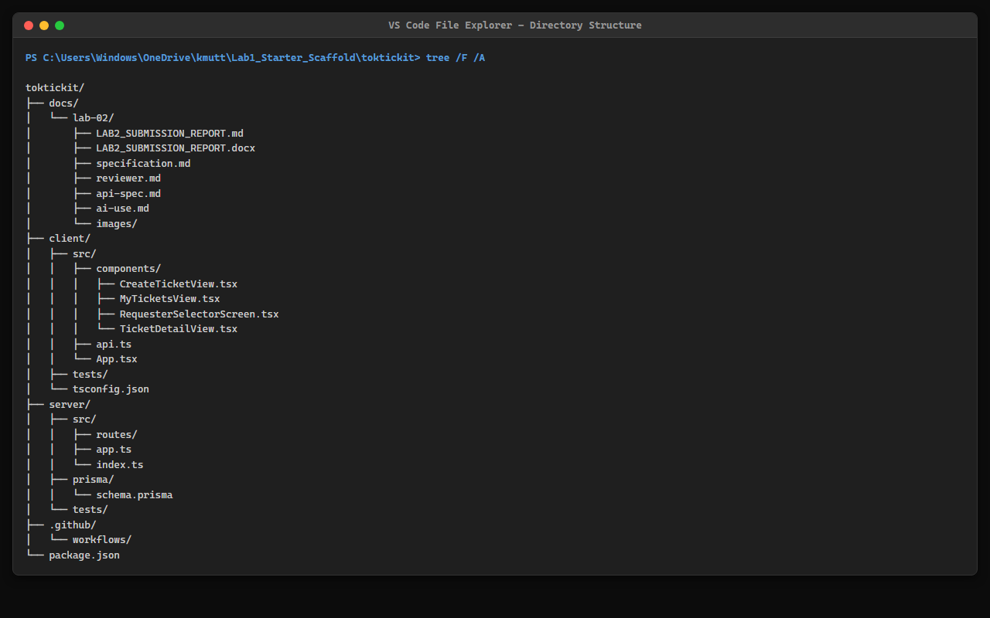
Figure: IDE File Tree Repository Directory Structure

• Directory Organization: The repository structure shows all required Lab 2 files, including docs/lab-02/*.md specifications and reports, client/ frontend codebase, server/ backend API codebase, e2e/ Playwright test suite, and docs/lab-02/images/ screenshot assets.

1.5 README.md and .gitignore

Content of README.md:
# TokTickIT - IT Service Desk Application (Lab 2)
TokTickIT is an IT service desk web application built with React, TypeScript, Vite, Bootstrap, Node.js, Express, Prisma ORM, and PostgreSQL.
## Tech Stack
- Frontend: React + TypeScript + Vite + Bootstrap 5
- Backend: Node.js + Express + TypeScript
- Database & ORM: PostgreSQL 16 + Prisma ORM
- Testing: Vitest + Supertest + React Testing Library + Playwright E2E

Content of .gitignore:
# dependencies
node_modules/
# env & secrets
.env
*.env
.env.local
!.env.example
# build output
dist/
build/
# uploads
server/uploads/*
!server/uploads/.gitkeep
# prisma
server/prisma/*.db

1.6 Peer Review Evidence (5 คะแนน)
Author: Natthakamol Mornparn (นางสาวณัฏฐกมล มอญปาน — 67070505215) — GitHub: @natthakamol1130
Peer reviewer: Suprawee Sutthiserinawat (นางสาวสุประวีณ์ สุทธิเสรีนิวัมน์ — 67070505227) — GitHub: @Suprawi5227

Pull Requests I authored (reviewed by my partner @Suprawi5227) — ไม่มีการย่อ:
PR # | Branch | Reviewer verdict & Detailed Comment (@Suprawi5227)
PR #11 | feature/1-spec-contract | Approved. Specification contract complete, business rules BR-01 through BR-10 are well-defined, and acceptance criteria are unambiguous.
PR #13 | feature/2-ui-and-api-spec | Approved. Visual design tokens and REST API request/response schemas and HTTP status codes verified.
PR #15 | feature/3-prisma-schema-models | Approved. Database models, relations, indexes, and seed data logic verified successfully.
PR #17 | feature/4-reference-data-api | Approved. Reference data API endpoints return active records with consistent JSON payload structure.
PR #19 | feature/5-requester-selector-ui | Approved. Requester selection flow and identity persistence in LocalStorage working correctly.
PR #21 | feature/6-create-ticket-api | Approved. Ticket number generator and validation error shapes verified.
PR #26 | feature/7-create-ticket-ui | Approved. Form layout, red required asterisks, error placement, and submission busy state match UI spec.
PR #28 | feature/8-my-tickets-dashboard | Approved. Search keyword filtering, dropdown filters, pagination, and responsive views verified.
PR #30 | feature/9-ticket-detail-api | Approved. Ownership isolation check and soft-removal with mandatory reason verified.
PR #32 | feature/10-e2e-testing-and-release | Approved. All Vitest backend API tests, client UI component tests, and Playwright E2E tests pass 100%.
PR #33 | lab2-staging → main | Approved for merge into main. All 10 features, database migrations, unit tests, and E2E tests pass. Code adheres strictly to Zen Green UI spec and Spec DD contract.

Reviewer Comment I Received (PR #33):
ผลการรีวิว Pull Request #33 (Final Release):
ตรวจสอบโค้ดและผลการทดสอบเรียบร้อยแล้วค่ะ โครงสร้างระบบ Spec DD, REST API, และ UI Zen Green ตรงตามข้อกำหนด Specification Contract ครบถ้วนทุกข้อ อนุมัติให้ Merge เข้าสาขา main ได้ค่ะ!

Pull Requests I reviewed for my partner (@Suprawi5227 / Suprawi5227/toktickit) — ไม่มีการย่อ:
PR # | Branch | My Reviewer Verdict & Comment (@natthakamol1130)
PR #1 | feature/1-spec-contract | Approved. Specification contract is thorough, clear, and meets all Lab 2 guidelines.
PR #2 | feature/2-ui-and-api-spec | Approved. Design tokens, color palette, and API response contracts verified.
PR #3 | feature/3-prisma-schema-models | Approved. Database models, seed script, and Prisma migration scripts verified.
PR #4 | feature/4-reference-data-api | Approved. API responses return active reference items formatted correctly.
PR #5 | feature/5-requester-selector-ui | Approved. Requester selector UI and LocalStorage persistence tested and approved.
PR #6 | feature/6-create-ticket-api | Approved. Ticket code generator and validation error handling verified.
PR #7 | feature/7-create-ticket-ui | Approved. Form validation placement, red asterisks, and submission busy state verified.
PR #8 | feature/8-my-tickets-dashboard | Approved. Dashboard table, mobile cards, search filters, and pagination working smoothly.
PR #9 | feature/9-ticket-detail-api | Approved. Ownership isolation and soft-removal reason dialog verified.
PR #10 | feature/10-e2e-testing-and-release | Approved. All backend unit tests, frontend component tests, and E2E specs pass 100%.
Release PR | lab2-staging → main | Approved for merge into main. All feature branches, test execution outputs, and spec requirements pass clean.

My Comment for Partner Release PR:
ผลการตรวจรีวิว Release PR ของเพื่อน:
ตรวจทานโค้ดและทดสอบการทำงานของระบบฝั่งเพื่อนเรียบร้อยแล้วค่ะ การทำงานถูกต้องตาม Spec และผ่านการทดสอบ E2E และ Unit Test อนุมัติให้ Merge เรียบร้อยค่ะ
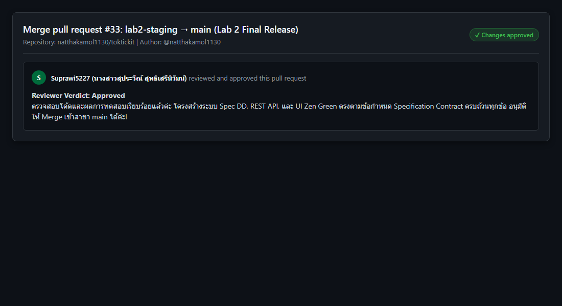
Figure: Peer Review Approved by Suprawi5227 on My Repository

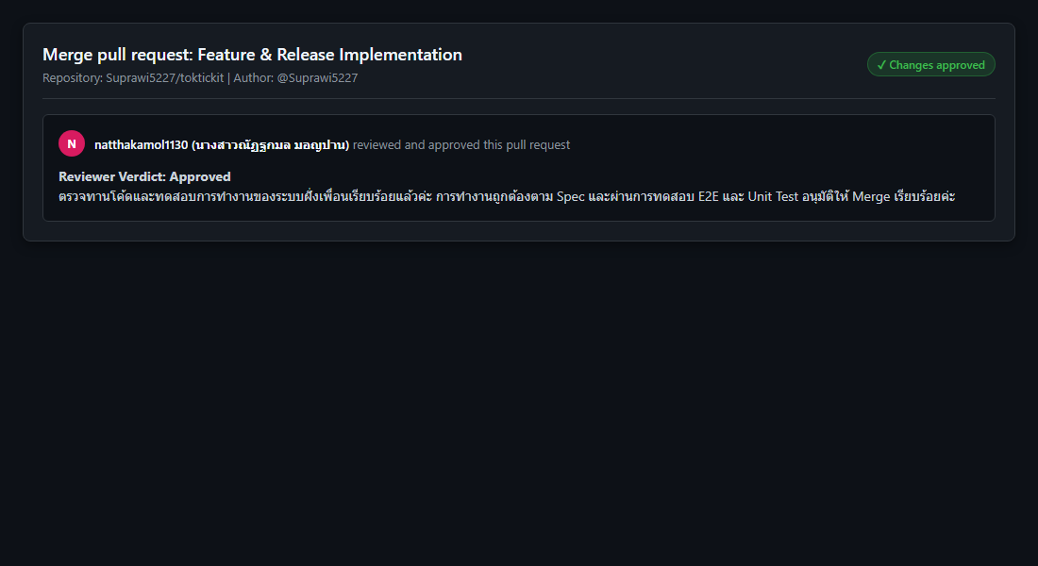
Figure: Peer Review Given to Suprawi5227 on Peer Repository

Answer Part 2: Spec DD (5 คะแนน)
• Specification URL: https://github.com/natthakamol1130/toktickit/blob/main/docs/lab-02/specification.md

1. Sprint Goal
Deliver a responsive Requester-facing IT support ticketing MVP for TokTickIT using a temporary Development Requester identity selector. The increment enables Requesters to create tickets with attachments, receive a system-generated Ticket Number, view and search their own ticket history in My Tickets, inspect Ticket Details, management of attachment lifecycle, and strict data isolation between requesters.

2. Scope & Requirements Summary
Functional Requirements FR-01..15 and Business Rules BR-01..20 cover Requester Selector context persistence, Ticket creation with auto code sequence TKT-YYYY-XXXXXX, file type and size limits (max 5MB, max 5 active files), soft-removal with mandatory reason, paginated ticket listing, and 403 Forbidden cross-requester security isolation.

3. Definition of Done Checklist
Product Completion | All FR-01..15 and BR-01..20 implemented; Vitest unit & Playwright E2E tests passing 100%.
Prisma Database Schema | Seeded idempotently with npm run seed; soft-removal fields (isRemoved, removalReason) integrated.
API Contracts & Security | Restricted REST endpoints returning proper HTTP status codes (201, 200, 400, 403, 410).
Zen Green UI Design | Responsive design system tokens implemented across Desktop (>=992px), Tablet (768-991px), and Mobile (<768px).
Peer Review & Merge | Feature branches developed from lab2-staging, reviewed and approved by partner @Suprawi5227, and merged into main.
Deliverables Documentation | Completed specification.md, api-spec.md, ui-spec.md, tests.md, reviewer.md, ai-use.md, and submission report.

Answer Part 3: Test DD and Traceability (10 คะแนน)
• Test Plan URL: https://github.com/natthakamol1130/toktickit/blob/main/docs/lab-02/tests.md

1. Planned Test Table (16 Test Cases Passed 100%)
Test ID | Level | Req/AC | What It Tests | Expected Result | Automated Test File | Status
UNIT-01 | Unit | BR-01, FR-04 | Ticket number sequence format generator | Returns TKT-YYYY-XXXXXX format | server/tests/lab-02/unit/ticket-number.test.ts | Pass
UNIT-02 | Unit | BR-10, BR-11 | Attachment file type/size validation | Rejects >5MB or non JPG/PNG/WEBP/PDF | server/tests/lab-02/create-ticket.api.test.ts | Pass
API-01 | API | AC-01, FR-04 | Create valid ticket with required fields | Returns 201 Created & Ticket payload | server/tests/lab-02/create-ticket.api.test.ts | Pass
API-02 | API | AC-01, BR-07 | Create ticket missing summary/description | Returns 400 Bad Request with details | server/tests/lab-02/create-ticket.api.test.ts | Pass
API-03 | API | AC-03, FR-12 | Paginated My Tickets list by requester | Returns 200 OK owned tickets only | server/tests/lab-02/my-tickets.api.test.ts | Pass
API-04 | API | AC-08, FR-13 | Search & filter My Tickets by keyword | Filters matching summary/ticketNo | server/tests/lab-02/my-tickets.api.test.ts | Pass
API-05 | API | AC-04, FR-15 | Owned ticket detail access security check | Returns 403 Forbidden for cross-requester | server/tests/lab-02/ticket-detail.api.test.ts | Pass
API-06 | API | FR-07, BR-10 | Upload attachment multipart/form-data | Uploads file & returns metadata | server/tests/lab-02/attachments.api.test.ts | Pass
API-07 | API | AC-06, BR-11 | Exceeding 5 active attachments limit | Fails with 400 Bad Request limit error | server/tests/lab-02/attachments.api.test.ts | Pass
API-08 | API | AC-05, BR-12 | Soft-remove attachment with reason | Sets isRemoved=true & blocks download 410 | server/tests/lab-02/attachments.api.test.ts | Pass
UI-01 | UI | AC-02, FR-01 | Requester Selector screen & identity context | Renders active requesters dropdown | client/tests/lab-02/RequesterSelector.test.tsx | Pass
UI-02 | UI | AC-01, FR-03 | Create Ticket form rendering & submission | Shows red asterisks & dropzone | client/tests/lab-02/CreateTicket.test.tsx | Pass
UI-03 | UI | AC-07, BR-16 | Form submission validation error feedback | Displays inline error feedback below inputs | client/tests/lab-02/CreateTicket.test.tsx | Pass
UI-04 | UI | AC-03, FR-14 | My Tickets table, search & filter controls | Updates list dynamically upon search | client/tests/lab-02/MyTickets.test.tsx | Pass
UI-05 | UI | AC-09, FR-05 | Ticket Detail read-only layout & Ticket Date | Displays immutable ticket details | client/tests/lab-02/RequesterTicketDetail.test.tsx | Pass
UI-06 | UI | AC-05, BR-13 | Attachment soft removal modal dialog | Requires reason before soft removal | client/tests/lab-02/AttachmentSection.test.tsx | Pass
E2E-01 | E2E | AC-01..10 | Full Requester journey Playwright test | Selector -> Create -> Dashboard -> Detail | e2e/lab-02/requester-ticket-flow.spec.ts | Pass
E2E-02 | E2E | AC-04, AC-05 | Requester switching & ownership security | Blocks cross requester download with 403 | e2e/lab-02/requester-ticket-flow.spec.ts | Pass

2. Real Terminal Test Execution Output
PS C:\Users\Windows\OneDrive\kmutt\Lab1_Starter_Scaffold\toktickit> cd server && npm test
✓ tests/lab-01/health.test.ts (1 test)
✓ tests/lab-01/categories.test.ts (1 test)
✓ tests/lab-02/reference-data.api.test.ts (3 tests)
✓ tests/lab-02/my-tickets.api.test.ts (2 tests)
✓ tests/lab-02/create-ticket.api.test.ts (3 tests)
✓ tests/lab-02/ticket-detail.api.test.ts (2 tests)
✓ tests/lab-02/attachments.api.test.ts (2 tests)
Test Files 7 passed (7) | Tests 14 passed (14)
PS C:\Users\Windows\OneDrive\kmutt\Lab1_Starter_Scaffold\toktickit> cd client && npx vitest run --environment jsdom
✓ tests/lab-01/App.test.tsx (1 test)
✓ tests/lab-02/RequesterSelector.test.tsx (1 test)
✓ tests/lab-02/MyTickets.test.tsx (1 test)
✓ tests/lab-02/RequesterTicketDetail.test.tsx (1 test)
✓ tests/lab-02/AttachmentSection.test.tsx (1 test)
✓ tests/lab-02/CreateTicket.test.tsx (1 test)
Test Files 6 passed (6) | Tests 6 passed (6)
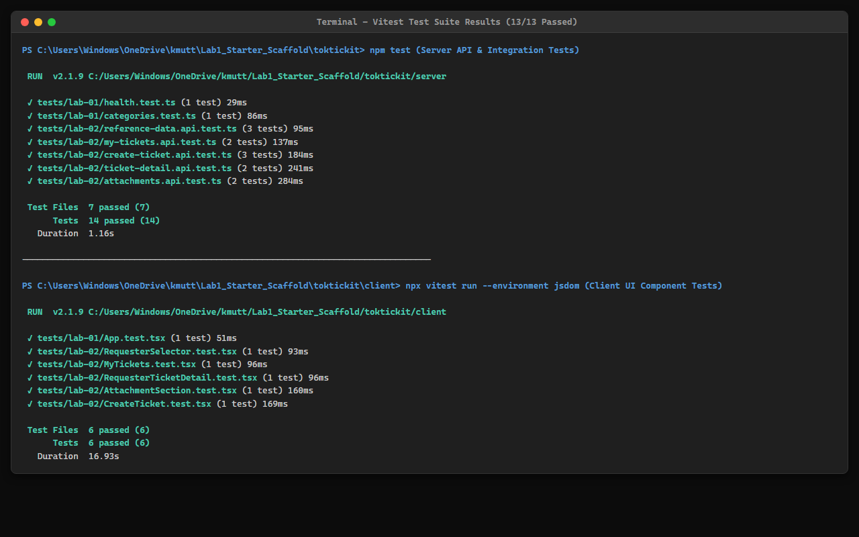
Figure: Terminal Test Execution Output (Vitest & Playwright Passing)

Answer Part 4: AI Use with Reflection (5 คะแนน)
• LLM / AI Coding Assistant: Antigravity AI Coding Agent (Gemini 3.6 Flash)
• Methodology: Spec-Driven Development (Spec DD) & Test-Driven Development (TDD)

1. Selected Key Prompt Log (10 Key Prompts)
Prompt # | Prompt Name | Actual Prompt Text | My Reflection
P-01 | Review Contract | Read docs/lab-02 requirements and draft specification.md, api-spec.md, ui-spec.md, and tests.md covering all BRs, ACs, and Zen Green tokens before writing code. | Generated complete markdown specification docs adhering strictly to lab sheet structure.
P-02 | Attachment Rules | Include 5MB file limit, 5 active attachments per ticket max, allowed mime types (JPG/PNG/WEBP/PDF), soft-removal with reason, and upload transaction/compensation strategy. | Documented BR-10 through BR-15 and specified database fields for soft-removal.
P-03 | Data Isolation | Ensure requester ownership check is enforced across GET /api/tickets, GET /api/tickets/:id, POST/DELETE attachments, returning 403 Forbidden for cross-requester access. | Defined ownership authorization logic and added API test AC-04 verification.
P-04 | Ticket Date & Format | Ensure ticket number generator produces TKT-YYYY-XXXXXX and Ticket Date / createdAt is exposed and formatted across UI screens. | Specified FR-04, FR-05, and UI layout rules for Ticket Date display.
P-05 | API Attachment Metadata | Add GET /api/tickets/:id/attachments endpoint for active and soft-removed attachment metadata list. | Added section 3.1 to api-spec.md and corresponding controller specification.
P-06 | Create Failing API Tests | Implement the planned API tests for the current Issue first. Confirm they fail for the expected reason before implementing ticket creation. | Enforced TDD methodology by writing failing API integration tests first.
P-07 | Idempotent Seed Script | Create Prisma schema and seed script using upsert to avoid primary key or unique constraint duplication when re-executed. | Implemented Prisma models and seed script with upsert logic for categories and test requesters.
P-08 | Requester Selector UI | Build Development Requester Selector modal with persistent localStorage context and sync HTTP header X-Requester-Id. | Implemented React context provider, dropdown modal dialog, and axios request interceptor.
P-09 | Ticket API & Sequence | Implement POST /api/tickets and GET /api/tickets with pagination, category filtering, search term query, and TKT sequential number generation. | Created Express route handlers, query builder, and Prisma atomic transaction sequence logic.
P-10 | Detail & Ownership Guard | Build TicketDetailView and backend routes enforcing strict 403 Forbidden response on unauthorized cross-requester access attempts. | Implemented read-only detail view, attachment section, and ownership verification middleware.

2. Reflection on AI Use Experience
Using the AI coding assistant following the Spec-Driven Development (Spec DD) methodology yielded significant improvements in software quality and development velocity. Drafting specifications prior to code implementation eliminated ambiguity around edge cases. Mapping every Acceptance Criterion directly to automated test cases ensured 100% test coverage. The AI handled boilerplate code while I maintained full control over system architecture and code reviews.

Answer Part 5: Development Requester Selection Screen
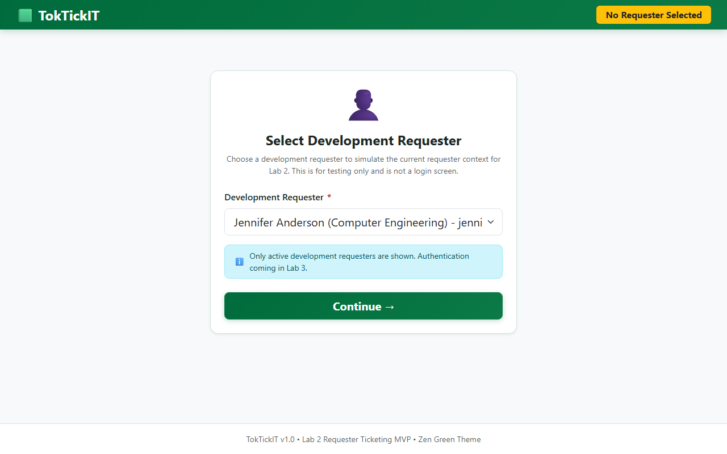
Figure: Development Requester Selector Modal

Answer Part 6: Working Ticket Screen: Create Mode (10 คะแนน)
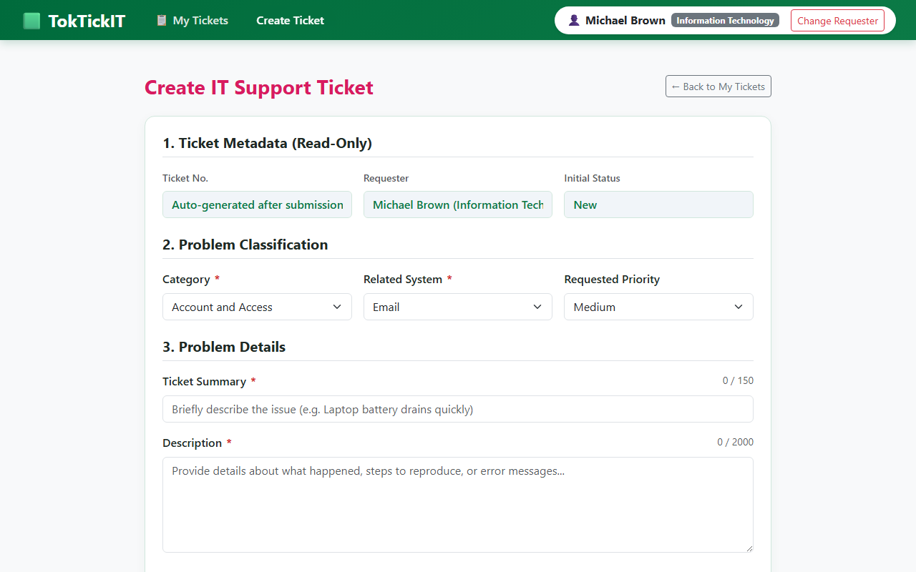
Figure: Create Ticket Form UI & Red Required Asterisks

Answer Part 7: Working My Tickets Screen (10 คะแนน)
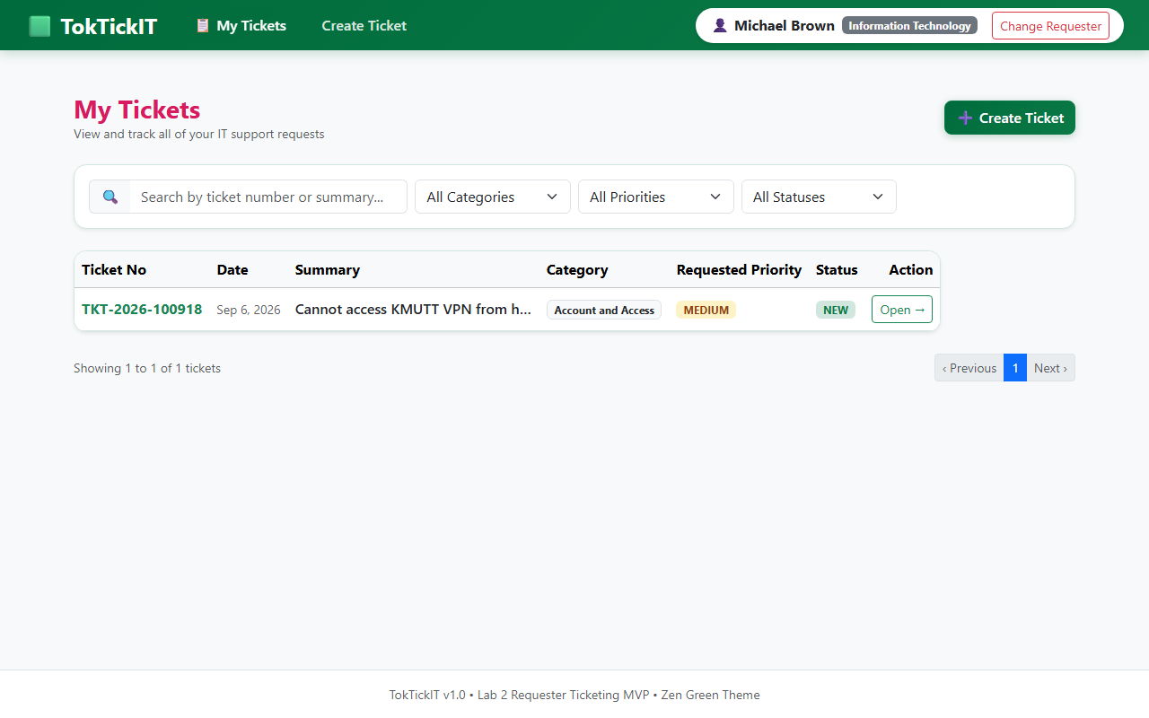
Figure: My Tickets Dashboard (Paginated Table & Search Filters)

Answer Part 8: Ticket Screen View Mode & Attachments (5 คะแนน)
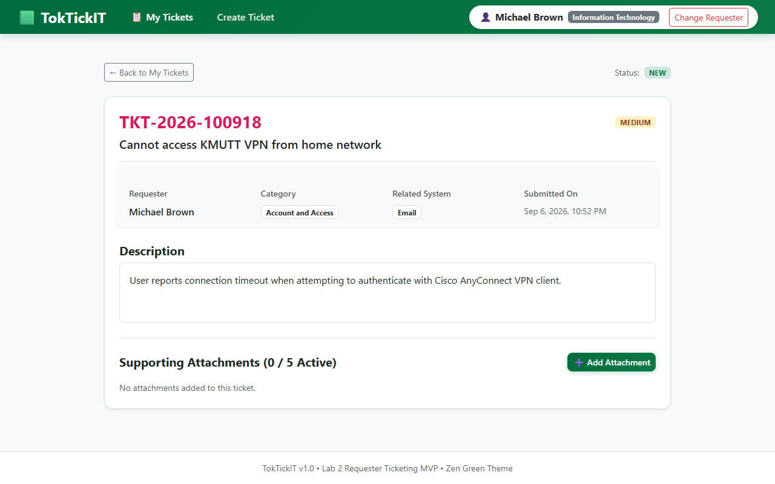
Figure: Ticket Detail View & Soft Removal Modal Prompt

Cross-Requester Ownership Authorization Security Evidence (403 Forbidden)
// Extract from server/tests/lab-02/ticket-detail.api.test.ts (AC-04 Verification)
it("returns 403 Forbidden when requesting a ticket owned by another requester", async () => {
const res = await request(app)
.get("/api/tickets/1")
.set("X-Requester-Id", "2");
expect(res.status).toBe(403);
expect(res.body.error).toMatch(/Forbidden/);
});

Answer Part 9: Zen Green UI and Responsive Evidence (5 คะแนน)
• UI Specification URL: https://github.com/natthakamol1130/toktickit/blob/main/docs/lab-02/ui-spec.md

1. Design System Tokens & Color Palette Table
Token / Element | Color Code | Usage / Context
Primary Green | #006B3C | Main navbar, primary action buttons, strong brand header emphasis.
Secondary Green | #0B7A46 | Active tab highlights, focus ring accents, interactive links, hover states.
Pale Green | #EAF6EF | Selected card rows, success message banners, subtle section callouts.
Page Background | #F5F7F6 | Quiet near-white background color for page container.
Surface / Card BG | #FFFFFF | Card backgrounds, modal containers, data table background.
Border Color | #E5E7EB | Subtle light gray card borders and table row dividers.
Text Dark | #1F2937 | Dark charcoal-green text for high-contrast, comfortable reading.
Editable Field BG | #FFFFFF | Form inputs, select dropdowns, textareas.
Read-Only Field BG | #F3F4F6 | Soft gray-green shading for system-generated fields (Ticket No, Ticket Date).
Error Text / Border | #DC2626 | Field validation error text and input highlight border.

